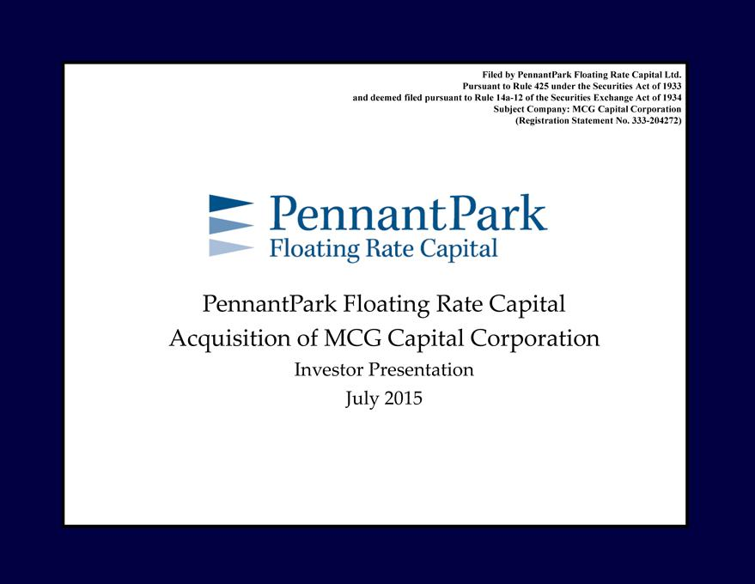

InvestorPennantParkPresentationFloating JulyRate2015Capital Acquisition of MCG Capital Corporation
PursuantFiledby PennantParktoRule425 underFloatingthe RateSecuritiesCapitalActLtd.of 1933
SubjectanddeemedCompany:filedpursuantMCGCapitaltoRuleCorporation14a-12ofthe Securities Exchange Act of 1934
(Registration Statement No. 333-204272)

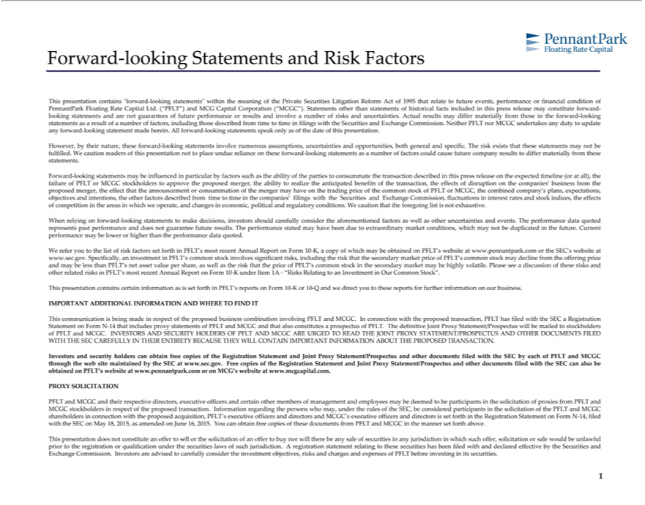

Forward-looking Statements and Risk Factors
This presentation contains “forward-looking statements” within the meaning of the Private Securities Litigation Reform Act of 1995 that relate to future events, performance or financial condition of PennantPark
Floating Rate Capital Ltd. (“PFLT”) and MCG Capital |  |  |  | (“MCGC”). Statements other than statements of historical facts included in this press release may constitute |  |  | -looking statements and are not
guarantees of future performance or results and involveCorporationnumberof risks and uncertainties. Actual results may differ materially from those in the forward-looking statements asforwardresult of number of factors,
including those described from time to time in filings with the Securities and Exchange Commission. Neither PFLT nor MCGC undertakes any duty to update any forward-looking statement made herein. All forward-
looking statements speak only as of the date of this presentation. |  |  |  |  |  | and opportunities, both general and specific. The risk exists that these statements may not be fulfilled. We
However, by their nature, these forward-looking statements involve numerous assumptions,
caution readers of this presentation not to place undue reliance on these forward-looking statementsuncertaintiesasnumber of factors could cause future company results to differ materially from these |  |  |  |  |  |  |  | .
 | -looking statements may be influenced in particular by factors such as the ability of the parties to consummate the transaction described in this press release on the expected timeline statements(orall), the failure of
ForwardPFLT MCGC stockholders to approve the proposed merger, the ability to realize the anticipated benefits of the transaction, the effects of disruption on the companies’ business from the proposed merger, the effect
that the announcement or consummation of the merger may have on the trading price of the common stock of PFLT or MCGC, the combined company’s plans, expectations, objectives and intentions, the other factors
described from time to time in the companies’ filings with |  |  | Securities and Exchange |  |  | fluctuations in interest rates and stock indices, the effects of competition in the areas in which we operate, and
changes | political and regulatory conditions. Wthecaution that the foregoing Commission,listnotexhaustive.
When relyingeconomic,forward-looking statements to make decisions, investors should carefully consider the aforementioned factors as well as other uncertainties and events. The performance data quoted represents past
performance and does not guarantee future results. The performance stated may have been due to extraordinary market conditions, which may not be duplicated in the future. Current performance may be lower or
than the performance data quoted. |  |  |  |  |  | copy of which may be obtained on PFLT’ website at www.pennantpark.com or the SEC’s website at www.sec.gov.
higherWrefer you to the list of risk factors set forth in PFLT’ most recent Annual Report on Form 10-K,
Specifically, an investment in PFLT’scommonstock involves |  |  |  | risks, | therisk that thesecondary market price of PFLT’scommonstock may decline from theoffering price and may be |  |  | than PFLT’s
net asset value per share, as well as the risk that the price of PFLT’ |  |  |  | common stock | the secondary market may be highly volatile. Please see a discussion of these risks and other related risks in PFLT’lessmost recent
Annual Report on Form 10-K under Item 1A— |  |  | to | InvestmentincludingOur Common Stock”.
This presentation contains certain information as“Risksset RelatingforthsignificantPFLT’reports on Form 10-K or 10-Q and we direct you to these reports for further information on our business.
IMPORTANT ADDITIONAL INFORMATION AND WHERE TO FIND IT
This communication is being made in respect of the proposed business combination involving PFLT and MCGC. In connection with the proposed transaction, PFLT has filed with the SEC a Registration Statement on
Form -14 that includes proxy statements of PFLT and MCGC and that also constitutes a prospectus of PFLT. The definitive Joint Proxy tatement/Prospectus will be mailed to stockholders of PFL |  |  |  |  |  |  |  | and MCGC.
INVESTORS AND SECURITY HOLDERS OF PFL AND MCGC ARE URGED TO READ THE JOINT PROXY STATEMENT/PROSPECTUS AND OTHER DOCUMENTS FILED WITH THE SEC
CAREFULLY IN THEIR ENTIRETY BECAUSE THEY WILL CONTAIN IMPORTANT INFORMATION ABOUT THE PROPOSED TRANSACTION.
Investors and security holders can obtain free copies of the Registration Statement and Joint Proxy Statement/Prospectus and other documents filed with the SEC by each of PFLT and MCGC through the web site
maintained by the SEC at www.sec.gov. Free copies of the Registration Statement and Joint Proxy Statement/Prospectus and other documents filed with the SEC can also be obtained on PFLT’s website at
www.pennantpark.com or on MCG’s website at www.mcgcapital.com.
ROXY SOLICITATION
PFLT and MCGC and their respective directors, executive officers and certain other members of management and employees may be deemed to be participants in the solicitation of proxies from PFLT and MCGC
stockholders in respect of the proposed |  | . Information regarding the persons who may, under the rules of the SEC, be considered participants in the solicitation of the PFLT and MCGC shareholders in
connection with the proposed acquisition,transactionPFLT’executive officers and directors and MCGC’s executive officers and directors is set forth in the Registration Statement on Form N-14, filed with the SEC on May 18, 2015, as amended on June 16, 2015. You can obtain free copies of these documents from PFLT and MCGC in the manner set forth above.
This presentation does not constitute an offer to sell or the solicitation of an offer to buy nor will there be any sale of securities in any jurisdiction in which such offer, solicitation or sale would be unlawful prior to the registration or qualification under the securities laws of such jurisdiction. A registration statement relating to these securities has been filed with and declared effective by the Securities and Exchange Commission. Investors are advised to carefully consider the investment objectives, risks and charges and expenses of PFLT before investing in its securities.

1

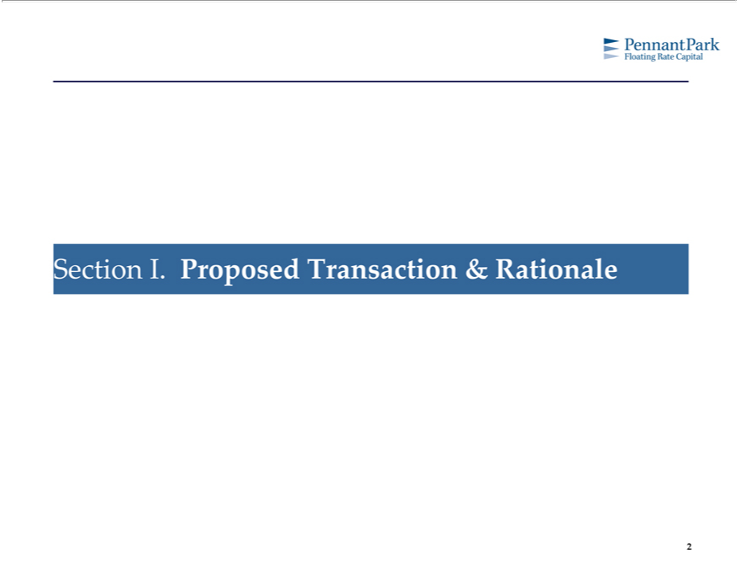

2Section I. Proposed Transaction & Rationale

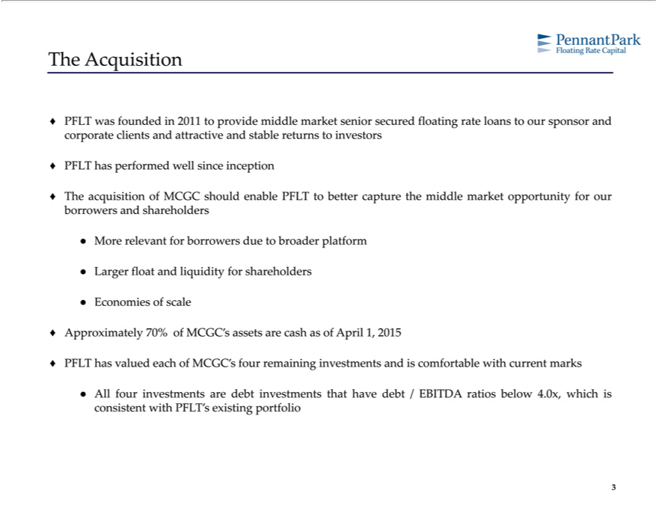

The Acquisition
^{PFLT} was founded in 2011 to provide middle market senior secured floating rate loans to our sponsor and corporate clients and attractive and stable returns to investors has performed well since inception
The acquisition of MCGC should enable PFLT to better capture the middle market opportunity for our borrowers and shareholders More relevant for borrowers due to broader platform
Econ_{Approximately}Largermiesfloatofandscaleliquidity for shareholders
70% of MCGC’s _{assets} are cash as of April 1, 2015
PFLT has valued each of MCGC’ four remaining investments and is comfortable with current marks
All four investments are debt investments that have debt / EBITDA ratios below 4.0x, which is consistent with PFLT’s existing portfolio 3

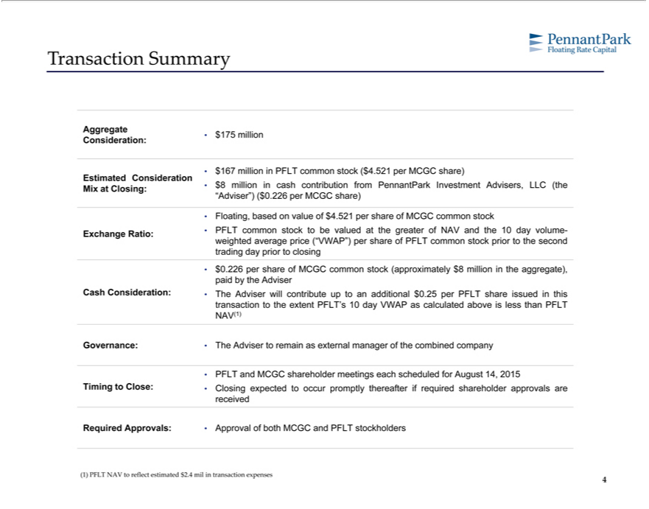

Transaction Summary
Consideration:Aggregate•$175 million
_{Estimated}•$167millionConsiderationinPFLTcommon stock ($4.521 per MCGC share)
Mix Closing: • $8 million in cash contribution from PennantPark Investment Advisers, LLC (the “Adviser”) ($0.226 per MCGC share)
• Floating, based on value of $4.521 per share of MCGC common stock
Exchange Ratio: • PFLT common stock to be valued at the greater of NAV and the 10 day volume-weighted average price (“VWAP”) per share of PFLT common stock prior to the second
trading day prior to closing
paid•$0.226bytheperAdvisershareof MCGC common stock (approximately $8 million in the aggregate),
Cash Consideration: • The _{Adviser} will contribute up to an additional $0.25 per PFLT share issued in this transaction to the extent PFLT’ 10 day VWAP as calculated above is less than PFLT
NAV(1)
Governance: • The Adviser to remain as external manager of the combined company
• PFLT and MCGC shareholder meetings each scheduled for August 14, 2015
Timing to Close: • Closing expected to occur promptly thereafter if required shareholder approvals are received
Required Approvals: • Approval of both MCGC and PFLT stockholders
4(1) PFLT NAV to reflect estimated $2.4 mil in transaction expenses

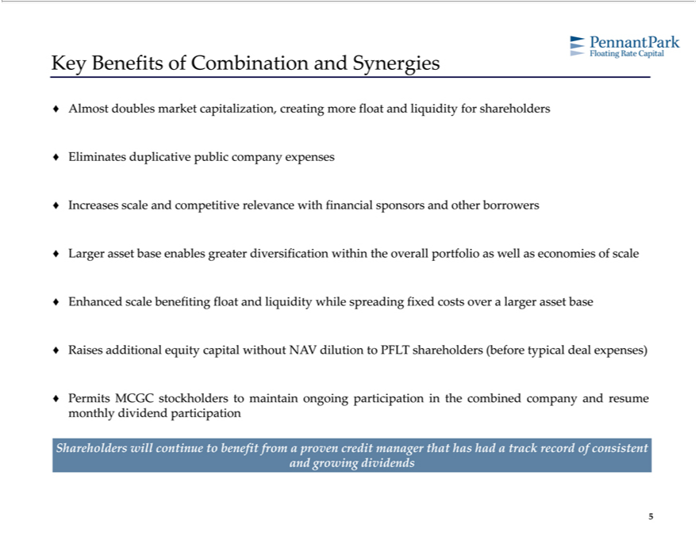

Key Benefits of Combination and Synergies
AlmostEliminatesdoublesduplicativemarketpubliccapitalization,companycreatingexpensesmore float and liquidity for shareholders
Increases scale and competitive relevance with financial sponsors and other borrowers
Larger asset base enables greater diversification within the overall portfolio as well as economies of scale Enhanced scale benefiting float and liquidity while spreading fixed costs over a larger asset base
? Raises additional equity capital without NAV dilution to PFLT shareholders (before typical deal expenses)
Permits MCGC _{stockholders} to maintain ongoing participation in the combined company and resume monthly dividend participation Shareholders will continue benefit from a proven credit manager that has had a track record of consistent and growing dividends
5

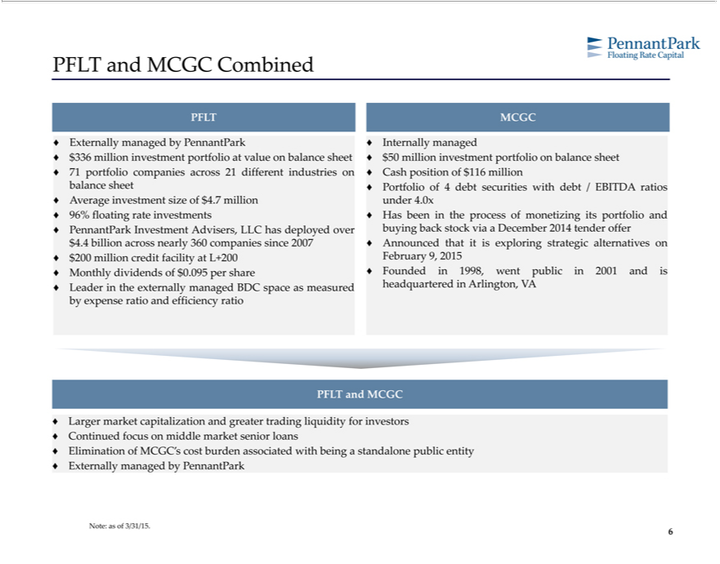

 | and MCGC Combined
PFLT MCGC
 | Externally managed by PennantPark ? Internally managed
? | $336 million investment portfolio at value on balance sheet ? $50 million investment portfolio on balance sheet
? | 71 portfolio companies across 21 different industries on ? Cash position of $116 million
balance sheet ? Portfolio of 4 debt securities with debt / EBITDA ratios
 | Average investment size of $4.7 million under 4.0x
? | 96% floating rate investments ? Has been in the process of monetizing its portfolio and
? | PennantPark Investment Advisers, LLC has deployed over buying back tock via a December 2014 tender offer
$4.4 billion across nearly 360 companies since 2007 ? Announced that it is exploring strategic alternatives on
 | $200 million credit facility at L+200 February 9, 2015
? | Monthly dividends of $0.095 per share ? Founded in 1998, went public in 2001 and is
? | Lead r in the externally managed BDC space as measured headquartered in Arlington, VA
by expense ratio and efficiency ratio
PFLT and MCGC |  | and greater trading liquidity for investors
 | Larger market | and greater trading liquidity for investors
Cont_{limination}uedfocuscapitalizationmiddlemarket senior loans
_{? Externally} managedofMCGC’sbyPennantParkcostburden associated with being a standalone public entity
6Note: as of 3/31/15.

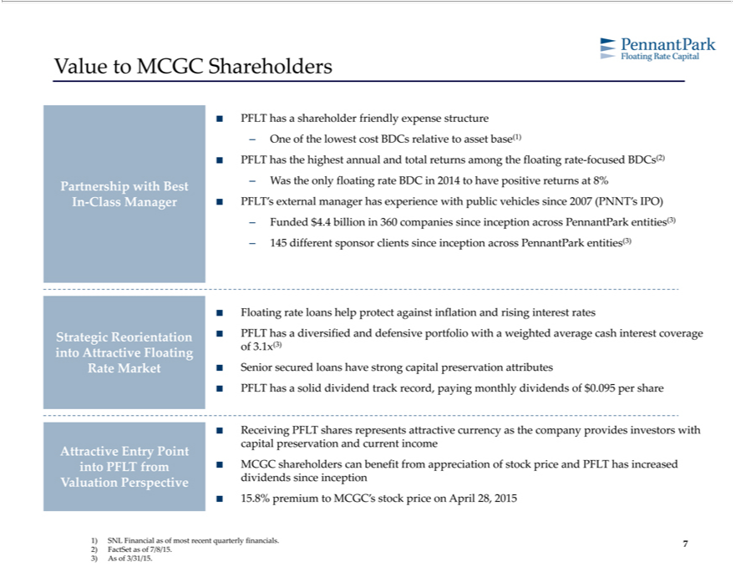

Value to MCGC Shareholders
PFLT has a shareholder friendly expense structure
– One of the lowest cost BDCs relative to asset base(1)
FLT has the highest annual and total returns among the floating rate-focused BDCs(2)
Partnership with Best – W the only floating rate BDC in 2014 to have positive returns at 8%
In-Class Manager ? PFLT’asexternal manager has experience with public vehicles since 2007 (PNNT’s IPO)
Funded $4.4 billion in 360 companies since inception across PennantPark entities(3)
– 145 different sponsor clients since inception across PennantPark entities(3)
Floating rate loans help protect |  |  |  | inflation and rising interest rates
Strategic Reorientation ? PFLT hasagainstdiversified and defensive portfolio with a weighted average cash interest coverage
into Attractive Floating of 3.1x(3)
Rate |  | ? Senior secured loans have strong capital preservation attributes
PFLTMarkethassolid dividend track record, paying monthly dividends of $0.095 per share
Receiving PFLT shares represents attractive currency as the company provides investors with
capital preservation and current income
Attractive Entry Point
into PFLT from ? MCGC shareholders can benefit from appreciation of stock price and PFLT has increased
Valuation Perspective |  |  | since
5.8% premium to MCGC’dividendsstock priceinceptionApril 28, 2015
1) | SNL Financial as of most recent quarterly financials.
2) | FactSet as of 7/8/15.
3) | As of 3/31/15.
7

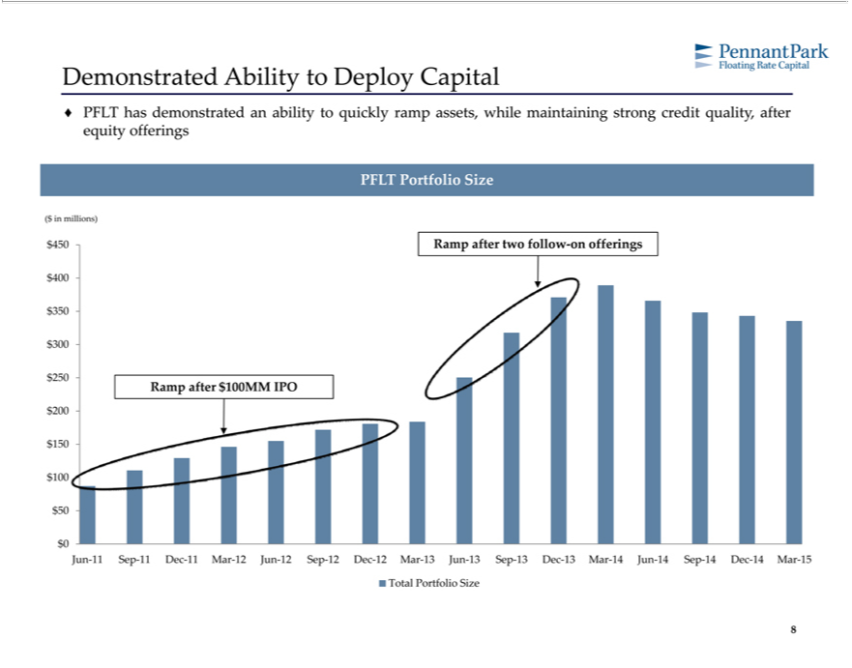

Demonstrated Ability to Deploy Capital
? PFLT has demonstrated an ability to quickly ramp assets, while maintaining strong credit quality, after equity offerings PFLT Portfolio Size
($ in millions)
⁴⁰⁰⁵⁰ Ramp after two follow-on offerings
$300250
Ramp after $100MM IPO
1200₅₀
$500
Jun-11 Sep-11 Dec-11 Mar-12 Jun-12 Sep-12 Dec-12 Mar-13 Jun-13 Sep-13 Dec-13 Mar-14 Jun-14 Sep-14 Dec-14 Mar-15 Total Portfolio Size
8

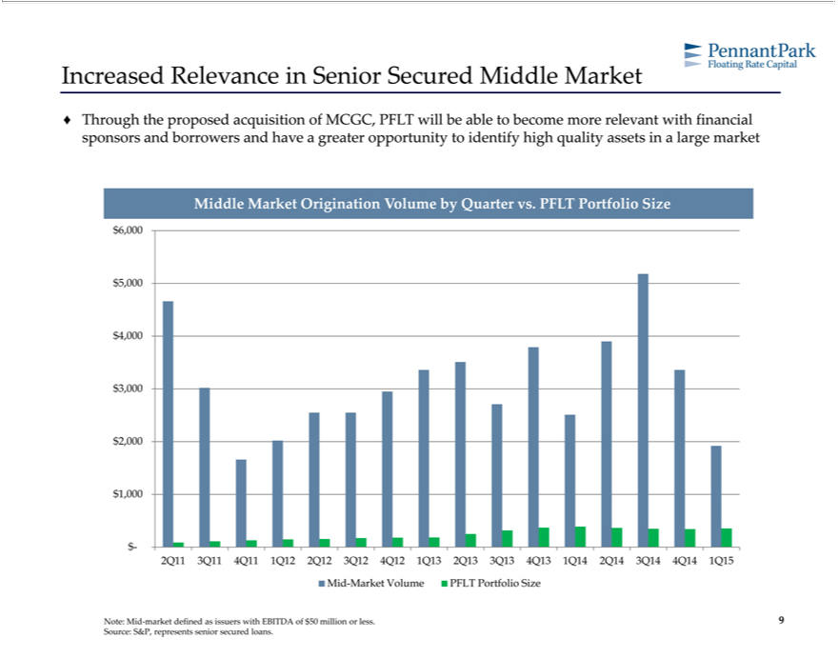

Increased Relevance in Senior Secured Middle Market
? Through the proposed acquisition of MCGC, PFLT will be able to become more relevant with financial sponsors and borrowers and have a greater opportunity to identify high quality assets in a large market Middle Market Origination Volume by Quarter vs. PFLT Portfolio Size
₅6
4
3
2
$1,000
-
Mid2Q11-Market3Q114Q11Volume1Q12PFLT2Q12Portfolio3Q12 4Q12Size 1Q13 2Q13 3Q13 4Q13 1Q14 2Q14 3Q14 4Q14 1Q15
9Note: Mid-market defined as issuers with EBITDA of $50 million or less. Source: S&P, represents senior secured loans.

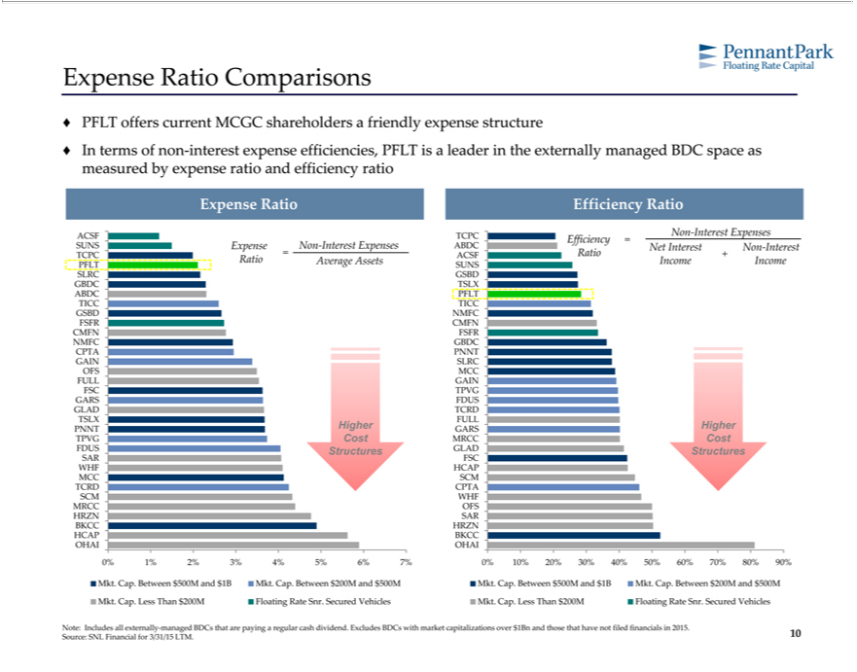

Expense Ratio Comparisons
? PFLT offers current MCGC shareholders a friendly expense structure
In terms of non-interest expense efficiencies, PFLT is a leader in the externally managed BDC space as measured by expense ratio and efficiency ratio Expense Ratio Efficiency Ratio
ACSFNon-InterestTCPC ExpensesEfficiency =
TCPCSUNS =ExpenseACSF RatioNon-Interest+ Expenses ABDC Net Interest Non-Interest
Ratio Average Assets Income Income
PFLT SUNS
SLRC GSBD
^{G}ABDC TSLXPFL
TICC TICC
GSBD NMFC
FSFR CMFN
CMFN FSFR
NMFC GBDC
_{GAIN}CPT PNNTSLRC
OFS MCC
^{FSC}
ULLTPVGGAIN
_{GLAD}ARS FDUS
TSLX FULLTCRD
TPVGPNNT CostHigherMRCCGARSCostHigher
FDUS Structures GLAD Structures
SARWHFFSCHCAP
MCC SCM
SCMTCRDWHFCPTA
MRCC OFS
BKCCHRZN HRZNSAR
OHAIHCAP OHAIBKCC
0% 1% 2% 3% 4% 5% 6% 7% 0% 10% 20% 30% 40% 50% 60% 70% 80% 90%
^{Mkt. Cap.} Between $500M and $1B Mkt. Cap. Between $200M and $500M Mkt. Cap. Between $500M and $1B Mkt. Cap. Between $200M and $500M Less Than $200M Floating Rate Snr. Secured Vehicles Mkt. Cap. Less Than $200M Floating Rate Snr. Secured Vehicles
Note: Includes all externally-managed BDCs that are paying a regular cash dividend. Excludes BDCs with market capitalizations over $1Bn and those that have not filed financials in 2015. Source: SNL Financial for 3/31/15 LTM.
10

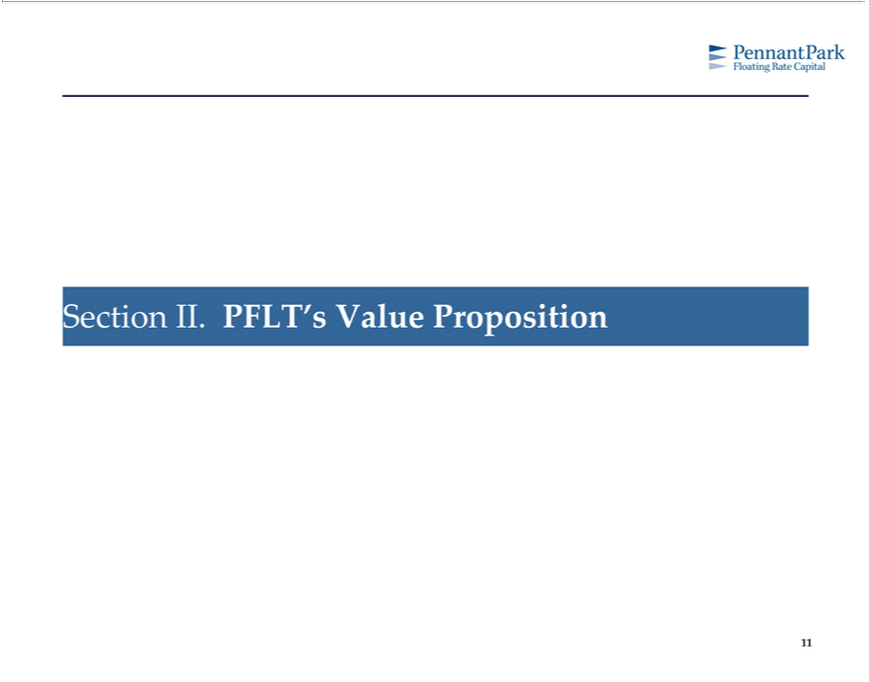

11Section II. PFLT’s Value Proposition

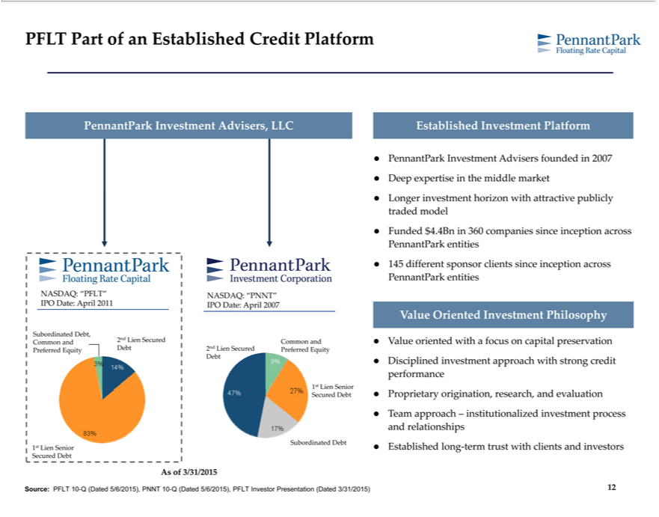

FLT Part of an Established Credit Platform
PennantPark Investment Advisers, LLC
FL
NASDAQ: “PNNT”
11
IPO Date: April 2007
Subordinated Debt,
Common and
2nd Lien Secured
Common and
Preferred Equity
Debt
2nd Lien Secured
Preferred Equity
Debt
1st Lien Senior
ecured Debt
Subordinated Debt
1st Lien Senior
Secured Debt
As of 3/31/2015
Established Investment Platform
PennantPark Investment Advisers founded in 2007
Deep expertise he middle market
investment
tradedLongermodel horizon with attractive publicly
PennantParkFunded$4.4Bnentitiesin360 companies since inception across
PennantPark145different entitiessponsor clients since inception across
^{Value} Oriented Investment Philosophy
oriented with a focus on capital preservation
^{perform}ProprietaryDisciplined^{nce}investment approach with strong credit
origination, research, and evaluation
andTeamrelationshipsapproach– institutionalized investment process
Established long-term trust with clients and investors
12Source: PFLT 10-Q (Dated 5/6/2015), PNNT 10-Q (Dated 5/6/2015), PFLT Investor Presentation (Dated 3/31/2015)

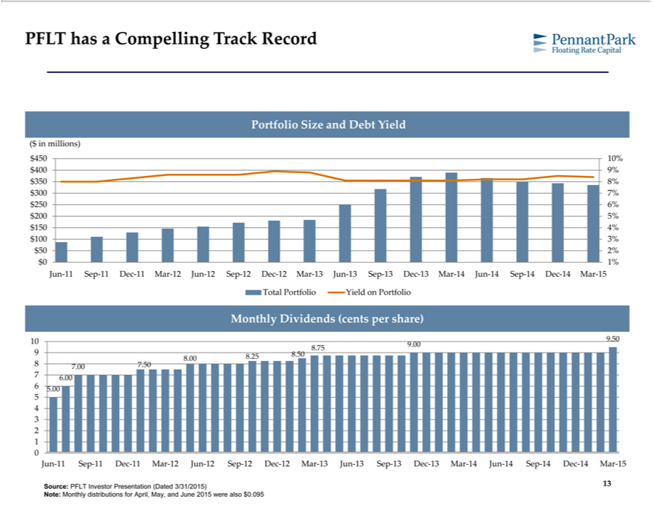

 | FLT has a Compelling Track Record
Portfolio Size and Debt Yield
($ in millions)
 | 400 |  | 10%
 |  |  | 9%
 | 50 |  | 8%
 | 300 |  | 7%
 | 50 |  | 6%
 | 200 |  | 5%
 | 150 |  | 4%
 |  |  | 3%
 | 50 | 2%
$0
Jun1%- Sep-11 Dec-11 Mar-12 Jun-12 Sep-12 Dec-12 Mar-13 Jun-13 Sep-13 Dec-13 Mar-14 Jun-14 Sep-14 Dec-14 Mar-15
Total Portfolio Yield on Portfolio
Monthly Dividends (cents per share)
10 9.50
8.75 9.00
9 8.50
8 | .00 8.25
8 |  |  |  | 7.00 7.50
7 |  |  |  | 6.00
6 |  |  |  | 5.00
5
4
3
2
1
0
Jun-11 Sep-11 Dec-11 Mar-12 Jun-12 Sep-12 Dec-12 Mar-13 Jun-13 Sep-13 Dec-13 Mar-14 Jun-14 Sep-14 Dec-14 Mar-15 Source: PFLT Investor Presentation (Dated 3/31/2015)

13Note: Monthly distributions for April, May, and June 2015 were also $0.095

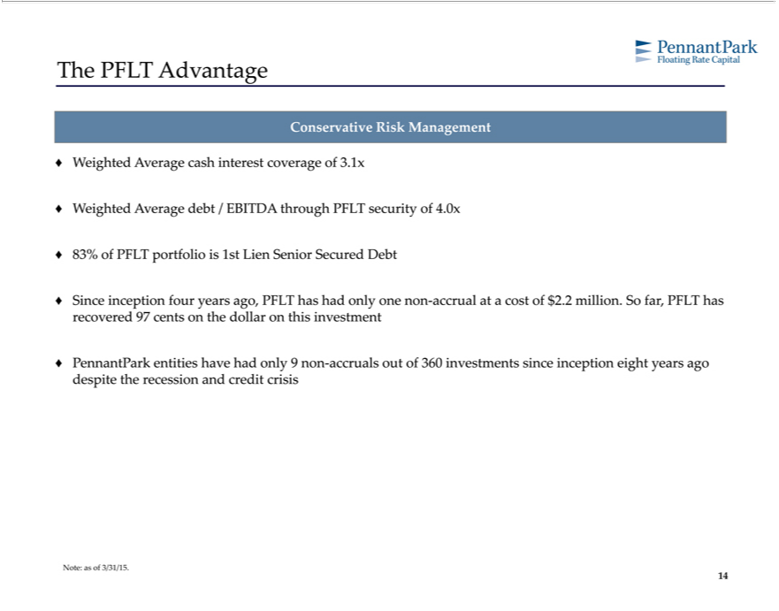

ConservativeThePFLTAdvantageRiskManagement
_{Weighted Average} cash interest coverage of 3.1x
83% of PFLT portfoliodebt is/ EBITDA1stLien SeniorthroughSecuredPFLTsecurityDebt of 4.0x
? Since inception four years ago, PFLT has had only one non-accrual at a cost of $2.2 million. So far, PFLT has recovered 97 cents on the dollar on this investment PennantPark entities have had only 9 non-accruals out of 360 investments since inception eight years ago despite the recession and credit crisis

14Note: as of 3/31/15.

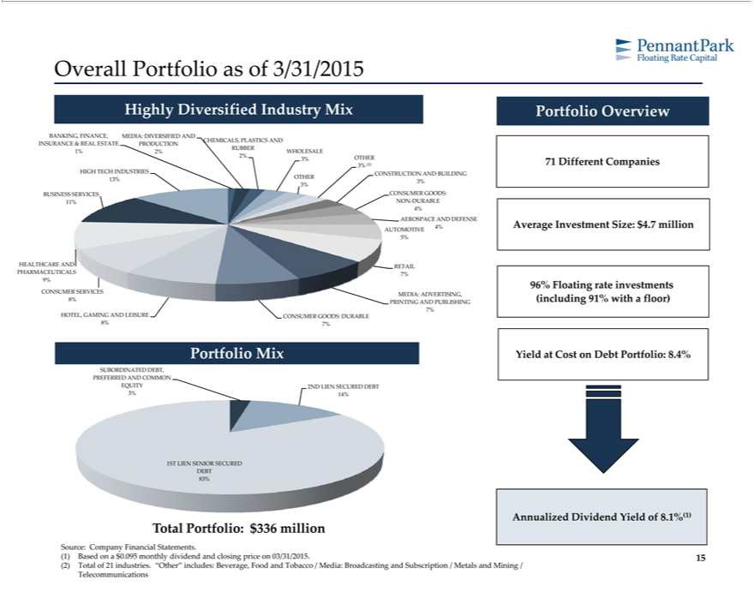

Overall Portfolio as of 3/31/2015
Highly Diversified Industry Mix
BANKING, FINANCE, MEDIA: DIVERSIFIED AND
CHEMICALS, PLASTICS
INSURANCE & REAL ESTANDTE PRODUCTION
RUBBER
1% | 2% WHOLESALE
2% | 3% OTHER
3% | (2)
HIGH TECH INDUSTRIES CONSTRUCTION AND BUILDING
OTHER
13% |  | 3%
BUSINESS SERVICES CONSUMER GOODS:
11% NON-DURABLE
4%
EROSPACE AND DEFENSE
AUTOMOTIVE 4%
5%
HEALTHCARE AND RETAIL
PHARMACEUTICALS 7%
9%
CONSUMER SERVICES MEDIA: ADVERTISING,
8% PRINTING AND PUBLISHING
7%
HOTEL, GAMING AND LEISURE CONSUMER GOODS: DURABLE
8% | 7%
Portfolio Mix
SUBORDINATED DEBT,
PREFERRED AND COMMON
EQUITY 2ND LIEN SECURED DEBT
3% | 14%
1ST LIEN SENIOR SECURED
DEBT
83%
Total Portfolio: $336 million
Portfolio Overview
71 Different Companies Average Investment Size: $4.7 million
96% |  | rate investments (including 91% with floor)
YieldFloatingCost on Source: Company Financial Statements.
(1) |  | Based on a $0.095 monthly dividend and closing price on 03/31/2015.
(2) Total of 21 industries. “Other” includes: Beverage, Food and Tobacco / Media: Broadcasting and Subscription / Metals and Mining / Telecommunications
15Debt Portfolio: 8.4%

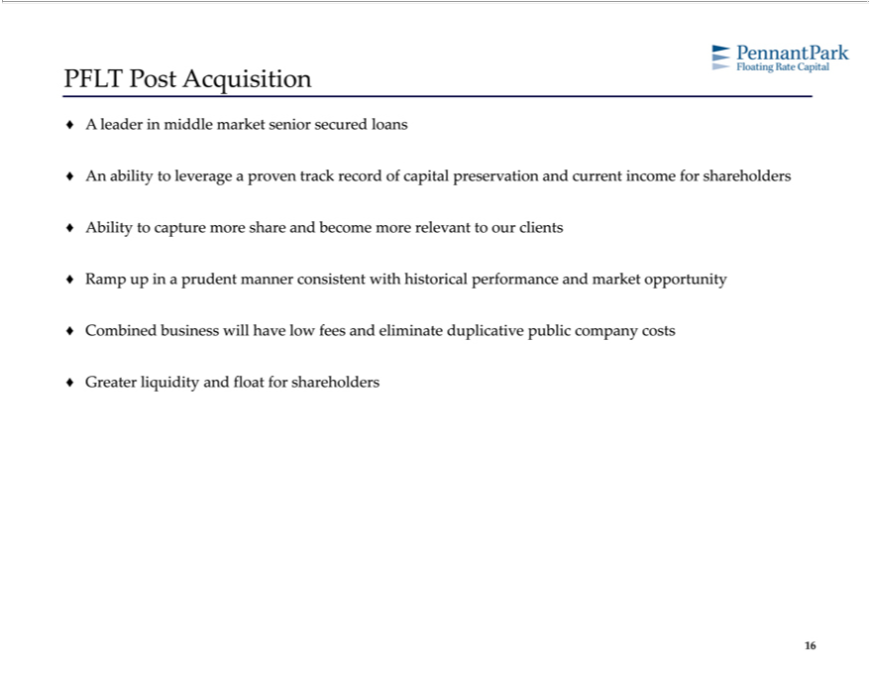

PFLT Post Acquisition |  | senior secured loans
leader in middle |  | senior secured loans
n ability to leveragemarketproven track record of capital preservation and current income for shareholders
Ability to | more share and become more relevant to our clients
capture
? CombinedRampupinbusinessprudentwillmannerhave lowconsistentfeesandwitheliminatehistoricalduplicativeperformancepublicandcompanymarket opportunitycosts
16Greater liquidity and float for shareholders

