SCHEDULE 14A

(RULE 14a-101)

Information Required in Proxy Statement
Schedule 14A Information
Proxy Statement Pursuant to Section 14(a) of the
Securities Exchange Act of 1934

Filed by the Registrant ☒ Filed by a Party other than the Registrant ☐

Check the appropriate box:

- Preliminary Proxy Statement

- Confidential, for Use of the Commission Only (as permitted by Rule 14a-6(e)(2))

- Definitive Proxy Statement

- Definitive Additional Material

- Soliciting Material Pursuant to Rule 14a-12

PennantPark Investment Corporation

PennantPark Floating Rate Capital Ltd.

(Name of Registrant as Specified in Its Charter)

(Name of Person(s) Filing Proxy Statement if other than the Registrant)

Payment of Filing Fee (Check the appropriate box):

- No fee required.

- Fee computed on table below per Exchange Act Rules 14a-6(i)(1) and 0-11.

  - Title of each class of securities to which transaction applies:

  - Aggregate number of securities to which transaction applies:

  - Per unit price or other underlying value of transaction computed pursuant to Exchange Act Rule 0-11 (Set forth the amount on which the filing fee is calculated and state how it was determined):

  - Proposed maximum aggregate value of transaction:

  - Total fee paid:

- Fee paid previously with preliminary materials

- Check box if any part of the fee is offset as provided by Exchange Act Rule 0-11(a)(2) and identify the filing for which the offsetting fee was paid previously. Identify the previous filing by registration statement number, or the form or schedule and the date of its filing.
  - Amount previously paid:

  - Form, schedule or registration statement no.:

  - Filing party:

  - Date filed:

December 18, 2013

Dear Stockholder:

You are cordially invited to attend a Joint Special Meeting of Stockholders of PennantPark Investment Corporation (“PNNT”) and PennantPark Floating Rate Capital Ltd. (“PFLT” and PNNT each, a “Company” and together, “the Companies”), to be held on February 4, 2014 at 2:00 p.m., Eastern Time, at the offices of Dechert LLP, located at 1095 Avenue of the Americas, New York, New York.

The Notice of Joint Special Meeting of Stockholders and the Joint Proxy Statement of the Boards of Directors of the Companies, which is accessible on the Internet or by request, provide an outline of the business to be conducted at the Joint Special Meeting of Stockholders. At the meeting, you will be asked to approve a proposal to authorize flexibility for your Company, with approval of the Company’s Board of Directors, to sell shares of the Company’s common stock, during the next 12 months, at a price below the then-current net asset value per share in one or more offerings, subject to certain conditions as set forth in the Joint Proxy Statement.

It is important that your shares be represented at the Joint Special Meeting of Stockholders. If you are unable to attend the meeting in person, I urge you to follow the instructions on the Notice of Internet Availability of Proxy Materials to vote your proxy on the Internet. We encourage you to vote via the Internet, as it saves us significant time and processing costs. However, on the Notice of Internet Availability of Proxy Materials you also will find instructions on how to request a hard copy of the Joint Proxy Statement and proxy card(s) for your Company free of charge, and you may vote your proxy by returning your proxy card(s) to us after you request the hard copy materials.

You will also receive separate proxy materials for the Joint Annual Meeting of Stockholders, which will be held on the same date and at the same location as the Joint Special Meeting. Please be certain to vote separately each proxy card you receive from us. Your vote and participation in the governance of your Company is very important to us.

Sincerely yours,

Arthur H. Penn

Chief Executive Officer

PennantPark

590 Madison Avenue, 15th Floor

New York, New York 10022

212-905-1000

PENNANTPARK INVESTMENT CORPORATION

PENNANTPARK FLOATING RATE CAPITAL LTD.

NOTICE OF JOINT SPECIAL MEETING OF STOCKHOLDERS

TO BE HELD ON FEBRUARY 4, 2014

December 18, 2013

Notice is hereby given to the owners of shares of common stock (the “Stockholders”) of PennantPark Investment Corporation (“PNNT”) and PennantPark Floating Rate Capital Ltd. (“PFLT” and PNNT each, a “Company” and together, the “Companies”) that:

A Joint Special Meeting of Stockholders of the Companies (the “Special Meeting”) will be held at the offices of Dechert LLP, located at 1095 Avenue of the Americas, New York, New York, on February 4, 2014 at 2:00 p.m., Eastern Time, for the following purpose, as to each Company:

- To consider and vote upon a proposal to authorize flexibility for the Company, with the approval of the Company’s Board of Directors, to sell shares of the Company’s common stock (during the next 12 months), at a price below the then-current net asset value per share, subject to certain limitations described in this Joint Proxy Statement.

You have the right to receive notice of, and to vote at, the Special Meeting if you were a stockholder of record of PNNT and/or a stockholder of record of PFLT at the close of business on December 9, 2013. The Companies are furnishing a Joint Proxy Statement and proxy card(s) to their Stockholders on the Internet, rather than mailing printed copies of those materials to each Stockholder. If you received a Notice of Internet Availability of Proxy Materials by mail, you will not receive a printed copy of the Joint Proxy Statement and proxy card(s) unless you request them. Instead, the Notice of Internet Availability of Proxy Materials will instruct you as to how you may access and review the Joint Proxy Statement, and vote your proxy, on the Internet.

Your vote is extremely important to us. If you are unable to attend the Special Meeting, we encourage you to vote your proxy on the Internet by following the instructions provided on the Notice of Internet Availability of Proxy Materials. You may also request from us free of charge hard copies of the Joint Proxy Statement and proxy card(s) for your Company by following the instructions on the Notice of Internet Availability of Proxy Materials. As to each Company, in the event there are not sufficient votes for a quorum or to approve that Company’s proposal at the time of the Special Meeting, the Special Meeting may be adjourned in order to permit further solicitation of proxies by the Company.

EACH COMPANY’S BOARD OF DIRECTORS, INCLUDING THE INDEPENDENT DIRECTORS, UNANIMOUSLY RECOMMENDS THAT YOU VOTE “FOR” THE PROPOSAL.

By Order of the Boards of Directors,

Thomas J. Friedmann

Secretary

PennantPark

590 Madison Avenue, 15th Floor

New York, New York 10022

212-905-1000

This is an important meeting. To ensure proper representation at the meeting, please follow the instructions on the Notice of Internet Availability of Proxy Materials to vote your proxy via the Internet or request, complete, sign, date and return a proxy card. Even if you vote your shares prior to the meeting, you still may attend the meeting and vote your shares in person if you wish to change your vote.

PENNANTPARK INVESTMENT CORPORATION

PENNANTPARK FLOATING RATE CAPITAL LTD.

590 Madison Avenue, 15th Floor

New York, New York 10022

- 905-1000

JOINT PROXY STATEMENT

For

2014 Joint Special Meeting of Stockholders

To be held on February 4, 2014

This document will give you the information you need to vote on the matters listed on the accompanying Notice of Joint Special Meeting of Stockholders (“Notice of Special Meeting”). Much of the information in this Joint Proxy Statement is required under the rules and regulations of the Securities and Exchange Commission (the “SEC”), and some of it is technical in nature. If there is anything you do not understand, please contact us at 212-905-1000.

This Joint Proxy Statement is furnished in connection with the solicitation of proxies by the Boards of Directors (each, a “Board” and together, the “Boards”) of PennantPark Investment Corporation (“PNNT”) and PennantPark Floating Rate Capital Ltd. (“PFLT” and PNNT each, a “Company” and together, the “Companies,” “we,” “us” or “our”) for use at the Companies’ Joint Special Meeting of Stockholders (the “Meeting”) to be held on Tuesday, February 4, 2014 at 2:00 p.m., Eastern Time, at the offices of Dechert LLP, located at 1095 Avenue of the Americas, New York, New York, and at any postponements or adjournments thereof. This Joint Proxy Statement is being provided to stockholders of the Companies (the “Stockholders”) via the Internet on or about December 18, 2013. In addition, a Notice of Special Meeting and a Notice of Internet Availability of Proxy Materials are being sent to Stockholders of record of PNNT and Stockholders of record of PFLT as of December 9, 2013.

Although each Company is a separate business development company and Stockholders of each Company will vote separately on the proposal contained herein, the Companies are soliciting votes through this Joint Proxy Statement to reduce expenses to the Companies of soliciting proxies for the Meeting.

We encourage you to vote your shares, either by voting in person at the Meeting or by voting by proxy (i.e., authorizing someone to vote your shares). Shares represented by duly executed proxies will be voted in accordance with your instructions. If you execute a proxy without specifying your voting instructions, your shares will be voted in accordance with the recommendation of your Company’s Board. If any other business is brought before the Meeting, your shares will be voted at the appropriate Board’s discretion unless you specifically state otherwise on your proxy.

You may revoke a proxy at any time before it is exercised by notifying the Companies’ Secretary in writing, by submitting a properly executed, later-dated proxy or by voting in person at the Meeting. Any Stockholder entitled to vote at the Meeting may attend the Meeting and vote in person, whether or not he or she has previously voted his or her shares via proxy or wishes to change a previous vote.

You will be eligible to vote your shares electronically via the Internet, by telephone or by mail.

Purpose of Meeting

At the Meeting, you will be asked to vote on the following proposal as to each Company:

- To consider and vote upon a proposal to authorize flexibility for the Company, with the approval of the Company’s Board, to sell shares of the Company’s common stock (during the next 12 months) at a price below the then-current net asset value per share, subject to certain limitations described in this Joint Proxy Statement (the “Proposal”).

1

Voting Securities

You may vote your shares at the Meeting only if you were a Stockholder of record of PNNT and/or a Stockholder of record of PFLT at the close of business on December 9, 2013 (the “Record Date”). There were [66,546,734] shares of PNNT common stock and [14,898,056] shares of PFLT common stock (the “Common Stock”) outstanding on the Record Date. Stockholders are entitled to one vote for each share held of Common Stock of their Company. Stockholders can vote only on matters affecting the Company (or Companies) in which they hold shares of Common Stock. Because the proposal stated above and in the Notice of Special Meeting is separate for each Company, it is essential that Stockholders who own shares in both Companies vote by Internet, telephone or mail in accordance with the instructions on the proxy card(s), with respect to each proxy card they receive.

Quorum Required

For a Company to conduct business at the Meeting, a quorum of a Company must be present at the Meeting. The presence at the Meeting, in person or by proxy, of the holders of a majority of the shares of Common Stock of a Company outstanding on the Record Date will constitute a quorum of such Company. If there are not enough votes for a quorum of a Company, the chairman of the Meeting will adjourn the Meeting with respect to that Company to permit the further solicitation of proxies.

Votes Required

Authorization to Offer and Sell Shares of Common Stock Below Net Asset Value

As to each Company, approval of the Proposal requires the affirmative vote of the Stockholders holding (1) a majority of the outstanding shares of the Company’s Common Stock entitled to vote at the Meeting and (2) a majority of the outstanding shares of the Company’s Common Stock entitled to vote at the Meeting that are not held by affiliated persons of the Company. For purposes of the Proposal, the Investment Company Act of 1940, as amended (the “1940 Act”), defines “a majority of outstanding voting securities” of a Company as: (1) 67% or more of the voting securities present at the Meeting if the holders of more than 50% of the outstanding voting securities of the Company are present or represented by proxy; or (2) more than 50% of the outstanding voting securities of the Company, whichever is less. Abstentions will have the effect of a vote against the Proposal.

Stockholders of a Company may not cumulate their votes.

Broker Non-Votes

“Broker Non-Votes” are votes that are not cast by a broker, bank or other nominee (the “Broker”) on a non-routine matter because the shares entitled to cast the vote are held in “street name”, the Broker lacks discretionary authority to vote the shares and the Broker has not received voting instructions from the beneficial owner. The Proposal is a non-routine matter for both Companies. As a result, if you hold shares of a Company’s Common Stock in street name through a Broker, your Broker will not be permitted to exercise voting discretion with respect to the Proposal for that Company. Thus, if you do not vote or give your Broker specific instructions on how to vote for you, your Broker cannot vote with respect to the Proposal. For this reason, it is imperative that Stockholders vote or provide instructions to their Broker as to how to vote.

Adjournment and Additional Solicitation. As to each Company, if there appear not to be enough votes to approve the Proposal at the Meeting, the chairman of the Meeting or the Stockholders of such Company who are represented in person or by proxy may vote to adjourn the Meeting with respect to that Company to permit further solicitation of proxies. If a vote to adjourn is submitted to the Stockholders, Messrs. Adam Bernstein and Jeffrey Flug are the persons named as proxies for each Company and will vote proxies held by them for such adjournment, unless marked to be voted against any proposal for which an adjournment is sought, to permit the further solicitation of proxies.

2

Information Regarding This Solicitation

Each Company will bear the expense of its solicitation of proxies for the Meeting, including the cost of preparing and posting this Joint Proxy Statement to the Internet and the cost of mailing the Notice of Special Meeting, the Notice of Internet Availability of Proxy Materials and any requested proxy materials to its respective Stockholders. The Companies intend to use the services of Broadridge Financial Solutions, Inc., a leading provider of investor communications solutions, to aid in the distribution and collection of proxy votes. The Companies expect to pay market rates for such services. If brokers, trustees or fiduciaries and other institutions holding shares in their own names or in the names of their nominee, which shares are beneficially owned by others, forward the Joint Proxy Statement and relevant proxy card(s) to, and obtain proxies from, such beneficial owners, the applicable Company will reimburse such persons for their reasonable expenses in so doing.

In addition to the solicitation of proxies by the use of the Internet, proxies may be solicited in person and/or by telephone, mail or facsimile transmission by directors or officers of the Companies, officers or employees of PennantPark Investment Advisers, LLC, the Companies’ investment adviser (the “Adviser”), PennantPark Investment Administration, LLC, the Companies’ administrator (the “Administrator”), and/or by a retained solicitor. No additional compensation will be paid to such directors, officers or regular employees for such services. If the Companies retain a solicitor, the Companies have estimated that they will pay an aggregate of approximately $60,000 for such services. If the Companies engage a solicitor, you could be contacted by telephone on behalf of your Company and be urged to vote. The solicitor will not attempt to influence how you vote your shares, but will only ask that you take the time to cast a vote. You may also be asked if you would like to vote over the telephone and to have your vote transmitted to our proxy tabulation firm. The address of each of the Adviser and the Administrator is 590 Madison Avenue, 15 th Floor, New York, New York 10022.

Stockholders may provide their voting instructions through the Internet, by telephone or by mail by following the instructions on the Notice of Internet Availability of Proxy Materials. These options require Stockholders to input the Control Number, which is provided with the Notice of Internet Availability of Proxy Materials. If you vote using the Internet, after visiting www.proxyvote.com and inputting your Control Number, you will be prompted to provide your voting instructions. Stockholders will have an opportunity to review their voting instructions and make any necessary changes before submitting them and terminating their Internet link. Stockholders who vote via the Internet, in addition to confirming their voting instructions prior to submission, also will receive upon request an e-mail confirming their instructions.

If a Stockholder wishes to participate in the Meeting, but does not wish to give a proxy by Internet, the Stockholder may attend the Meeting in person or request and submit a proxy card by following the instructions on the Notice of Internet Availability of Proxy Materials.

Any proxy authorized pursuant to this solicitation may be revoked by notice from the person giving the proxy at any time before it is exercised. A revocation may be effected by resubmitting voting instructions via the Internet voting site, by telephone, by obtaining and properly completing another proxy card that is dated later than the original proxy and returning it, by mail, in time to be received before the Meeting, by attending the Meeting and voting in person or by a notice, provided in writing and signed by the Stockholder, delivered to the Companies’ Secretary on any business day before the date of the Meeting.

Security Ownership of Certain Beneficial Owners and Management

As of the Record Dates, to our knowledge, no person would be deemed to “control” (as such term is defined in the 1940 Act) either Company.

Each Company’s Board is composed of the same individuals. Our directors consist of an interested director and four independent directors. An interested director is an “interested person” of the Companies, as defined in the 1940 Act, and independent directors are all other directors (the “Independent Directors”).

3

The following table sets forth, as of November 14, 2013, certain ownership information with respect to each Company’s Common Stock for those persons who directly or indirectly own, control or hold with the power to vote, five percent or more of a Company’s outstanding Common Stock and all officers and directors of the Companies, as a group.

 |  |  |  |  |  |  |  | Percentage of
Name and address⁽¹⁾ |  | Type of ownership⁽⁴⁾ |  |  |  |  |  | Common Stock
 |  |  |  | Shares Owned |  |  |  | Outstanding
 |  |  |  | PNNT |  | PFLT |  | PNNT |  | PFLT
Independent directors
Adam K. Bernstein(2) |  | Record/Beneficial |  | 88,971 |  | 5,000 | * |  |  | *
Marshall Brozost |  | Record/Beneficial |  | 13,540 |  | — | * |  |  | —
Jeffrey Flug |  | Record/Beneficial |  | 227,288 |  | — | * |  |  | —
Samuel L. Katz |  | Record/Beneficial |  | 113,482 |  | 59,500 | * |  |  | *
Interested director
Arthur H. Penn(3) |  | Record/Beneficial |  | 537,323 |  | 149,209 | 0.8% |  |  | 1.0%
Executive officer
Aviv Efrat |  | Record/Beneficial |  | 44,790 |  | 13,750 |  | * |  | *
All directors and executive officer as a group (6 persons) |  |  |  | 1,025,394 |  | 227,459 | 1.5% |  |  | 1.5%

- The address for each officer and director is c/o PennantPark, 590 Madison Avenue, 15th Floor, New York, New York 10022.

- Mr. Bernstein is the President of JAM Investments, LLC and may therefore be deemed to own beneficially the 68,236 shares of PNNT held by JAM Investments, LLC.
- Mr. Penn is the Managing Member of the Adviser, and may therefore be deemed to own beneficially the 342,611 shares of PNNT and 149,209 shares of PFLT held by the Adviser.
- Sole voting power.

- Less than 1 percent.

4

PROPOSAL: AUTHORIZATION TO OFFER AND SELL SHARES OF

COMMON STOCK BELOW NET ASSET VALUE

The 1940 Act generally prohibits each Company, as a business development company (“BDC”), from offering and selling shares of its Common Stock at a price below the then-current net asset value per share (“NAV”), unless the policy and practice of doing so is approved by the Company’s Stockholders within one year immediately prior to any such sales. Shares of our Common Stock have traded at a price both above and below their NAV since they have begun trading on the NASDAQ Global Select Market in 2007 for PNNT and in 2011 for PFLT.

Each Company is seeking Stockholder approval now to sell its shares below NAV in order to provide flexibility for future sales, which typically are undertaken quickly in response to market conditions. The final terms of any such sales will be determined by the relevant Company’s Board at the time of sale. Also, because neither Company has any immediate plans to sell any shares of its Common Stock below NAV, it is impracticable to describe the transaction or transactions in which such shares would be sold. Instead, any transaction where a Company would sell shares of its Common Stock, including the nature and amount of consideration that would be received by that Company at the time of sale and the use of any such consideration, will be reviewed and approved by the Company’s Board at the time of sale. If this Proposal is approved, the relevant Company will not solicit further authorization from its Stockholders prior to any such sale, and the authorization would be effective for shares sold during a period beginning on the date of Stockholder approval and expiring one year from such approval.

In a common stock offering, investors are offered an ownership interest in a corporation. Stockholders typically are entitled to vote on the selection of corporate directors and other important matters, as well as to receive distributions on their holdings to the extent such distributions are declared.

Generally, common stock offerings by BDCs are priced based on the market price of the currently outstanding shares of common stock, less a small discount of approximately 5%. Accordingly, even when shares of a Company’s Common Stock trade at a market price below NAV, the Proposal, if approved by the Stockholders, would permit that Company to offer and sell shares of its Common Stock in accordance with pricing standards that market conditions generally require. This Joint Proxy Statement is not an offer to sell securities of either Company. Securities may not be offered or sold in the United States absent registration with the SEC or an applicable exemption from SEC registration requirements.

1940 Act Conditions for Sales below NAV

Each Company’s ability to issue shares of its Common Stock at a price below NAV is governed by the 1940 Act. Specifically, Section 63(2) of the 1940

Act provides that a Company may offer and sell shares of Common Stock at prices below the then-current NAV with Stockholder approval, provided that:

- any such sales are approved by (1) a majority of the Company’s Independent Directors and (2) a majority of the Company’s directors who have no financial interest in the proposal as being in the best interests of us and our Stockholders; and

- such a required majority of directors, in consultation with the underwriter of the offering, if it is underwritten, has determined in good faith, and as of a time immediately prior to the first solicitation by or on behalf of the Company of any firm commitment to purchase such securities or immediately prior to the issuance of such securities, that the price at which such securities are to be sold is not less than a price which closely approximates the market value for those securities, less any underwriting commission or discount.

Without the approval of its Stockholders to offer and sell shares of Common Stock at prices below NAV, each Company would be prohibited from selling such shares to raise capital when the market price for its Common Stock is below NAV.

5

Board Approval

On November 12, 2013, the Board of each Company unanimously approved, and is recommending that Stockholders vote in favor of, this Proposal to offer and sell shares of their Company’s Common Stock at prices that may be less than NAV. Each Board concluded that the Proposal is in the best interests of the relevant Company and its Stockholders. In doing so, each Board, including the Independent Directors, considered and evaluated various factors, including the following, as discussed more fully below:

- possible long-term benefits to the Company’s Stockholders; and

- possible dilution to the Company’s NAV.

Prior to approving this Proposal, the Boards met to consider and evaluate material that the Companies’ management provided on the merits of the Companies possibly raising additional capital and the merits of publicly offering shares of Common Stock at a price below NAV. The Boards considered the objectives of a possible offering, the mechanics of an offering, establishing size parameters for an offering, the possible effects of dilution, Common Stock trading volume and other matters. The Independent Directors also consulted with their independent counsel to consider and evaluate and voted separately on the issues presented.

Each Board evaluated a full range of offering sizes. However, neither Board has drawn any definite conclusions regarding the size of a contemplated capital raise at this time. Each Board expects that any increase in capital would be from a public offering of the Company’s Common Stock, or the possibility of one or more private placements. Additionally, each Company’s Common Stock could be issued as part of a purchase of assets, portfolios or other companies.

In determining whether or not to offer and sell a Company’s Common Stock, the Board has a duty to act in that Company’s best interests and that of the Company’s Stockholders and must comply with the other requirements of Section 63(2) of the 1940 Act. If Stockholders of a Company do not approve this Proposal, that Company’s Board will consider and evaluate its options to determine what alternatives are in the Company’s best interests and that of the Company’s Stockholders.

Possible Long-Term Benefits to Stockholders

Each Board believes that having the flexibility for the Company to sell its Common Stock below NAV in certain instances is in the Company’s best interests and that of the Company’s Stockholders. If a Company were unable to access the capital markets when attractive investment opportunities arise, the Company’s ability to grow over time and to continue to pay distributions to Stockholders could be adversely affected. In reaching that conclusion, each Board considered the following possible benefits to the Company’s Stockholders:

Current Market Conditions Have Created Attractive Opportunities

Current market opportunities have created, and we believe will continue to create for the foreseeable future, favorable opportunities to invest, including opportunities that, all else being equal, may increase each Company’s NAV over the longer-term, even if financed with the issuance of Common Stock below NAV. Stockholder approval of this Proposal, subject to the conditions detailed below, is expected to provide the Companies with the flexibility to invest in such opportunities. We believe that current market conditions provide attractive opportunities to use capital.

Market conditions also have beneficial effects for capital providers, including reduced competition, more favorable pricing of credit risk, more conservative capital structures and more creditor-friendly contractual terms. Accordingly, we believe that the Companies could benefit from access to capital in this constrained credit market and that the current environment should provide attractive investment opportunities. Each Company’s ability to take advantage of these opportunities will depend upon its access to capital.

6

Greater Investment Opportunities Due to Larger Capital Resources

Each Board believes that additional capital raised through an offering of shares of the Company’s Common Stock may help the Company generate additional deal flow. Based on discussions with the Companies’ management, the Boards believe that greater deal flow, which may be achieved with more capital, would enable the Companies to be more significant participants in the private debt and equity markets and to compete more effectively for attractive investment opportunities. With more capital to invest in portfolio opportunities, the Companies intend to be more meaningful capital providers to companies and to compete for high quality investment opportunities with other companies having greater resources than we do currently. Management has represented to the Boards that such investment opportunities may be funded with proceeds of an offering of shares of each Company’s Common Stock. However, management has not identified specific companies in which to invest the proceeds of an offering given that specific investment opportunities will change depending on the timing of an offering, if any.

Higher Market Capitalization and Liquidity May Make Our Common Stock More Attractive to Investors

If a Company issues additional shares, its market capitalization and the amount of its publicly tradable Common Stock will increase, which may afford all holders of its Common Stock greater liquidity. A larger market capitalization may make a Company’s Common Stock more attractive to a larger number of investors who have limitations on the size of companies in which they invest. Furthermore, a larger number of shares outstanding may increase a Company’s trading volume, which could decrease the volatility in the secondary market price of its Common Stock.

Maintenance or Possible Increase of Distributions

A larger and more diversified portfolio could provide each Company with more consistent cash flow, which may support the maintenance and growth of the Company’s dividends. Each Company generally makes distributions to its Stockholders. Although management will continue to seek to generate income sufficient to pay our distributions in the future, the proceeds of future offerings, and the investments thereof, could enable each Company to maintain and possibly grow its distributions, which may include a return of capital, in the future.

Reduced Expenses Per Share

For each Company, an offering that increases its total assets may reduce its expenses per share of Common Stock due to the spreading of fixed expenses over a larger asset base. Each Company must bear certain fixed expenses, such as certain administrative, governance and compliance costs that do not generally vary based on its asset size. On a per share basis, these fixed expenses will be reduced when supported by a larger asset base.

Trading History

PNNT’s Common Stock has been quoted on The NASDAQ Global Select Market under the symbol “PNNT” since April 24, 2007, and PFLT’s Common Stock has been quoted on The NASDAQ Global Select Market under the symbol “PFLT” since April 8, 2011.

7

The following table lists the high and low closing sales price for PNNT’s Common Stock, the closing sales price as a percentage of NAV and quarterly distributions per share on a quarterly basis for the Company’s last two completed fiscal years, as well as the period ended November 14, 2013. On November 14, 2013, the last reported closing sale price for PNNT’s Common Stock was $11.41 per share.

 |  |  |  |  |  |  |  |  |  | Premium / |  | Premium /
 |  |  |  |  |  | Closing Sales Price |  |  |  | Discount of |  | Discount of
 |  |  |  |  |  |  |  |  |  | High Sales |  | Low Sales
 |  |  |  | _{NAV}(1) |  |  |  |  |  | Price to |  | Price to |  |  | Dividends
Period |  |  |  |  |  | High |  | Low |  | _{NAV}(2) |  | _{NAV}(2) |  |  | Declared
 | Fiscal year ending September 30, 2014
 | First quarter (as of November 14, 2013) |  | $ N/A |  |  | $ 11.52 |  | $10.83 |  | N/A% |  | N/A% |  | $ N/A
 | Fiscal year ended September 30, 2013
 | Fourth quarter |  | 10.48 |  |  | 11.83 |  | 10.97 | 13 |  |  | 5 |  | 0.28
 | Third quarter |  | 10.43 |  |  | 11.13 |  | 10.97 | 7 |  |  | 5 |  | 0.28
 | Second quarter |  | 10.50 |  |  | 11.53 |  | 11.24 | 9 |  |  | 7 |  | 0.28
 | First quarter |  | 10.38 |  |  | 11.03 |  | 10.66 | 6 |  |  | 3 |  | 0.28
Fiscal year ended September 30, 2012
 | Fourth quarter |  | 10.22 |  |  | 11.44 |  | 10.36 | 12 |  |  | 1 |  | 0.28
 | Third quarter |  | 10.16 |  |  | 10.70 |  | 9.27 | 5 |  |  | -9 |  | 0.28
 | Second quarter |  | 10.38 |  |  | 11.23 |  | 10.31 | 8 |  |  | -1 |  | 0.28
 | First quarter |  | 10.19 |  |  | 11.02 |  | 8.57 | 8 |  |  | -16 |  | 0.28

- NAV per share is determined as of the last day in the relevant quarter and therefore may not reflect the NAV per share on the date of the high and low sales prices. The NAVs shown are based on outstanding shares at the end of each period.
- Calculated as the discount (difference between NAV and relevant closing price) to the high or low closing sales price divided by the quarter end NAV.

The following table lists the high and low closing sales price for PFLT’s Common Stock, the closing sales price as a percentage of NAV and monthly distributions per share on a quarterly basis for the Company’s last two completed fiscal years, as well as the period ended November 14, 2013. On November 14, 2013, the last reported closing sale price for PFLT’s Common Stock was $13.40 per share.

 |  |  |  |  |  |  |  |  |  | Premium / |  | Premium /
 |  |  |  |  |  | Closing Sales Price |  |  |  | Discount of |  | Discount of
 |  |  |  |  |  |  |  |  |  | High Sales |  | Low Sales
 |  |  |  | NAV⁽¹⁾ |  |  |  |  |  | Price to |  | Price to |  |  | Dividends
Period |  |  |  |  |  | High |  | Low |  | NAV⁽²⁾ |  | NAV⁽²⁾ |  |  | Declared
 | Fiscal year ending September 30, 2014
 | First quarter (as of November 14, 2013) |  |  | $ N/A |  | $13.60 | $13.14 |  |  | N/A% |  | N/A% |  | $0.1775
 | Fiscal year ended September 30, 2013
 | Fourth quarter |  | 14.10 |  |  | 14.60 | 13.01 |  |  | 4 |  | -8 |  | 0.2625
 | Third quarter |  | 13.98 |  |  | 14.31 | 13.75 |  |  | 2 |  | -2 |  | 0.2625
 | Second quarter |  | 14.10 |  |  | 13.98 | 13.80 |  |  | -1 |  | -2 |  | 0.2550
 | First quarter |  | 13.99 |  |  | 12.86 | 12.65 |  |  | -8 |  | -10 |  | 0.2475
Fiscal year ended September 30, 2012
 | Fourth quarter |  | 13.98 |  |  | 13.03 | 11.85 |  |  | -6 |  | -15 |  | 0.2400
 | Third quarter |  | 13.94 |  |  | 11.93 | 11.46 |  |  | -14 |  | -18 |  | 0.2350
 | Second quarter |  | 14.12 |  |  | 12.10 | 10.52 |  |  | -14 |  | -25 |  | 0.2250
 | First quarter |  | 13.68 |  |  | 11.03 | 10.01 |  |  | -19 |  | -27 |  | 0.2100
 |  |  | 8

- NAV per share is determined as of the last day in the relevant quarter and therefore may not reflect the NAV per share on the date of the high and low sales prices. The NAVs shown are based on outstanding shares at the end of each period.
- Calculated as the discount (difference between NAV and relevant closing price) to the high or low closing sales price divided by the quarter end NAV.

Conditions to the Sale of a Company’s Common Stock below NAV

As to each Company, if Stockholders approve this Proposal, the Company will sell shares of its Common Stock at a price below NAV, exclusive of sales compensation, only if the following conditions are met:

- a majority of the Company’s Independent Directors who have no financial interest in the sale have approved the sale; and

- a majority of such Independent Directors, who, in consultation with the underwriter or underwriters of the offering, if any, have determined in good faith, and as of a time immediately prior to the first solicitation by or on behalf of the Company of firm commitments to purchase such securities, or immediately prior to the sale of such securities, that the price at which such securities are to be sold is not less than a price which closely approximates the market value of those securities, less any underwriting commission or discount.

Dilution

Before voting on this Proposal or giving proxies with regard to this matter, Stockholders of each Company should consider the potentially dilutive effect on the NAV of the issuance of shares of the Company’s Common Stock at a price less than NAV. Any sale of Common Stock by a Company at a price below NAV would result in an immediate dilution to existing Stockholders on a per share basis. This dilution would include reduction in the NAV as a result of the issuance of shares at a price below NAV and a proportionately greater decrease in a Stockholder’s per share interest in the earnings and assets of the Company and per share voting interest in the Company. Each Board has considered the potential dilutive effect of the issuance of shares at a price below NAV and will consider again such dilutive effect when considering whether to authorize any specific issuance of shares of a Company’s Common Stock below NAV.

The 1940 Act establishes a connection between market price and NAV because, when stock is sold at a market price below NAV, the resulting increase in the number of outstanding shares is not accompanied by a proportionate increase in the net assets of the issuer. Stockholders of each Company should also consider that they will have no subscription, preferential or preemptive rights to additional shares of Common Stock proposed to be authorized for issuance, and thus any future issuance of Common Stock at a price below NAV would dilute a Stockholder’s holdings of Common Stock as a percentage of shares outstanding to the extent the Stockholder does not purchase sufficient shares in the offering or otherwise to maintain the Stockholder’s percentage interest. Further, if the Stockholder does not purchase, or is unable to purchase, any shares to maintain the Stockholder’s percentage interest, regardless of whether such offering is at a price above or below the then-current NAV, the Stockholder’s voting power will be diluted.

The precise extent of any such dilution to a Company’s Common Stock cannot be estimated before the terms of a Common Stock offering are set. As a general proposition, however, the amount of potential dilution will increase as the size of the offering increases. Another factor that will influence the amount of dilution in an offering is the amount of net proceeds that the Company receives from such offering. Each Board would expect that the net proceeds to a Company will be equal to the price that investors pay per share, less the amount of any underwriting discounts and commissions, typically approximately 95% of the market price.

As previously discussed, the Boards evaluated a full range of offering sizes. The following examples indicate how an offering would immediately affect the NAV of each Company’s Common Stock based on the

9

assumptions set forth below. They do not include any effects or influence on market share price due to changes in investment performance over time, dividend policy, increased trading volume or other qualitative aspects of the shares of either Company’s Common Stock.

Examples of Dilutive Effect of the Issuance of Shares Below NAV

Impact on Existing Stockholders who do not Participate in the Offering

Existing Stockholders of each Company who do not participate, or who are not given the opportunity to participate, in an offering below NAV per share by their Company or who do not buy additional shares of their Company in the secondary market at the same or lower price obtained by the Company in the offering (after any underwriting discounts and commissions) face the greatest potential risks. All Stockholders will experience an immediate decrease (often called dilution) in the NAV of the Company’s shares they hold. Stockholders who do not participate in the offering will also experience a disproportionately greater decrease in their participation in their Company’s earnings and assets and their voting power than Stockholders who do participate in the offering. All Stockholders may also experience a decline in the market price of their shares of the Company’s Common Stock, which often reflects, to some degree, announced or potential increases and decreases in NAV per share. Their decrease could be more pronounced as the size of the offering and level of discounts increase.

The following examples illustrate the level of NAV dilution that would be experienced by a nonparticipating Stockholder in three different hypothetical common stock offerings of different sizes and levels of discount from NAV per share, although it is not possible to predict the level of market price decline that may occur. Actual sales prices and discounts may differ from the presentation below.

The examples assume that Company XYZ has 1,000,000 shares of common stock outstanding, $15,000,000 in total assets and $5,000,000 in total liabilities. The current NAV and NAV per share are thus $10,000,000 and $10.00, respectively. The table below illustrates the dilutive effect on nonparticipating stockholder A of (1) an offering of 50,000 shares (5% of the outstanding shares) at $9.50 per share after any underwriting discounts and commissions (a 5% discount from NAV); (2) an offering of 100,000 shares (10% of the outstanding shares) at $9.00 per share after any underwriting discounts and commissions (a 10% discount from NAV); and (3) an offering of 200,000 shares (20% of the outstanding shares) at $8.00 per share after any underwriting discounts and commissions (a 20% discount from NAV). The examples apply equally to Stockholders of both Companies.

10

 |  |  |  |  |  |  | Example 1 |  |  |  |  | Example 2 |  |  |  |  | Example 3
 |  |  |  |  |  |  | 5% Offering |  |  |  |  | 10% Offering |  |  |  |  | 20% Offering
 |  | Prior to Sale |  |  |  |  | at 5% Discount |  |  |  |  | at 10% Discount |  |  |  |  | at 20% Discount
 |  |  |  |  |  |  | Following |  | % |  |  | Following |  | % |  |  | Following |  | %
 |  | Below NAV |  |  |  |  | Sale |  | Change |  |  | Sale |  | Change |  |  | Sale |  | Change
Offering Price
Price per Share to Public |  |  | — |  | $ |  | 10.05 |  | — |  | $ | 9.52 |  | — |  | $ | 8.47 |  | —
Net Proceeds per Share to Issuer |  |  | — |  | $ |  | 9.50 |  | — |  | $ | 9.00 |  | — |  | $ | 8.00 |  | —
Decrease to NAV
Total Shares Outstanding |  |  | 1,000,000 |  |  |  | 1,050,000 |  | 5.00% |  |  | 1,100,000 |  | 10.00% |  |  | 1,200,000 |  | 20.00%
NAV per Share | $ |  | 10.00 |  | $ |  | 9.98 |  | (0.20)% |  | $ | 9.91 |  | (0.90)% |  | $ | 9.67 |  | (3.30)%
Dilution to Stockholder
Shares Held by Stockholder A |  |  | 10,000 |  |  |  | 10,000 |  | — |  |  | 10,000 |  | — |  |  | 10,000 |  | —
Percentage Held by Stockholder A |  |  | 1.00% |  |  |  | 0.95% |  | (5.00)% |  |  | 0.91% |  | (9.00)% |  |  | 0.83% |  | (17.00)%
Total Asset Values
Total NAV Held by Stockholder A | $ |  | 100,000 |  | $ |  | 99,800 |  | (0.20)% |  | $ | 99,100 |  | (0.90)% |  | $ | 96,700 |  | (3.30)%
Total Investment by Stockholder A (Assumed
to be $10.00 per Share) | $ |  | 100,000 |  | $ |  | 100,000 |  | — |  | $ | 100,000 |  | — |  | $ | 100,000 |  | —
Total Dilution to Stockholder A (Total NAV
Less Total Investment) |  |  | — |  | $ |  | (200) |  | — |  | $ | (900) |  | — |  | $ | (3,300) |  | —
Per Share Amounts
NAV per Share Held by Stockholder A |  |  | — |  | $ |  | 9.98 |  | — |  | $ | 9.91 |  | — |  | $ | 9.67 |  | —
Investment per Share Held by Stockholder A
(Assumed to be $10.00 per Share on
Shares Held Prior to Sale) | $ |  | 10.00 |  | $ |  | 10.00 |  | — |  | $ | 10.00 |  | — |  | $ | 10.00 |  | —
Dilution per Share Held by Stockholder A
(NAV per Share Less Investment per
Share) |  |  | — |  | $ |  | (0.02) |  | — |  | $ | (0.09) |  | — |  | $ | (0.33) |  | —
Percentage Dilution to Stockholder A
(Dilution per Share Divided by Investment
per Share) |  |  | — |  |  |  | — |  | (0.20)% |  |  | — |  | (0.90)% |  |  | — |  | (3.30)%
Impact on Existing Stockholders who Participate in the Offering

An existing Stockholder of either Company who participates in an offering by their Company below NAV per share or who buys additional shares of their Company in the secondary market at the same or lower price as obtained by the Company in the offering (after any underwriting discounts and commissions) will experience the same types of NAV dilution as the nonparticipating Stockholders, albeit at a lower level, to the extent they purchase less than the same percentage of the discounted offering as their interest in the Company’s Common Stock immediately prior to the offering. The level of NAV dilution on an aggregate basis will decrease as the number of shares of the Company’s Common Stock such Stockholders purchase increases. Existing Stockholders of the Company who buy more than such percentage will experience NAV dilution, but will, in contrast to existing Stockholders of that Company who purchase less than their proportionate share of the offering, experience an increase (often called accretion) in NAV per share over their investment per share and will also

11

experience a disproportionately greater increase in their participation in the Company’s earnings and assets and their voting power than the Company’s increase in assets, potential earning power and voting interests due to the offering. The level of accretion will increase as the excess number of shares of the Company’s Common Stock such Stockholder purchases increases. Even a Stockholder who over-participates will, however, be subject to the risk that the Company may make additional discounted offerings in which such Stockholder does not participate, in which case such Stockholder will experience NAV dilution as described above in such subsequent offerings. These Stockholders may also experience a decline in the market price of their shares, which often reflects to some degree announced or potential increases and decreases in NAV per share. Their decrease could be more pronounced as the size of a Company’s offering and level of discount to NAV increases.

The examples assume that Company XYZ has 1,000,000 shares of common stock outstanding, $15,000,000 in total assets and $5,000,000 in total liabilities. The current NAV and NAV per share are thus $10,000,000 and $10.00, respectively. The table below illustrates the dilutive and accretive effect in the hypothetical 20% discount offering from the prior chart for stockholder A that acquires shares equal to (1) 50% of their proportionate share of the offering (i.e., 1,000 shares, which is 0.50% of the offering of 200,000 shares rather than their 1.00% proportionate share) and (2) 150% of their proportionate share of the offering (i.e., 3,000 shares, which is 1.50% of the offering of 200,000 shares rather than their 1.00% proportionate share). A Company’s prospectus supplement pursuant to which any discounted offering by such Company is made will include a chart for its example based on the actual number of shares in such offering and the actual discount from the most recently determined NAV per share. The examples apply equally to Stockholders of both Companies.

 |  | Prior to Sale |  |  |  |  | 50% Participation |  |  |  |  | 150% Participation
 |  |  |  |  |  |  | Following |  | % |  |  | Following |  | %
 |  | Below NAV |  |  |  |  | Sale |  | Change |  |  | Sale |  | Change
Offering Price
Price per share to public |  |  | — |  | $ |  | 8.47 |  | — |  | $ | 8.47 |  | —
Net proceeds per share to issuer |  |  | — |  | $ |  | 8.00 |  | — |  | $ | 8.00 |  | —
Increases in Shares and Decrease to NAV
Total shares outstanding |  |  | 1,000,000 |  |  |  | 1,200,000 |  | 20.00% |  |  | 1,200,000 |  | 20.00%
NAV per share | $ |  | 10.00 |  | $ |  | 9.67 |  | (3.30)% |  | $ | 9.67 |  | (3.30)%
(Dilution)/Accretion to Participating Stockholder A
Shares held by stockholder A |  |  | 10,000 |  |  |  | 11,000 |  | 10.00% |  |  | 13,000 |  | 30.00%
Percentage held by stockholder A |  |  | 1.0% |  |  |  | 0.92% |  | (8.00)% |  |  | 1.08% |  | 8.00%
Total Asset Values
Total NAV held by stockholder A | $ |  | 100,000 |  | $ |  | 106,370 |  | 6.37% |  | $ | 125,710 |  | 25.71%
Total investment by stockholder A (assumed to be $10.00 per share on
shares held prior to sale) | $ |  | 100,000 |  | $ |  | 108,470 |  | 8.47% |  | $ | 125,410 |  | 25.41%
Total (dilution)/accretion to stockholder A (total NAV less total
investment) |  |  | — |  |  |  | (2,100) |  | — |  | $ | 300 |  | —
Per Share Amounts
NAV per share held by stockholder A |  |  | — |  | $ |  | 9.67 |  | — |  | $ | 9.67 |  | —
Investment per share held by stockholder A (assumed to be $10.00 per
share on shares held prior to sale) | $ |  | 10.00 |  | $ |  | 9.86 |  | (1.40)% |  | $ | 9.65 |  | (3.50)%
(Dilution)/accretion per share held by stockholder A (NAV per share
less investment per share) |  |  | — |  | $ |  | (0.19) |  | — |  | $ | 0.02 |  | —
Percentage (dilution)/accretion to stockholder A (dilution/accretion per
share divided by investment per share) |  |  | — |  |  |  | — |  | (1.93)% |  |  | — |  | 0.21%
 |  |  | 12

Impact on New Investors

The following examples illustrate the level of NAV dilution or accretion that would be experienced by a new Stockholder in either Company in three different hypothetical common stock offerings of different sizes and levels of discount from NAV per share, although it is not possible to predict the level of market price decline that may occur. Actual sales prices and discounts may differ from the presentation below.

Investors who are not currently Stockholders of a Company, but who participate in an offering by one of the Companies below NAV and whose investment per share is greater than the resulting NAV per share due to any underwriting discounts and commissions paid by the Company will experience an immediate decrease, albeit small, in the NAV of their shares of the Company’s Common Stock and their NAV per share compared to the price they pay for their shares. Investors who are not currently Stockholders of a Company and who participate in an offering by one of the Companies below NAV per share and whose investment per share is also less than the resulting NAV per share due to any underwriting commissions and discounts paid by the Company being significantly less than the discount per share, will experience an immediate increase in the NAV of their shares of the Company’s Common Stock and their NAV per share compared to the price they pay for their shares. All these investors will experience a disproportionately greater participation in the Company’s earnings and assets and their voting power than the Company’s increase in assets, potential earning power and voting interests. These investors will, however, be subject to the risk that such Company may make additional discounted offerings in which such new Stockholder does not participate, in which case such new Stockholder will experience dilution as described above in such subsequent offerings by that Company. These investors may also experience a decline in the market price of their shares, which often reflects to some degree announced or potential increases and decreases in NAV per share. Their decrease could be more pronounced as the size of the offering and level of discounts increases.

The following examples illustrate the level of NAV dilution or accretion that would be experienced by a new stockholder who purchases the same percentage (1.00%) of the shares in the three different hypothetical offerings of common stock of different sizes and levels of discount from NAV per share. The examples assume that Company XYZ has 1,000,000 shares of common stock outstanding, $15,000,000 in total assets and $5,000,000 in total liabilities. The current NAV and NAV per share are thus $10,000,000 and $10.00, respectively. The table below illustrates the dilutive and accretive effects on stockholder A at

- an offering of 50,000 shares (5% of the outstanding shares) at $9.50 per share after any underwriting discounts and commissions (a 5% discount from NAV);

- an offering of 100,000 shares (10% of the outstanding shares) at $9.00 per share after any underwriting discounts and commissions (a 10% discount from NAV); and (3) an offering of 200,000 shares (20% of the outstanding shares) at $8.00 per share after any underwriting discounts and commissions (a 20% discount from NAV). The examples apply equally to Stockholders of both Companies.

13

 |  |  |  | Example 1 |  |  |  |  |  | Example 2 |  |  |  |  |  | Example 3
 |  |  |  | 5% Offering |  |  |  |  |  | 10% Offering |  |  |  |  |  | 20% Offering
 | Prior to Sale |  |  | at 5% Discount |  |  |  |  |  | at 10% Discount |  |  |  |  |  | at 20% Discount
 | Prior to Sale |  |  | Following |  | % |  |  |  | Following |  | % |  |  |  | Following |  | %
 | Below NAV |  |  | Sale |  | Change |  |  |  | Sale |  | Change |  |  |  | Sale |  | Change
Offering Price
Price per share to public | — | $ |  | 10.05 |  | — |  | $ |  | 9.52 |  | — |  | $ |  | 8.47 |  | —
Net offering proceeds per share to issuer | — | $ |  | 9.50 |  | — |  | $ |  | 9.00 |  | — |  | $ |  | 8.00 |  | —
Decrease to NAV
Total shares outstanding | — |  |  | 1,050,000 |  | 5.00% |  |  |  | 1,100,000 |  | 10.00% |  |  |  | 1,200,000 |  | 20.00%
NAV per share | — | $ |  | 9.98 |  | (0.20)% |  | $ |  | 9.91 |  | (0.90)% |  | $ |  | 9.67 |  | (3.30)%
Dilution to Stockholder A
Shares held by stockholder A | — |  |  | 500 |  | — |  |  |  | 1,000 |  | — |  |  |  | 2,000 |  | —
Percentage held by
stockholder A | — |  |  | 0.05% |  | — |  |  |  | 0.09% |  | — |  |  |  | 0.17% |  | —
Total Asset Values
Total NAV held by
stockholder A | — | $ |  | 4,990 |  | — |  | $ |  | 9,910 |  | — |  | $ |  | 19,340 |  | —
Total investment by stockholder A | — | $ |  | 5,025 |  | — |  | $ |  | 9,952 |  | — |  | $ |  | 16,940 |  | —
Total dilution to stockholder A (total NAV
less total investment) | — | $ |  | (35) |  | — |  | $ |  | 390 |  | — |  | $ |  | 2,400 |  | —
Per Share Amounts
NAV per share held by stockholder A | — | $ |  | 9.98 |  | — |  | $ |  | 9.91 |  | — |  | $ |  | 9.67 |  | —
Investment per share held by stockholder A | — | $ |  | 10.05 |  | — |  | $ |  | 9.52 |  | — |  | $ |  | 8.47 |  | —
Dilution per share held by stockholder A
(NAV per share less investment per
share) | — | $ |  | (0.07) |  | — |  | $ |  | 0.39 |  | — |  | $ |  | 1.20 |  | —
Percentage dilution to stockholder A
(dilution per share divided by
investment per share) | — |  |  | — |  | (0.70)% |  |  |  | — |  | 4.10% |  |  |  | — |  | 14.17%
The discount to NAV is a result of market perception that moves the share price and thus NAV is only one determinant of market value.

Each Company expects the market price of shares of its Common Stock will incorporate a discount or premium factor based on the market assessment of future earnings and the likelihood of those earnings supporting growth in our dividend yield.

Notwithstanding the dilutive effect of any equity financing on a Company’s NAV, each Board has considered its Company’s need to obtain additional capital for investment and other factors discussed in this Joint Proxy Statement. With more capital to invest, the Boards believe that the Companies would be able to make investments with more significant earnings and growth potential. The Boards further believe that over time the value of the incremental assets available for investment, taken together with the other factors previously discussed, may be reflected positively in the market price of the Companies’ shares and that such increases may exceed the initial dilutive effects that a Company is likely to experience in its NAV due to offerings of shares of Common Stock in accordance with its Proposal. In our view, the secondary market price of our Common Stock is an important gauge of the true economic impact on Stockholders of any equity offering.

14

Other Considerations

In reaching its recommendation to Stockholders to approve this Proposal, each Board considered a possible source of conflict of interest due to the fact that the proceeds from the issuance of additional shares of a Company’s Common Stock will increase the management fees that such Company pays to the Adviser as such fees are partially based on the amount of the Company’s gross assets. Each Board, including its Independent Directors, concluded that the benefits to the Company’s Stockholders from increasing the Company’s capital base outweighed any detriment from increased management fees, especially considering that the management fees would increase regardless of whether the Company offers shares of Common Stock below NAV or above NAV. Each Board also considered the effect of the following factors:

- The costs and benefits of a Common Stock offering below NAV compared to other possible means for raising capital or concluding not to raise capital;

- the size of a Common Stock offering in relation to the number of shares outstanding;

- the general conditions of the securities markets; and

- any impact on operating expenses associated with an increase in capital.

Potential Investors

Neither Company has solicited any potential buyers of the shares that it may elect to issue in any future offering to comply with the federal securities laws. No shares are earmarked for management or other affiliated persons of the Companies. However, members of our management and other affiliated persons may participate in a Common Stock offering by either Company on the same terms as others.

Required Stockholder Vote

As to each Company, if Stockholders approve this Proposal, during a one-year period commencing on the date of such approval, the Company will be permitted, but not required or otherwise obligated, to offer and sell newly issued shares of its Common Stock at a price below NAV at the time sold.

EACH BOARD, INCLUDING ITS INDEPENDENT DIRECTORS, UNANIMOUSLY RECOMMENDS THAT STOCKHOLDERS VOTE FOR THIS PROPOSAL TO AUTHORIZE THEIR COMPANY TO OFFER AND SELL SHARES OF ITS COMMON STOCK AT A PRICE BELOW CURRENT NAV.

15

OTHER BUSINESS

The Boards know of no other matter that is likely to come before the Meeting or that may properly come before the Meeting, apart from the consideration of an adjournment or postponement.

If there appears not to be enough votes for a quorum of a Company or to approve the Proposal at the Meeting, the chairman of the Meeting or the Stockholders of such Company who are represented in person or by proxy may vote to adjourn the Meeting with respect to that Company to permit the further solicitation of proxies. The person(s) named as proxies will vote proxies held by them for such adjournment.

ANNUAL AND QUARTERLY REPORTS

Copies of the Companies’ Annual Reports on Form 10-K, Quarterly Reports on Form 10-Q and Current Reports on Form 8-K are available at our website at (www.pennantpark.com) or without charge upon request. Please direct your request to PennantPark, Attention: Investor Relations, 590 Madison Avenue, 15th Floor, New York, New York 10022. Copies of such reports are also posted via EDGAR on the SEC’s website at (http://www.sec.gov).

SUBMISSION OF STOCKHOLDER PROPOSALS

The Companies expect to hold their 2015 Joint Annual Meeting of Stockholders in February 2015, but the exact date, time and location of such meeting have yet to be determined. A Stockholder of either Company who intends to present a proposal at that meeting, including nomination of a director, must submit the proposal in writing addressed to Thomas J. Friedmann, Secretary, c/o PennantPark, 590 Madison Avenue, 15th Floor, New York, New York 10022. Notices of intention to present proposals, including nomination of a director, at the 2015 Joint Annual Meeting of Stockholders must be received by the relevant Company between July 21, 2014 and August 20, 2014. The submission of a proposal does not guarantee its inclusion in the Companies’ joint proxy statement or presentation at the meeting unless certain securities law requirements are met. The Companies reserve the right to reject, rule out of order, or to take other appropriate action with respect to any proposal that does not comply with these and other applicable requirements.

The Audit Committee of each Company has established guidelines and procedures regarding the receipt, retention and treatment of complaints regarding accounting, internal accounting controls or auditing matters (collectively, “Accounting Matters”). Persons with complaints or concerns regarding Accounting Matters may submit their complaints to the Companies’ Chief Compliance Officer (“CCO”). Persons who are uncomfortable submitting complaints to the CCO, including complaints involving the CCO, may submit complaints directly to the Audit Committees’ Co-Chairs. Complaints may be submitted on an anonymous basis.

The CCO may be contacted at:

Mr. Guy F. Talarico

PennantPark

Chief Compliance Officer

590 Madison Avenue, 15th Floor

New York, New York 10022

The Audit Committees’ Co-Chairs may be contacted at:

Messrs. Jeffrey Flug and/or Samuel L. Katz

PennantPark

Audit Committee Co-Chair

590 Madison Avenue, 15th Floor

New York, New York 10022

16

You are cordially invited to attend our Joint Special Meeting of Stockholders in person. Whether or not you plan to attend the Meeting, you are requested to vote in accordance with the voting instructions in the Notice of Internet Availability of Proxy Materials, or by requesting hard copy proxy materials from us and returning a proxy card(s).

By Order of the Boards of Directors,

Thomas J. Friedmann

Secretary

New York, New York

December 18, 2013

17

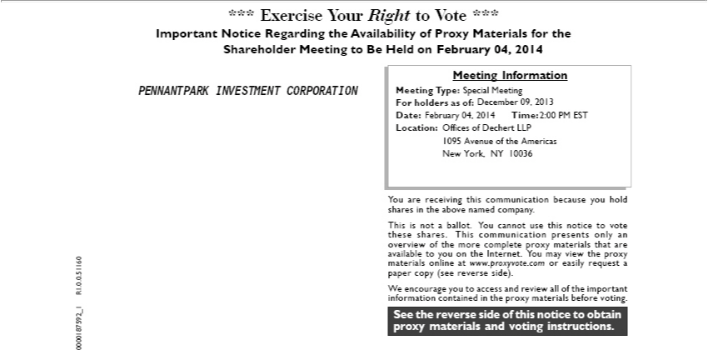

proxySeethematerialsreverse sideand ofvotingthis noticeinstructions.toobtain
sharesYouareinreceivingtheabovethisnamedcommunicationcompany. because you hold
This is_{shares}not ballot. You cannot use this notice to vote
these . This communication presents only an
availableoverview toof youthe moreonthecompleteInternet. proxyYoumaymaterialsview thethatproxyare
_{paper}materialscopyonline(see reverseatwww.proxyvote.comside). or easily request a
W encourage you to access and review all of the important
_{Meeting}informationInformationcontained in the proxy materials before voting.
For holdersType:as of:<mtgtype><recdate>
Location:Date:Time: <mtgtime>
*** Exercise Your Right to Vote ***
Important Notice_{Meeting}Regarding the Availability of Proxy Materials for the
Shareholder to Be Held on <mtgdate>.
0000187592_1 R1.0.0.51160
PENNANTPARK INVESTMENT CORPORATION
Special Meeting
February 04, 2014 2:00 PM EST
December 09, 2013
Offices of Dechert LLP
New1095 York,AvenueNYof10036theAmericas

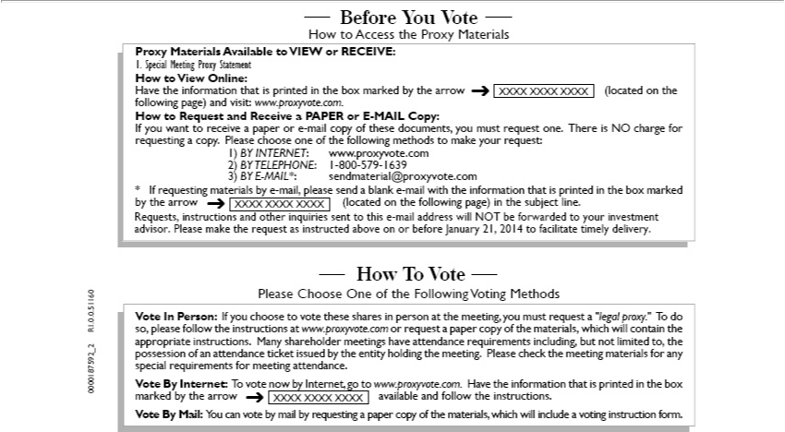

How To Vote
Please Choose One of the Following Voting Methods
Vote In Person: If you choose to vote these shares in person at the meeting, you must request “legal proxy.” T do
so, please follow the instructions at www.proxyvote.com or request paper copy of the materials, which will contain the
appropriate instruc ions. Many shareholder meetings have attendance requirements including, but not limited to, the
possession of an attendance ticket issued by the entity holding the meeting. Please check the meeting materials for any
special requirements for meeting attendance.
Vote By Internet: T vote now by Internet, go to www.proxyvote.com. Have the information that is printed in the box
marked by the arrow available and follow the instructions.
Vote By Mail: You can vote by mail by requesting a paper copy of the materials, which will include a voting instruction form.
Before You Vote
How to Access the Proxy Materials
Proxy Materials Available to VIEW or RECEIVE:
ow to View Online:
Have the information that is printed in the box marked by the arrow (located on the
following page) and visit: www.proxyvote.com.
How to Request and Receive a PAPER or E-MAIL Copy:
If you want to receive |  | paper or e-mail copy of these documents, you must request one. There is NO charge for
requesting a copy. Please choose one of the following methods to make your request:
1) | INTERNET www.proxyvote.com
2) |  | 1-800-579-1639 | .com
3) BY TELEPHONE:-MAIL*: |  |  | .com
sendmaterial@proxyvote
* If requesting_{(located}mrials by -mail, please send a blank_{subject}-mail with the information that is printed in the box marked
by the arrow on the following page) in the line.
XXXX XXXX XXXX
₀₀₀₀₁₈₇₅₉₂_2 R1.0.0.51160
. Special Meeting Proxy Statement

Requests, instructions and other inquiries sent to this e-mail address will NOT be forwarded to your investment advisor. Please make the request as instructed above on or before January 21, 2014 to facilitate timely delivery.

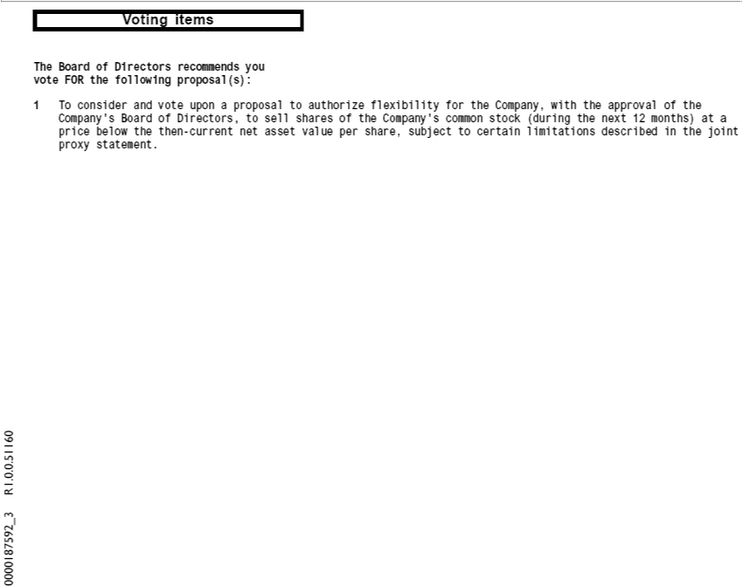

Voting items
0000187592_3 R1.0.0.51160
voteThe BoardFORtheof Directorsfollowing recommends_{proposal(s):} you
_{Company’}1T_{consider} and vote upon proposal to authorize flexibility for the Company, with the approval of the Board of Directors, to sell shares of the Company’s common stock (during the next 12 months) at a
^{proxy}icebelow the then-current net asset value per share, subject to certain limitations described in the joint statement.



0000187592VotingInstructions_4R1.0.0.51160

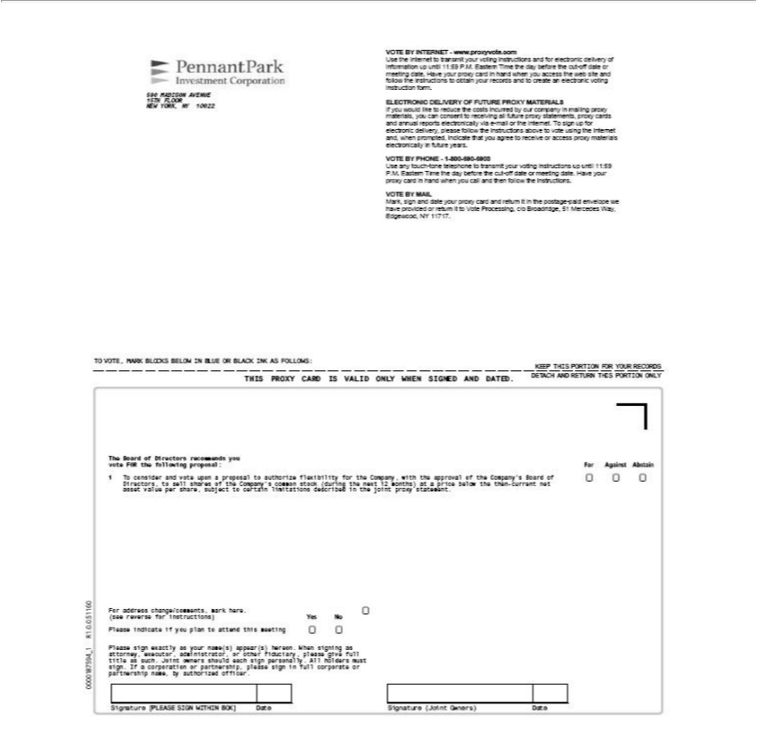

THIS PROXY CARD IS VALID ONLY WHEN SIGNED AND DATED.
K EP THIS PORTION FOR YOUR RECORDS
ACH AND RETURN THIS PORTION ONLY
DETOVOTE, MARK BLOCKS BELOW IN BLUE OR BLACK INK AS FOLLOWS:
Signature [PLEASE SIGN WITHIN BOX] Date Signature (Joint Owners) Date
0 0
00 0187594_1 R1.0.0.51160
590 MADISON AVENUE
15TH FLOOR
NEW YORK, NY 10022
VOTE BY INTERNET - www.proxyvote.com
Use the Internet to transmit your voting instructions and electronic delivery of
information up until 11:59 P.M. Eastern Time the day before the cut-off date or
meeting date. Have your proxy card in hand when you access the web site and
follow the instructions to obtain your records and to create an electronic voting
instruction form.
ELECTRONIC DELIVERY OF FUTURE PROXY MATERIALS
If you would like to reduce the costs incurred by our company in mailing proxy
materials, you can consent to |  | all future proxy statements, proxy cards
and annual reports electronicallyreceivingvia-mail or the Internet. T sign up for
electronic delivery please follow the instructions above to vote using the Internet
and, when prompted, indicate that you agree to receive or access proxy materials electronically in future years.
VOTE BY PHONE - 1-800-690-6903
Use any touch-tone telephone to transmit your voting instructions up until 11:59
P.M. Eastern Time the day before the cut-off date or meeting date. Have your proxy card in hand when you call and then follow the instructions.
VOTE BY MAIL
Mark, sign and date your proxy card and return it in the postage-paid envelope we
have provided re u n it to Vote Processing, c/o Broadridge, 51 Mercedes Way, Edgewood, NY 11717.
The Board of Directors recommends you
vote FOR the following |  | For Against Abstain
1 T consider and vote uponproposal:proposal to authorize flexibility for the Company, with the approval of the Company’s Board of
Directors, to sell shares of the Company’s common stock (during the next 12 months) at a price below the then-current net asset value per share, subject to certain limitations described in the joint proxy
statement.
Please sign exactly as your name(s) appear(s) hereon. When signing as
attorney, executor, administrator, or other fiduciary, please give full
title as su h. Joint owners should each sign personally. All holders must
sign. If | corporation or partnership, please sign in full corporate or
partnership name, by authorized officer.

(seeFor addressreverse change/comments,forinstructions)YesmarkNo here.

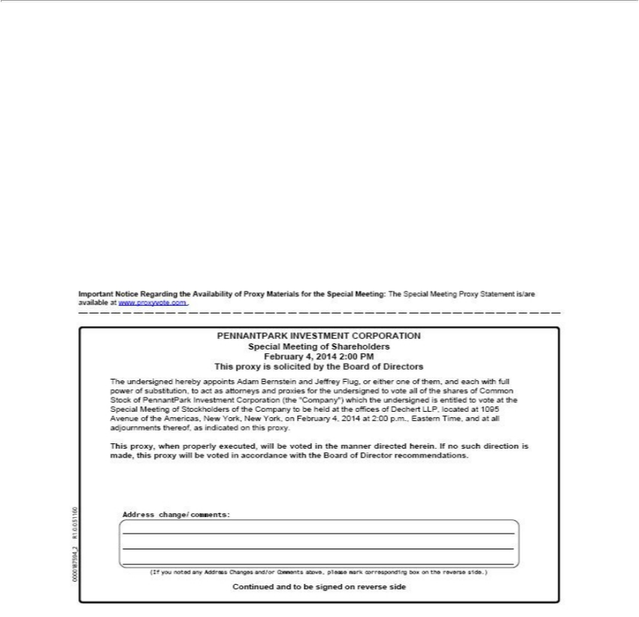

0000187594_2 R1.0.0.51160
Important Notice Regarding the Availability of Proxy Materials for the Special Meeting: The Special Meeting Proxy Statement is/are
available at www.proxyvote.com .
PENNANTPARK INVESTMENT CORPORATION
Special Meeting of Shareholders
February 4, 2014 2:00 PM
is proxy is solicited by the Board of Directors |  | and each with full
The undersigned hereby appoints Adam Bernstein and Jeffrey Flug, or either one of
power of substitution, to act as attorneys nd proxies for the undersigned to vote all ofthem, shares of Common
tock of PennantPark Investment Corporation (the “Company”) which the undersigned is entitled to vote at the
Special Meeting of Stockholders of the Company to be held at the offices of Dechert LLP, located at 1095
Avenue of the | New York, New York, on February 4, 2014 at 2:00 p.m., Eastern Time, and at all
adjournments thereof,Americas, indicated on this proxy. |  |  | is made, this proxy will be voted in accordance with the Board of Director recommendations.
This proxy, when properly executed, will be voted in the manner directed herein. If no such
direction
Address(Ifyounotedchange/comments:anyAddressChanges and/or Comments above, please mark corresponding box the reverse side.)

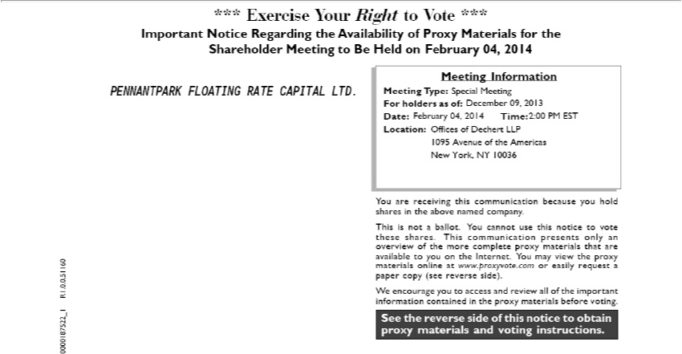

proxySeethematerialsreverse sideand ofvotingthis noticeinstructions.toobtain
sharesYouareinreceivingtheabovethisnamedcommunicationcompany. because you hold
This is_{shares}not ballot. You cannot use this notice to vote
these . This communication presents only an
availableoverview toof youthe moreonthecompleteInternet. proxyYoumaymaterialsview thethatproxyare
_{paper}materialscopyonline(see reverseatwww.proxyvote.comside). or easily request a
W encourage you to access and review all of the important
_{Meeting}informationInformationcontained in the proxy materials before voting.
For holdersType:as of:<mtgtype><recdate>
Location:Date:Time: <mtgtime>
*** Exercise Your Right to Vote ***
Important Notice_{Meeting}Regarding the Availability of Proxy Materials for the
Shareholder to Be Held on <mtgdate>.
0000187522_1 R1.0.0.51160
PENNANTPARK FLOATING RATE CAPITAL LTD. Special Meeting
February 04, 2014 2:00 PM EST
December 09, 2013
Offices of Dechert LLP
1095 Avenue of the Americas

New York, NY 10036

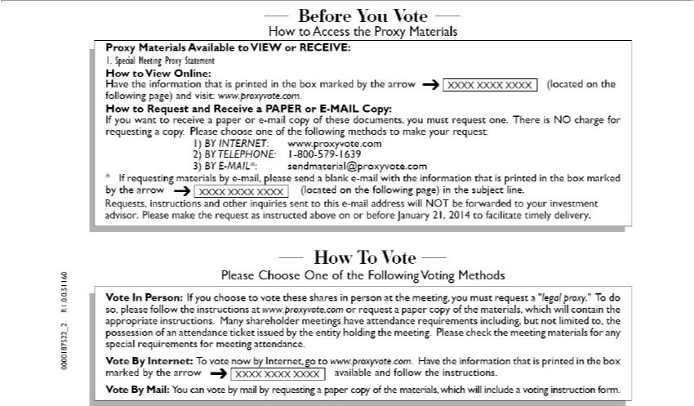

How To Vote
Please Choose One of the Following Voting Methods
Vote In Person: If you choose to vote these shares in person at the meeting, you must request “legal proxy.” T do
so, please follow the instructions at www.proxyvote.com or request paper copy of the materials, which will contain the
appropriate instruc ions. Many shareholder meetings have attendance requirements including, but not limited to, the
possession of an attendance ticket issued by the entity holding the meeting. Please check the meeting materials for any
special requirements for meeting attendance.
Vote By Internet: T vote now by Internet, go to www.proxyvote.com. Have the information that is printed in the box
marked by the arrow available and follow the instructions.
Vote By Mail: You can vote by mail by requesting a paper copy of the materials, which will include a voting instruction form.
Before You Vote
How to Access the Proxy Materials
Proxy Materials Available to VIEW or RECEIVE:
ow to View Online:
Have the information that is printed in the box marked by the arrow (located on the
following page) and visit: www.proxyvote.com.
How to Request and Receive a PAPER or E-MAIL Copy:
If you want to receive |  | paper or e-mail copy of these documents, you must request one. There is NO charge for
requesting a copy. Please choose one of the following methods to make your request:
1) | INTERNET www.proxyvote.com
2) |  | 1-800-579-1639 | .com
3) BY TELEPHONE:-MAIL*: |  |  | .com
sendmaterial@proxyvote
* If requesting_{(located}mrials by -mail, please send a blank_{subject}-mail with the information that is printed in the box marked
by the arrow on the following page) in the line.
XXXX XXXX XXXX
₀₀₀₀₁₈₇₅₂₂_2 R1.0.0.51160
. Special Meeting Proxy Statement

Requests, instructions and other inquiries sent to this e-mail address will NOT be forwarded to your investment advisor. Please make the request as instructed above on or before January 21, 2014 to facilitate timely delivery.

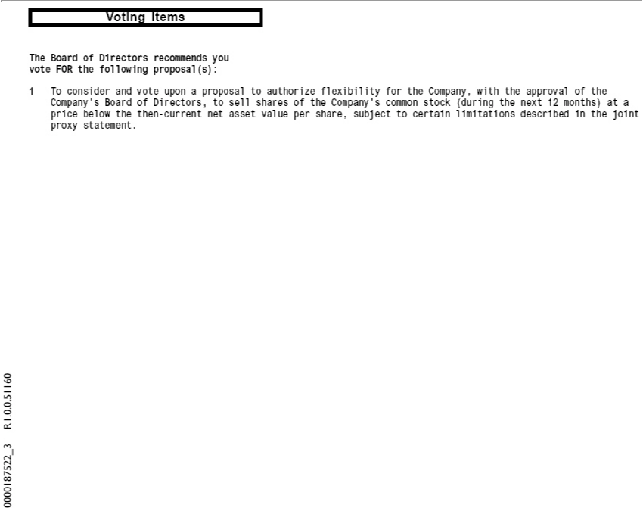

Voting items
0000187522_3 R1.0.0.51160
voteThe BoardFORtheof Directorsfollowing recommends_{proposal(s):} you
_{Company’}1T_{consider} and vote upon proposal to authorize flexibility for the Company, with the approval of the Board of Directors, to sell shares of the Company’s common stock (during the next 12 months) at a
^{proxy}icebelow the then-current net asset value per share, subject to certain limitations described in the joint statement.



Voting Instructions 0000187522_4 R1.0.0.51160

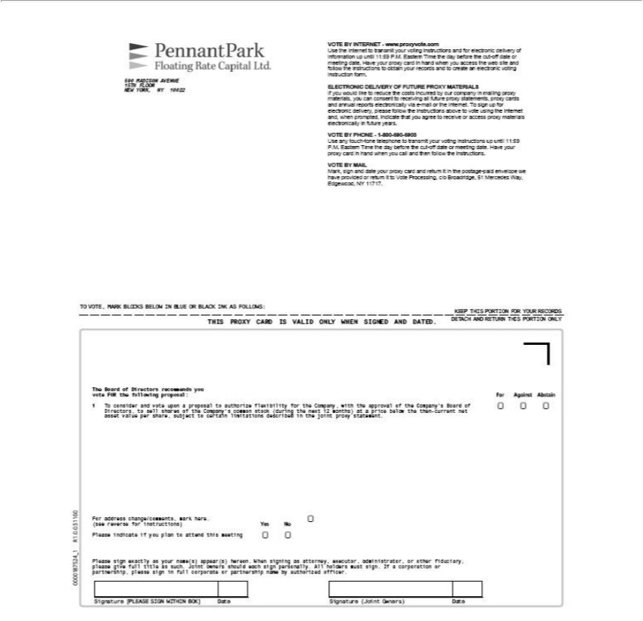

THIS PROXY CARD IS VALID ONLY WHEN SIGNED AND DATED.
K EP THIS PORTION FOR YOUR RECORDS
ACH AND RETURN THIS PORTION ONLY
DETOVOTE, MARK BLOCKS BELOW IN BLUE OR BLACK INK AS FOLLOWS:
Signature [PLEASE SIGN WITHIN BOX] Date Signature (Joint Owners) Date
0 0
00 0187524_1 R1.0.0.51160
590 MADISON AVENUE
15TH FLOOR
NEW YORK, NY 10022
VOTE BY INTERNET - www.proxyvote.com |  |  | electronic delivery of
Use the Internet to transmit your voting instructions and |  |  | electronic delivery of
information up until 11:59 P.M. Eastern Time the day before the cut-off date or
meeting date. Have your proxy card in hand when you access the web site and
follow the instructions to obtain your records and to create an electronic voting
instruction form.
ELECTRONIC DELIVERY OF FUTURE PROXY MATERIALS
If you would like to reduce the costs incurred by our company in mailing proxy
materials, you can consent to |  | all future proxy statements, proxy cards
and annual reports electronicallyreceivingvia-mail or the Internet. T sign up for
electronic delivery please follow the instructions above to vote using the Internet
and, when prompted, indicate that you agree to receive or access proxy materials
electronically in future years.
VOTE BY PHONE - 1-800-690-6903
Use any touch-tone telephone to transmit your voting instructions up until 11:59
P.M. Eastern Time the day before the cut-of date or meeting date. Have your
proxy card in hand when you call and then follow the instructions.
VOTE BY MAIL
Mark, sign and date your proxy card and return it in the postage-paid envelope we
have provided or return it to Vote Processing, c/o Broadridge, 51 Mercedes Way,
Edgewood, NY 11717.
The Board of Directors recommends you
vote FOR the following | For Against Abstain
1 T consider and vote uponproposal:proposal to authorize flexibility for the Company, with the approval of the Company’s Board of
Directors, to sell shares of the Compa |  | y’ common stock | the next 12 months) a price below the then-current net
asset value per share, subject to certain limitations described(duringthe joint proxy statement. |  |  |  | , other fiduciary,
sign exactly as your name(s) appear(s) hereon. When signing as attorney, executor,
Please give full title as such. Joint owners should each sign personally. All holders must sign.administratorcorporationIf |  |  |  |  | or
partnership, please sign in full corporate or partnership name by authorized officer.
For address change/comments, mark here.
(see reverse for instructions) Yes No

Please indicate if you plan to attend this meeting

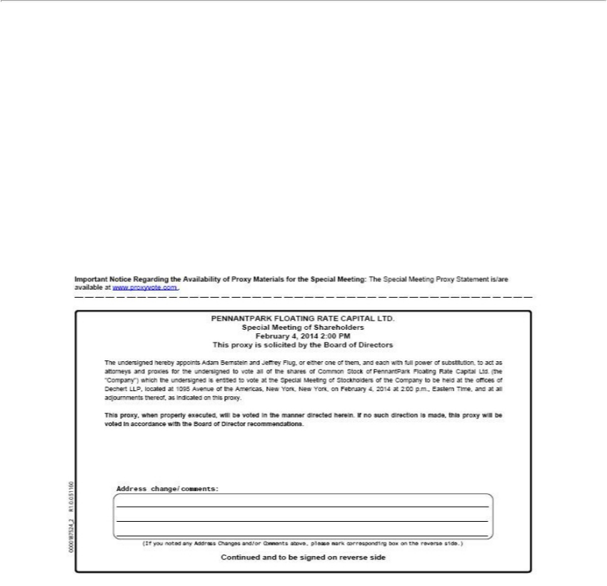

0000187524_2 R1.0.0.51160
Important Notice Regarding the Availability of Proxy Materials for the Special Meeting: The Special Meeting Proxy Statement is/are available at www.proxyvote.com .
SpecialPENNANTPARKMeetingofFLOATINGShareholdersRATE CAPITAL LTD.
February 4, 2014 2:00 PM
^{The}is proxy is solicited by the Board of Directors
undersigned hereby appoints Adam Bernstein and Jeffrey Flug, or either one of them, and each with full power of substitution, to act as attorneys and proxies for the undersigned to vote all of the shares of Common Stock of PennantPark Floating Rate Capital Ltd. (the “Company”) which the undersigned is entitled to vote at the Special Meeting of Stockholders of the _{Company} to be held at the offices of Dechert LLP, located at 1095 Avenue of the Americas, New York, New York, on February 4, 2014 at 2:00 . ., Eastern Time, and at all adjournments thereof, as indicated on this proxy.

This proxy, when properly executed, will be voted in the manner directed herein. If no such direction is made, this proxy will be voted in accordance with the Board of Director recommendations.
Address(Ifyounotedchange/comments:anyAddressChanges and/or Comments above, please mark corresponding box on the reverse side.)
Continued and to be signed on reverse side

