
Filed by PennantPark Floating Rate Capital Ltd.

Pursuant to Rule 425 under the Securities Act of 1933

and deemed filed pursuant to Rule 14a-12 of the Securities Exchange Act of 1934 Subject Company: MCG Capital Corporation (File No. 814-00239)

PennantPark Floating Rate Capital

Acquisition of MCG Capital Corporation

Investor Presentation

April 29, 2015

Forward-looking Statements and Risk Factors

This presentation contains "forward-looking statements" within the meaning of the Private Securities Litigation Reform Act of 1995 that relate to future events, performance or financial condition of PennantPark Floating Rate Capital Ltd. (“PFLT”) and MCG Capital Corporation (“MCGC”). Statements other than statements of historical facts included in this press release may constitute forward-looking statements and are not guarantees of future performance or results and involve a number of risks and uncertainties. Actual results may differ materially from those in the forward-looking statements as a result of a number of factors, including those described from time to time in filings with the Securities and Exchange Commission. Neither PFLT nor MCGC undertakes any duty to update any forward-looking statement made herein. All forward-looking statements speak only as of the date of this presentation.

However, by their nature, these forward-looking statements involve numerous assumptions, uncertainties and opportunities, both general and specific. The risk exists that these statements may not be fulfilled.

We caution readers of this presentation not to place undue reliance on these forward-looking statements as a number of factors could cause future company results to differ materially from these statements.

Forward-looking statements may be influenced in particular by factors such as the ability of the parties to consummate the transaction described in this press release on the expected timeline (or at all), the failure of PFLT or MCGC stockholders to approve the proposed merger, the ability to realize the anticipated benefits of the transaction, the effects of disruption on the companies’ business from the proposed merger, the effect that the announcement or consummation of the merger may have on the trading price of the common stock of PFLT or MCGC, the combined company’s plans, expectations, objectives and intentions, the other factors described from time to time in the companies’ filings with the Securities and Exchange Commission, fluctuations in interest rates and stock indices, the effects of competition in the areas in which we operate, and changes in economic, political and regulatory conditions. We caution that the foregoing list is not exhaustive.

When relying on forward-looking statements to make decisions, investors should carefully consider the aforementioned factors as well as other uncertainties and events. The performance data quoted represents past performance and does not guarantee future results. The performance stated may have been due to extraordinary market conditions, which may not be duplicated in the future. Current performance may be lower or higher than the performance data quoted.

We refer you to the list of risk factors set forth in PFLT’s most recent Annual Report on Form 10-K, a copy of which may be obtained on PFLT’s website at www.pennantpark.com or the SEC’s website at www.sec.gov. Specifically, an investment in PFLT’s common stock involves significant risks, including the risk that the secondary market price of PFLT’s common stock may decline from the offering price and may be less than PFLT’s net asset value per share, as well as the risk that the price of PFLT’s common stock in the secondary market may be highly volatile. Please see a discussion of these risks and other related risks in PFLT’s most recent Annual Report on Form 10-K under Item 1A - “Risks Relating to an Investment in Our Common Stock”.

This presentation contains certain information as is set forth in PFLT’s reports on Form 10-K or 10-Q and we direct you to these reports for further information on our business.

IMPORTANT ADDITIONAL INFORMATION AND WHERE TO FIND IT

This communication is being made in respect of the proposed business combination involving PFLT and MCGC. In connection with the proposed transaction, PFLT plans to file with the SEC a Registration Statement on Form N-14 that includes proxy statements of PFLT and MCGC and that also constitutes a prospectus of PFLT. The definitive Joint Proxy Statement/Prospectus will be mailed to stockholders of
PFLT and MCGC. INVESTORS AND SECURITY HOLDERS OF PFLT AND MCGC ARE URGED TO READ THE JOINT PROXY STATEMENT/PROSPECTUS AND OTHER DOCUMENTS FILED WITH THE SEC CAREFULLY IN THEIR ENTIRETY WHEN THEY BECOME AVAILABLE BECAUSE THEY WILL CONTAIN IMPORTANT INFORMATION ABOUT THE PROPOSED TRANSACTION.

Investors and security holders will be able to obtain free copies of the Registration Statement and Joint Proxy Statement/Prospectus (when available) and other documents filed with the SEC by each

of PFLT and MCGC through the web site maintained by the SEC at www.sec.gov. Free copies of the Registration Statement and Joint Proxy Statement/Prospectus (when available) and other documents filed with the SEC can also be obtained on PFLT’s website at www.pennantpark.com or on MCG’s website at www.mcgcapital.com.

PROXY SOLICITATION

PFLT and MCGC and their respective directors, executive officers and certain other members of management and employees may be deemed to be participants in the solicitation of proxies from PFLT and MCGC stockholders in respect of the acquisition. Information regarding the persons who may, under the rules of the SEC, be considered participants in the solicitation of the PFLT and MCGC stockholders in connection with the proposed acquisition will be set forth in the Joint Proxy Statement/Prospectus when it is filed with the SEC. You can find information about PFLT’s executive officers and directors in its definitive proxy statement filed with the SEC on November 26, 2014. You can find information about MCGC’s executive officers and directors in its Annual Report on Form 10-K/A for the year ended December 31, 2014 filed with the SEC on April 29, 2015. You can obtain free copies of these documents from PFLT and MCGC in the manner set forth above.

This presentation does not constitute an offer to sell or the solicitation of an offer to buy nor will there be any sale of securities in any jurisdiction in which such offer, solicitation or sale would be unlawful prior to the registration or qualification under the securities laws of such jurisdiction. A registration statement relating to these securities will be filed with the Securities and Exchange Commission, and the securities may not be sold until the registration statement becomes effective. Investors are advised to carefully consider the investment objectives, risks and charges and expenses of PFLT before investing in its securities.

1

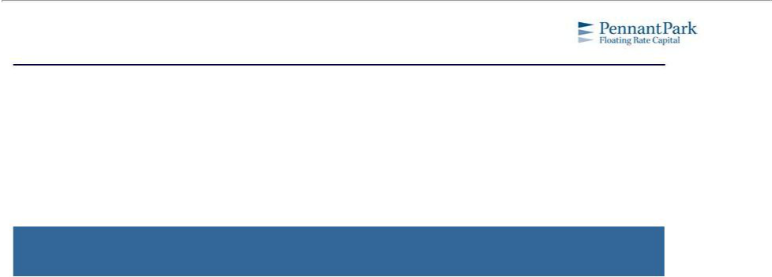

Section I. Proposed Transaction & Rationale

2

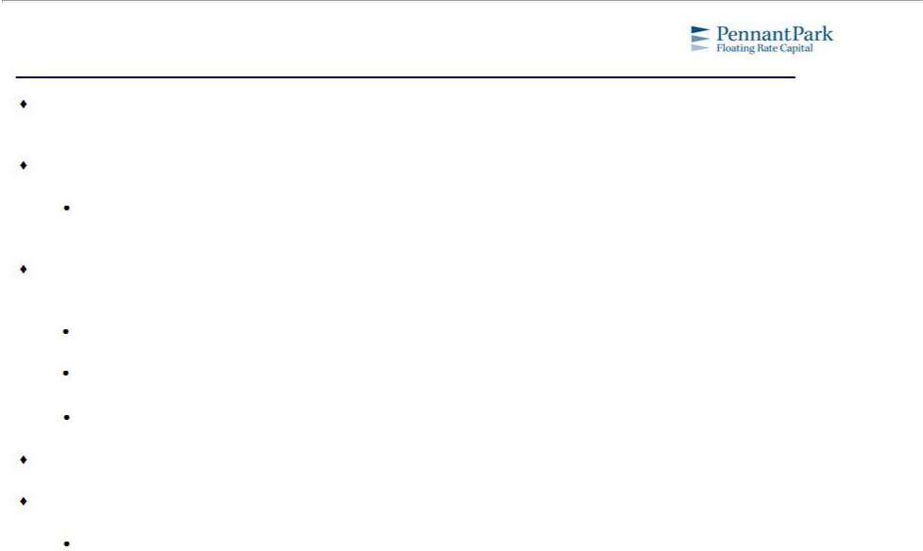
The Acquisition

PFLT was founded in 2011 to provide middle market senior secured

floating

rate loans to our sponsor

and corporate clients and attractive and stable returns to investors

PFLT has performed well since inception

Since 2013 PFLT has had a total return of 33% compared to a total return of 18% for the BDC index (1) and a total return of (2%) for the senior secured floating rate BDCs (2)

The acquisition of MCGC should

enable

PFLT to better capture

the middle

market

opportunity

for our

borrowers and shareholders

More relevant for borrowers due to broader platform

Larger float and liquidity for shareholders

Economies of scale

Approximately 70% of MCGC’s assets are cash as of April 1, 2015

PFLT has valued each of MCGC’s four remaining investments and is comfortable with current marks

All four investments are debt investments that have debt / EBITDA ratios below 4.0x, which is consistent with PFLT’s existing portfolio

- Represents 51 publicly traded BDCs. Market data as of 4/24/15.

(2) Includes SUNS, FSFR and ACSF. Market data as of 4/24/15. | 3

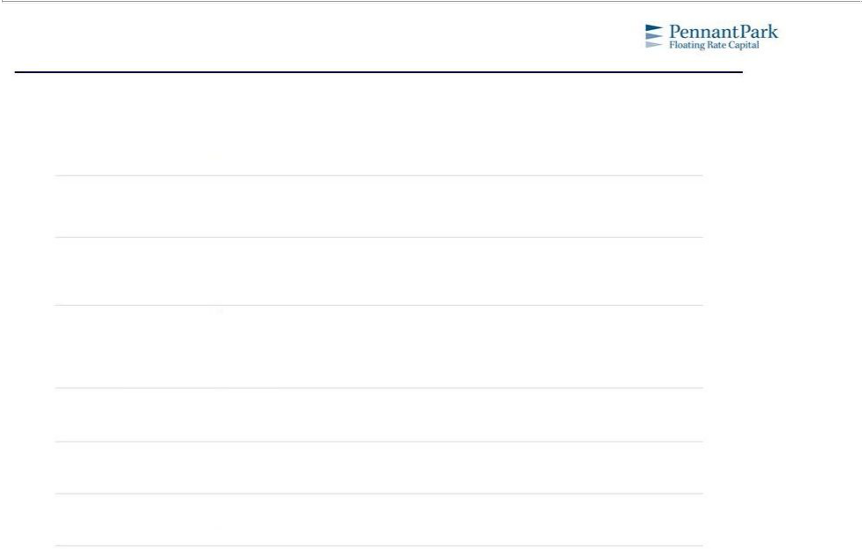
Transaction Summary

Estimated Consideration Mix at Closing:

Aggregate

Consideration:

Exchange Ratio:

Cash Consideration:

Governance:

- $167 million in PFLT common stock ($4.521 per MCGC share)

- $8 million in cash contribution from PennantPark Investment Advisers, LLC (the “Adviser”) ($0.226 per MCGC share)

- $175 million

- Floating, based on value of $4.521 per share of MCGC common stock

- PFLT common stock to be valued at the greater of NAV and the 10 day volume-weighted average price (“VWAP”) per share of PFLT common stock prior to the second trading day prior to closing

- $0.226 per share of MCGC common stock (approximately $8 million in the aggregate), paid by the Adviser

- The Adviser will contribute up to an additional $0.25 per PFLT share issued in this transaction to the extent PFLT’s 10 day VWAP as calculated above is less than PFLT NAV

- The Adviser to remain as external manager of the combined company

- Two members of the MCGC Board of Directors expected to join PFLT Board of Directors at closing

Expected Closing: • Q3 2015

Required Approvals: • Approval of both MCGC and PFLT stockholders

4

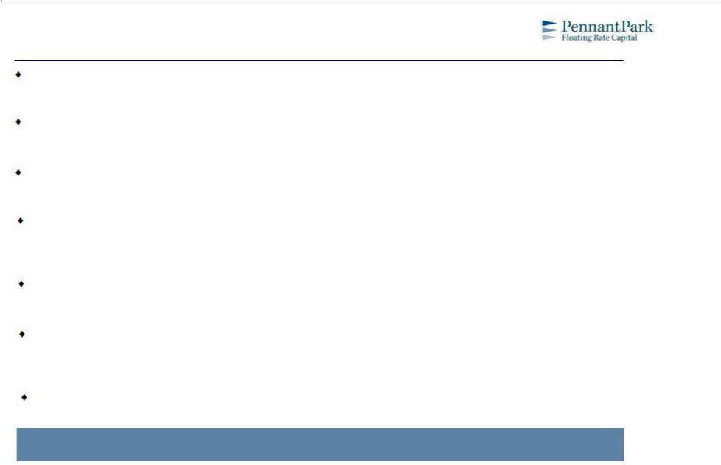
Key Benefits of Combination and Synergies

Almost doubles market capitalization, creating more float and liquidity for shareholders

Elimination of duplicative public company expenses

Increases scale and competitive relevance with financial sponsors and other borrowers

Larger asset base enables greater diversification within the overall portfolio as well as economies of scale

Enhanced scale benefiting float and liquidity while spreading fixed costs over a larger asset base

Serves as a “synthetic equity” raise without NAV dilution to PFLT shareholders (before typical deal expenses)

Permits MCGC stockholders to maintain ongoing participation in the combined company and resume monthly dividend participation

Shareholders will continue to benefit from a proven credit manager that has had a track record of consistent and growing dividends

5

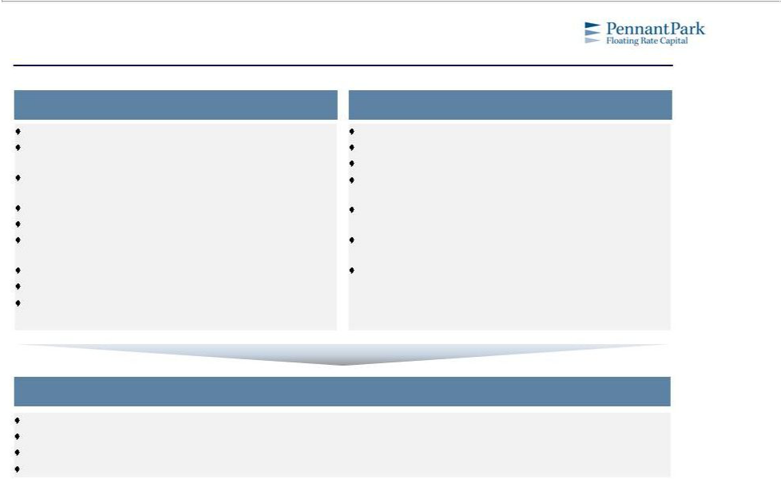
PFLT and MCGC Combined

PFLT |  |  |  | MCGC
Externally managed by PennantPark |  |  |  | Internally managed
$343 million investment portfolio at value on balance |  |  |  | $50 million investment portfolio on balance sheet (2)
sheet (1) |  |  |  | Cash position of $116 million (2)
72 portfolio companies across 21 different industries on |  |  |  | Portfolio of 4 debt securities with debt / EBITDA ratios
balance sheet (1) |  |  |  | under 4.0x (2)
Average investment size of $4.8 million | (1) |  |  | Has been in the process of liquidating its portfolio and
95% floating rate investments (1) |  |  |  | buying back stock via a December 2014 tender offer
PennantPark Investment Advisers, LLC has deployed |  |  |  | Announced that it is exploring strategic alternatives on
over $4.3 billion across nearly 350 companies since 2007 |  |  | (1) | February 9, 2015
$200 million five-year credit facility at L+200 |  | (1) |  | Founded in 1998, went public in 2001 and is
Monthly dividends of $0.095 per share |  |  |  | headquartered in Arlington, VA
Leader in the externally managed BDC space as
measured by expense ratio and efficiency ratio |  | (1)

PFLT and MCGC

Larger market capitalization and greater trading liquidity for investors

Continued focus on middle market senior loans

Elimination of MCGC’s cost burden associated with being a standalone public entity

Externally managed by PennantPark

1) As of 12/31/14. | 6
- As of 3/31/15.

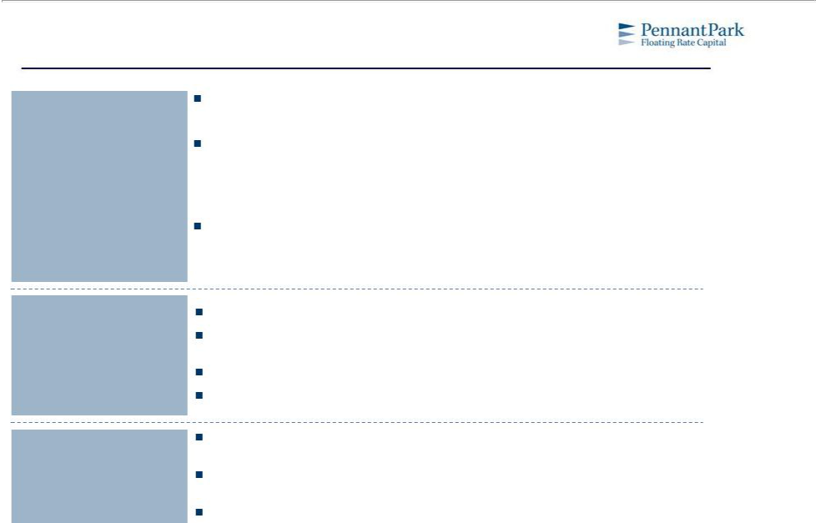
Value to MCGC Shareholders

Partnership with Best In-Class Manager

PFLT has a shareholder friendly expense structure
– | One of the lowest cost BDCs relative to asset base | (1)
PFLT has the highest annual and total returns among the floating |  |  | rate-focused BDCs (2)
– Since 2013, PFLT has had a total return of 33% compared to a total return of 18% for the

BDC index (3) and a total return of (2%) for the senior secured floating rate BDCs(4)
– Was the only floating rate BDC in 2014 to have positive returns at 8%

PFLT’s external manager has experience with public vehicles since 2007 (PNNT’s IPO)

– | Funded $4.3 billion in 350 companies since inception across PennantPark entities |  | (5)
– | 145 different sponsor clients since inception across PennantPark | entities (5)

Strategic Reorientation into Attractive Floating Rate Market

Attractive Entry Point

into PFLT from

Valuation Perspective

Floating rate loans help protect against inflation and rising interest rates

PFLT has a diversified and defensive portfolio with a weighted average cash interest coverage of 3.2x (5)

Senior secured loans have strong capital preservation attributes

PFLT has a solid dividend track record, paying monthly dividends of $0.095 per share

Receiving PFLT shares represents attractive currency as the company provides investors with capital preservation and current income

MCGC shareholders can benefit from appreciation of stock price and PFLT has increased dividends since inception

15.8% premium to MCGC’s stock price on April 28, 2015

- SNL Financial as of most recent quarterly financials.

2) | SNL Financial as of 4/24/15. | 7
3) | Represents 51 publicly traded BDCs. | 7
4) | Includes SUNS, FSFR and ACSF.
5) | As of 12/31/14.

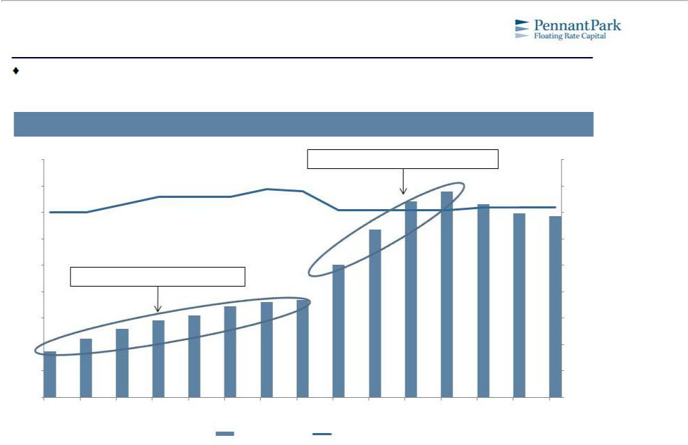
Demonstrated Ability to Deploy Capital

PFLT has demonstrated an ability to quickly ramp assets, while maintaining strong credit quality, after equity offerings

PFLT Portfolio Size and Debt Yield

($ in millions)
$450 | Ramp after two follow-on offerings | 10%
$400 |  | 9%
$350 |  | 8%
$300 |  | 7%
$250 |  | 6%
Ramp after $100mm IPO
$200 |  | 5%
$150 |  | 4%
$100 |  | 3%
$50 |  | 2%
$0 |  | 1%
Jun -11 Sep-11 Dec-11 Mar-12Jun -12 Sep-12 Dec-12 Mar-13 | Jun -13 Sep-13 Dec-13 Mar-14 Jun -14 Sep-14 | Dec-14
Total Portfolio Size | Yield on Portfolio

8

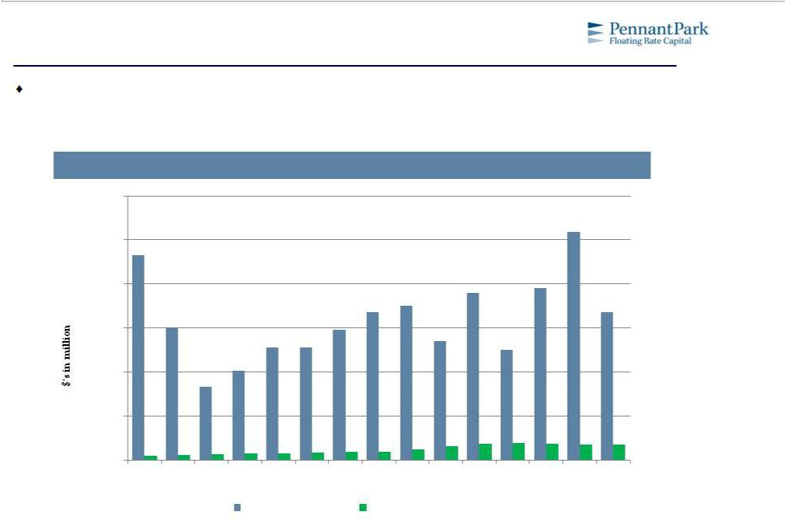
Increased Relevance in Senior Secured Middle Market

Through the proposed acquisition of MCGC, PFLT will be able to become more relevant with financial sponsors and borrowers and have a greater opportunity to identify high quality assets in a large market

Middle Market Origination Volume by Quarter vs. PFLT Portfolio Size

$6,000
$5,000
$4,000
$3,000
$2,000
$1,000
$0
2Q11 | 3Q11 | 4Q11 | 1Q12 | 2Q12 | 3Q12 | 4Q12 | 1Q13 | 2Q13 | 3Q13 | 4Q13 | 1Q14 | 2Q14 | 3Q14 | 4Q14
 |  |  | Mid-Market Volume |  |  |  | PFLT Portfolio Size
Note: Mid-market defined as issuers with EBITDA of $50 million or less. |  |  |  |  |  |  |  |  |  |  |  |  |  | 9
Source: S&P, represents senior secured loans.

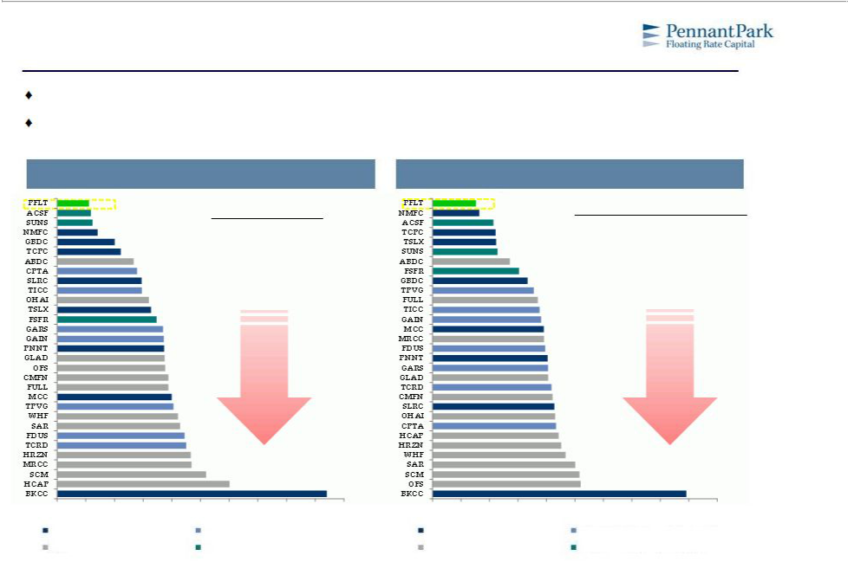
Expense Ratio Comparisons

PFLT offers current MCGC shareholders a friendly expense structure

In terms of non-interest expense efficiencies, PFLT is a leader in the externally managed BDC space as measured by expense ratio and efficiency ratio

Expense Ratio |  |  | Efficiency Ratio
Expense | = | Non-Interest Expenses | Efficiency | = | Non-Interest Expenses
 |  |  |  |  | Net Interest |  | Non-Interest
Ratio |  | Average Assets | Ratio |  | Net Interest | + | Non-Interest
 |  |  |  |  | Income |  | Income

Higher | Higher
Cost | Cost
Structures | Structures

0% | 1% | 2% | 3% | 4% | 5% | 6% | 7% | 8% | 9% | 10% | 0% | 10% | 20% | 30% | 40% | 50% | 60% | 70% | 80% | 90% | 100%
Mkt. Cap. Between $500M and $1B |  |  |  |  | Mkt. Cap. Between $200M and $500M |  |  |  |  |  | Mkt. Cap. Between $500M and $1B |  |  |  |  | Mkt. Cap. Between $200M and $500M
Mkt. Cap. Less Than $200M |  |  |  |  | Floating Rate Snr. Secured Vehicles |  |  |  |  |  | Mkt. Cap. Less Than $200M |  |  |  |  | Floating Rate Snr. Secured Vehicles

Note: Includes all externally-managed BDCs that are paying a regular cash dividend. Excludes BDCs that have not filed quarterly financials since Q3'14.
Source: SNL Financial as of most recent quarterly financials. | 10

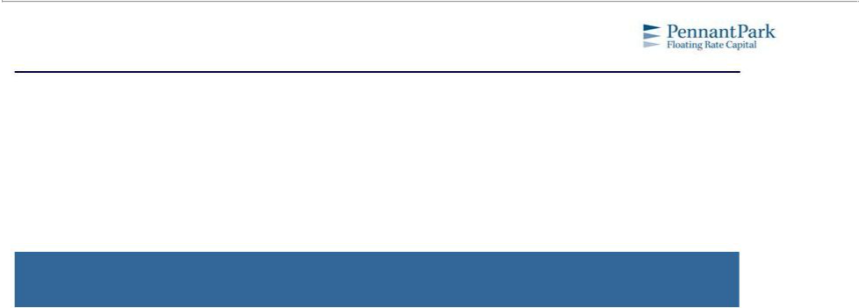

Section II. PFLT’s Value Proposition

11

Established Credit Platform

PennantPark Investment Advisers, LLC

Established Investment Platform
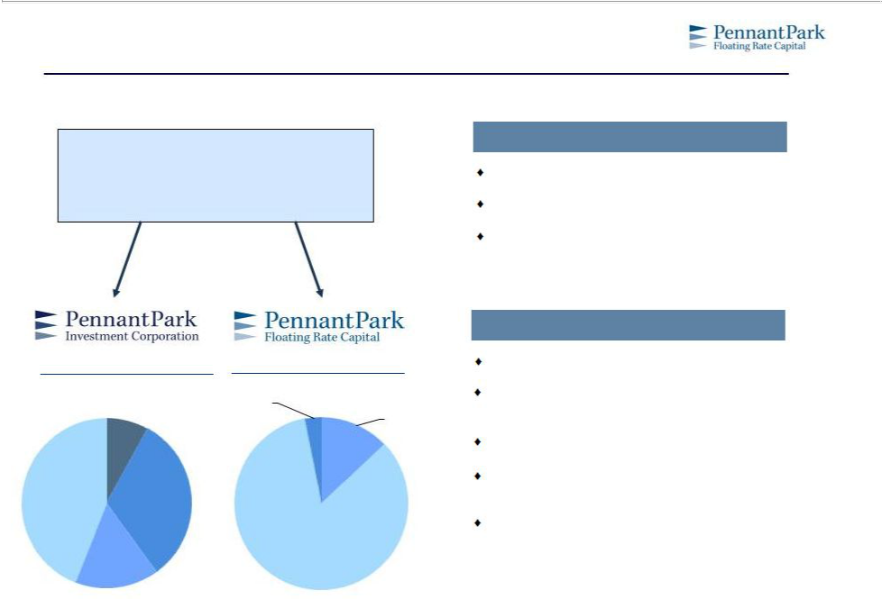

The Adviser founded in 2007

Deep expertise in the middle market

Longer investment horizon with attractive

publicly traded model

NASDAQ: “PNNT” |  | NASDAQ: “PFLT”
IPO Date: April 2007 |  | IPO Date: April 2011
 | Common and | Subordinated
 | Common and | Debt, Common
 | Preferred | Debt, Common | 2nd Lien
 | Preferred | and Perferred | 2nd Lien
 | Equity | and Perferred | 2nd Lien
 | Equity | Equity | Secured Debt
 | 8% | Equity | Secured Debt
 | 8% | 3% | 13%
2nd Lien | 1st Lien
Secured | Senior
Debt | Secured
44% | Debt |  | 1st Lien Senior
 | 32% |  | Secured Debt
Subordinated |  |  | 84%

Debt

16%

As of 12/31/14

Value Oriented Investment Philosophy

Value oriented with a focus on capital preservation

Disciplined investment approach with strong credit performance

Proprietary origination, research and evaluation

Team approach – institutionalized investment process and relationships

Established long-term trust with clients and investors

12

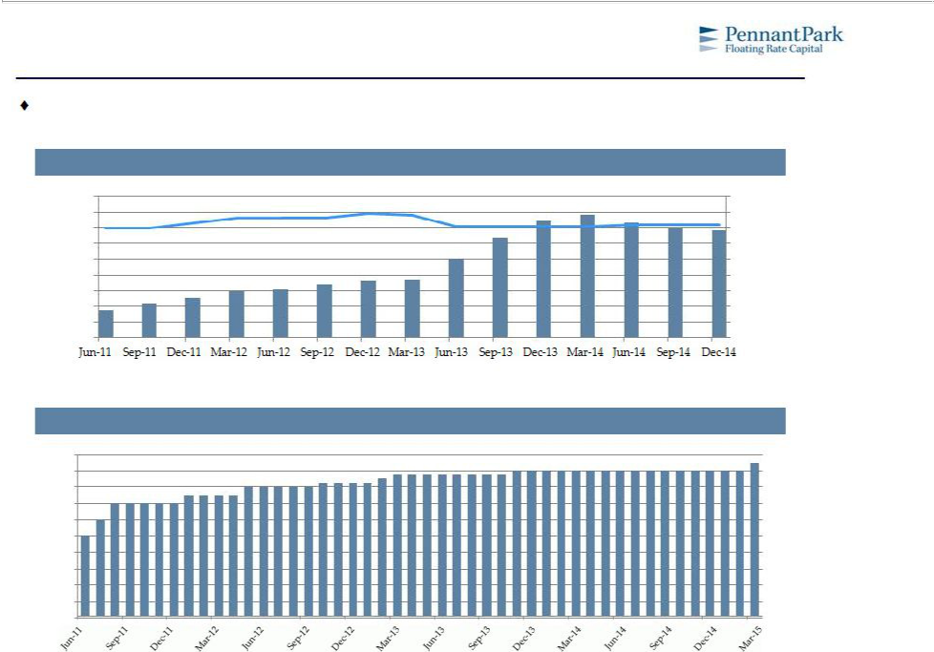
PFLT has a Compelling Track Record

Shareholders will continue to benefit from a proven credit manager that has had consistent and growing dividends

Portfolio Size ($ in millions) and Debt Yield

$450

$400

$350

$300

$250

$200

$150

$100

$50

$0

Total Portfolio Size Yield on Portfolio

10%

9%

8%

7%

6%

5%

4%

3%

2%

1%

Monthly Dividends (cents per share)

10 |  |  |  |  | 9.50
10 |  |  |  | 8.75 | 9.00
9 |  |  |  | 8.75 | 9.00
9 |  | 8.00 | 8.25 | 8.50
8 |  | 8.00 | 8.25 | 8.50
8 | 7.00 | 7.50
- 6.00
- 5.00
5

4

3

2

1

0

13

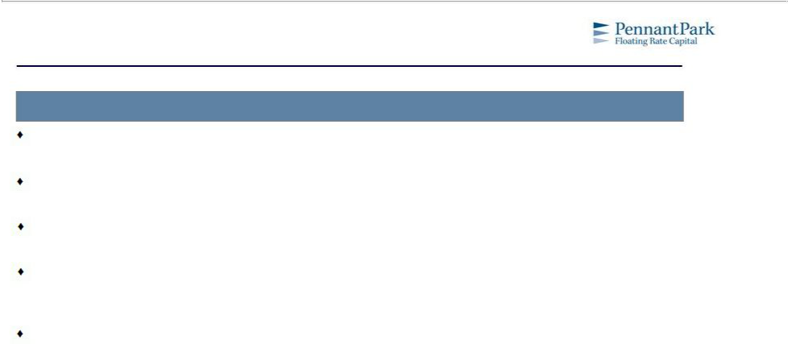
The PFLT Advantage

Conservative Risk Management

Weighed Average cash interest coverage of 3.2x⁽¹⁾

Weighted Average debt / EBITDA through PFLT security of 3.8x⁽¹⁾

84% of PFLT portfolio is 1st Lien Senior Secured Debt ⁽¹⁾

Since inception four years ago, PFLT has had only one non-accrual at a cost of $2.2 million. So far, PFLT has recovered 97 cents on the dollar on this investment

PennantPark entities have had only 9 non-accruals out of 350 investments since inception eight years ago despite the recession and credit crisis

- As of 12/31/14.
14

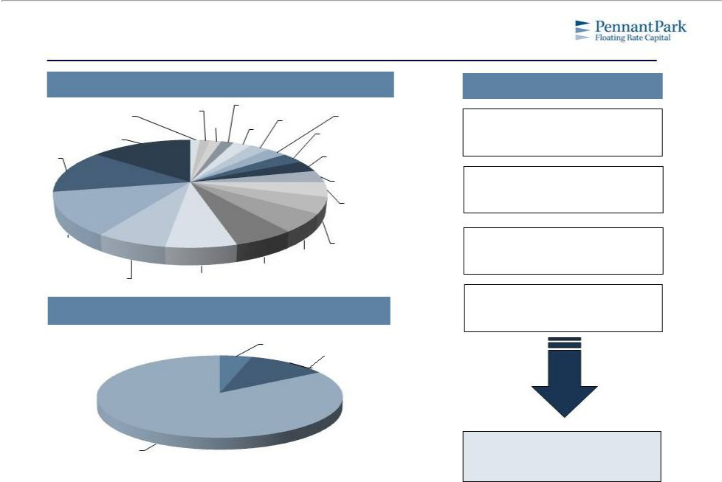
Pro-Forma Overall Portfolio as of 12/31/2014

Highly | Diversified |  | Industry Mix (1)
CHEMICALS, PLASTICS AND |  |  |  | ENERGY: OIL AND GAS
MEDIA: DIVERSIFIED AND | RUBBER |  |  |  |  |  |  | CONSTRUCTION AND
MEDIA: DIVERSIFIED AND | RUBBER |  |  |  | 2% |  |  | CONSTRUCTION AND
PRODUCTION | 1% | OTHER |  | WHOLESALE |  | AUTOMOTIVE |  | BUILDING
1% |  | 2% |  | 3% |  |  |  | 3%
HEALTHCARE AND |  | 2% |  | 3% |  | 3% |  | 3%
HEALTHCARE AND | 0 |  |  |  |  | 3% | AEROSPACE AND DEFENSE
PHARMACEUTICALS | 0
PHARMACEUTICALS |  |  |  |  |  |  |  | 3%
15% |  |  |  |  |  |  |  | 3%
HIGH TECH INDUSTRIES |  |  |  |  |  |  | CONSUMER GOODS: NON -
13%
 |  |  |  |  |  |  |  | DURABLE
 |  |  |  |  |  |  |  | 3%
 |  |  |  |  |  |  |  | MEDIA: BROADCASTING
 |  |  |  |  |  |  |  | AND SUBSCRIPTION
 |  |  |  |  |  |  |  | 4%
 |  |  |  |  |  |  |  | BANKING, FINANCE,
 |  |  |  |  |  |  |  | INSURANCE & REAL
 |  |  |  |  |  |  |  | ESTATE
 |  |  |  |  |  |  |  | 4%
BUSINESS SERVICES |  |  |  |  |  |  |  | CONSUMER GOODS:
BUSINESS SERVICES |  |  |  |  |  | RETAIL |  | DURABLE
13% |  |  |  |  |  |  |  | DURABLE
13% |  |  |  |  |  |  | 5% | 5%
 |  |  |  | MEDIA: ADVERTISING,
 | HOTEL, GAMING AND |  |  | PRINTING AND
CONSUMER SERVICES |  | LEISURE |  |  | PUBLISHING
7% |  | 7% |  |  |  | 6%

Portfolio Mix

Portfolio Overview

77 Different Companies

Average Investment Size: $5.1 million

94% Floating rate investments

(including 88% with a floor)

Yield at Cost on Debt Portfolio: 8.9%

SUBORDINATED
DEBT, PREFERRED
AND COMMON
EQUITY | 2ND LIEN SECURED
5% | DEBT
 | 11%

1ST LIEN SENIOR |  | Annualized Dividend Yield of 8.1% | (2)
SECURED DEBT | Total Portfolio: $393 million | Annualized Dividend Yield of 8.1% | (2)
84% | Total Portfolio: $393 million
Source: Company Financial Statements. |  |  | 15
Note: Portfolio companies from MCGC include: C7 Data Centers, GMC Television Broadcasting, RadioPharmacy Investors, South Bay Mental Health and Broadview Networks Holdings at 3/31/15 fair value marks. |  |  | 15
(1)Total of 21 industries. “Other” includes: Beverage, Foodand Tobacco /MetalsandMining / Telecommunications. |  |  | 15
- Based on a $0.095 monthly dividend and closing price on 3/31/15.

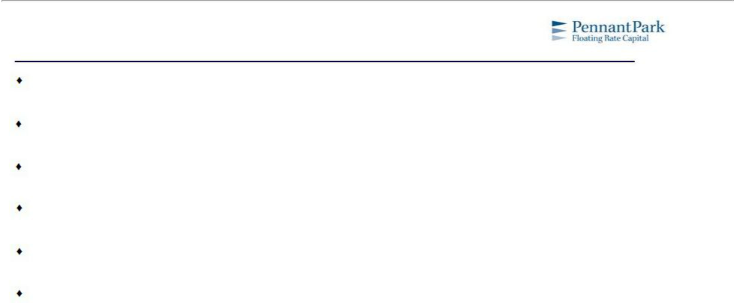
PFLT Post Acquisition

A leader in middle market senior secured loans

An ability to leverage a proven track record of capital preservation and current income for shareholders

Ability to capture more share and become more relevant to our clients

Ramp up in a prudent manner consistent with historical performance and market opportunity

Combined business will have low fees and eliminate duplicative public company costs

Greater liquidity and float for shareholders

16

