SCHEDULE 14A

(RULE 14a-101)

Information Required in Proxy Statement

Schedule 14A Information

Proxy Statement Pursuant to Section 14(a) of the
Securities Exchange Act of 1934

Filed by the Registrant ☒ Filed by a Party other than the Registrant ☐

Check the appropriate box:

- Preliminary Proxy Statement

- Confidential, for Use of the Commission Only (as permitted by Rule 14a-6(e)(2))

☒Definitive Proxy Statement

- Definitive Additional Material

- Soliciting Material Pursuant to Rule 14a-12

PennantPark Floating Rate Capital Ltd.

(Name of Registrant as Specified in Its Charter)

(Name of Person(s) Filing Proxy Statement if other than the Registrant)

Payment of Filing Fee (Check the appropriate box):

- No fee required.

- Fee computed on table below per Exchange Act Rules 14a-6(i)(1) and 0-11.

  - Title of each class of securities to which transaction applies:

  - Aggregate number of securities to which transaction applies:

  - Per unit price or other underlying value of transaction computed pursuant to Exchange Act Rule 0-11 (Set forth the amount on which the filing fee is calculated and state how it was determined):

  - Proposed maximum aggregate value of transaction:

  - Total fee paid:

- Fee paid previously with preliminary materials

- Check box if any part of the fee is offset as provided by Exchange Act Rule 0-11(a)(2) and identify the filing for which the offsetting fee was paid previously. Identify the previous filing by registration statement number, or the form or schedule and the date of its filing.
  - Amount previously paid:

  - Form, schedule or registration statement no.:

  - Filing party:

  - Date filed:

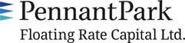
December 6, 2018

Dear Stockholder:

You are cordially invited to attend the 2019 Annual Meeting of Stockholders of PennantPark Floating Rate Capital Ltd. (“PFLT” or the “Company”) to be held on February 5, 2019 at 9:45 a.m., Eastern Time, at the offices of Dechert LLP, located at 1095 Avenue of the Americas, New York, New York.

The Notice of Annual Meeting of Stockholders and the Proxy Statement of the Company, which is accessible on the Internet or by request, provides an outline of the business to be conducted at the Annual Meeting of Stockholders. At the meeting, you will be asked to: (1) elect two directors of the Company and (2) ratify the selection of RSM US LLP to serve as the Company’s independent registered public accounting firm for the fiscal year ending September 30, 2019. I will also report on the progress of the Company during the past year and respond to stockholders’ questions.

It is important that your shares be represented at the Annual Meeting of Stockholders. If you are unable to attend the meeting in person, I urge stockholders to follow the instructions on the Notice of Internet Availability of Proxy Materials to vote your proxy on the Internet. We encourage you to vote via the Internet, as it saves us significant time and processing costs. However, on the Notice of Internet Availability of Proxy Materials you also will find instructions on how to request a hard copy of the Proxy Statement and proxy card free of charge and you may vote your proxy by returning your proxy card to us after you request the hard copy materials. If you hold your shares through a TASE member, please follow the voting instructions in the Proxy Statement, which are otherwise different to that of other stockholders.

Your vote and participation in the governance of the Company is very important to us.

Sincerely yours,

Arthur H. Penn

Chief Executive Officer

PennantPark Floating Rate Capital Ltd.
590 Madison Avenue, 15th Floor
New York, New York 10022

212-905-1000

PENNANTPARK FLOATING RATE CAPITAL LTD.

NOTICE OF ANNUAL MEETING OF STOCKHOLDERS

TO BE HELD ON FEBRUARY 5, 2019

December 6, 2018

Notice is hereby given to the owners of shares of common stock (the “Stockholders”) of PennantPark Floating Rate Capital Ltd. (“PFLT” or the “Company”) that:

The 2019 Annual Meeting of Stockholders of the Company (the “Annual Meeting”) will be held at the offices of Dechert LLP, located at 1095

Avenue of the Americas, New York, New York, on February 5, 2019 at 9:45 a.m., Eastern Time, for the following purposes:

- To elect two directors to the Board of Directors of the Company, who will each serve until the 2022 annual meeting of stockholders and until his successor is duly elected and qualifies; and

- To ratify the selection of RSM US LLP to serve as the Company’s independent registered public accounting firm for the fiscal year ending September 30, 2019.

You have the right to receive notice of, and to vote at, the Annual Meeting if you were a stockholder of record of the Company at the close of business on November 19, 2018. The Company is furnishing a Proxy Statement and proxy card to the Stockholders on the Internet, rather than mailing printed copies of those materials to each Stockholder. If you received a Notice of Internet Availability of Proxy Materials by mail, you will not receive a printed copy of the Proxy Statement and proxy card unless you request them. Instead, the Notice of Internet Availability of Proxy Materials will instruct you as to how you may access and review the Proxy Statement, and vote your proxy, on the Internet.

Your vote is extremely important to us. If you are unable to attend the Annual Meeting, we encourage you to vote your proxy on the Internet by following the instructions provided on the Notice of Internet Availability of Proxy Materials. You may also request from us free of charge hard copies of the Proxy Statement and proxy card for the Company by following the instructions on the Notice of Internet Availability of Proxy Materials. In the event there are not sufficient votes for a quorum or to approve the Company’s proposals at the time of the Annual Meeting, the Annual Meeting may be adjourned in order to permit further solicitation of proxies by the Company.

THE COMPANY’S BOARD OF DIRECTORS, INCLUDING THE INDEPENDENT DIRECTORS, UNANIMOUSLY RECOMMENDS THAT YOU VOTE “FOR” EACH OF THE PROPOSALS.

By Order of the Board of Directors,

Thomas J. Friedmann

Secretary

PennantPark Floating Rate Capital Ltd.
590 Madison Avenue, 15th Floor
New York, New York 10022

212-905-1000

This is an important meeting. To ensure proper representation at the meeting, please follow the instructions on the Notice of Internet Availability of Proxy Materials to vote your proxy via the Internet or request, complete, sign, date and return a proxy card. Even if you vote your shares prior to the meeting, you still may attend the meeting and vote your shares in person should you wish to change your vote.

PENNANTPARK FLOATING RATE CAPITAL LTD.

590 Madison Avenue, 15th Floor

New York, New York 10022

- 905-1000

PROXY STATEMENT

for

2019 Annual Meeting of Stockholders

To be held on February 5, 2019

This document will give you the information you need to vote on the matters listed on the accompanying Notice of Annual Meeting of Stockholders (“Notice of Annual Meeting”). Much of the information in this Proxy Statement is required under the rules and regulations of the Securities and Exchange Commission (the “SEC”), and some of it is technical in nature. If there is anything you do not understand, please contact us at 212-905-1000.

This Proxy Statement is furnished in connection with the solicitation of proxies by the Board of Directors (the “Board”) of PennantPark Floating Rate Capital Ltd. (“PFLT”, the “Company,” “we,” “us” or “our”) for use at the Company’s 2019 Annual Meeting of Stockholders (the “Meeting”) to be held on Tuesday, February 5, 2019 at 9:45 a.m., Eastern Time, at the offices of Dechert LLP, located at 1095 Avenue of the Americas, New York, New York, and at any postponements or adjournments thereof. This Proxy Statement and the Company’s Annual Report for the fiscal year ended September 30, 2018 are being provided to the stockholders thereof (the “Stockholders”) via the Internet on or about December 10, 2018. In addition, a Notice of Annual Meeting and a Notice of Internet Availability of Proxy Materials are being sent to Stockholders of record of the Company as of November 19, 2018 (the “Record Date”).

We encourage you to vote your shares, either by voting in person at the Meeting or by voting by proxy (i.e., authorizing someone to vote your shares). Shares represented by duly executed proxies will be voted in accordance with your instructions. If you execute a proxy without specifying your voting instructions, your shares will be voted in accordance with the recommendation of the Board. If any other business is brought before the Meeting, your shares will be voted at the proxy’s discretion unless you specifically state otherwise on your proxy.

You may revoke a proxy at any time before it is exercised by notifying the Company’s Secretary in writing, by submitting a properly executed, later-dated proxy or by voting in person at the Meeting. Any Stockholder entitled to vote at the Meeting may attend the Meeting and vote in person, whether or not he or she has previously voted his or her shares via proxy or wishes to change a previous vote.

You will be eligible to vote your shares electronically via the Internet, by telephone or by mail.

Purpose of Meeting

At the Meeting, you will be asked to vote on the following proposals:

- To elect two directors to the Board, who will each serve until the 2022 annual meeting of stockholders and until his successor is duly elected and qualifies (“Proposal 1”); and

- To ratify the selection of RSM US LLP to serve as the Company’s independent registered public accounting firm for the fiscal year ending September 30, 2019 (“Proposal 2”).

Voting Securities

You may vote your shares at the Meeting only if you were a Stockholder of record of the Company at the close of business on November 19, 2018. There were 38,772,074 shares of the Company’s common stock (the “Common Stock”) outstanding on the Record Date. Stockholders are entitled to one vote for each share of Common Stock held.

1

Quorum Required

For the Company to conduct business at the Meeting, a quorum of Stockholders for the Company must be present at the Meeting. The presence at the Meeting, in person or by proxy, of the holders of a majority of the shares of Common Stock of the Company outstanding on the Record Date will constitute a quorum of the Company. Abstentions and Broker Non-Votes (as defined below) will be treated as shares present at the Meeting for quorum purposes. If there are not enough votes for a quorum of the Company, the chairman of the Meeting will adjourn the Meeting to permit the further solicitation of proxies.

Votes Required

Election of Directors

The election of a director to the Board requires the affirmative vote of a majority of the votes cast for and affirmatively withheld at the Meeting in person or by proxy. If you vote “Withhold Authority” with respect to a nominee, your shares will not be voted with respect to the person indicated. Votes to withhold authority with respect to a nominee will be included in determining the number of votes cast and, as a result, will have the effect of a vote against the nominee. Abstentions and Broker Non-Votes will have no effect on the result of the vote.

Stockholders of the Company may not cumulate their votes.

Ratification of Independent Registered Public Accounting Firm

The affirmative vote of a majority of the votes cast at the Meeting in person or by proxy is required to ratify the appointment of RSM US LLP to serve as the Company’s independent registered public accounting firm. Abstentions will not be included in determining the number of votes cast and, as a result, will have no effect on this proposal.

Broker Non-Votes

“Broker Non-Votes” are votes that are not cast by a broker, bank or other nominee (the “Broker”) on a non-routine matter because the shares entitled to cast the vote are held in “street name”, the Broker lacks discretionary authority to vote the shares and the Broker has not received voting instructions from the beneficial owner. Proposal 1 is a non-routine matter. As a result, if you hold shares of the Company’s Common Stock in street name, your Broker will not be permitted to exercise voting discretion with respect to Proposal 1.

Accordingly, if you are a Stockholder and you do not vote or give your Broker specific instructions on how to vote for you, your shares will have no effect on the result of Proposal 1.

Proposal 2 is a routine matter. As a result, if you beneficially own shares of Common Stock of the Company and you do not vote or provide your Broker with proxy instructions, your Broker will be able to vote your shares for you on Proposal 2.

Adjournment and Additional Solicitation

If there appears not to be enough votes to approve a proposal at the Meeting, the chairman of the Meeting may adjourn the Meeting to permit further solicitation of proxies.

A Stockholder vote may be taken on any of the proposals in this Proxy Statement prior to any such adjournment if there are sufficient votes for approval of such proposal.

2

Information Regarding This Solicitation

We will bear the expense of the solicitation of proxies for the Meeting, including the portion of the cost of preparing and posting this Proxy Statement and the Annual Report to the Internet and the cost of mailing the Notice of Annual Meeting, the Notice of Internet Availability of Proxy Materials and any requested proxy materials to the Stockholders. We intend to use the services of Broadridge Financial Solutions, Inc., a leading provider of investor communications solutions, to aid in the distribution and collection of proxy votes. We expect to pay market rates for such services. If brokers, trustees or fiduciaries and other institutions holding shares in their own names or in the names of their nominee, which shares are beneficially owned by others, forward the Proxy Statement and proxy card to, and obtain proxies from, such beneficial owners, we will reimburse such persons for their reasonable expenses in so doing.

We combine any mailings for multiple accounts going to a single household, which is commonly referred to as “householding,” by delivering to that address a Notice of Internet Availability of Proxy Materials or other communications for all accounts who have consented or are deemed to have consented to receiving such communications in such manner in accordance with the rules promulgated by the SEC. If you have received notice from your Broker that it will be "householding" communications to your address, "householding" will continue until you are notified otherwise or until you revoke your consent. We will promptly deliver a separate copy of these documents to you upon written or oral request to our Investor Relations Department at 590 Madison Avenue, 15th Floor, New York, New York 10022 or 212-905-1000. If, at any time, you no longer wish to participate in "householding" and would prefer to receive a separate Notice of Internet Availability of Proxy Materials or other communications, please notify your Broker. Stockholders who currently receive multiple copies of the Notice of Internet Availability of Proxy Materials or other communications at their addresses and would like to request "householding" of their communications should contact their Brokers.

In addition to the solicitation of proxies by the use of the Internet, proxies may be solicited in person and/or by telephone, mail or facsimile

transmission by directors or officers of the Company, officers or employees of PennantPark Investment Advisers, LLC, our investment adviser (the

“Adviser”), PennantPark Investment Administration, LLC, our administrator (the “Administrator”), and/or by a retained solicitor. No additional compensation

will be paid to such directors, officers or regular employees for such services. If we retain a solicitor, we have estimated that we will pay approximately

$60,000 for such services. If we engage a solicitor, you could be contacted by telephone on behalf of the Company and be urged to vote. The solicitor will not

attempt to influence how you vote your shares, but will only ask that you take the time to cast a vote. You may also be asked if you would like to vote over

the telephone and to have your vote transmitted to our proxy tabulation firm. The address of each of the Adviser and the Administrator is 590 Madison

Avenue, 15th Floor, New York, New York 10022.

Stockholders, other than those who hold shares through a Tel Aviv Stock Exchange (“TASE”) member, may provide their voting instructions through the Internet, by telephone or by mail by following the instructions on the Notice of Internet Availability of Proxy Materials. These options require Stockholders to input the Control Number, which is provided with the Notice of Internet Availability of Proxy Materials. If you vote using the Internet, after visiting www.proxyvote.com and inputting your Control Number, you will be prompted to provide your voting instructions. Stockholders will have an opportunity to review their voting instructions and make any necessary changes before submitting them and terminating their Internet link. Stockholders who vote via the Internet, in addition to confirming their voting instructions prior to submission, will receive upon request an e-mail confirming their instructions.

If your shares of Common Stock are held by a TASE member, please complete, sign and date the form of proxy card that we filed via MAGNA and attach to it an ownership certificate from the TASE member through which your shares are registered (i.e., your broker, bank or other nominee) indicating that you were the beneficial owner of the shares on November 19, 2018, the record date for voting, and return the proxy card along with the ownership certificate, to the Company’s Israeli counsel, Goldfarb Seligman & Co., c/o Daniel Kahn, 98 Yigal Alon Street, 36th Floor, Tel Aviv 6789141, Israel (email: daniel.kahn@goldfarb.com). The proxy card and ownership certificate must be received no later than January 31, 2019, to be included in the tally of shares voted.

3

If a Stockholder, other than those who hold shares through a TASE member, wishes to participate in the Meeting, but does not wish to give a proxy by Internet, the Stockholder may attend the Meeting in person or request and submit a proxy card by following the instructions on the Notice of Internet Availability of Proxy Materials.

If your shares of Common Stock are held by a TASE member, and you wish to participate in the Meeting, you need to bring an ownership certificate from the TASE member through which your shares are registered (i.e., your broker, bank or other nominee) indicating that you were the beneficial owner of the shares on November 19, 2018, the record date for voting.

Any proxy authorized pursuant to this solicitation may be revoked by notice from the person giving the proxy at any time before it is exercised. A revocation may be effected by (i) resubmitting voting instructions via the Internet voting site, by telephone, by obtaining and properly completing another proxy card that is dated later than the original proxy and returning it, by mail, in time to be received before the Meeting, (ii) by attending the Meeting and voting in person or (iii) by a notice, provided in writing and signed by the Stockholder, delivered to the Company’s Secretary on any business day before the date of the Meeting.

4

Security Ownership of Certain Beneficial Owners and Management

As of the Record Date, to our knowledge, no person would be deemed to “control” (as such term is defined in the Investment Company Act of 1940, as amended (the “1940 Act”)) the Company.

Our directors consist of an interested director and four independent directors. An interested director is an “interested person” of the Company, as defined in the 1940 Act, and independent directors are all other directors (the “Independent Directors”).

The following table sets forth, as of December 3, 2018, certain ownership information with respect to the Company’s Common Stock for those persons who directly or indirectly own, control or hold with the power to vote, five percent or more of the Company’s outstanding Common Stock and all officers and directors of the Company, as a group.

 |  |  |  |  | Shares |  |  | Percentage of
Name and address(1) |  |  | Type of ownership(3) |  |  |  |  | Common Stock
 |  |  |  |  | Owned |  |  | Outstanding
Independent directors
Adam K. Bernstein |  |  | Record/Beneficial |  | 5,000 |  |  | *
Marshall Brozost |  |  | Record/Beneficial |  | — |  |  | *
Jeffrey Flug |  |  | Record/Beneficial |  | 15,500 |  |  | *
Samuel L. Katz |  |  | Record/Beneficial |  | 147,100 |  |  | *
Interested director
Arthur H. Penn(2) |  |  | Record/Beneficial |  | 184,709 |  |  | *
Executive officer
Aviv Efrat |  |  | Record/Beneficial |  | 28,750 |  |  | *
All directors and executive officer as a group (6 persons) |  |  |  |  | 381,059 |  |  | 1%

- The address for each officer and director is c/o PennantPark, 590 Madison Avenue, 15th Floor, New York, New York 10022.

- Mr. Penn is the Managing Member of the Adviser and may therefore be deemed to own beneficially the 184,709 shares held by the Adviser.

- Sole voting power.
- Less than 1 percent.

5

Section 16(a) Beneficial Ownership Reporting Compliance

Pursuant to Section 16(a) of the Securities Exchange Act of 1934, as amended (the “Exchange Act”), the Company’s directors and other executive officer and any persons holding more than 10% of the Company’s Common Stock are required to report their beneficial ownership and any changes therein to the SEC and the Company. Specific due dates for those reports have been established, and the Company is required to report herein any failure to file such reports by those due dates. Based on the Company’s review of Forms 3, 4 and 5 filed by such persons and information provided by the Company’s directors and other executive officer, the Company believes that, during the fiscal year ended September 30, 2018, all Section 16(a) filing requirements applicable to such persons were met in a timely manner.

Dollar Range of Securities Beneficially Owned by Directors

The following table sets forth the dollar range of (i) the Company’s Common Stock and (ii) the common stock of the Fund Complex beneficially owned by each of our directors as of December 3, 2018. Information as to beneficial ownership is based on information furnished to the Company by such persons. For purposes of this proxy statement, the term “Fund Complex” is defined to include the Company and PennantPark Investment Corporation (“PNNT”).

Directors of the Company |  |  | Dollar Range of the Common Stock of the |  | Aggregate Dollar Range of the Common Stock of
 |  |  | Company(1) |  | the Fund Complex(1)
Independent directors
 | Adam K. Bernstein |  | $50,001 - $100,000 |  | $100,001 - $500,000
 | Marshall Brozost |  | None |  | $100,001 - $500,000
 | Jeffrey Flug |  | $100,001 - $500,000 |  | Over $1,000,000
 | Samuel L. Katz |  | Over $1,000,000 |  | Over $1,000,000
 | Interested director
 | Arthur H. Penn(2) |  | Over $1,000,000 |  | Over $1,000,000

- Dollar ranges are as follows: None; $1-$10,000; $10,001-$50,000; $50,001-$100,000; $100,001-$500,000; $500,001-$1,000,000 or over $1,000,000.

- Also reflects holdings of the Adviser.

6

PROPOSAL 1: ELECTION OF DIRECTORS

In accordance with its bylaws, the Company currently has five members on the Board. Directors are divided into three classes and are elected for staggered terms of three years each, with a term of office of one of the three classes of directors expiring each year. After this election, the terms of Class I, II and III directors will expire in 2021, 2022 and 2020, respectively. Each director will hold office for the term to which he is elected and until a successor is duly elected and qualifies.

A Stockholder can vote for, or withhold his or her vote from, any nominee named below. In the absence of instructions to the contrary, it is the intention of the person named as proxy to vote such proxy FOR the election of each nominee named below. If a nominee should decline or be unable to serve as a director, it is intended that the proxy will be voted for the election of such person as is nominated by the Board as a replacement. The Board has no reason to believe that its nominees will be unable or unwilling to serve.

THE BOARD, INCLUDING ITS INDEPENDENT DIRECTORS, UNANIMOUSLY RECOMMENDS THAT YOU VOTE FOR THE ELECTION OF THE NOMINEES NAMED IN THIS PROXY STATEMENT.

Information about the Nominees and Directors

Certain information with respect to the nominees for election at the Meeting, as well as each of the other directors, is set forth below, including their names, ages, a brief description of their recent business experience, including present occupations and employment, certain directorships that each person holds and the year in which each person became a director of the Company. The nominees currently serve as directors of the Company.

Each of Mr. Adam Bernstein and Mr. Jeffrey Flug has been nominated for election as a Class II director of the Company for a three-year term expiring in 2022. Neither Mr. Bernstein nor Mr. Flug is being proposed for election pursuant to any agreement or understanding between either Mr. Bernstein or Mr. Flug and the Company.

 |  |  |  | Company, |  |  |  |  |  | Other
 |  |  |  | Company, |  | Principal |  | Number of |  | Directorships
 |  |  |  | Term of Office |  |  |  |  |  | Held by Director
 |  | Position(s) held |  | and |  | Occupation(s) During, at |  | Companies in Fund |  | or Nominee for
Name, Address and Age(1) |  | Position(s) held |  | Length of Time |  | least, the |  | Complex Overseen |  | Director During
Name, Address and Age(1) |  | with Company |  | Served |  | Past 5 Years |  | by Director |  | the Past 5 Years(2)
Independent Directors
Adam K. Bernstein (55) | Director |  | PFLT - Class II |  | President of The Bernstein |  |  | Two |  | None
 | Nominee |  | Director since |  | Companies, a Washington, D.C.-
 |  |  | October 2010; |  | based real estate investment and
 |  |  | Term Expires, if |  | development firm, since 1995 and
 |  |  | elected, 2022 |  | President and Chief Executive
 |  |  |  |  | Officer of Consortium Atlantic
 |  |  |  |  | Realty Trust, Inc., a private real
 |  |  |  |  | estate investment trust operating in
 |  |  |  |  | the Mid-Atlantic region, from
 |  |  |  |  | 2006. Also, Mr. Bernstein has
 |  |  |  |  | served on the Board of Overseers
 |  |  |  |  | of the School of Arts and Sciences
 |  |  |  |  | at the University of Pennsylvania
 |  |  |  |  | since 2012.

7

 |  |  |  | Company, |  | Principal
 |  |  |  | Term of Office |  | Principal
 |  | Position(s) held |  | and |  | Occupation(s) During, at
Name, Address and Age(1) |  | Position(s) held |  | Length of Time |  | least, the
Name, Address and Age(1) |  | with Company |  | Served |  | Past 5 Years
Marshall Brozost (51) | Director |  | PFLT - Class I |  | Partner at Orrick, Herrington &
 |  |  | Director since |  | Sutcliffe LLP, where he practices
 |  |  | October 2010; |  | in the real estate and private
 |  |  | Term Expires, 2021 |  | equity groups, since July 2016.
 |  |  |  |  | Prior to Orrick, Herrington &
 |  |  |  |  | Sutcliffe LLP Mr. Brozost
 |  |  |  |  | practiced law at Schulte Roth &
 |  |  |  |  | Zabel from May 2012 to July
 |  |  |  |  | 2016 and at Dewey & LeBoeuf
 |  |  |  |  | LLP from 2005 to 2012.
Jeffrey Flug (56) | Director |  | PFLT - Class II |  | Mr. Flug was President of Union
 | Nominee |  | Director since |  | Square Hospitality Group, an
 |  |  | October 2010; |  | exclusive chain of restaurants,
 |  |  | Term Expires, if |  | from 2009 to June 2015. Mr. Flug
 |  |  | elected, 2022 |  | served as Chief Executive Officer
 |  |  |  |  | and Executive Director of
 |  |  |  |  | Millennium Promise Alliance,
 |  |  |  |  | Inc., a non-profit organization
 |  |  |  |  | whose mission is to eradicate
 |  |  |  |  | extreme global poverty, from 2006
 |  |  |  |  | to 2008. From 2000 to 2006, Mr.
 |  |  |  |  | Flug was a Managing Director and
 |  |  |  |  | Head of North American
 |  |  |  |  | Institutional Sales at JP Morgan’s
 |  |  |  |  | Investment Bank.
 |  |  |  |  | 8

 |  | Other
Number of |  | Directorships
 |  | Held by Director
Companies in Fund |  | or Nominee for
Complex Overseen |  | Director During
by Director |  | the Past 5 Years(2)
Two |  | None

Two Shake Shack Inc.,

since September

2014; Sears

Hometown and Outlet

Stores, Inc., from

October 2012 to

September 2015.

 |  |  |  | Company, |  | Principal
 |  |  |  | Term of Office |  | Principal
 |  | Position(s) held |  | and |  | Occupation(s) During, at
Name, Address and Age(1) |  | Position(s) held |  | Length of Time |  | least, the
Name, Address and Age(1) |  | with Company |  | Served |  | Past 5 Years
Samuel L. Katz (53) | Director |  | PFLT - Class I |  | Managing Partner of TZP Group
 |  |  | Director since |  | LLC, a private equity fund, since
 |  |  | October 2010; |  | 2007. Before joining TZP Group,
 |  |  | Term Expires 2021 |  | Mr. Katz was Chief Executive
 |  |  |  |  | Officer of MacAndrews & Forbes
 |  |  |  |  | Acquisition Holdings, Inc. from
 |  |  |  |  | 2006 to 2007. Prior to that
 |  |  |  |  | position, Mr. Katz was Chairman
 |  |  |  |  | and Chief Executive Officer of the
 |  |  |  |  | Cendant Travel Distribution
 |  |  |  |  | Services Division from 2001 to
 |  |  |  |  | 2005.
 |  |  |  |  | 9

 |  | Other
Number of |  | Directorships
 |  | Held by Director
Companies in Fund |  | or Nominee for
Complex Overseen |  | Director During
by Director |  | the Past 5 Years(2)
Two |  | None

 |  |  |  | Company, |  |  |  |  |  | Other
 |  |  |  | Company, |  | Principal |  | Number of |  | Directorships
 |  |  |  | Term of Office |  |  |  |  |  | Held by Director
 |  | Position(s) held |  | and |  | Occupation(s) During, at |  | Companies in Fund |  | or Nominee for
Name, Address and Age(1) |  | Position(s) held |  | Length of Time |  | least, the |  | Complex Overseen |  | Director During
Name, Address and Age(1) |  | with Company |  | Served |  | Past 5 Years |  | by Director |  | the Past 5 Years(2)
Interested Director
Arthur H. Penn (55)(3) | Director, |  | PFLT - Class III |  | Founder, Chairman and Chief |  |  | Two |  | None
 | Chief Executive |  | Director since |  | Executive Officer of the Company
 | Officer and |  | October 2010; |  | from its inception in 2010. Mr.
 | Chairman of the |  | Term Expires 2020 |  | Penn also is the Founder and
 | Board of |  |  |  | Managing Member of the Adviser.
 | Directors |  |  |  | Before founding PNNT, Mr. Penn
 |  |  |  |  | was the Co-Founder of Apollo
 |  |  |  |  | Investment Management, where
 |  |  |  |  | he was a Managing Partner from
 |  |  |  |  | 2004 to 2006. He also served as
 |  |  |  |  | Chief Operating Officer of Apollo
 |  |  |  |  | Investment Corporation from
 |  |  |  |  | inception in 2004 to 2006 and
 |  |  |  |  | served as President and Chief
 |  |  |  |  | Operating Officer in 2006. He
 |  |  |  |  | formerly was a Managing Partner
 |  |  |  |  | of Apollo Value Fund L.P.
 |  |  |  |  | (formerly Apollo Distressed
 |  |  |  |  | Investment Fund, L.P.) from 2003
 |  |  |  |  | to 2006.

- The address for each officer and director is c/o PennantPark, 590 Madison Avenue, 15th Floor, New York, New York 10022.

- No director otherwise serves as a director of an investment company subject to the 1940 Act.

- Mr. Penn is an interested director due to his position as an officer of the Company and of the Adviser.

Corporate Governance

The Company believes that maintaining the highest standards of corporate governance is a crucial part of its business, and is committed to having in place the necessary controls and procedures designed to ensure compliance with applicable laws, rules and regulations, as well as its own ethical standards of conduct.

10

Director Independence

NASDAQ corporate governance rules require listed companies to have a board of directors with at least a majority of independent directors. Under NASDAQ corporate governance rules, in order for a director to be deemed independent, the Board must determine that the individual does not have a relationship that would interfere with the director’s exercise of independent judgment in carrying out his responsibilities. On an annual basis, each director is required to complete an independence questionnaire designed to provide information to assist the Board in determining whether the director is independent under NASDAQ corporate governance rules, the 1940 Act and applicable corporate governance guidelines. The Board has determined that each of its directors, other than Mr. Penn, is independent under the applicable listing standards of the NASDAQ Global Select Market and the New York Stock Exchange and under the Exchange Act and the 1940 Act. The Company’s governance guidelines require any director who has previously been determined to be independent to inform the Chairman of the Board, the Chairman of the Nominating and Corporate Governance Committee and the Company’s Corporate Secretary of any change in circumstance that may cause his status as an Independent Director to change. The Board limits membership on its Audit Committee, its Nominating and Corporate Governance Committee and its Compensation Committee to Independent Directors.

Board’s Oversight Role in Management

The Board performs its risk oversight function primarily through (1) its three standing committees, described more fully below, which report to the entire Board and are comprised solely of Independent Directors and (2) monitoring by the Company’s Chief Compliance Officer (the “CCO”) in accordance with the Company’s compliance policies and procedures.

As described below in more detail under “Audit Committee”, “Nominating and Corporate Governance Committee”, and “Compensation Committee”, the Board’s Audit Committee, Nominating and Corporate Governance Committee and Compensation Committee assist the Board in fulfilling its risk oversight responsibilities. The Audit Committee’s risk oversight responsibilities include overseeing the Company’s accounting and financial reporting processes, including the annual audit of the Company’s financial statements, the Company’s systems of internal controls regarding finance and accounting, pre-approving the engagement of an independent registered public accounting firm to render audit and/or permissible non-audit services and evaluating the qualifications, performance and independence of the independent registered public accounting firm. The Nominating and Corporate Governance Committee’s risk oversight responsibilities include selecting, researching and nominating directors for election by the Company’s Stockholders, developing and recommending to the Board a set of corporate governance principles and overseeing the evaluation of the Board and the Company’s management. The Compensation Committee’s risk oversight responsibilities include determining, or recommending to the Board for determining, the compensation of the Company’s chief executive officer and all other executive officers, paid directly by the Company, if any, and assisting the Board with matters related to compensation, as directed by the Board. Each of the Audit Committee, Nominating and Corporate Governance Committee and Compensation Committee consists solely of Independent Directors.

The Board also performs its risk oversight responsibilities with the assistance of a CCO. The Company’s CCO prepares a written report annually discussing the adequacy and effectiveness of the compliance policies and procedures of the Company and certain of its service providers. The CCO’s report, which is reviewed by the Board, addresses, at a minimum: (1) the operation of the compliance policies and procedures of the Company and certain of its service providers since the last report; (2) any material changes to such policies and procedures since the last report; (3) any recommendations for material changes to such policies and procedures as a result of the CCO’s annual review; and (4) any compliance matter that has occurred since the date of the last report about which the Board would reasonably need to know to oversee the Company’s compliance activities and risks. In addition, the CCO meets separately in executive session with the Independent Directors at least once each year and presents quarterly reports to the Board.

The Company believes that the Board’s role in risk oversight is effective and appropriate given the extensive regulation to which it is already subject as a business development company. Specifically, as a business development company, the Company must comply with certain regulatory requirements that control the levels of

11

risk in its business and operations. For example, the ability of the Company to incur indebtedness is limited by the asset coverage ratio set forth in the 1940 Act (as modified by any exemptive relief granted by the SEC) and the Company generally must invest at least 70% of its total assets in “qualifying assets.” The Company also has elected to be treated as a regulated investment company (a “RIC”) under Subchapter M of the Internal Revenue Code of 1986, as amended. As a RIC, the Company must, among other things, meet certain income source and asset diversification requirements.

The Company believes that the extent of the Board’s and its committees’ roles in risk oversight complements the Board’s leadership structure. Because they are comprised solely of Independent Directors, the Audit Committee, the Nominating and Corporate Governance Committee and Compensation Committee are able to exercise their oversight responsibilities without any conflict of interest that might discourage critical questioning and review. Through regular executive session meetings with the Company’s independent registered public accounting firm, the CCO and the Chief Executive Officer, the Independent Directors have similarly established direct communication and oversight channels that the Board believes foster open communication and early detection of issues of concern.

The Company believes that the Board’s role in risk oversight must be evaluated on a case by case basis and that the current configuration and allocation of responsibilities among the Board and its committees with respect to the oversight of risk is appropriate. However, the Board and its committees continually re-examine the manner in which they administer their respective risk oversight functions, including through formal annual assessments of performance, to ensure that they meet the Company’s needs.

Board’s Composition and Leadership Structure

The 1940 Act requires that at least a majority of the Company’s directors not be “interested persons” (as defined in the 1940 Act) of the Company. Currently, four of the five directors on the Board are Independent Directors; however, the Chairman of the Board is an interested person of the Company. The Independent Directors believe that the combined position of Chief Executive Officer of the Company and Chairman of the Board of the Company results in greater efficiencies in managing the Company, by eliminating the need to transfer substantial information quickly and repeatedly between the Chief Executive Officer and the Chairman, and the ability to capitalize on the specialized knowledge acquired from the duties of the roles. The Board has not identified a lead Independent Director; however, the Board has determined that its leadership structure, in which 80% of the directors are Independent Directors and, as such, are not affiliated with the Adviser or the Administrator, is appropriate in light of the services that the Adviser and the Administrator provide to the Company and the potential conflicts of interest that could arise from these relationships.

Information about Each Director’s Experience, Qualifications, Attributes or Skills

The Board believes that the significance of each director’s experience, qualifications, attributes and/or skills is an individual matter (meaning that experience that is important for one director may not have the same value for another) and that these factors are best evaluated at the Board level, with no single director, or particular factor, being indicative of Board effectiveness. However, the Board believes that directors need to have the ability to review, evaluate, question and discuss critical information provided to them, and to interact effectively with management, service providers and counsel, in order to exercise effective business judgment in the performance of their duties. The Board believes that its members satisfy this standard. Experience relevant to having this ability may be achieved through a director’s educational background, business or professional training or practice (e.g., finance, accounting or law), public service or academic positions, experience from service as a board member (including the Board of the Company) or as an executive of investment companies, public companies or significant private or not-for-profit entities or other organizations and/or other life experiences. To assist them in evaluating matters under federal and state law, the Independent Directors have their own independent legal counsel, who participates in Board meetings and interacts with the Adviser and the Company’s counsel. Both the Independent Directors’ and the Company’s counsel have significant experience advising funds and fund board members. The Board and its committees have the ability to engage other experts as appropriate. The Board evaluates its performance on an annual basis.

12

Role of the Chairman and Chief Executive Officer

As Chairman of the Board and Chief Executive Officer of the Company, Mr. Penn assumes a leading role in strategic planning and supports major transaction initiatives of the Company. Mr. Penn also manages the day-to-day operations of the Company, with the support of the other investment professionals and officers. As Chief Executive Officer, Mr. Penn has general responsibility for the implementation of the policies of the Company, as determined by the Board, and for the management of the business and affairs of the Company.

Experience, Qualifications, Attributes and/or Skills that Led to the Board’s Conclusion that such Members Should Serve as Directors of the Company

The Board believes that, collectively, the directors have balanced and diverse experience, qualifications, attributes and skills, which allow the Board to operate effectively in governing the Company and protecting the interests of its Stockholders. Below is additional information about each director (supplementing the information provided in the table above) that describes some of the specific experiences, qualifications, attributes and/or skills that each director possesses, and which the Board believes has prepared each director to be an effective director.

Arthur H. Penn

The Board benefits from Mr. Penn’s business leadership and experience and knowledge of senior lending, mezzanine lending, leveraged finance, distressed debt and private equity businesses, as well as diverse management practices. Mr. Penn is the Founder, Chairman and Chief Executive Officer of the Company and Managing Member of the Adviser and the Administrator. Mr. Penn co-founded Apollo Investment Management in 2004, where he was a Managing Partner from 2004 to 2006. He also served as Chief Operating Officer of Apollo Investment Corporation from its inception in 2004 to 2006, and served as President and Chief Operating Officer of that company in 2006. Mr. Penn was a Managing Partner of Apollo Value Fund L.P. (formerly Apollo Distressed Investment Fund, L.P.) from 2003 through 2006. From 2002 to 2003, prior to joining Apollo, Mr. Penn was a Managing Director of CDC-IXIS Capital Markets. Mr. Penn served as Global Head of Leveraged Finance at UBS Warburg LLC (now UBS Investment Bank) from 1999 through 2001. Prior to joining UBS Warburg, Mr. Penn was Global Head of Fixed Income Capital Markets for BT Securities and BT Alex Brown Incorporated from 1994 to

1999. In these capacities, Mr. Penn oversaw groups responsible for more than 200 high-yield and leveraged bank financings aggregating over $34 billion in capital raised. From 1992 to 1994, Mr. Penn served as Head of High Yield Capital Markets at Lehman Brothers. Mr. Penn’s longstanding service as Chairman and Chief Executive Officer of the Company and Managing Member of the Adviser and the Administrator provide him with a specific and valuable understanding of the Company, its operations and the business and regulatory issues facing it.

Adam K. Bernstein

Mr. Bernstein brings to the Board over 30 years of experience at a real estate development, investment and management business in the Mid-Atlantic region of the United States. Mr. Bernstein affords the Board his vast experience in the area of strategic and financial planning and capital and risk management. Mr. Bernstein is currently President of The Bernstein Companies, a Washington, D.C.-based real estate investment and development firm which he joined in 1986. Mr. Bernstein runs a diversified company that includes a Hotel division, a Private Real Estate Investment Trust, and a structured financed group that focuses on tax credit syndication and project lending for community development projects nationwide. In 2012, Mr. Bernstein was appointed to the Board of Overseers of the School of Arts and Sciences at the University of Pennsylvania.

Marshall Brozost

Mr. Brozost brings to the Board 23 years of experience in the areas of finance, private equity, mergers and acquisitions and restructurings. Since July 2016, Mr. Brozost has been a Partner at Orrick, Herrington & Sutcliffe LLP, where he practices in the real estate and private equity groups. Prior to Orrick, Herrington & Sutcliffe LLP, Mr. Brozost practiced law at Schulte Roth & Zabel, LLP from May 2012 to July 2016, at Dewey & LeBoeuf LLP from 2005 to 2012, at Solomon & Weinberg LLP from 2004 to 2005 and at O’Melveny & Myers LLP from 2001 to 2004. Mr. Brozost also served as a Vice President of Nomura Asset Capital Corporation from 1997 through 2000.

13

Jeffrey Flug

Mr. Flug brings to the Board expertise in fixed income, investment banking, accounting and business operations. From 2009 to June 2015, Mr. Flug held a variety of senior positions, including, most recently, President, with Union Square Hospitality Group, an exclusive chain of restaurants. Since September 2014, Mr. Flug has served as a director of Shake Shack, Inc. From October 2012 to September 2015, Mr. Flug was a director of Sears Hometown and Outlet Stores, Inc. Mr. Flug was Chief Executive Officer and Executive Director of Millennium Promise Alliance, Inc. from 2006 to 2008. Millennium Promise is a non-profit organization whose mission is to eradicate extreme global poverty. Mr. Flug was Managing Director and Head of North American Institutional Sales at JP Morgan’s Investment Bank from 2000 to 2006. From 1988 to 2000, Mr. Flug was Managing Director for Goldman Sachs & Co. in its Fixed Income Division.

Samuel L Katz

Mr. Katz brings to the Board a diverse knowledge of business and finance as a result of his career over the past 30 years. Mr. Katz is the Managing Partner of TZP Group LLC, a private equity fund he formed in 2007. Prior to joining TZP Group, Mr. Katz was Chief Executive Officer of MacAndrews & Forbes Acquisition Holdings, Inc. from 2006 through 2007. From 1996 through 2005, Mr. Katz held a variety of senior positions at Cendant Corporation, including, most recently, Chairman and Chief Executive Officer of the Cendant Travel Distribution Services Division from 2001 to 2005. From 1992 to 1995, Mr. Katz invested in private and public equity as Co-Chairman of Saber Capital, Inc. and Vice President of Dickstein Partners Inc. From 1988 to 1992, Mr. Katz was an Associate and Vice President at The Blackstone Group, where he worked on numerous private equity transactions, including the initial leveraged buyouts of several hotel franchise brands which created the predecessor to Cendant Corporation. From 1986 to 1988, Mr. Katz was a Financial Analyst at Drexel Burnham Lambert.

Committees of the Board

The Board has established an Audit Committee, a Nominating and Corporate Governance Committee and a Compensation Committee. For the fiscal year ended September 30, 2018, the Board held seven board meetings, four Audit Committee meetings, one Nominating and Corporate Governance Committee meeting and one Compensation Committee meeting. All directors attended at least 75% of the aggregate number of meetings of the Board and of the respective committees on which they served. The Company requires each director to make a diligent effort to attend all Board and committee meetings, and encourages directors to attend the Company’s annual stockholders’ meetings. Last year, all members of the Board attended the annual stockholders’ meeting.

Audit Committee

The members of the Audit Committee of the Company are Messrs. Bernstein, Brozost, Flug and Katz, each of whom is independent for purposes of the 1940 Act and the NASDAQ corporate governance rules. Messrs. Flug and Katz serve as Co-Chairmen of the Audit Committee. The Audit Committee operates pursuant to an Audit Committee Charter approved by the Board. The charter sets forth the responsibilities of the Audit Committee, which include: selecting or retaining each year an independent registered public accounting firm (the “auditors”) to audit the accounts and records of the Company; reviewing and discussing with management and the auditors the annual audited financial statements of the Company, including disclosures made in management’s discussion and analysis of financial condition and results of operations, and recommending to the Board whether the audited financial statements should be included in the Company’s annual report on Form 10-K; reviewing and discussing with management and the auditors the Company’s quarterly financial statements prior to the filings of its quarterly report on Form 10-Q; pre-approving the auditors’ engagement to render audit and/or permissible non-audit services; reviewing and approving all related party transactions; and evaluating the qualifications, performance and independence of the auditors. The Audit Committee is also responsible for aiding the Board in fair valuing the Company’s portfolio securities that are not publicly traded or for which current market values are not readily available. Such investments are valued at fair value as determined in good faith by or under the direction of the Board using a documented valuation policy and a consistently applied valuation process. The Board and Audit Committee use the services of nationally recognized independent valuation firms to help them determine the fair value of certain securities held by the Company. The Board has determined that each of Messrs. Flug and Katz is an “audit committee financial expert” as that term is defined under Item 407 of Regulation S-K under the Exchange Act. The Audit Committee Charter is available on the Company’s website (http://www.pennantpark.com).

14

Nominating and Corporate Governance Committee

The members of the Nominating and Corporate Governance Committee of the Company are Messrs. Bernstein, Brozost, Flug and Katz, each of whom is independent for purposes of the 1940 Act and the NASDAQ corporate governance rules. Messrs. Bernstein and Brozost serve as Co-Chairmen of the Nominating and Corporate Governance Committee. The Nominating and Corporate Governance Committee is responsible for selecting, researching and nominating directors for election by the Company’s Stockholders, selecting nominees to fill vacancies on the Board or a committee of the Board, developing and recommending to the Board a set of corporate governance principles and overseeing the evaluation of the Board and the Company’s management. The Nominating and Corporate Governance Committee of the Company has adopted a written Nominating and Corporate Governance Committee Charter that is available on the Company’s website (http://www.pennantpark.com).

The Nominating and Corporate Governance Committee will consider Stockholder recommendations for possible nominees for election as directors when such recommendations are submitted in accordance with the Company’s bylaws, the Nominating and Corporate Governance Committee Charter and any applicable law, rule or regulation regarding director nominations. Nominations should be sent to Thomas J. Friedmann, Secretary, c/o PennantPark, 590 Madison Avenue, 15th Floor, New York, New York 10022. When submitting a nomination to the Company for consideration, a Stockholder must provide all information that would be required under applicable SEC rules to be disclosed in connection with the election of a director, including the following minimum information for each director nominee: full name, age and address; principal occupation during the past five years; directorships on publicly held companies and investment companies during the past five years; number of shares of the Company’s Common Stock owned, if any; and a written consent of the individual to stand for election if nominated by the Board and to serve if elected by the Stockholders.

Criteria considered by the Nominating and Corporate Governance Committee in evaluating the qualifications of individuals for election as a director of the Board include: compliance with the independence and other applicable requirements of the NASDAQ corporate governance rules and the 1940 Act, and all other applicable laws, rules, regulations and listing standards; the criteria, policies and principles set forth in the Company’s Nominating and Corporate Governance Committee Charter; and the ability to contribute to the effective management of the Company, taking into account the needs of the Company and such factors as the individual’s experience, perspective, skills and knowledge of the industry in which the Company operates. The Nominating and Corporate Governance Committee has not adopted a formal policy with regard to the consideration of diversity in identifying individuals for election as members of the Board, but the Nominating and Corporate Governance Committee will consider such factors as they may deem are in the best interests of the Company and its Stockholders. Those factors may include a person’s differences of viewpoint, professional experience, education and skills, as well as his or her race, gender and national origin. In addition, as part of the Board’s annual self-assessment, the members of the Nominating and Corporate Governance Committee evaluate the membership of the Board and whether the Board maintains satisfactory policies regarding membership selection.

Compensation Committee

The Compensation Committee is responsible for determining, or recommending to the Board for determining, the compensation of the Company’s chief executive officer and all other executive officers, paid directly by the Company, if any. The Compensation Committee also assists the Board with all matters related to compensation, as directed by the Board. The current members of the Compensation Committee are Messrs. Bernstein, Brozost, Flug and Katz, each of whom is independent for purposes of the 1940 Act and the NASDAQ corporate governance rules. As discussed below, none of our executive officers are directly compensated by the Company and, as a result, the Compensation Committee does not produce and/or review and report on executive compensation practices. The Compensation Committee Charter is available on the Company’s website (http://www.pennantpark.com).

15

Communication with the Board of Directors

Stockholders with questions about the Company are encouraged to contact our Investor Relations Department at 590 Madison Avenue, 15th Floor, New York, New York 10022 or by visiting the investor relations web page on our website (http://www.pennantpark.com). However, if Stockholders believe that their questions have not been addressed, they may communicate with the relevant Board by sending their communications to Thomas J. Friedmann, Secretary, c/o PennantPark, 590 Madison Avenue, 15th Floor, New York, New York 10022. All Stockholder communications received in this manner will be delivered to one or more members of the Board.

Information about the Executive Officer Who is Not a Director

The following information pertains to our executive officer who is not a director of the Company.

Name, Address and Age(1) |  |  | Position(s) held |  | Principal Occupation(s) During, at least, the Past 5 Years
 |  |  | with the Company |  | Principal Occupation(s) During, at least, the Past 5 Years
 | Aviv Efrat (54) |  | Chief Financial Officer and |  | Chief Financial Officer and Treasurer of PNNT and the Company from their inception in
 |  |  | Treasurer |  | 2007 and 2010, respectively. Managing Director of the Administrator from inception in 2007.
 |  |  |  |  | Mr. Efrat was a Director at BlackRock, Inc., where he was responsible for a variety of
 |  |  |  |  | administrative, operational, and financial aspects of closed-end and open-end registered
 |  |  |  |  | investment companies from 1997 to 2007. From 1994 to 1997, Mr. Efrat was in the
 |  |  |  |  | Investment Companies Business Unit at Deloitte & Touche LLP. He is a member of the
 |  |  |  |  | American Institute of Certified Public Accountants and the New York State Society of
 |  |  |  |  | Certified Public Accountants.

- The business address of the executive officer is c/o PennantPark, 590 Madison Avenue, 15th Floor, New York, New York 10022.

Information about Chief Compliance Officer

The following information pertains to our CCO who is not a director of the Company.

Name, Address and Age(1) |  |  | Position held |  | Principal Occupation(s) During the Past 5 Years
 |  |  | with the Company |  | Principal Occupation(s) During the Past 5 Years
 | Guy F. Talarico (63) |  | Chief Compliance Officer |  | Chief Compliance Officer of PNNT and the Company from May 2008 and March 2011,
 |  |  |  | respectively. Mr. Talarico has held the position of Chief Compliance Officer for a number of
 |  |  |  | investment advisers, private funds and investment companies from 2004 when he founded
 |  |  |  | Alaric Compliance Services, LLC, of which he is chief executive officer.

- The business address of the CCO is c/o PennantPark, 590 Madison Avenue, 15th Floor, New York, New York 10022.

Code of Conduct and Code of Ethics

We expect each of our officers and directors, as well as any person affiliated with our operations, to act in accordance with the highest standards of personal and professional integrity at all times, and to comply with the Company’s policies and procedures and all laws, rules and regulations of any applicable international, federal, provincial, state or local government. To this effect, the Company has adopted a Joint Code of Conduct, which is posted on the Company’s website (http://www.pennantpark.com). The Joint Code of Conduct applies to the directors, officers and staff of the Company.

16

As required by the 1940 Act, the Company, together with PNNT, maintains a Joint Code of Ethics with the Adviser that establishes procedures that apply to the Company’s directors, officers, staff and the employees of the Adviser with respect to their personal investments and investment transactions. The Joint Code of Ethics generally does not permit investments by the Company’s directors, officers or any other covered person in securities that may be purchased or held by the Company. The Company filed the Joint Code of Ethics as Exhibit 14.1 to its Annual Report on Form 10-K, filed with the SEC on November 14, 2018. You may access the Joint Code of Ethics via the Internet site of the SEC (http://www.sec.gov) or our website (http://www.pennantpark.com). The Company intends to disclose any material amendments to or waivers of required provisions of its Joint Code of Conduct or its Joint Code of Ethics on Form 8-K.

Compensation of Independent Directors

Each Independent Director receives an annual payment of $70,000 for services performed on behalf of the Company as a director. The Independent Directors also receive $2,500 plus reimbursement of reasonable out-of-pocket expenses incurred in connection with attending each Board meeting and receive $500 plus reimbursement of reasonable out-of-pocket expenses incurred in connection with attending each committee meeting (unless combined with a Board meeting). In addition, each Co-Chairman of the Audit Committee receives an annual fee of $3,750 and each Co-Chairman of any other committee receives an annual fee of $1,250 for his additional services in these capacities. Also, the Company has purchased directors’ and officers’ liability insurance on behalf of its directors and officers and indemnifies such persons against certain losses. Independent Directors have the option to receive their directors’ fees paid in shares of the Company’s Common Stock issued at a price per share equal to the greater of net asset value or the market price at the time of payment. No compensation is expected to be paid to directors who are “interested persons” (as defined in the 1940 Act).

Compensation of Directors and Executive Officer

The following table shows information regarding the compensation paid by (i) the Company and (ii) all of the companies in the Fund Complex, including the Company, in the aggregate, to our directors for the fiscal year ended September 30, 2018. No compensation is paid directly by the Company to any interested director or executive officer of the Company.

 |  |  |  |  |  |  |  | Aggregate |  | Pension or |  |  |  |  |  | Total paid to
 |  |  |  |  |  |  |  |  |  | retirement |  |  | Total paid to
 |  |  |  |  |  |  |  | compensation |  | benefits accrued |  |  | Total paid to |  |  | director/officer
Name |  |  |  |  |  |  |  | from the |  | as part of our |  |  | director/officer |  |  | from the Fund
 |  |  |  |  |  |  |  | Company |  | expense(1) |  |  | from the Company |  |  | Complex
Independent directors
 | Adam K. Bernstein |  |  |  |  | $ |  | 83,750 |  | None | $ |  | 83,750 | $ |  | 206,250
 | Marshall Brozost |  |  |  |  | $ |  | 83,750 |  | None | $ |  | 83,750 | $ |  | 206,250
 | Jeffrey Flug |  |  |  |  | $ |  | 86,250 |  | None | $ |  | 86,250 | $ |  | 218,750
 | Samuel L. Katz |  |  |  |  | $ |  | 86,250 |  | None | $ |  | 86,250 | $ |  | 218,750
 | Interested director
 | Arthur H. Penn |  |  |  |  |  |  | None |  | None |  |  | None |  |  | None
 | Executive officer
 | Aviv Efrat(2) |  |  |  |  |  |  | None |  | None |  |  | None |  |  | None

- We do not have a profit sharing or retirement plan, and directors do not receive any pension or retirement benefits from us.

- Mr. Efrat also is an employee of the Administrator.

17

Certain Relationships and Related Party Transactions

The Company’s investment activities are managed by the Adviser and supervised by the Board, of which 80% of the members are Independent Directors. The Company’s Investment Management Agreement with the Adviser was re-approved by the Board, including a majority of the Independent Directors, in February 2018. Under the Company’s Investment Management Agreement, the Adviser, subject to the overall supervision of the Board, manages the day-to-day operations of and provides investment advisory services to the Company. For providing these services, the Adviser receives a fee from the Company, consisting of two components: a base management fee and an incentive fee. For the fiscal year ended September 30, 2018, the Adviser earned a base management fee of $8.4 million and an incentive fee of $3.5 million (before $(0.1) million on realized gains and $(1.0) million on net unrealized gains accrued but not payable) from the Company.

The Company’s Administration Agreement with the Administrator was re-approved by the Board, including a majority of the Independent Directors, in February 2018. Under the Company’s Administration Agreement, the Company has agreed to reimburse the Administrator for its allocable portion of overhead and other expenses incurred by the Administrator in performing its obligations under the Administration Agreement, including rent and the Company’s allocable portion of the costs of compensation and related expenses of the CCO, Chief Financial Officer and their respective staffs. The Company’s Chief Financial Officer, is the Managing Director of the Administrator. For the fiscal year ended September 30, 2018, the Adviser and the Administrator, collectively, were reimbursed $1.3 million from the Company for the services described above.

The Adviser has granted a non-exclusive, royalty-free license to the Company to use the name “PennantPark.”

In addition, pursuant to the terms of the Administration Agreement, the Administrator provides the Company with the office facilities and administrative services necessary to conduct its day-to-day operations. The Adviser is the sole member of, and controls, the Administrator.

The Audit Committee of the Company, in consultation with the Company’s Chief Executive Officer, CCO and legal counsel, has established a written policy to govern the review of potential related party transactions. The Audit Committee of the Company conducts quarterly reviews of any potential related party transactions and, during these reviews, it also considers any conflicts of interest brought to its attention pursuant to the Company’s Joint Code of Conduct or Joint Code of Ethics.

18

PROPOSAL 2: RATIFICATION OF SELECTION OF INDEPENDENT REGISTERED PUBLIC ACCOUNTING FIRM

RSM US LLP (“RSM”), has been selected as the independent registered public accounting firm to audit the consolidated financial statements of the Company and its subsidiaries on and during the Company’s fiscal year ending September 30, 2019. RSM was selected by the Audit Committee, and that selection was ratified by a majority of the Board, including all of the Independent Directors, by a vote cast in person. This selection is subject to ratification or rejection by the Stockholders of the Company. The Company does not know of any direct or indirect financial interest of RSM in the Company. Representative(s) of RSM will attend the Meeting and will have the opportunity to make a statement if they desire to do so and will be available to answer questions.

Principal Accountant Fees and Services

The following aggregate fees by RSM were billed to the Company for work attributed to audit, tax and other services provided to the Company for the fiscal years ended September 30, 2018 and 2017.

 |  | September 30, 2017 |  |  |  | September 30, 2018
Audit Fees | $ | 440,052 |  |  | $ | 417,609
Audit Related Fees | $ | — | $ |  |  | —
Tax Fees | $ | 17,855 | $ |  |  | 7,575
All Other Fees | $ | 760 | $ |  |  | 1,846
Total | $ | 458,666 |  |  | $ | 427,030

Audit Fees: Audit fees consist of fees billed for professional services rendered for the audit of our year-end financial statements and services that were normally provided in connection with statutory and regulatory filings.

Audit-Related Fees: Audit-related services consist of fees billed for assurance and related services that are reasonably related to the performance of the audit or review of our financial statements and are not reported under “Audit Fees.” These services include attestation services that are not required by statute or regulation and consultations concerning financial accounting and reporting standards.

Tax Fees: Tax fees consist of fees billed for professional services for tax compliance. These services include assistance regarding federal, state and local tax compliance.

All Other Fees: Other fees would include fees billed for products and services other than the services reported above.

The Audit Committee has established a pre-approval policy that describes the permitted audit, audit-related, tax and other services to be provided by RSM, as the Company’s independent registered public accounting firm. The policy requires that the Audit Committee pre-approve the audit and permissible non-audit services performed by the independent registered public accounting firm in order to assure that the provision of such service does not impair the auditors’ independence with respect to the Company. In addition, all audit-related, tax and other services provided by RSM to the Company during the fiscal year ended September 30, 2018 were approved by the Audit Committee in accordance with such policy.

Any requests for audit, audit-related, tax and other services that have not received general pre-approval must be submitted to the Audit Committee of the Company for specific pre-approval and cannot commence until such approval has been granted. Normally, pre-approval is provided at regularly scheduled meetings of the Audit Committee. However, the Audit Committee may delegate pre-approval authority to one or more of its members. The member or members to whom such authority is delegated shall report any pre-approval decisions to the Audit Committee at its next scheduled meeting. The Audit Committee does not delegate its responsibilities to pre-approve services performed by the independent registered public accounting firm to Company management.

19

THE BOARD, INCLUDING ITS INDEPENDENT DIRECTORS, UNANIMOUSLY RECOMMENDS THAT YOU VOTE FOR RATIFICATION OF RSM AS INDEPENDENT REGISTERED PUBLIC ACCOUNTING FIRM TO THE COMPANY FOR THE FISCAL YEAR ENDING SEPTEMBER 30, 2019.

Audit Committee Report (1)

The following is the report of the Audit Committee with respect to the Company’s audited financial statements for the fiscal year ended September 30, 2018.

The Audit Committee has reviewed and discussed the Company’s audited financial statements with management and RSM, the Company’s independent registered public accounting firm, with and without management present. The Audit Committee included in its review results of RSM’s audits, the Company’s internal controls and the quality of the Company’s financial reporting. The Audit Committee also reviewed the Company’s procedures and internal control processes designed to ensure full, fair and adequate financial reporting and disclosures, including procedures for certifications by the Company’s Chief Executive Officer and Chief Financial Officer that are required in periodic reports filed by the Company with the SEC. The Audit Committee is satisfied that the Company’s internal control systems are adequate and that the Company employs appropriate accounting procedures.

The Audit Committee also has discussed with RSM matters relating to RSM’s assessment about the quality, as well as the acceptability, of the Company’s accounting principles as applied in its financial reporting as required by PCAOB Auditing Standard 1301 (Communications with Audit Committees). In addition, the Audit Committee has discussed with RSM its independence from management and the Company, as well as the matters in the written disclosures received from RSM and required by Public Company Accounting Oversight Board Rule 3520 (Auditor Independence). The Audit Committee received a report from RSM confirming its independence and discussed the report with RSM. The Audit Committee discussed and reviewed with RSM the Company’s critical accounting policies and practices, internal controls, other material written communications to management and the scope of RSM’s audits and all fees paid to RSM during the fiscal year. The Audit Committee adopted guidelines requiring review and pre-approval by the Audit Committee of audit and non-audit services performed by RSM for the Company. The Audit Committee has reviewed and considered the compatibility of RSM’s performance of non-audit services with the maintenance of RSM’s independence as the Company’s independent registered public accounting firm.

Based on the Audit Committee’s review and discussions referred to above, the Audit Committee recommended to the Board (and the Board has approved) that the Company’s audited financial statements be included in the Company’s Annual Report on Form 10-K for the fiscal year ended September 30, 2018 for filing with the SEC.

November 13, 2018

The Audit Committee

Jeffrey Flug, Co-Chair

Samuel L. Katz, Co-Chair

Adam K. Bernstein

Marshall Brozost

- The material in this report is not “soliciting material,” is not deemed “filed” with the SEC and is not to be incorporated by reference into any filing of the Company under the Securities Act of 1933, as amended, or under the Exchange Act, whether made before or after the date hereof and irrespective of any general incorporation language in any such filing.

20

OTHER BUSINESS

The Board knows of no other matter that is likely to come before the Meeting or that may properly come before the Meeting, apart from the consideration of an adjournment or postponement.

If there appears not to be enough votes for a quorum of the Company or to approve a proposal at the Meeting, the chairman of the Meeting may adjourn the Meeting with respect to the Company to permit the further solicitation of proxies.

ANNUAL AND QUARTERLY REPORTS

Copies of the Company’s Annual Reports on Form 10-K, Quarterly Reports on Form 10-Q and Current Reports on Form 8-K are available at our website (http://www.pennantpark.com) or without charge upon request. Please direct your request to PennantPark, Attention: Investor Relations, 590 Madison Avenue, 15th Floor, New York, New York 10022. Copies of such reports are also posted via EDGAR on the SEC’s website (http://www.sec.gov).

SUBMISSION OF STOCKHOLDER PROPOSALS

The Company expects to hold its 2020 Annual Meeting of Stockholders in February 2020, but the exact date, time and location of such meeting have yet to be determined. A Stockholder of the Company who intends to present a proposal at that meeting, including nomination of a director, must submit the proposal in writing addressed to Thomas J. Friedmann, Secretary, c/o PennantPark, 590 Madison Avenue, 15th Floor, New York, New York 10022. Notices of intention to present proposals, including nomination of a director, at the 2020 Annual Meeting of Stockholders must be received by the Company between July 10, 2019 and August 9, 2019. The submission of a proposal does not guarantee its inclusion in the Company’s proxy statement or presentation at the meeting unless certain securities law requirements are met. The Company reserves the right to reject, rule out of order or to take other appropriate action with respect to any proposal that does not comply with these and other applicable requirements.

The Audit Committee of the Company has established guidelines and procedures regarding the receipt, retention and treatment of complaints regarding accounting, internal accounting controls or auditing matters (collectively, “Accounting Matters”). Persons with complaints or concerns regarding Accounting Matters may submit their complaints to the CCO. Persons who are uncomfortable submitting complaints to the CCO, including complaints involving the CCO, may submit complaints directly to the Audit Committee’s Co-Chairs. Complaints may be submitted on an anonymous basis.

The CCO may be contacted at:

PennantPark

Chief Compliance Officer

590 Madison Avenue, 15th Floor

New York, New York 10022

The Audit Committee’s Co-Chairs may be contacted at:

Messrs. Jeffrey Flug and/or Samuel L. Katz

PennantPark

Audit Committee Co-Chair

590 Madison Avenue, 15th Floor

New York, New York 10022

21

You are cordially invited to attend our Annual Meeting of Stockholders in person. Whether or not you plan to attend the Meeting, you are requested to vote in accordance with the voting instructions in the Notice of Internet Availability of Proxy Materials, or by requesting hard copy proxy materials from us and returning a proxy card.

By Order of the Board of Directors

Thomas J. Friedmann

Secretary

New York, New York

December 6, 2018

22

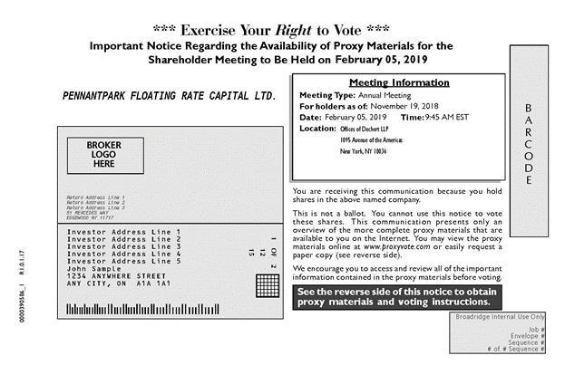

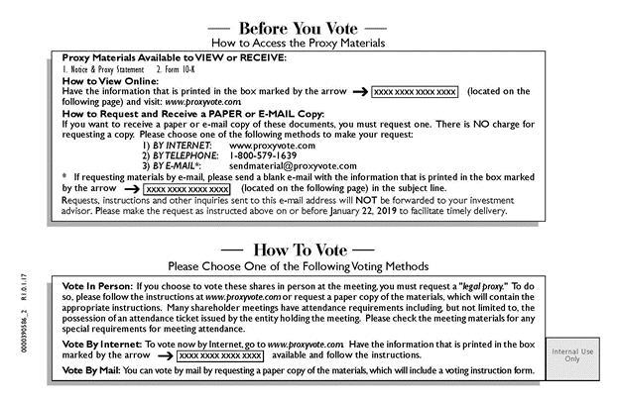

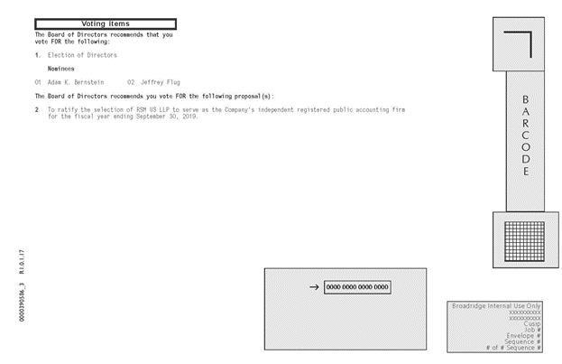

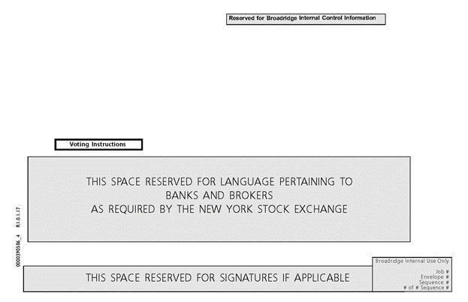

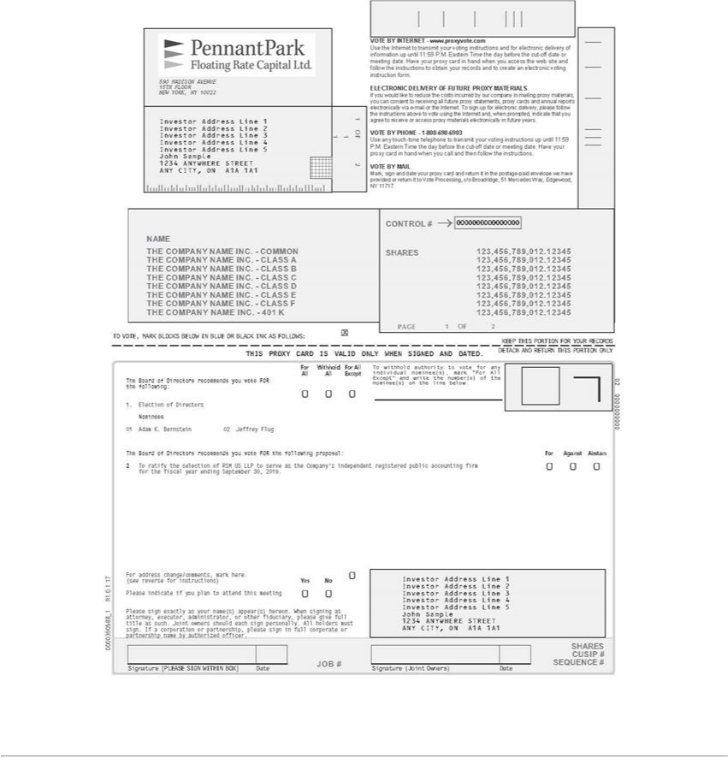

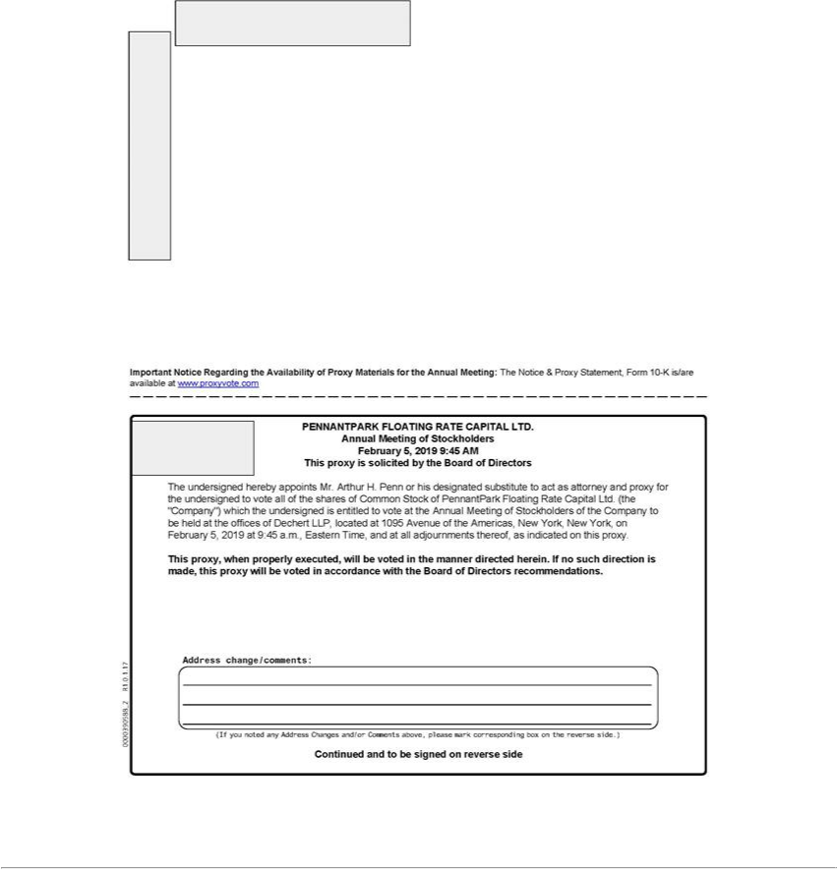

PENNANTPARK FLOATING RATE CAPITAL LTD.

590 Madison Avenue

New York, NY 10022

PROXY CARD FOR SHAREHOLDERS WHO HOLD SHARES VIA TASE MEMBERS

Annual Meeting of Stockholders

February 5, 2019 at 9:45 a.m., Eastern

This proxy is solicited by the Board of Directors

The undersigned hereby appoints Mr. Arthur H. Penn or his designated substitute to act as attorney and proxy for the undersigned to vote all the shares of Common Stock of PennantPark Floating Rate Capital Ltd. (the "Company") which the undersigned is entitled to vote at the Annual Meeting of Stockholders of the Company (the “Meeting”) to be held at the offices of Dechert LLP, located at 1095 Avenue of the Americas, New York, New York, on February 5, 2019 at 9:45 a.m., Eastern time, and at all adjournments thereof, as indicated on this proxy.

This proxy, when properly executed, will be voted in the manner directed herein. If no direction is made, this proxy will be voted in accordance with the Board of Directors recommendations.

Please sign and date this proxy card and return it promptly, together with an Ownership Certificate from the TASE member through which your shares are registered, to the Company's Israeli counsel, Goldfarb Seligman & Co., c/o Daniel Kahn, 98 Yigal Alon Street, 36th Floor, Tel Aviv 6789141, Israel (email: daniel.kahn@goldfarb.com) so your shares may be represented at the Meeting. The proxy card and Ownership Certificate must be received no later than January 31, 2019 to be validly included in the tally of shares voted at the Meeting.

Continued and to be signed on next page

The Board of Directors recommends you vote FOR the following:

- Election of directors

Nominees:

01 Mr. Adam Bernstein

02 Mr. Jeffrey Flug

☐

FOR ALL

☐

WITHHOLD ALL

☐

FOR ALL EXCEPT

To withhold authority to vote for any individual nominee(s), mark "For All Except" and write the number(s) of the nominee(s) on the line below

The Board of Directors recommends you vote FOR the following:

- To ratify the selection of RSM US LLP to serve as the Company's independent registered public accounting firm for the fiscal year ending September 30, 2019.

☐ FOR ☐ AGAINST ☐ ABSTAIN

Please indicate if you plan to attend this meeting

☐ YES ☐ NO

Please sign exactly as your name(s) appear(s) on the ownership confirmation issued by your TASE member. When signing as attorney, executor, administrator, or other fiduciary, please give full title as such. Joint holders should each sign personally. All holders must sign. If a corporation or partnership, please sign in full corporate or partnership name by duly authorized officer.

Print name |  |  | Signature |  |  | Date
Print name |  |  | (Joint Owners) |  |  | Signature |  |  | Date

