SCHEDULE 14A

(RULE 14a-101)

Information Required in Proxy Statement
Schedule 14A Information
Proxy Statement Pursuant to Section 14(a) of the
Securities Exchange Act of 1934

Filed by the Registrant ☒ Filed by a Party other than the Registrant ☐

Check the appropriate box:

- Preliminary Proxy Statement

- Confidential, for Use of the Commission Only (as permitted by Rule 14a-6(e)(2))

☒ Definitive Proxy Statement

- Definitive Additional Material

- Soliciting Material Pursuant to Rule 14a-12

PennantPark Investment Corporation

PennantPark Floating Rate Capital Ltd.

(Name of Registrant as Specified in Its Charter)

(Name of Person(s) Filing Proxy Statement if other than the Registrant)

Payment of Filing Fee (Check the appropriate box):

- No fee required.

- Fee computed on table below per Exchange Act Rules 14a-6(i)(1) and 0-11.

  - Title of each class of securities to which transaction applies:

  - Aggregate number of securities to which transaction applies:

  - Per unit price or other underlying value of transaction computed pursuant to Exchange Act Rule 0-11 (Set forth the amount on which the filing fee is calculated and state how it was determined):

  - Proposed maximum aggregate value of transaction:

  - Total fee paid:

- Fee paid previously with preliminary materials

- Check box if any part of the fee is offset as provided by Exchange Act Rule 0-11(a)(2) and identify the filing for which the offsetting fee was paid previously. Identify the previous filing by registration statement number, or the form or schedule and the date of its filing.

  - Amount previously paid:

  - Form, schedule or registration statement no.:

  - Filing party:

  - Date filed:

December 18, 2013

Dear Stockholder:

You are cordially invited to attend the 2014 Joint Annual Meeting of Stockholders of PennantPark Investment Corporation (“PNNT”) and PennantPark Floating Rate Capital Ltd. (“PFLT” and PNNT each, a “Company” and together, the “Companies”) to be held on February 4, 2014 at 9:30 a.m., Eastern Time, at the offices of Dechert LLP, located at 1095 Avenue of the Americas, New York, New York.

The Notice of Joint Annual Meeting of Stockholders and the Joint Proxy Statement of the Boards of Directors of the Companies, which is accessible on the

Internet or by request, provides an outline of the business to be conducted at the Joint Annual Meeting of Stockholders. At the meeting, you will be asked to:

- elect two directors for PNNT and/or one director for PFLT and (2) ratify the selection of McGladrey LLP as your Company’s independent registered public accounting firm for the fiscal year ending September 30, 2014. I will also report on the progress of the Companies during the past year and respond to stockholders’ questions.

It is important that your shares be represented at the Joint Annual Meeting of Stockholders. If you are unable to attend the meeting in person, I urge you to follow the instructions on the Notice of Internet Availability of Proxy Materials to vote your proxy on the Internet. We encourage you to vote via the Internet, as it saves us significant time and processing costs. However, on the Notice of Internet Availability of Proxy Materials you also will find instructions on how to request a hard copy of the Joint Proxy Statement and proxy card(s) for your Company free of charge and you may vote your proxy by returning your proxy card(s) to us after you request the hard copy materials.

You will also receive separate proxy materials for the Joint Special Meeting of Stockholders, which will be held on the same date and at the same location as the Joint Annual Meeting. Please be certain to vote separately each proxy card you receive from us. Your vote and participation in the governance of your Company is very important to us.

Sincerely yours,

Arthur H. Penn

Chief Executive Officer

PennantPark

590 Madison Avenue, 15th Floor

New York, New York 10022

212-905-1000

PENNANTPARK INVESTMENT CORPORATION

PENNANTPARK FLOATING RATE CAPITAL LTD.

NOTICE OF JOINT ANNUAL MEETING OF STOCKHOLDERS

TO BE HELD ON FEBRUARY 4, 2014

December 18, 2013

Notice is hereby given to the owners of shares of common stock (the “Stockholders”) of PennantPark Investment Corporation (“PNNT”) and PennantPark Floating Rate Capital Ltd. (“PFLT” and PNNT each, a “Company” and together, the “Companies”) that:

The 2014 Joint Annual Meeting of Stockholders of the Companies (the “Annual Meeting”) will be held at the offices of Dechert LLP, located at 1095

Avenue of the Americas, New York, New York, on February 4, 2014 at 9:30 a.m., Eastern Time, for the following purposes:

- (a) For Stockholders of PNNT: to elect two directors to the Board of Directors of PNNT, who will each serve for a term of three years or until his successor is duly elected and qualifies; and

  - For Stockholders of PFLT: to elect one director to the Board of Directors of PFLT, who will serve for a term of three years or until his successor is duly elected and qualifies; and

- For Stockholders of each Company: to ratify the selection of McGladrey LLP to serve as the Company’s independent registered public accounting firm for the fiscal year ending September 30, 2014.

You have the right to receive notice of, and to vote at, the Annual Meeting if you were a stockholder of record of PNNT and/or a stockholder of record of PFLT at the close of business on December 9, 2013. The Companies are furnishing a Joint Proxy Statement and proxy card(s) to their Stockholders on the Internet, rather than mailing printed copies of those materials to each Stockholder. If you received a Notice of Internet Availability of Proxy Materials by mail, you will not receive a printed copy of the Joint Proxy Statement and proxy card(s) unless you request them. Instead, the Notice of Internet Availability of Proxy Materials will instruct you as to how you may access and review the Joint Proxy Statement, and vote your proxy, on the Internet.

Your vote is extremely important to us. If you are unable to attend the Annual Meeting, we encourage you to vote your proxy on the Internet by following the instructions provided on the Notice of Internet Availability of Proxy Materials. You may also request from us free of charge hard copies of the Joint Proxy Statement and proxy card(s) for your Company by following the instructions on the Notice of Internet Availability of Proxy Materials. As to each Company, in the event there are not sufficient votes for a quorum or to approve that Company’s proposals at the time of the Annual Meeting, the Annual Meeting may be adjourned in order to permit further solicitation of proxies by the Company.

EACH COMPANY’S BOARD OF DIRECTORS, INCLUDING THE INDEPENDENT DIRECTORS, UNANIMOUSLY RECOMMENDS THAT YOU VOTE “FOR” EACH OF THE PROPOSALS.

By Order of the Boards of Directors,

Thomas J. Friedmann

Secretary

PennantPark

590 Madison Avenue, 15th Floor

New York, New York 10022

212-905-1000

This is an important meeting. To ensure proper representation at the meeting, please follow the instructions on the Notice of Internet Availability of Proxy Materials to vote your proxy via the Internet or request, complete, sign, date and return a proxy card. Even if you vote your shares prior to the meeting, you still may attend the meeting and vote your shares in person if you wish to change your vote.

PENNANTPARK INVESTMENT CORPORATION

PENNANTPARK FLOATING RATE CAPITAL LTD.

590 Madison Avenue, 15th Floor

New York, New York 10022

- 905-1000

JOINT PROXY STATEMENT

For

2014 Joint Annual Meeting of Stockholders

To be held on February 4, 2014

This document will give you the information you need to vote on the matters listed on the accompanying Notice of Joint Annual Meeting of Stockholders (“Notice of Annual Meeting”). Much of the information in this Joint Proxy Statement is required under the rules and regulations of the Securities and Exchange Commission (the “SEC”), and some of it is technical in nature. If there is anything you do not understand, please contact us at 212-905-1000.

This Joint Proxy Statement is furnished in connection with the solicitation of proxies by the Boards of Directors (each, a “Board” and together, the “Boards”) of PennantPark Investment Corporation (“PNNT”) and PennantPark Floating Rate Capital Ltd. (“PFLT” and PNNT each, a “Company” and together, the “Companies,” “we,” “us” or “our”) for use at the Companies’ 2014 Joint Annual Meeting of Stockholders (the “Meeting”) to be held on Tuesday, February 4, 2014 at 9:30 a.m., Eastern Time, at the offices of Dechert LLP, located at 1095 Avenue of the Americas, New York, New York, and at any postponements or adjournments thereof. This Joint Proxy Statement and each Company’s Annual Report for the fiscal year ended September 30, 2013 are being provided to the stockholders thereof (the “Stockholders”) via the Internet on or about December 18, 2013. In addition, a Notice of Annual Meeting and a Notice of Internet Availability of Proxy Materials are being sent to Stockholders of record of PNNT and Stockholders of record of PFLT as of December 9, 2013.

Although each Company is a separate business development company that holds an annual meeting of stockholders, the Companies’ Proxy Statements have been combined into this Joint Proxy Statement to reduce expenses to the Companies of soliciting proxies for the Meeting.

We encourage you to vote your shares, either by voting in person at the Meeting or by voting by proxy (i.e., authorizing someone to vote your shares). Shares represented by duly executed proxies will be voted in accordance with your instructions. If you execute a proxy without specifying your voting instructions, your shares will be voted in accordance with the recommendation of your Company’s Board. If any other business is brought before the Meeting, your shares will be voted by the appropriate proxy’s discretion unless you specifically state otherwise on your proxy.

You may revoke a proxy at any time before it is exercised by notifying the Companies’ Secretary in writing, by submitting a properly executed, later-dated proxy or by voting in person at the Meeting. Any Stockholder entitled to vote at the Meeting may attend the Meeting and vote in person, whether or not he or she has previously voted his or her shares via proxy or wishes to change a previous vote.

You will be eligible to vote your shares electronically via the Internet, by telephone or by mail.

1

Purpose of Meeting

At the Meeting, you will be asked to vote on the following proposals:

- (a)For Stockholders of PNNT: to elect two directors to the Board of PNNT, who will each serve for a term of three years or until his successor is duly elected and qualifies; and

  - For Stockholders of PFLT: to elect one director to the Board of PFLT, who will serve for a term of three years or until his successor is duly elected and qualifies (together with clause (a) above, “Proposal 1”); and

- For Stockholders of each Company: to ratify the selection of McGladrey LLP to serve as the Company’s independent registered public accounting firm for the fiscal year ending September 30, 2014 (“Proposal 2”).

Voting Securities

You may vote your shares at the Meeting only if you were a Stockholder of record of PNNT and/or a Stockholder of record of PFLT at the close of business on December 9, 2013 (the “Record Date”). There were 66,546,734 shares of PNNT common stock and 14,898,056 shares of PFLT common stock (the “Common Stock”) outstanding on the Record Date. Stockholders are entitled to one vote for each share of Common Stock of their Company held. Stockholders can vote only on matters affecting the Company (or Companies) in which they hold shares of Common Stock. Because the proposals stated above and in the Notice of Annual Meeting are separate for each Company, it is essential that Stockholders who own shares in both Companies vote by Internet, telephone or mail in accordance with the instructions on the proxy card(s), with respect to each proxy card they receive.

Quorum Required

For a Company to conduct business at the Meeting, a quorum of Stockholders of that Company must be present at the Meeting. The presence at the Meeting, in person or by proxy, of the holders of a majority of the shares of Common Stock of a Company outstanding on the Record Date will constitute a quorum of such Company. Abstentions and Broker Non-Votes (as defined below) will be treated as shares present at the Meeting for quorum purposes. If there are not enough votes for a quorum of a Company, the chairman of the Meeting will adjourn the Meeting with respect to that Company to permit the further solicitation of proxies.

Votes Required

Election of Director

For PNNT, the election of a director to the Board of the Company requires the affirmative vote of a majority of the Company’s outstanding shares of Common Stock. If you vote “Withhold Authority” with respect to a nominee, your shares will not be voted with respect to the person indicated. Because a director is elected by a majority of the votes of the outstanding Common Stock of PNNT, votes to withhold authority, as well as abstentions and Broker Non-Votes or no votes, will have the effect of a vote against the nominee.

For PFLT, the election of a director to the Board of the Company requires the affirmative vote of a majority of the votes cast for and affirmatively withheld at the Meeting in person or by proxy. If you vote “Withhold Authority” with respect to a nominee, your shares will not be voted with respect to the person indicated. Votes to withhold authority with respect to a nominee will be included in determining the number of votes cast and, as a result, will have the effect of a vote against the nominee. Abstentions and Broker Non-Votes will have no effect on the result of the vote.

Stockholders of a Company may not cumulate their votes.

2

Ratification of Independent Registered Public Accounting Firm

For each Company, the affirmative vote of a majority of the votes of that Company cast at the Meeting in person or by proxy is required to ratify the appointment of McGladrey LLP to serve as such Company’s independent registered public accounting firm. Abstentions will not be included in determining the number of votes cast and, as a result, will have no effect on this proposal.

Broker Non-Votes

“Broker Non-Votes” are votes that are not cast by a broker, bank or other nominee (the “Broker”) on a non-routine matter because the shares entitled to cast the vote are held in “street name”, the Broker lacks discretionary authority to vote the shares and the Broker has not received voting instructions from the beneficial owner. Proposal 1 is a non-routine matter for both Companies. As a result, if you hold shares of a Company’s Common Stock in street name, your Broker will not be permitted to exercise voting discretion with respect to Proposal 1 for that Company. Thus, if you are a Stockholder of PNNT and you do not vote or give your Broker specific instructions on how to vote for you, your shares will have the effect of a vote against Proposal 1.

For this reason, it is imperative that Stockholders of PNNT vote or provide instructions to their Brokers as to how to vote with respect to Proposal

1.

Proposal 2 is a routine matter for both Companies. As a result, if you beneficially own shares of Common Stock of a Company and you do not vote or provide your Brokers with proxy instructions, your Brokers will be able to vote your shares for you on Proposal 2.

Adjournment and Additional Solicitation. As to each Company, if there appears not to be enough votes to approve a proposal at the Meeting, the chairman of the Meeting or the Stockholders of such Company who are represented in person or by proxy may vote to adjourn the Meeting with respect to that Company to permit further solicitation of proxies. If a vote to adjourn is submitted to the Stockholders, Messrs. Adam Bernstein and Jeffrey Flug are the persons named as proxies for the Companies and will vote proxies held by them for such adjournment, unless marked to be voted against any proposal for which an adjournment is sought, to permit the further solicitation of proxies.

A Stockholder vote may be taken on any of the proposals in this Joint Proxy Statement prior to any such adjournment if there are sufficient votes for approval of such proposal.

Information Regarding This Solicitation

Each Company will bear the expense of its solicitation of proxies for the Meeting, including the cost of preparing and posting this Joint Proxy Statement and the Annual Report to the Internet and the cost of mailing the Notice of Annual Meeting, the Notice of Internet Availability of Proxy Materials and any requested proxy materials to its respective Stockholders. The Companies intend to use the services of Broadridge Financial Solutions, Inc., a leading provider of investor communications solutions, to aid in the distribution and collection of proxy votes. The Companies expect to pay market rates for such services. If brokers, trustees or fiduciaries and other institutions holding shares in their own names or in the names of their nominee, which shares are beneficially owned by others, forward the Joint Proxy Statement and relevant proxy card(s) to, and obtain proxies from, such beneficial owners, the applicable Company will reimburse such persons for their reasonable expenses in so doing.

In addition to the solicitation of proxies by the use of the Internet, proxies may be solicited in person and/or by telephone, mail or facsimile transmission by directors or officers of the Companies, officers or employees of PennantPark Investment Advisers, LLC, the Companies’ investment adviser (the “Adviser”), PennantPark Investment Administration, LLC, the Companies’ administrator (the “Administrator”), and/or by a retained solicitor. No additional compensation will be paid to such directors, officers or regular employees for such services. If the Companies retain a solicitor, the Companies have estimated that they will pay an aggregate of approximately $60,000 for such services. If the Companies engage a solicitor, you could be contacted by

3

telephone on behalf of your Company and be urged to vote. The solicitor will not attempt to influence how you vote your shares, but will only ask that you take the time to cast a vote. You may also be asked if you would like to vote over the telephone and to have your vote transmitted to our proxy tabulation firm. The address of each of the Adviser and the Administrator is 590 Madison Avenue, 15th Floor, New York, New York 10022.

Stockholders may provide their voting instructions through the Internet, by telephone or by mail by following the instructions on the Notice of Internet Availability of Proxy Materials. These options require Stockholders to input the Control Number, which is provided with the Notice of Internet Availability of Proxy Materials. If you vote using the Internet, after visiting www.proxyvote.com and inputting your Control Number, you will be prompted to provide your voting instructions. Stockholders will have an opportunity to review their voting instructions and make any necessary changes before submitting them and terminating their Internet link. Stockholders who vote via the Internet, in addition to confirming their voting instructions prior to submission, also will receive upon request an e-mail confirming their instructions.

If a Stockholder wishes to participate in the Meeting, but does not wish to give a proxy by Internet, the Stockholder may attend the Meeting in person or request and submit a proxy card by following the instructions on the Notice of Internet Availability of Proxy Materials.

Any proxy authorized pursuant to this solicitation may be revoked by notice from the person giving the proxy at any time before it is exercised. A revocation may be effected by resubmitting voting instructions via the Internet voting site, by telephone, by obtaining and properly completing another proxy card that is dated later than the original proxy and returning it, by mail, in time to be received before the Meeting, by attending the Meeting and voting in person or by a notice, provided in writing and signed by the Stockholder, delivered to the Companies’ Secretary on any business day before the date of the Meeting.

Security Ownership of Certain Beneficial Owners and Management

As of the Record Dates, to our knowledge, no person would be deemed to “control” (as such term is defined in the Investment Company Act of 1940, as amended (the “1940 Act”)) either Company.

Each Company’s Board is composed of the same individuals. Our directors consist of an interested director and four independent directors. An interested director is an “interested person” of the Companies, as defined in the 1940 Act, and independent directors are all other directors (the “Independent Directors”).

The following table sets forth, as of December 4, 2013, certain ownership information with respect to each Company’s Common Stock for those persons who directly or indirectly own, control or hold with the power to vote, five percent or more of a Company’s outstanding Common Stock and all officers and directors of the Companies, as a group.

 |  |  |  |  |  |  |  |  | Percentage of
Name and address⁽¹⁾ |  |  | Type of ownership⁽⁴⁾ |  |  |  |  |  | Common Stock
 |  |  |  |  | Shares Owned |  |  |  | Outstanding
 |  |  |  |  | PNNT |  | PFLT |  | PNNT |  | PFLT
Independent directors
Adam K. Bernstein(2) |  |  | Record/Beneficial |  | 88,971 | 5,000 |  | * |  |  | *
Marshall Brozost |  |  | Record/Beneficial |  | 13,540 |  | — | * |  |  | —
Jeffrey Flug |  |  | Record/Beneficial |  | 227,288 |  | — | * |  |  | —
Samuel L. Katz |  |  | Record/Beneficial |  | 113,482 | 59,500 |  | * |  |  | *
Interested director
Arthur H. Penn(3) |  |  | Record/Beneficial |  | 537,323 | 149,209 |  | 0.8% |  |  | 1.0%
Executive officer
Aviv Efrat |  |  | Record/Beneficial |  | 44,790 |  | 13,750 |  | * |  | *
All directors and executive officer as a group (6 persons)
 |  |  |  |  | 1,025,394 |  | 227,459 |  | 1.5% |  | 1.5%
 |  | 4

- The address for each officer and director is c/o PennantPark, 590 Madison Avenue, 15th Floor, New York, New York 10022.

- Mr. Bernstein is the President of JAM Investments, LLC and may therefore be deemed to own beneficially the 68,236 shares of PNNT held by JAM Investments, LLC.
- Mr. Penn is the Managing Member of the Adviser and may therefore be deemed to own beneficially the 342,611 shares of PNNT and 149,209 shares of PFLT held by the Adviser.
- Sole voting power.

- Less than 1 percent.

Section 16(a) Beneficial Ownership Reporting Compliance

Pursuant to Section 16(a) of the Securities Exchange Act of 1934, as amended (the “Exchange Act”), each Company’s directors and other executive officer and any persons holding more than 10% of that Company’s Common Stock are required to report their beneficial ownership and any changes therein to the SEC and the Company. Specific due dates for those reports have been established, and the Companies are required to report herein any failure to file such reports by those due dates. Based on the Companies’ review of Forms 3, 4 and 5 filed by such persons and information provided by the Companies’ directors and other executive officer, the Companies believe that, during the fiscal year ended September 30, 2013, all Section 16(a) filing requirements applicable to such persons were met in a timely manner.

Dollar Range of Securities Beneficially Owned by Directors

The following table sets forth the dollar range of each Company’s Common Stock beneficially owned by each of our directors as of December 4, 2013.

Information as to beneficial ownership is based on information furnished to the Companies by such persons.

Directors of the Companies |  |  |  | Dollar Range of the Common Stock of the Companies⁽¹⁾
 |  |  | PNNT |  | PFLT |  | Total
Independent directors
Adam K. Bernstein |  |  | Over $1,000,000(2) | $50,001 - $100,000 |  |  | Over $1,000,000
Marshall Brozost |  |  | $100,001 - $500,000 |  | None |  | $100,001 - $500,000
Jeffrey Flug |  |  | Over $1,000,000 |  | None |  | Over $1,000,000
Samuel L. Katz |  |  | Over $1,000,000 | $500,001 - $1,000,000 |  |  | Over $1,000,000
Interested director
Arthur H. Penn(3) |  |  | Over $1,000,000 |  | Over $1,000,000 |  | Over $1,000,000

- Dollar ranges are as follows: None; $1-$10,000; $10,001-$50,000; $50,001-$100,000; $100,001-$500,000; $500,001-$1,000,000 or over $1,000,000.

- Also reflects holdings of JAM Investments, LLC.

- Also reflects holdings of the Adviser.

5

PROPOSAL 1: ELECTION OF DIRECTORS

In accordance with its bylaws, each of the Companies currently has five members on its Board. Directors are divided into three classes and are elected for staggered terms of three years each, with a term of office of one of the three classes of directors expiring each year. Each director will hold office for the term to which he is elected or until his successor is duly elected and qualifies. After this election, the terms of Class I, II and III will expire as follows:

Companies |  | Class I |  | Class II |  | Class III
PennantPark | Investment Corporation | 2017 |  | 2015 |  | 2016
PennantPark Floating Rate Capital Ltd. |  | 2015 |  | 2016 |  | 2017

A Stockholder can vote for, or withhold his or her vote from, any nominee for his or her Company’s Board. In the absence of instructions to the contrary, it is the intention of the persons named as proxies to vote such proxy FOR the election of each nominee named below. If a nominee should decline or be unable to serve as a director, it is intended that the proxy will be voted for the election of such person as is nominated by the relevant Board as a replacement. The Boards have no reason to believe that either of their nominees will be unable or unwilling to serve.

EACH BOARD, INCLUDING ITS INDEPENDENT DIRECTORS, UNANIMOUSLY RECOMMENDS THAT YOU VOTE FOR THE ELECTION OF THE NOMINEES NAMED IN THIS JOINT PROXY STATEMENT.

Information about the Nominees and Directors

Certain information with respect to the nominees for election at the Meeting, as well as each of the other directors, is set forth below, including their names, ages, a brief description of their recent business experience, including present occupations and employment, certain directorships that each person holds and the year in which each person became a director of each Company. The nominees currently serve as directors of each Company.

Each of Mr. Marshall Brozost and Mr. Samuel L. Katz has been nominated for election as a Class I director of PNNT for a three-year term expiring in 2017. Neither Mr. Brozost nor Mr. Katz is being proposed for election pursuant to any agreement or understanding between either Mr. Brozost or Mr. Katz and PNNT.

Mr. Arthur H. Penn has been nominated for election as a Class III director of PFLT for a three-year term expiring in 2017. Mr. Penn is not being proposed for election pursuant to any agreement or understanding between Mr. Penn and PFLT.

6

 |  |  |  |  | Company, |  | Principal
 |  |  |  |  | Term of Office |  | Occupation(s)
Name, Address and Age ⁽¹⁾ |  |  | Position(s) held |  | and Length of |  | During the Past
 |  |  | with Company |  | Time Served |  | 5 Years
Independent Directors
Adam K. Bernstein (50) |  | Director |  | PNNT—Class II |  | President of The Bernstein Companies,
 |  |  |  | Director since |  | a Washington, D.C.-based real estate
 |  |  |  | February 2007; |  | firm, since 1995 and President and
 |  |  |  | Term Expires |  | Chief Executive Officer of Consortium
 |  |  |  | 2015 |  | Atlantic Realty Trust, Inc., a private real
 |  | Director |  | PFLT—Class II |  | estate investment trust operating in the
 |  |  |  |  |  | Mid-Atlantic region, from 2006.
 |  |  |  | Director since
 |  |  |  | October 2010;
 |  |  |  | Term Expires 2016

Other
Directorships

Held by Director

or Nominee for
Director
During the
Past 5 Years ⁽²⁾

None.

Marshall Brozost (46) Director

Nominee

Director

Jeffrey Flug (51) Director

Director

PNNT—Class I | Partner at Schulte Roth & Zabel LLP,
Director since | where he practices in the real estate and
February 2007; | private equity groups, since May 2012.
Term Expires, if | Prior to Schulte Roth & Zabel, Mr.
elected, 2017 | Brozost practiced law at Dewey &
PFLT—Class I | LeBoeuf LLP from 2005 to 2012, at
PFLT—Class I | Solomon & Weinberg LLP from 2004
Director since October | to 2005 and at O’Melveny & Myers
2010; Term Expires 2015 | LLP from 2001 to 2004.
PNNT—Class II | Mr. Flug has held a variety of senior
Director since | positions, including President of Union
February 2007; | Square Hospitality Group, an exclusive
Term Expires | chain of restaurants, from 2009. Mr.
2015 | Flug served as Chief Executive Officer
PFLT—Class II | and Executive Director of Millennium
PFLT—Class II | Promise Alliance, Inc., a non-profit
Director since | organization whose mission is to
October 2010; | eradicate extreme global poverty, from
Term Expires 2016 | 2006 to 2008. From 2000 to 2006, Mr.
 | Flug was a Managing Director and
 | Head of North American Institutional
 | Sales at JP Morgan’s Investment Bank.
7

None.

Sears Hometown and Outlet Stores, Inc., from October 2012.

Name, Address and Age ⁽¹⁾ |  |  | Position(s) held
 |  |  | with Company
Independent Directors | (continued)
Samuel L. Katz (48) |  | Director
 |  | Nominee

Director

Interested Director

Arthur H. Penn (50)(3) Chief Executive

Officer and

Chairman of the

Board of

Directors

Director Nominee

Chief Executive

Officer and

Chairman of the

Board of

Directors

 |  |  |  | Other
 |  |  |  | Directorships
 |  |  |  | Held by Director
Company, |  | Principal |  | or Nominee for
Term of Office |  | Occupation(s) |  | Director
and Length of |  | During the Past |  | During the
Time Served |  | 5 Years |  | Past 5 Years ⁽²⁾
PNNT—Class I | Managing Partner of TZP Group LLC, a |  |  | None.
Director since | private equity fund, since 2007. Before
February 2007; | joining TZP Group, Mr. Katz was Chief
Term Expires, if | Executive Officer of MacAndrews &
elected, 2017 | Forbes Acquisition Holdings, Inc. from
PFLT—Class I | 2006 to 2007. Prior to that position,
PFLT—Class I | Mr. Katz was Chairman and Chief
Director since | Executive Officer of the Cendant Travel
October 2010; | Distribution Services Division from
Term Expires 2015 | 2001 to 2005.
PNNT—Class III | Founder, Chairman and Chief Executive |  |  | None.
Director since | Officer of PNNT and of PFLT from
February 2007; | their inception in 2007 and 2010,
Term Expires 2016 | respectively. Mr. Penn also is the
 | Founder and Managing Member of the
 | Adviser. Before founding PNNT, Mr.
PFLT—Class III | Penn was the Co-Founder of Apollo
Director since | Investment Management, where he was
October 2010; | a Managing Partner from 2004 to 2007.
Term Expires, if elected, | He also served as Chief Operating
2017 | Officer of Apollo Investment
 | Corporation from inception in 2004 to
 | 2006 and served as President and Chief
 | Operating Officer in 2006. He formerly
 | was a Managing Partner of Apollo
 | Value Fund L.P. (formerly Apollo
 | Distressed Investment Fund, L.P.) from
 | 2003 to 2006.

- The address for each officer and director is c/o PennantPark, 590 Madison Avenue, 15th Floor, New York, New York 10022.

- No director otherwise serves as a director of an investment company subject to the 1940 Act.

- Mr. Penn is an interested director due to his position as an officer of each Company and of the Adviser.

8

Corporate Governance

Each Company believes that maintaining the highest standards of corporate governance is a crucial part of its business, and is committed to having in place the necessary controls and procedures designed to ensure compliance with applicable laws, rules and regulations, as well as its own ethical standards of conduct.

Director Independence

NASDAQ corporate governance rules require listed companies to have a board of directors with at least a majority of independent directors. Under NASDAQ corporate governance rules, in order for a director to be deemed independent, the Board of each Company must determine that the individual does not have a relationship that would interfere with the director’s exercise of independent judgment in carrying out his responsibilities. On an annual basis, each director is required to complete an independence questionnaire designed to provide information to assist the Companies’ Boards in determining whether the director is independent under NASDAQ corporate governance rules, the 1940 Act and applicable corporate governance guidelines. The Boards have determined that each of their directors, other than Mr. Penn, is independent under the applicable listing standards of the NASDAQ Global Select Market and the New York Stock Exchange and under the Exchange Act and the 1940 Act. Each Company’s governance guidelines require any director who has previously been determined to be independent to inform the Chairman of the Board, the Chairman of the Nominating and Corporate Governance Committee and the Company’s Corporate Secretary of any change in circumstance that may cause his status as an Independent Director to change. Each Board limits membership on its Audit Committee, its Nominating and Corporate Governance Committee and its Compensation Committee to Independent Directors.

Boards’ Oversight Role in Management

Each Board performs its risk oversight function primarily through (1) its three standing committees, which report to the entire Board and are comprised solely of Independent Directors and (2) monitoring by the Company’s Chief Compliance Officer (the “CCO”) in accordance with the Company’s compliance policies and procedures.

As described below in more detail under “Audit Committees”, “Nominating and Corporate Governance Committees” and “Compensation Committees”, each Board’s Audit Committee, Nominating and Corporate Governance Committee and Compensation Committee assist the Board in fulfilling its risk oversight responsibilities. Each Audit Committee’s risk oversight responsibilities include overseeing the Company’s accounting and financial reporting processes, including the annual audit of the Company’s financial statements, the Company’s systems of internal controls regarding finance and accounting, pre-approving the engagement of an independent registered public accounting firm to render audit and/or permissible non-audit services and evaluating the qualifications, performance and independence of the independent registered public accounting firm. Each Nominating and Corporate Governance Committee’s risk oversight responsibilities include selecting, researching and nominating directors for election by the Company’s Stockholders, developing and recommending to its Board a set of corporate governance principles and overseeing the evaluation of the Board and the Company’s management. Each Compensation Committee’s risk oversight responsibilities include determining, or recommending to its Board for determining, the compensation of the Company’s chief executive officer and all other executive officers, paid directly by the Company, if any, and assisting its Board with matters related to compensation, as directed by each Board. The Audit Committee, the Nominating and Corporate Governance Committee and the Compensation Committee of each Board consist solely of Independent Directors.

Each Board also performs its risk oversight responsibilities with the assistance of a CCO, who is the same individual for both Companies. The Companies’ CCO prepares a written report annually discussing the adequacy and effectiveness of the compliance policies and procedures of the Companies and certain of their service providers. The CCO’s report, which is reviewed by the Boards, addresses, at a minimum: (1) the operation of the compliance policies and procedures of the Companies and certain of their service providers since the last report; (2) any material changes to such policies and procedures since the last report; (3) any recommendations for

9

material changes to such policies and procedures as a result of the CCO’s annual review; and (4) any compliance matter that has occurred since the date of the last report about which the Boards would reasonably need to know to oversee the Companies’ compliance activities and risks. In addition, the CCO meets separately in executive session with the Independent Directors at least once each year.

Each Company believes that its Board’s role in risk oversight is effective and appropriate given the extensive regulation to which it is already subject as a business development company. Specifically, as a business development company, each Company must comply with certain regulatory requirements that control the levels of risk in its business and operations. For example, the ability of each Company to incur indebtedness is limited by the asset coverage requirements set forth in the 1940 Act and each Company generally must invest at least 70% of its total assets in “qualifying assets.” Each Company also has elected to be treated as a regulated investment company (a “RIC”) under Subchapter M of the Internal Revenue Code of 1986, as amended. As a RIC, each Company must, among other things, meet certain income source and asset diversification requirements.

Each Company believes that the extent of its Board’s and its committees’ roles in risk oversight complements the Board’s leadership structure. Because they are comprised solely of Independent Directors, the Audit Committees, the Nominating and Corporate Governance Committees and Compensation Committees are able to exercise their oversight responsibilities without any conflict of interest that might discourage critical questioning and review. Through regular executive session meetings with the Companies’ independent registered public accounting firms, their CCO and their Chief Executive Officer, the Independent Directors have similarly established direct communication and oversight channels that the Boards believe foster open communication and early detection of issues of concern.

Each Company believes that its Board’s role in risk oversight must be evaluated on a case by case basis and that the current configuration and allocation of responsibilities among the Board and its committees with respect to the oversight of risk is appropriate. However, each Board and its committees continually re-examine the manner in which they administer their respective risk oversight functions, including through formal annual assessments of performance, to ensure that they meet their Company’s needs.

Boards’ Composition and Leadership Structure

The 1940 Act requires that at least a majority of each Company’s directors not be “interested persons” (as defined in the 1940 Act) of the Company. Currently, four of the five directors on each Board are Independent Directors; however, the Chairman of the Boards is an interested person of each Company. The Independent Directors believe that the combined position of Chief Executive Officer of the Companies and Chairman of the Boards of the Companies results in greater efficiencies in managing the Companies, by eliminating the need to transfer substantial information quickly and repeatedly between the Chief Executive Officer and the Chairman, and the ability to capitalize on the specialized knowledge acquired from the duties of the roles. The Boards have not identified a lead Independent Director; however, each Board has determined that its leadership structure, in which 80% of the directors are Independent Directors and, as such, are not affiliated with the Adviser or the Administrator, is appropriate in light of the services that the Adviser and the Administrator provide to the Company and the potential conflicts of interest that could arise from these relationships.

Information about Each Director’s Experience, Qualifications, Attributes or Skills

Below is additional information about each director (supplementing the information provided in the table above) that describes some of the specific experiences, qualifications, attributes and/or skills that each director possesses, and which each Board believes has prepared each director to be an effective director. Each Board believes that the significance of each director’s experience, qualifications, attributes and/or skills is an individual matter (meaning that experience that is important for one director may not have the same value for another) and that these factors are best evaluated at the Board level, with no single director, or particular factor, being indicative of Board effectiveness. However, each Board believes that directors need to have the ability to review,

10

evaluate, question and discuss critical information provided to them, and to interact effectively with management, service providers and counsel, in order to exercise effective business judgment in the performance of their duties. Each Board believes that its members satisfy this standard. Experience relevant to having this ability may be achieved through a director’s educational background, business or professional training or practice (e.g., finance, accounting or law), public service or academic positions, experience from service as a board member (including the Boards of the Companies) or as an executive of investment companies, public companies or significant private or not-for-profit entities or other organizations and/or other life experiences. To assist them in evaluating matters under federal and state law, the Independent Directors have their own independent legal counsel, who participates in Board meetings and interacts with the Adviser and the Companies’ counsel. Both the Independent Directors’ and the Companies’ counsels have significant experience advising funds and fund board members. Each Board and its committees have the ability to engage other experts as appropriate. Each Board evaluates its performance on an annual basis.

Role of the Chairman and Chief Executive Officer

As Chairman of each Board and Chief Executive Officer of each Company, Mr. Penn assumes a leading role in strategic planning and supports major transaction initiatives of the Companies. Mr. Penn also manages the day-to-day operations of the Companies, with the support of the other investment professionals and officers. As Chief Executive Officer, Mr. Penn has general responsibility for the implementation of the policies of the Companies, as determined by the Boards, and for the management of the business and affairs of the Companies.

Experience, Qualifications, Attributes and/or Skills that Led to the Boards’ Conclusion that such Members Should Serve as Directors of the Companies

Each Board believes that, collectively, the directors have balanced and diverse experience, qualifications, attributes and skills, which allow the Board to operate effectively in governing the Company and protecting the interests of its Stockholders. Below is a description of the various experiences, qualifications, attributes and/or skills with respect to each director considered by the Boards.

Arthur H. Penn

Each Board benefits from Mr. Penn’s business leadership and experience and knowledge of senior loan, mezzanine lending, leveraged finance, distressed debt and private equity businesses, as well as diverse management practices. Mr. Penn is the Founder, Chairman and Chief Executive Officer of the Companies and Managing Member of the Adviser and the Administrator. Mr. Penn co-founded Apollo Investment Management in 2004, where he was a Managing Partner from 2004 to 2006. He also served as President and Chief Operating Officer of Apollo Investment Corporation from its inception in 2004 to 2006, and served as President and Chief Operating Officer of that company in 2006. Mr. Penn was a Managing Partner of Apollo Value Fund L.P. (formerly Apollo Distressed Investment Fund, L.P.) from 2003 through 2006. From 2002 to 2003, prior to joining Apollo, Mr. Penn was a Managing Director of CDC-IXIS Capital Markets. Mr. Penn served as Global Head of Leveraged Finance at UBS Warburg LLC (now UBS Investment Bank) from 1999 through 2001. Prior to joining UBS Warburg, Mr. Penn was Global Head of Fixed Income Capital Markets for BT Securities and BT Alex Brown Incorporated from 1994 to 1999. In these capacities, Mr. Penn oversaw groups responsible for more than 200 high-yield and leveraged bank financings aggregating over $34 billion in capital raised. From 1992 to 1994, Mr. Penn served as Head of High Yield Capital Markets at Lehman Brothers. Mr. Penn’s longstanding service as Chairman and Chief Executive Officer of the Companies and Managing Member of the Adviser and the Administrator provide him with a specific and valuable understanding of the Companies, their operations and the business and regulatory issues facing them.

Adam K. Bernstein

Mr. Bernstein brings to the Boards 27 years of experience in leading a real estate development, investment and management business in the Mid-Atlantic region of the United States. Mr. Bernstein affords the Boards his

11

vast experience in the area of strategic and financial planning and capital and risk management. Mr. Bernstein is President of The Bernstein Companies, a Washington D.C.-based real estate firm, which he joined in 1986. Mr. Bernstein runs a diversified company that includes a Hotel division, a Private Real Estate Investment Trust, and a structured financed group that focuses on tax credit syndication and project lending for community development projects nationwide. In 2012, Mr. Bernstein was appointed to the Board of Overseers of the School of Arts and Sciences at the University of Pennsylvania.

Marshall Brozost

Mr. Brozost brings to the Boards 19 years of experience in the areas of finance, private equity, mergers and acquisitions and restructurings. Since May 2012, Mr. Brozost has been a Partner at Schulte Roth & Zabel LLP, where he practices in the real estate and private equity groups. Prior to Schulte Roth & Zabel, Mr. Brozost practiced law at Dewey & LeBoeuf LLP from 2005 to 2012, at Solomon & Weinberg LLP from 2004 to 2005 and at O’Melveny & Myers LLP from 2001 to 2004. Mr. Brozost also served as a Vice President of Nomura Asset Capital Corporation from 1997 through 2000.

Jeffrey Flug

Mr. Flug brings to the Boards expertise in fixed income, investment banking, accounting and business operations. Since October 2012, Mr. Flug has been a director of Sears Hometown and Outlet Stores, Inc. Since 2009, Mr. Flug has held a variety of senior positions, including, currently, President of Union Square Hospitality Group, an exclusive chain of restaurants. Mr. Flug was Chief Executive Officer and Executive Director of Millennium Promise Alliance, Inc. from 2006 to 2008. Millennium Promise is a non-profit organization whose mission is to eradicate extreme global poverty. Mr. Flug was Managing Director and Head of North American Institutional Sales at JP Morgan’s Investment Bank from 2000 to 2006. From 1988 to 2000, Mr. Flug was Managing Director for Goldman Sachs & Co. in its Fixed Income Division.

Samuel L Katz

Mr. Katz brings to the Boards a diverse knowledge of business and finance as a result of his career over the past 27 years. Mr. Katz is the Managing Partner of TZP Group, LLP, a private equity fund he formed in 2007. Prior to joining TZP Group, Mr. Katz was Chief Executive Officer of MacAndrews & Forbes Acquisition Holdings, Inc. from 2006 through 2007. From 1996 through 2005, Mr. Katz held a variety of senior positions at Cendant Corporation, including, most recently, Chairman and Chief Executive Officer of the Cendant Travel Distribution Services Division from 2001 to 2005. From 1992 to 1995, Mr. Katz invested in private and public equity as Co-Chairman of Saber Capital, Inc. and Vice President of Dickstein Partners Inc. From 1988 to 1992, Mr. Katz was an Associate and Vice President at The Blackstone Group, where he worked on numerous private equity transactions, including the initial leveraged buyouts of several hotel franchise brands which created the predecessor to Cendant Corporation. From 1986 to 1988, Mr. Katz was a Financial Analyst at Drexel Burnham Lambert.

Committees of the Boards

Each Board has established an Audit Committee, a Nominating and Corporate Governance Committee and a Compensation Committee. For the fiscal year ended September 30, 2013, the Board of PNNT held four board meetings, four Audit Committee meetings and one Nominating and Corporate Governance Committee meeting and the Board of PFLT held five board meetings, four Audit Committee meetings and one Nominating and Corporate Governance Committee meeting. Each Board’s Compensation Committee was established in November 2013. All directors attended at least 75% of the aggregate number of meetings of the respective Board and of the respective committees on which they served. The Companies require each director to make a diligent effort to attend all Board and committee meetings, and encourage directors to attend the Companies’ joint annual stockholders’ meetings. Last year, all of the members of the Boards attended the joint annual stockholders’ meeting.

12

Audit Committees

The members of the Audit Committee of each Company are Messrs. Bernstein, Brozost, Flug and Katz, each of whom is independent for purposes of the 1940 Act and the NASDAQ corporate governance rules. Messrs. Flug and Katz serve as Co-Chairmen of the Audit Committees. Each Audit Committee operates pursuant to a separate Audit Committee Charter approved by its Board. Each charter sets forth the responsibilities of the Audit Committee, which include: selecting or retaining each year an independent registered public accounting firm (the “auditors”) to audit the accounts and records of the Company; reviewing and discussing with management and the auditors the annual audited financial statements of the Company, including disclosures made in management’s discussion and analysis of financial condition and results of operations, and recommending to the Board whether the audited financial statements should be included in the Company’s annual report on Form 10-K; reviewing and discussing with management and the auditors the Company’s quarterly financial statements prior to the filings of their quarterly reports on Form 10-Q; pre-approving the auditors’ engagement to render audit and/or permissible non-audit services; and evaluating the qualifications, performance and independence of the auditors. The Audit Committees are also responsible for aiding the Boards in fair value pricing of debt and equity securities for their respective funds. The Boards and Audit Committees use the services of nationally recognized independent valuation firms to help them determine the fair value of certain securities held by the Companies. The Boards have determined that each of Messrs. Flug and Katz is an “audit committee financial expert” as that term is defined under Item 407 of Regulation S-K under the Exchange Act. Each Audit Committee Charter is available on the Companies’ website (http://www.pennantpark.com).

Nominating and Corporate Governance Committees

The members of the Nominating and Corporate Governance Committee of each Company are Messrs. Bernstein, Brozost, Flug and Katz, each of whom is independent for purposes of the 1940 Act and the NASDAQ corporate governance rules. Messrs. Bernstein and Brozost serve as Co-Chairmen of the Nominating and Corporate Governance Committees. Each Nominating and Corporate Governance Committee is responsible for selecting, researching and nominating directors for election by the Company’s Stockholders, selecting nominees to fill vacancies on the Board or a committee of the Board, developing and recommending to the Board a set of corporate governance principles and overseeing the evaluation of the Board and the Company’s management. The Nominating and Corporate Governance Committee of each Company has adopted a written Nominating and Corporate Governance Committee Charter that is available on the Companies’ website (http://www.pennantpark.com).

Each Nominating and Corporate Governance Committee will consider Stockholder recommendations for possible nominees for election as directors when such recommendations are submitted in accordance with the Company’s bylaws, the Nominating and Corporate Governance Committee Charter and any applicable law, rule or regulation regarding director nominations. Nominations should be sent to Thomas J. Friedmann, Secretary, c/o PennantPark, 590 Madison Avenue, 15th Floor, New York, New York 10022. When submitting a nomination to a Company for consideration, a Stockholder must provide all information that would be required under applicable SEC rules to be disclosed in connection with election of a director, including the following minimum information for each director nominee: full name, age and address; principal occupation during the past five years; directorships on publicly held companies and investment companies during the past five years; number of shares of the Company’s Common Stock owned, if any; and a written consent of the individual to stand for election if nominated by the Board and to serve if elected by the Stockholders.

Criteria considered by the Nominating and Corporate Governance Committees in evaluating the qualifications of individuals for election as director of the Boards include: compliance with the independence and other applicable requirements of the NASDAQ corporate governance rules and the 1940 Act, and all other applicable laws, rules, regulations and listing standards; the criteria, policies and principles set forth in the Companies’ Nominating and Corporate Governance Committee Charters; and the ability to contribute to the effective management of the Companies, taking into account the needs of the Companies and such factors as the individual’s experience, perspective, skills and knowledge of the industry in which the Companies operate.

13

Neither Nominating and Corporate Governance Committee has adopted a formal policy with regard to the consideration of diversity in identifying individuals for election as members of the Board, but the Nominating and Corporate Governance Committees will consider such factors as they may deem are in the best interests of the Companies and their Stockholders. Those factors may include a person’s differences of viewpoint, professional experience, education and skills, as well as his or her race, gender and national origin. In addition, as part of each Board’s annual-self assessment, the members of the Nominating and Corporate Governance Committee evaluates the membership of the Board and whether the Board maintains satisfactory policies regarding membership selection.

Compensation Committees

The Compensation Committee is responsible for determining, or recommending to the Board for determining, the compensation of the Company’s chief executive officer and all other executive officers, paid directly by the Company, if any. The Compensation Committee also assists each Board with all matters related to compensation, as directed by each Board. The current members of the Compensation Committee are Messrs. Bernstein, Brozost, Flug and Katz, each of whom is not an interested person of us for purposes of the 1940 Act and the NASDAQ corporate governance rules. As discussed below, none of our executive officers is directly compensated by either Company and, as a result, the Compensation Committees do not produce and/or review and report on executive compensation practices. Each Compensation Committee Charter is available on the Companies’ website (http://www.pennantpark.com).

Communication with the Boards of Directors

Stockholders with questions about a Company are encouraged to contact the Companies’ Investor Relations Department at 590 Madison Avenue, 15th Floor, New York, New York 10022 or by visiting the investor relations web page on our website (http://www.pennantpark.com). However, if Stockholders believe that their questions have not been addressed, they may communicate with the relevant Board by sending their communications to Thomas J. Friedmann, Secretary, c/o PennantPark, 590 Madison Avenue, 15th Floor, New York, New York 10022. All Stockholder communications received in this manner will be delivered to one or more members of the relevant Board.

Information about the Executive Officer Who is Not a Director

The following information pertains to our executive officer who is not a director of the Companies.

Name, Address |  | Position(s) held
and Age ⁽¹⁾ |  | with the Companies |  | Principal Occupation(s) During the Past 5 Years
Aviv Efrat (49)
 |  | PNNT and PFLT— |  | Chief Financial Officer and Treasurer of PNNT and PFLT from their inception in 2007 and
 |  | Chief Financial Officer |  | 2010, respectively. Managing Director of the Administrator from inception in 2007. Mr. Efrat
 |  | and Treasurer |  | was a Director at BlackRock, Inc. from 1997 to 2007 where he was responsible for a variety
 |  |  |  | of administrative, operational and financial aspects of closed-end and open-end registered
 |  |  |  | investment companies.

- The business address of the executive officer is c/o PennantPark, 590 Madison Avenue, 15th Floor, New York, New York 10022. 14

Information about Chief Compliance Officer

The following information pertains to our CCO who is not a director of the Companies.

Name, Address |  | Position held
and Age ⁽¹⁾ |  | with the Companies |  | Principal Occupation(s) During the Past 5 Years
Guy F. Talarico (58)
 |  | PNNT and PFLT— |  | Chief Compliance Officer of PNNT and PFLT from May 2008 and March 2011, respectively.
 |  | Chief Compliance |  | Mr. Talarico has held the position of Chief Compliance Officer for a number of investment
 |  | Officer |  | advisers, private funds and investment companies from 2004 when he founded Alaric
 |  |  |  | Compliance Services, LLC.

- The business address of the CCO is c/o PennantPark, 590 Madison Avenue, 15th Floor, New York, New York 10022.

Code of Conduct and Code of Ethics

We expect each of our officers and directors, as well as any person affiliated with our operations, to act in accordance with the highest standards of personal and professional integrity at all times, and to comply with the Companies’ policies and procedures and all laws, rules and regulations of any applicable international, federal, provincial, state or local government. To this effect, each Company has adopted a Joint Code of Conduct, which is posted on the Companies’ website (http://www.pennantpark.com). The Joint Code of Conduct applies to the directors, officers and their respective staffs.

As required by the 1940 Act, each Company maintains a Joint Code of Ethics with the Adviser that establishes procedures that apply to the Companies’ directors, officers, their respective staffs and the employees of the Adviser with respect to their personal investments and investment transactions. The Joint Code of Ethics generally does not permit investments by a Company’s directors, officers or any other covered person in securities that may be purchased or held by the Company. PNNT and PFLT filed its Joint Code of Ethics as Exhibit 14.1 to its Annual Report on Form 10-K, filed with the SEC on each of November 13 and 14, 2013. You may access the Joint Codes of Ethics via the Internet site of the SEC (http://www.sec.gov) or our website (http://www.pennantpark.com). Each Company intends to disclose any material amendments to or waivers of required provisions of its Joint Code of Conduct or its Joint Code of Ethics on Form 8-K.

Compensation of Independent Directors

For PNNT, each Independent Director receives an annual payment of $90,000 for services performed on behalf of PNNT as a director. The Independent Directors also receive $2,500 plus reimbursement of reasonable out-of-pocket expenses incurred in connection with attending each Board meeting and receive $1,000 plus reimbursement of reasonable out-of-pocket expenses incurred in connection with attending each committee meeting (unless combined with a Board meeting). In addition, each Co-Chairman of the Audit Committee receives an annual fee of $12,500 and each Co-Chairman of any other committee receives an annual fee of $2,500 for his additional services in these capacities. Also, PNNT has purchased directors’ and officers’ liability insurance on behalf of its directors and officers. Independent Directors have the option to receive their directors’ fees paid in shares of the Company’s Common Stock issued at a price per share equal to the greater of net asset value or the market price at the time of payment. No compensation is expected to be paid to directors who are “interested persons” (as defined in the 1940 Act).

For PFLT, each Independent Director receives an annual payment of $50,000 for services performed on behalf of PFLT as a director. The Independent Directors also receive $1,250 plus reimbursement of reasonable out-of-pocket expenses incurred in connection with attending each Board meeting and receive $500 plus reimbursement of reasonable out-of-pocket expenses incurred in connection with attending each committee meeting (unless combined with a Board meeting). In addition, each Co-Chairman of the Audit Committee receives an annual fee of $3,750 and each Co-Chairman of any other committee receives an annual fee of $1,250

15

for his additional services in these capacities. Also, PFLT has purchased directors’ and officers’ liability insurance on behalf of its directors and officers. Independent Directors have the option to receive their directors’ fees paid in shares of the Company’s Common Stock issued at a price per share equal to the greater of net asset value or the market price at the time of payment. No compensation is expected to be paid to directors who are “interested persons” (as defined in the 1940 Act).

Compensation of Directors and Executive Officer

The following table shows information regarding the compensation paid by the Companies to our directors for the fiscal year ended September 30, 2013.

No compensation is paid directly by either Company to any interested director or executive officer of the Companies.

 |  |  |  |  |  |  |  |  |  | PNNT |  |  |  |  |  |  |  |  | PFLT
 |  |  |  |  |  |  |  |  |  | Pension or |  |  |  |  |  |  |  |  | Pension or
 |  |  |  |  |  |  |  | Aggregate |  | retirement |  |  |  |  |  |  | Aggregate |  | retirement
 |  |  |  |  |  |  | compensation |  |  | benefits accrued |  |  |  |  |  | compensation |  |  | benefits accrued
 |  |  |  |  |  |  |  | from the |  | as part of our |  |  | Total paid to |  |  |  | from the |  | as part of our |  | Total paid to
Name |  |  |  |  |  |  |  | Company |  | expense ⁽¹⁾ |  |  | director/officer |  |  |  | Company |  | expense ⁽¹⁾ |  | director/officer
 | Independent directors
 | Adam K. Bernstein |  |  |  |  | $ |  | 102,500 |  | None |  | $ |  | 102,500 |  | $ | 57,500 |  | None |  | $ | 57,500
 | Marshall Brozost |  |  |  |  | $ |  | 102,500 |  | None |  | $ |  | 102,500 |  | $ | 57,500 |  | None |  | $ | 57,500
 | Jeffrey Flug |  |  |  |  | $ |  | 112,500 |  | None |  | $ |  | 112,500 |  | $ | 60,000 |  | None |  | $ | 60,000
 | Samuel L. Katz |  |  |  |  | $ |  | 112,500 |  | None |  | $ |  | 112,500 |  | $ | 60,000 |  | None |  | $ | 60,000
Interested director
 | Arthur H. Penn |  |  |  |  |  |  | None |  | None |  |  |  | None |  |  | None |  | None |  |  | None
Executive officer
 | Aviv Efrat(2) |  |  |  |  |  |  | None |  | None |  |  |  | None |  |  | None |  | None |  |  | None

- We do not have a profit sharing or retirement plan, and directors do not receive any pension or retirement benefits from us.

- Mr. Efrat also is an employee of the Administrator.

Certain Relationships and Related Party Transactions

Each Company’s investment activities are managed by the Adviser and supervised by its Board, 80% of who are Independent Directors. Each Company’s Investment Management Agreement with the Adviser was re-approved by its Board, including a majority of the Independent Directors, in February 2013. Under each Company’s Investment Management Agreement, the Adviser, subject to the overall supervision of the Board, manages the day-to-day operations of and provides investment advisory services to the Company. For providing these services, the Adviser receives a fee from each Company, consisting of two components: a base management fee and an incentive fee. For the fiscal year ended September 30, 2013, the Adviser earned a base management fee of $21.3 million and an incentive fee of $16.8 million from PNNT, and a base management fee of $2.2 million and an incentive fee of $1.9 million from PFLT.

In connection with PFLT’s initial public offering, the Adviser paid to the underwriters 2% of the sales load, or approximately $2.1 million in the aggregate, with respect to the offering of shares of PFLT’s Common Stock. PFLT (and indirectly its Stockholders) agreed to repay this amount (a) if during any four consecutive calendar quarter-periods ending on or after April 13, 2012 its Pre-Incentive Fee Net Investment Income equaled or exceeded 1.75% (7.0% annualized) of its net assets at the beginning of such period (as adjusted for any issuances or repurchases of shares of its Common Stock) or (b) upon its liquidation. Based on actual returns, PFLT met the conditions for repayment to the Adviser at the end of the quarter ended December 31, 2012 and repaid approximately $2.1 million to the Adviser, which then used such amounts to purchase shares of PFLT’s Common Stock in the secondary market.

16

Each Company’s Administration Agreement with the Administrator was re-approved by its Board, including a majority of the Independent Directors, in February 2013. Under each Company’s Administration Agreement, the Company has agreed to reimburse the Administrator for its allocable portion of overhead and other expenses incurred by the Administrator in performing its obligations under the Administration Agreement, including rent and the Company’s allocable portion of the costs of compensation and related expenses of the CCO, Chief Financial Officer and their respective staffs. Aviv Efrat, each Company’s Chief Financial Officer, is the Managing Director of the Administrator. For the fiscal year ended September 30, 2013, the Adviser and the Administrator, collectively, were reimbursed $2.9 million from PNNT and $0.3 million from PFLT, for the services described above.

The Adviser has granted a non-exclusive, royalty-free license to each Company to use the name “PennantPark.”

In addition, pursuant to the terms of each Administration Agreement, the Administrator provides the Companies with the office facilities and administrative services necessary to conduct their day-to-day operations. The Adviser is the sole member of, and controls, the Administrator.

The Audit Committee of each Company, in consultation with the Companies’ Chief Executive Officer, CCO and legal counsel, has established a written policy to govern the review of potential related party transactions. The Audit Committee of each Company conducts quarterly reviews of any potential related party transactions and, during these reviews, it also considers any conflicts of interest brought to its attention pursuant to the Company’s Joint Code of Conduct or Joint Code of Ethics.

17

PROPOSAL 2: RATIFICATION OF SELECTION OF INDEPENDENT REGISTERED PUBLIC ACCOUNTING FIRM

The respective Audit Committees and the non-interested directors have selected McGladrey LLP (“McGladrey”) to serve as the independent registered public accounting firm for the Companies for the fiscal year ending September 30, 2014. This selection is subject to ratification or rejection by the stockholders of the Companies.

On November 21, 2013, the Board of each Company dismissed KPMG LLP (“KPMG”) as the Companies’ independent registered public accounting firm.

The Boards’ decision to dismiss KPMG was recommended by each Audit Committee.

KPMG served as the Companies’ independent registered public accounting firm for the Company’s fiscal years ended September 30, 2012 and 2013. The reports of KPMG on the financial statements of each Company for the years ended September 30, 2012 and 2013 did not contain an adverse opinion or disclaimer of opinion and were not qualified or modified as to uncertainty, audit scope or accounting principles.

Prior to its dismissal, there were no disagreements with KPMG on any matter of accounting principles or practices, financial statement disclosure, or auditing scope or procedure, which disagreements if not resolved to the satisfaction of KPMG would have caused it to make reference to the subject matter of the disagreements in connection with its report, nor were there any “reportable events” as such term as described in Item 304(a)(1)(v) of Regulation S-K, promulgated under the Exchange Act.

On November 21, 2013, upon the recommendation of its Audit Committee, each Board, including a majority of the Independent Directors, engaged

McGladrey to serve as the independent registered accounting firm to audit the applicable Company’s consolidated financial statements for the fiscal year ending

September 30, 2014, and directed that the selection of McGladrey should be submitted to the Companies’ Stockholders for ratification.

During the two most recent fiscal years and through November 21, 2013, the date of the engagement of McGladrey, neither the Companies nor any person on their behalf has consulted with McGladrey with respect to either (i) the application of accounting principles to a specified transaction, either completed or proposed, or the type of audit opinion that might be rendered on the Companies’ consolidated financial statements or (ii) any matter that was either the subject of a “disagreement” or a “reportable event” as such terms are described in Items 304(a)(1)(iv) or 304(a)(1)(v), respectively, of Regulation S-K promulgated under the Exchange Act.

McGladrey has advised the Companies that neither the firm nor any present member or associate of it has any material financial interest, direct or indirect, in the Companies or their respective its affiliates. It is expected that a representative of McGladrey will be present at the Annual Meeting and will have an opportunity to make a statement if he or she chooses and will be available to answer questions.

Principal Accountant Fees and Services

The following aggregate fees by KPMG LLP, the Company’s former independent registered public accounting firm, were billed to the Companies for work attributed to audit, tax and other services provided to the Companies for the fiscal years ended September 30, 2012 and 2013.

 |  |  |  |  | PNNT |  |  |  |  |  |  |  | PFLT
 |  | Fiscal Year Ended |  |  |  | Fiscal Year Ended |  |  |  | Fiscal Year Ended |  |  |  | Fiscal Year Ended
 |  | September 30, 2012 |  |  |  | September 30, 2013 |  |  |  | September 30, 2012 |  |  |  | September 30, 2013
 | Audit Fees | $ | 304,149 |  |  | $ | 349,500 |  |  | $ | 141,350 |  |  | $ | 314,000
 | Audit Related Fees |  | — |  |  |  | — |  |  |  | — |  |  |  | —
 | Tax Fees | $ | 37,525 |  |  |  | — |  | $ |  | 27,750 |  |  |  | —
 | All Other Fees |  | — |  |  |  | — |  |  |  | — |  |  |  | —
 | Total | $ | 341,674 |  | $ |  | 349,500 |  | $ |  | 169,100 |  | $ |  | 314,000
 |  |  |  |  | 18

Audit Fees: Audit fees consist of fees billed for professional services rendered for the audit of our year-end financial statements and services that were normally provided by KPMG in connection with statutory and regulatory filings.

Audit-Related Fees: Audit-related services consist of fees billed for assurance and related services that are reasonably related to the performance of the audit or review of our financial statements and are not reported under “Audit Fees.” These services include attestation services that are not required by statute or regulation and consultations concerning financial accounting and reporting standards.

Tax Fees: Tax fees consist of fees billed for professional services for tax compliance. These services include assistance regarding federal, state and local tax compliance.

All Other Fees: Other fees would include fees billed for products and services other than the services reported above.

Each Audit Committee has established a pre-approval policy that describes the permitted audit, audit-related, tax and other services to be provided by McGladrey, as the Company’s independent registered public accounting firm. The policy requires that the Audit Committee pre-approve the audit and permissible non-audit services performed by the independent registered public accounting firm in order to assure that the provision of such service does not impair the auditors’ independence with respect to the Company. In addition, all audit-related, tax and other services provided by KPMG to the Companies during the fiscal year ended September 30, 2013 were approved by the Audit Committees in accordance with such policy.

Any requests for audit, audit-related, tax and other services that have not received general pre-approval must be submitted to the Audit Committee of the relevant Company for specific pre-approval and cannot commence until such approval has been granted. Normally, pre-approval is provided at regularly scheduled meetings of the Audit Committees. However, each Audit Committee may delegate pre-approval authority to one or more of its members. The member or members to whom such authority is delegated shall report any pre-approval decisions to the Audit Committee at its next scheduled meeting. The Audit Committees do not delegate their responsibilities to pre-approve services performed by the independent registered public accounting firm to Company management.

EACH BOARD, INCLUDING ITS INDEPENDENT DIRECTORS, UNANIMOUSLY RECOMMENDS THAT YOU VOTE FOR RATIFICATION OF MCGLADREY AS INDEPENDENT REGISTERED PUBLIC ACCOUNTING FIRM TO YOUR COMPANY FOR THE FISCAL YEAR ENDING SEPTEMBER 30, 2014.

19

Audit Committee Report(1)

The following is the joint report of the Audit Committees with respect to each Company’s audited financial statements for the fiscal year ended September 30, 2013.

Each Audit Committee has reviewed and discussed the Company’s audited financial statements with management and KPMG, the Companies’ independent registered public accounting firm, with and without management present. Each Audit Committee included in its review results of KPMG’s audits, the Company’s internal controls and the quality of the Company’s financial reporting. Each Audit Committee also reviewed the Company’s procedures and internal control processes designed to ensure full, fair and adequate financial reporting and disclosures, including procedures for certifications by the Company’s Chief Executive Officer and Chief Financial Officer that are required in periodic reports filed by the Company with the SEC. The Audit Committees are satisfied that the Companies’ internal control systems are adequate and that the Companies employ appropriate accounting procedures.

Each Audit Committee also has discussed with KPMG matters relating to KPMG’s assessment about the quality, as well as the acceptability, of the Company’s accounting principles as applied in its financial reporting as required by PCAOB Auditing Standard 16 (Communications with Audit Committees). In addition, each Audit Committee has discussed with KPMG its independence from management and the Company, as well as the matters in the written disclosures received from KPMG and required by Public Company Accounting Oversight Board Rule 3520 (Auditor Independence). Each Audit Committee received a report from KPMG confirming its independence and discussed the report with KPMG. Each Audit Committee discussed and reviewed with KPMG the Company’s critical accounting policies and practices, internal controls, other material written communications to management and the scope of KPMG’s audits and all fees paid to KPMG during the fiscal year. Each Audit Committee adopted guidelines requiring review and pre-approval by the Audit Committee of audit and non-audit services performed by KPMG for the Company. Each Audit Committee has reviewed and considered the compatibility of KPMG’s performance of non-audit services with the maintenance of KPMG’s independence as the Company’s independent registered public accounting firm.

Based on each Audit Committee’s review and discussions referred to above, each Audit Committee recommended to its Board (and the Board has approved) that the Company’s audited financial statements be included in the Company’s Annual Report on Form 10-K for the fiscal year ended September 30, 2013 for filing with the SEC.

November 12, 2013

The Audit Committees

Jeffrey Flug, Co-Chair

Samuel L. Katz, Co-Chair

Adam K. Bernstein

Marshall Brozost

- The material in this report is not “soliciting material,” is not deemed “filed” with the SEC and is not to be incorporated by reference into any filing of the Companies under the Securities Act of 1933, as amended, or under the Exchange Act, whether made before or after the date hereof and irrespective of any general incorporation language in any such filing.

20

OTHER BUSINESS

The Boards know of no other matter that is likely to come before the Meeting or that may properly come before the Meeting, apart from the consideration of an adjournment or postponement.

If there appears not to be enough votes for a quorum of a Company or to approve the proposals of a Company at the Meeting, the chairman of the Meeting or the Stockholders of such Company who are represented in person or by proxy may vote to adjourn the Meeting with respect to that Company to permit the further solicitation of proxies. The person(s) named as proxies will vote proxies held by them for such adjournment.

ANNUAL AND QUARTERLY REPORTS

Copies of the Companies’ Annual Reports on Form 10-K, Quarterly Reports on Form 10-Q and Current Reports on Form 8-K are available at our website (http://www.pennantpark.com) or without charge upon request. Please direct your request to PennantPark, Attention: Investor Relations, 590 Madison Avenue, 15th Floor, New York, New York 10022. Copies of such reports are also posted via EDGAR on the SEC’s website (http://www.sec.gov).

SUBMISSION OF STOCKHOLDER PROPOSALS

The Companies expect to hold their 2015 Joint Annual Meeting of Stockholders in February 2015, but the exact date, time and location of such meeting have yet to be determined. A Stockholder of either Company who intends to present a proposal at that meeting, including nomination of a director, must submit the proposal in writing addressed to Thomas J. Friedmann, Secretary, c/o PennantPark, 590 Madison Avenue, 15th Floor, New York, New York 10022. Notices of intention to present proposals, including nomination of a director, at the 2015 Joint Annual Meeting of Stockholders must be received by the relevant Company between July 21, 2014 and August 20, 2014. The submission of a proposal does not guarantee its inclusion in the Companies’ joint proxy statement or presentation at the meeting unless certain securities law requirements are met. The Companies reserve the right to reject, rule out of order or to take other appropriate action with respect to any proposal that does not comply with these and other applicable requirements.

The Audit Committee of each Company has established guidelines and procedures regarding the receipt, retention and treatment of complaints regarding accounting, internal accounting controls or auditing matters (collectively, “Accounting Matters”). Persons with complaints or concerns regarding Accounting Matters may submit their complaints to the CCO. Persons who are uncomfortable submitting complaints to the CCO, including complaints involving the CCO, may submit complaints directly to the Audit Committees’ Co-Chairs. Complaints may be submitted on an anonymous basis.

The CCO may be contacted at:

Mr. Guy F. Talarico

PennantPark

Chief Compliance Officer

590 Madison Avenue, 15th Floor

New York, New York 10022

The Audit Committees’ Co-Chairs may be contacted at:

Messrs. Jeffrey Flug and/or Samuel L. Katz

PennantPark

Audit Committee Co-Chair

590 Madison Avenue, 15th Floor

New York, New York 10022

21

You are cordially invited to attend our Joint Annual Meeting of Stockholders in person. Whether or not you plan to attend the Meeting, you are requested to vote in accordance with the voting instructions in the Notice of Internet Availability of Proxy Materials, or by requesting hard copy proxy materials from us and returning a proxy card(s).

By Order of the Boards of Directors

Thomas J. Friedmann

Secretary

New York, New York

December 18, 2013

22

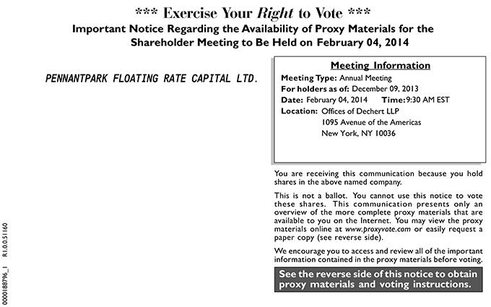

0000188796_1 R1.0.0.51160 *** Exercise Your Right to Vote *** Important Notice Regarding the Availability of Proxy Materials for the Shareholder Meeting to Be Held on February 04, 2014 PENNANTPARK FLOATING RATE CAPITAL LTD. Meeting Information Meeting Type: Annual Meeting For holders as of: December 09, 2013 Date: February 04, 2014Thisime: 9:30 AM EST Location:OfficesofDechertLLP1095AvenueoftheAmericasNewYork,NY10036Youarereceivingthiscommunicationbecauseyouholdsharesintheabovenamedcompany.isnotballot.Youcannot materials use thisnoticetotheseshares.ThispresentsonlyanofthemorecompleteproxymaterialsthatareavailabletoyoutheInternet.Youmayviewtheproxyonlineat
www.proxyvote.com or easily requestcommunicationpapercopy (see reverse side)overview.Wencourage you to access and review all of the important information contained in the proxy materials before voting. See the reverse side of this notice to obtain proxy materials and voting instructions.

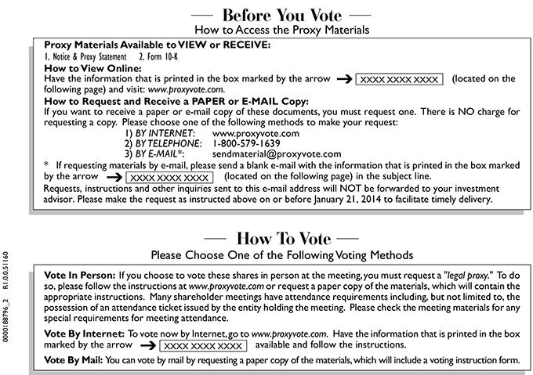

0000188796_2 R1.0.0.51160 Before You Vote How to Access the Proxy Materials Proxy Materials Available to VIEW or RECEIVE: 1. Notice & Proxy Statement 2. Form 10-K How to View Online: Have the
information that is printed in | box marked by the arrow XXXX XXXX XXXX (located on the following page) and visit: www.proxyvote.com. How to Request and Receive |  |  |  |  | PAPER or E-MAIL Copy: If
you want to receive a paper orthe-mail copy of these documents, you must request one. There is NO charge for requesting a copy. Please choose one of |  |  |  |  | following methods to | your request: 1) BY
INTERNET: www.proxyvote.com 2) BY TELEPHONE: 1-800-579-1639 3) BY E-MAIL*: sendmaterial@proxyvote.com * If requesting materials bythe-mail, please send a blankmake-mail with the information that
is printed the box marked by the arrow XXXX XXXX XXXX (located on the following page) in the subject line. Requests, instructions |  |  |  | and other inquiries sent to this e-mail address will NOT be forwarded
to your investment advisor. Please make the request as instructed above on or before |  |  | 21, 2014 facilitate timely delivery. How T | Vote Please Choose One of the Following Voting Methods Vote In
Person: If you choose to vote these shares person at the meeting, you must request January“legal proxy.” Tto do so, please follow the instructions at www.proxyvote.com or request a paper copy of the materials,
which will contain the appropriate instructions. |  | shareholder meetings have attendance requirements including, but not limited to, the possession of an attendance ticket issued by the entity holding the
meeting. Please check the meeting materials forManyspecial requirements for meeting attendance. Vote By Internet: To vote now by Internet, go to www.proxyvote.com. Have the |  |  |  |  |  | that is printed the
box marked by the arrow XXXX XXXX XXXX available and follow the instructions. Vote By Mail: You can vote by mail by requesting a paper copy of the materials, which willinformationinclude voting instruction form.

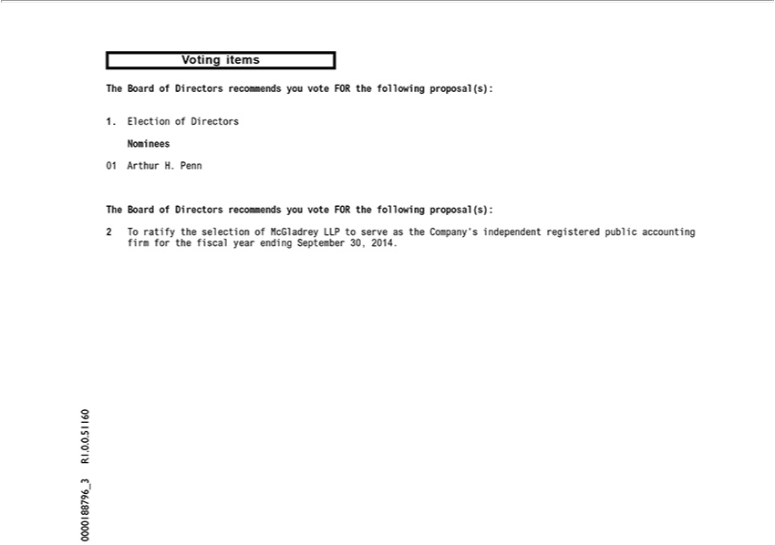

0000188796_2 R1.0.0.51160 Before You Vote How to Access the Proxy Materials Proxy Materials Available to VIEW or RECEIVE: 1. Notice & Proxy Statement 2. Form 10-K How to View Online: Have the
information that is printed in the box marked by the arrow XXXX XXXX XXXX (located on the following page) and visit: www.proxyvote.com. How to Request and Receive PAPER or E-MAIL Copy: If you
ant to receive a paper or e-mail copy of these documents, you must request one. There is NO charge for requesting a copy. Please choose one of the following | to make your request: 1) BY INTERNET:
www.proxyvote.com 2) BY TELEPHONE: 1-800-579-1639 3) BY E-MAIL*: sendmaterial@proxyvote.com * If requesting materials by -mail, please send a blankmethods-mail with the information that is printed in
the box marked by the arrow XXXX XXXX XXXX (located on the following page) in the subject line. Requests, instructions and other inquiries sent to this e-mail address will NOT be forwarded to your
investment advisor. Please make the request as instructed above on or before January 21, 2014 to facilitate timely delivery. How To Vote Please Choose One of the Following Voting M thods Vote In Person: If
you choose to vote these shares person at the meeting, you must request “legal proxy.” To do so, please follow the instructions at www.proxyvote.com or request a paper copy of the materials, which will
ontain the appropriate instructions. Many shareholder meetings have attendance requirements including, but not limited to, the possession of an attendance ticket issued by the entity holding the meeting. Please
check the meeting materials for any special requirements for meeting attendance. Vote By Internet: To vote now by Internet, go to www.proxyvote.com. Have the | that is printed in the box marked by
the arrow XXXX XXXX XXXX available and follow the instructions. Vote By Mail: You can vote by mail by requesting a paper copy of the materials, which willinformationincludevoting instruction form.



0000188796_3 R1.0.0.51160 Voting items The Board of _{Directors} recommends you vote FOR the following proposal(s): 1. Election of Directors Nominees 01 Arthur H. Penn The Board of Directors

recommends you vote FOR the following proposal(s): 2 T ratify the selection of McGladrey LLP to serve as the Company’s independent registered public accounting firm for the fiscal year ending September 30, 2014.

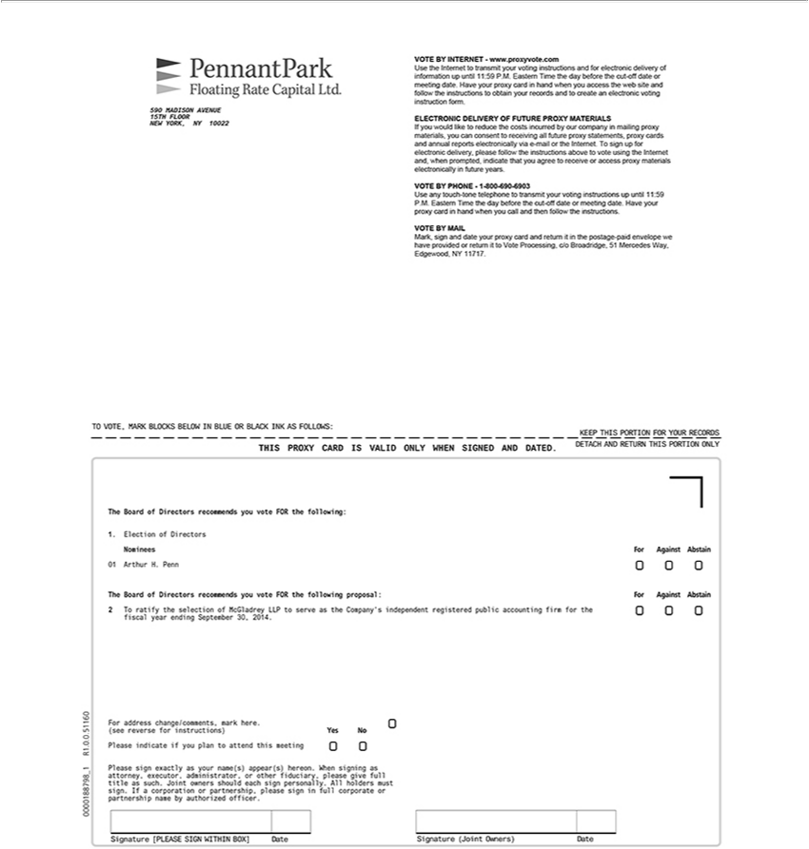

590 MADISON AVENUE | FLOOR NEW YORK, NY 10022 VOTE BY INTERNET - www.proxyvote.com Use the Internet to transmit your voting instructions and for electronic delivery of information
up until 11:59 P.M. Eastern15THime the day before the cut-off date or meeting date. Have your proxy card in hand when you access the web site and follow the |  |  |  | to obtain your records and to create an
electronic voting instruction form. ELECTRONIC DELIVERY OF FUTURE PROXY MATERIALS If you |  | like to reduce the costs incurred by our companyinstructionsmailing proxy materials, you can consent
to receiving all future proxy statements, proxy cards and annual reports electronically via -mail or the Internet.would sign up for electronic delivery, please follow the instructions above to vote using the Internet
and, when prompted, indicate that you agree to receive access proxy materials electronically in future years. VOTE |  |  | BY PHONE - 1-800-690-6903 Use any touch-tone telephone to transmit your voting
instructions up until 11:59 P.M. Eastern Time the day before the cut-off date or meeting date. Have your proxy card in hand when you call and then follow the instructions. VOTE BY MAIL Mark, sign and date
your proxy card and return it in the postage-paid envelope we have provided or return it to Vote Processing, c/o Broadridge, 51 Mercedes Way, Edgewood, NY 11717. TO VOTE, MARK BLOCKS BELOW IN
BLUE OR BLACK INK AS FOLLOWS: KEEP THIS PORTION FOR YOUR RECORDS DETACH AND RETURN |  |  | PORTION ONLY THIS PROXY CARD IS VALID ONLY WHEN SIGNED AND
DATED. The Board of Directors recommends you vote FOR the following: 1. Election of Directors Nominees 01 ArthurTHIS.Penn The Board of Directors recommends you vote FOR the following proposal: 2 To
ratify the selection of McGladrey LLP to serve as the Company’ independent registered public accounting firm for the fiscal year ending September 30, 2014. For Against Abstain For Against Abstain For
ddress | mark here. (see reverse for instructions) Yes No R1.0.0.51160 Please indicate if you plan to attend this meeting 1 _ Please sign exactly as your name(s) appear(s) hereon. When signing
as attorneychange/comments,executoradministrator,_{authorized}otherfiduciary, please give full title as such. Joint owners should each sign personally. All holders must sign. If a corporation or partnership, please sign in full corporate or
0000188798 partnership name by officer. Signature [PLEASE SIGN WITHIN BOX] Date Signature (Joint Owners) Date

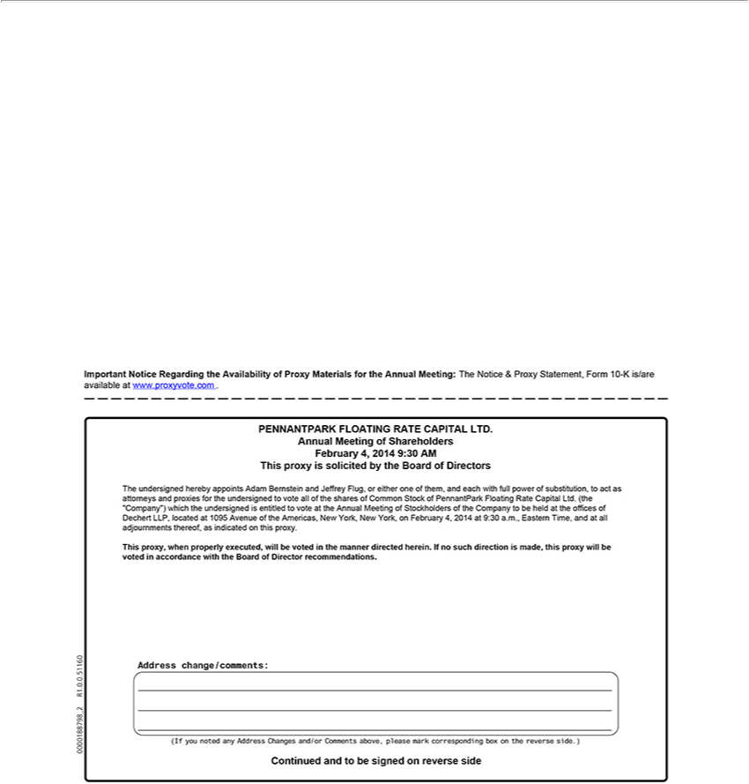

Important Notice Regarding the Availability of Proxy Materials for the Annual Meeting: The Notice & Proxy Statement, Form 10-K is/are available at www.proxyvote.com . PENNANTPARK FLOATING
RATE CAPITAL LTD. Annual Meeting of Shareholders February 4, 2014 9:30 AM This proxy is solicited by the Board of Directors The undersigned hereby appoints Adam Bernstein and Jeffrey Flug, or either
one of them, and each with full power of substitution, to act as attorneys and proxies for the undersigned to vote all of the shares of Common Stock of PennantPark Floating Rate Capital Ltd. (the “Company”)
which the undersigned is entitled to vote at the Annual Meeting of Stockholders of the Company to be held at the offices of Dechert LLP located at 1095 Avenue of the Americas, New York, New York,
February 4, 2014 at 9:30 a.m., Eastern Time, and at all adjournments thereof, as indicated on this proxy. This proxy, when properly executed, will be voted in the manner directed herein. If no such direction is
made, this proxy will be voted in accordance with the Board of | recomme dations. 0000188798_2 R1.0.0.51160 Address change/comments: (If you noted any Address Changes and/or Comments above,
please mark corresponding box on the reverse side.) Continued Directorandbe signed on reverse side

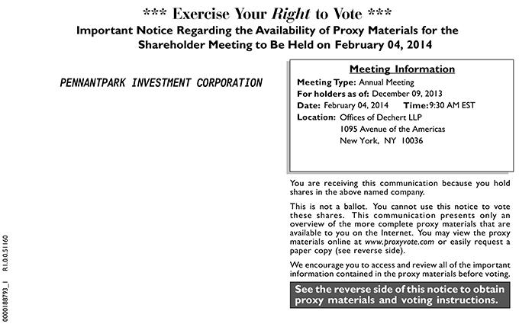

0000188793_1 R1.0.0.51160 *** Exercise Your Right to Vote *** Important Notice Regarding the Availability of Proxy Materials for the Shareholder Meeting to Be Held on <mtgdate>. February 04, 2014
PENNANTPARK INVESTMENT CORPORATION Meeting Information Meeting Type: Annual <mtgtype> Meeting For holders as of: December <recdate> 09, 2013 Date: February 04, 2014 Time: 9:30
<mtgtime> AM EST Location: Offices of Dechert LLP 1095 Avenue of the Americas New York, NY 10036 You are receiving this communication because you hold shares in the above named company. This is
not a ballot. You cannot use this notice to vote these shares. This communication presents only an | of the more complete proxy materials that are available to you the Internet. You may view the
proxy materials online at www.proxyvote.com or easily request_{materials}paper copy (see reverse side). Woverviewencourage you to access and review all of the important information contained in the proxy materials before
voting. See the reverse side of this notice to obtain proxy and voting instructions.

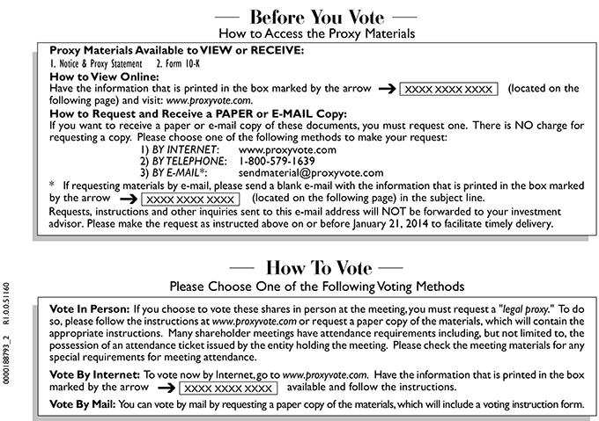

0000188793_2 R1.0.0.51160 Before You Vote How to Access the Proxy Materials Proxy Materials Available to VIEW or RECEIVE: 1. Notice & Proxy Statement 2. Form 10-K How to View Online: Have the
information that is printed in the box marked by the arrow XXXX XXXX XXXX (located on the following page) and visit: www.proxyvote.com. How to Request and Receive PAPER or E-MAIL Copy: If you
ant to receive a paper or e-mail copy of these documents, you must request one. There is NO charge for requesting a copy. Please choose one of the following | to make your request: 1) BY INTERNET:
www.proxyvote.com 2) BY TELEPHONE: 1-800-579-1639 3) BY E-MAIL*: sendmaterial@proxyvote.com * If requesting materials by -mail, please send a blankmethods-mail with the information that is printed in
the box marked by the arrow XXXX XXXX XXXX (located on the following page) in the subject line. Requests, instructions and other inquiries sent to this e-mail address will NOT be forwarded to your
investment advisor. Please make the request as instructed above on or before January 21, 2014 to facilitate timely delivery. How To Vote Please Choose One of the Following Voting M thods Vote In Person: If
you choose to vote these shares person at the meeting, you must request “legal proxy.” To do so, please follow the instructions at www.proxyvote.com or request a paper copy of the materials, which will
ontain the appropriate instructions. Many shareholder meetings have attendance requirements including, but not limited to, the possession of an attendance ticket issued by the entity holding the meeting. Please
check the meeting materials for any special requirements for meeting attendance. Vote By Internet: To vote now by Internet, go to www.proxyvote.com. Have the | that is printed in the box marked by
the arrow XXXX XXXX XXXX available and follow the instructions. Vote By Mail: You can vote by mail by requesting a paper copy of the materials, which willinformationincludevoting instruction form.

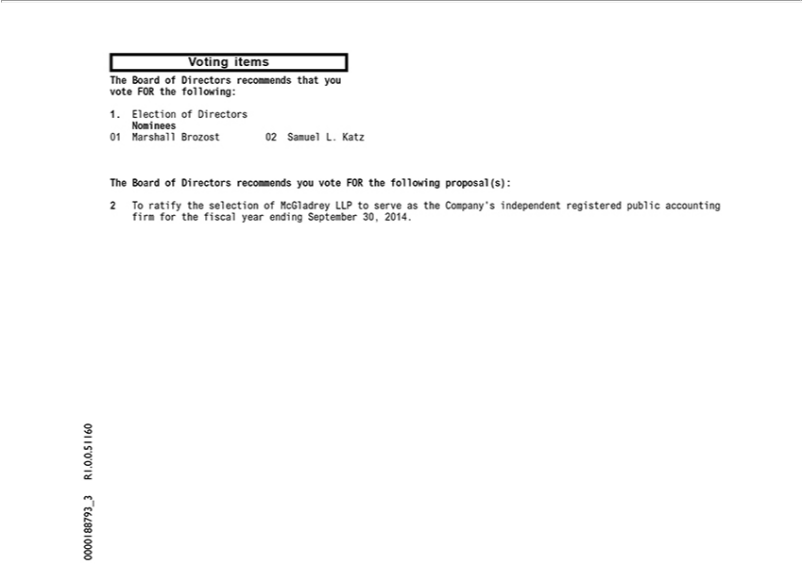

0000188793_3 R1.0.0.51160 Voting items The Board of Directors _{recommends} that you vote FOR the following: 1. Election of _{Directors} Nominees 01 Marshall Brozost 02 Samuel L. Katz The Board of

Directors recommends you vote FOR the following proposal(s): 2 T ratify the selection of McGladrey LLP to serve as the Company’ independent registered public accounting firm for the fiscal year ending September 30, 2014.



0000188793_4 R1.0.0.51160 Voting Instructions

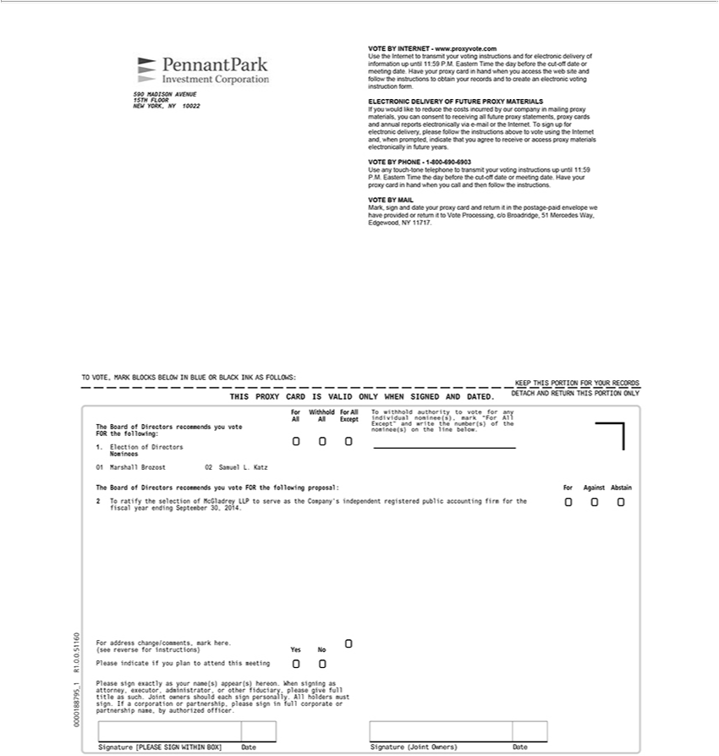

590 MADISON AVENUE | FLOOR NEW YORK, NY 10022 VOTE BY INTERNET - www.proxyvote.com Use the Internet to transmit your voting instructions and for electronic delivery of information
up until 11:59 P.M. Eastern15THime the day before the cut-off date or meeting date. Have your proxy card in hand when you access the web site and follow the |  |  |  | to obtain your records and to create an
electronic voting instruction form. ELECTRONIC DELIVERY OF FUTURE PROXY MATERIALS If you |  | like to reduce the costs incurred by our companyinstructionsmailing proxy materials, you can consent
to receiving all future proxy statements, proxy cards and annual reports electronically via -mail or the Internet.would sign up for electronic delivery, please follow the instructions above to vote using the Internet
and, when prompted, indicate that you agree to receive access proxy materials electronically in future years. VOTE BY PHONE - 1-800-690-6903 Use any touch-tone telephone to transmit your voting
instructions up until 11:59 P.M. Eastern Time the day before the cut-off date or meeting date. Have your proxy card in hand when you call and then follow the instructions. VOTE BY MAIL Mark, sign and date
your proxy card and return it in the postage-paid envelope we have provided or return it to Vote Processing, c/o Broadridge, 51 Mercedes Way, Edgewood, NY 11717. TO VOTE, MARK BLOCKS BELOW IN
BLUE OR BLACK INK AS FOLLOWS: KEEP THIS PORTION FOR YOUR RECORDS DETACH AND RETURN THIS PORTION ONLY THIS PROXY CARD IS VALID ONLY WHEN SIGNED AND
DATED. The Board of Directors recommends you vote FOR the following: 1. Election of Directors Nominees 01 Marshall Brozost 02 Samuel L. Katz For Withh ld For All All All Except T withhold
o vote for any individual nominee(s), mark “For All Except” and write the number(s) of the nominee(s) on the line below. The Board of Directors recommends you vote FOR the following proposal: 2 Tauthorityratify
the selection of McGladrey LLP to serve as the Company’ independent registered public accounting firm for the fiscal year ending September 30, 2014. For Against Abstain 0000188795_1 R1.0.0.51160 For
address | mark here. (see reverse for instructions) Please indicate if you plan to attend this meeting Yes No Please sign |  | as your name(s) appear(s) hereon. When signing as attorney,
executorchange/comments,administratoror other fiduciary, please give full title as such. Joint owners should each sign personally. All holders must sign. Ifexactlycorporation or partnership, please sign in full corporate or partnership name, by authorized officer. Signature [PLEASE SIGN WITHIN BOX] Date Signature (Joint Owners) Date

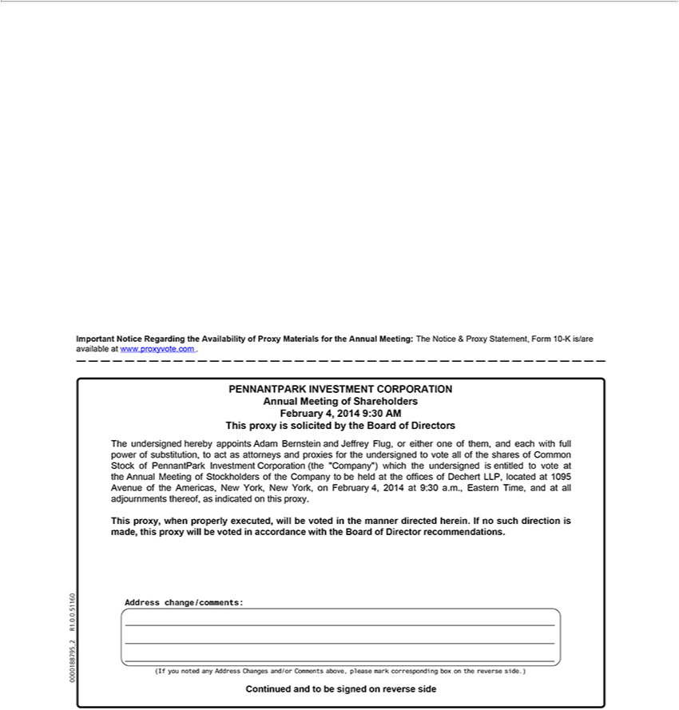

side0000188795Important_2 NoticeR1.0.0.51160RegardingAddressthe^{Annual}change/comments:vailabilityofProxy(IfMaterialsyounotedforanythe AddressAnnual Meeting:Changes Theand/orNoticeComments&Proxyabove,Statement,please Formmark 10corresponding-Kis/areavailableboxonatthewww.proxyvote.comreverseside.)Continued.PENNANTPARKandtobesigned on reverse
INVESTMENT CORPORATION Meeting of Shareholders February 4, 2014 9:30 AM This proxy is solicited by the Board of Directors The undersigned hereby appoints Adam_{Investment}Brnstein and Jeffrey
Flug, or either one of them, and each with full power of substitution, to act as attorneys and proxies for the undersigned to vote all of the shares of Common Stock of PennantPark Corporation (the “Company”) which the undersigned is entitled to vote at the Annual Meeting of Stockholders of the Company to be held at the offices of Dechert LLP, located at 1095 Avenue of the Americas, New York, New _{direction}York, February 4, 2014 at 9:30 a.m., Eastern Time, and at all adjournments thereof,_{recommendations}asindicated this proxy. This proxy, when properly executed, will be voted in the manner directed herein. If no such
is made, this proxy will be voted in accordance with the Board of Director .

