SCHEDULE 14A

(RULE 14a-101)

Information Required in Proxy Statement

Schedule 14A Information

Proxy Statement Pursuant to Section 14(a) of the Securities

Exchange Act of 1934

Filed by the Registrant x

Filed by a Party other than the Registrant ☐

Check the appropriate box:

- Preliminary Proxy Statement

- Confidential,₍₂₎₎ for Use of the Commission Only (as permitted by Rule 14a-6(e)

- Definitive Proxy Statement ☐ Definitive Additional Material

☐ Soliciting Material Pursuant to Rule 14a-12

PennantPark Investment Corporation

PennantPark Floating Rate Capital Ltd.

(Name of Registrant as Specified in Its Charter)

(Name of Person(s) Filing Proxy Statement if other than the Registrant)

Payment of Filing Fee (Check the appropriate box):

- No fee required.

- Fee computed on table below per Exchange Act Rules 14a-6(i)(1) and 0-11.

  - Title of each class of securities to which transaction applies:

___________________________________________________________________________________________________________

  - Aggregate number of securities to which transaction applies:

___________________________________________________________________________________________________________

  - Per unit price or other underlying value of transaction computed pursuant to Exchange Act Rule 0-11 (Set forth the amount on which the filing fee is calculated and state how it was determined):

___________________________________________________________________________________________________________

  - Proposed maximum aggregate value of transaction:

___________________________________________________________________________________________________________

  - Total fee paid:

___________________________________________________________________________________________________________

- Fee paid previously with preliminary materials

- Check box if any part of the fee is offset as provided by Exchange Act Rule 0-11(a)(2) and identify the filing for which the offsetting fee was paid previously. Identify the previous filing by registration statement number, or the form or schedule and the date of its filing.
  - Amount previously paid:

___________________________________________________________________________________________________________

  - Form, schedule or registration statement no.:

___________________________________________________________________________________________________________

  - Filing party:

___________________________________________________________________________________________________________

  - Date filed:

___________________________________________________________________________________________________________




December 21, 2011

Dear Stockholder:

You are cordially invited to attend the 2012 Joint Annual Meeting of Stockholders of PennantPark Investment Corporation (“PNNT”) and PennantPark Floating Rate Capital Ltd. (“PFLT” and PNNT each, a "Company" and together, “the Companies”) to be held on February 7, 2012 at 9:30 a.m., Eastern Time, at the offices of Dechert LLP, located at 1095 Avenue of the Americas, New York, New York.

The Notice of Joint Annual Meeting of Stockholders and the Joint Proxy Statement of the Boards of Directors of the Companies, which is accessible on the Internet or by request, provides an outline of the business to be conducted at the Joint Annual Meeting of Stockholders. At the meeting, you will be asked to: (1) elect two directors for your Company, and (2) ratify the selection of KPMG LLP as your Company's independent registered public accounting firm for the fiscal year ending September 30, 2012. I will also report on the progress of the Companies during the past year and respond to stockholders' questions.

It is important that your shares be represented at the Joint Annual Meeting of Stockholders. If you are unable to attend the meeting in person, I urge you to follow the instructions on the Notice of Internet Availability of Proxy Materials to vote your proxy on the Internet. We encourage you to vote via the Internet, as it saves us significant time and processing costs. However, on the Notice of Internet Availability of Proxy Materials you also will find instructions on how to request a hard copy of the Joint Proxy Statement and proxy card(s) for your Company free of charge and you may vote your proxy by returning your proxy card(s) to us after you request the hard copy materials. Your vote and participation in the governance of your Company is very important to us.

Sincerely yours,
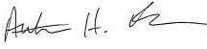

Arthur H. Penn

Chief Executive Officer

PennantPark
590 Madison Avenue, 15th Floor
New York, New York 10022

212-905-1000

PENNANTPARK INVESTMENT CORPORATION

PENNANTPARK FLOATING RATE CAPITAL LTD.

NOTICE OF JOINT ANNUAL MEETING OF STOCKHOLDERS

TO BE HELD ON FEBRUARY 7, 2012

December 21, 2011

Notice is hereby given to the owners of shares of common stock (the “Stockholders”) of PennantPark Investment Corporation (“PNNT”) and

PennantPark Floating Rate Capital Ltd. (“PFLT” and PNNT each, a "Company" and together, the “Companies”) that:

The 2012 Joint Annual Meeting of Stockholders of the Companies (the "Annual Meeting") will be held at the offices of Dechert LLP, located at 1095

Avenue of the Americas, New York, New York, on February 7, 2012 at 9:30 a.m., Eastern Time, for the following purposes, as to each Company:

- To elect two directors to the Board of the Company who will each serve for a term of three years or until his successor is duly elected and qualifies; and

- To ratify the selection of KPMG LLP to serve as the Company's independent registered public accounting firm for the fiscal year ending September 30, 2012.

You have the right to receive notice of, and to vote at, the Annual Meeting if you were a stockholder of record of PNNT at the close of business on December 13, 2011, and/or a stockholder of record of PFLT at the close of business on December 14, 2011. The Companies are furnishing a Joint Proxy Statement and proxy card(s) to their Stockholders on the Internet, rather than mailing printed copies of those materials to each Stockholder. If you received a Notice of Internet Availability of Proxy Materials by mail, you will not receive a printed copy of the Joint Proxy Statement and proxy card(s) unless you request them. Instead, the Notice of Internet Availability of Proxy Materials will instruct you as to how you may access and review the Joint Proxy Statement, and vote your proxy, on the Internet.

Your vote is extremely important to us. If you are unable to attend the Annual Meeting, we encourage you to vote your proxy on the Internet by following the instructions provided on the Notice of Internet Availability of Proxy Materials. You may also request from us free of charge hard copies of the Joint Proxy Statement and proxy card(s) for your Company by following the instructions on the Notice of Availability of Proxy Materials. As to each Company, in the event there are not sufficient votes for a quorum or to approve that Company's proposals at the time of the Annual Meeting, the Annual Meeting may be adjourned in order to permit further solicitation of proxies by the Company.

EACH COMPANY'S BOARD OF DIRECTORS, INCLUDING THE INDEPENDENT DIRECTORS, UNANIMOUSLY RECOMMENDS THAT YOU VOTE “FOR” EACH OF THE PROPOSALS.

By Order of the Boards of Directors,
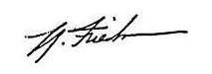

Thomas Friedman

Secretary

PennantPark
590 Madison Avenue, 15th Floor
New York, New York 10022

212-905-1000

This is an important meeting. To ensure proper representation at the meeting, please follow the instructions on the Notice of Internet Availability of Proxy Materials to vote your proxy via the Internet or request, complete, sign, date and return a proxy card. Even if you vote your shares prior to the meeting, you still may attend the meeting and vote your shares in person if you wish to change your vote.

PENNANTPARK INVESTMENT CORPORATION

PENNANTPARK FLOATING RATE CAPITAL LTD.

590 Madison Avenue, 15th Floor

New York, New York 10022

- 905-1000

JOINT PROXY STATEMENT

For

2012 Joint Annual Meeting of Stockholders

To Be Held on February 7, 2012

This document will give you the information you need to vote on the matters listed on the accompanying Notice of Joint Annual Meeting of Stockholders (“Notice of Annual Meeting”). Much of the information in this Joint Proxy Statement is required under the rules and regulations of the Securities and Exchange Commission (“SEC”), and some of it is technical in nature. If there is anything you do not understand, please contact us at 212-905-1000.

This Joint Proxy Statement is furnished in connection with the solicitation of proxies by the Boards of Directors (each a “Board” and together, the "Boards") of PennantPark Investment Corporation (“PNNT”) and PennantPark Floating Rate Capital Ltd. (“PFLT” and PNNT each a "Company" and together, the “Companies,” “we,” “us” or “our”), for use at the Companies' 2012 Joint Annual Meeting of Stockholders (the “Meeting”) to be held on Tuesday, February 7, 2012 at 9:30 a.m., Eastern Time, at the offices of Dechert LLP, located at 1095 Avenue of the Americas, New York, New York, and at any postponements or adjournments thereof. This Joint Proxy Statement and the Companies' Annual Reports for the fiscal year (or, for PFLT, partial fiscal year) ended September 30, 2011 are being provided to stockholders of the relevant Companies (the “Stockholders”) via the Internet on or about December 21, 2011. In addition, a Notice of Annual Meeting and a Notice of Internet Availability of Proxy Materials are being sent to Stockholders of record of PNNT as of December 13, 2011, and Stockholders of record of PFLT as of December 14, 2011.

Although each Company is a separate business development company that holds an annual meeting of stockholders, the Companies' Proxy Statements have been combined into this Joint Proxy Statement to reduce expenses to the Companies of soliciting proxies for the Meeting.

We encourage you to vote your shares, either by voting in person at the Meeting or by voting by proxy (i.e., authorizing someone to vote your shares). Shares represented by duly executed proxies will be voted in accordance with your instructions. If you execute a proxy without specifying your voting instructions, your shares will be voted in accordance with the recommendation of your Company's Board. If any other business is brought before the Meeting, your shares will be voted at the Board's discretion unless you specifically state otherwise on your proxy.

You may revoke a proxy at any time before it is exercised by notifying your Company's Secretary in writing, by submitting a properly executed, later-dated proxy, or by voting in person at the Meeting. Any Stockholder entitled to vote at the Meeting may attend the Meeting and vote in person, whether or not he or she has previously voted his or her shares via proxy or wishes to change a previous vote.

You will be eligible to vote your shares electronically via the Internet, by telephone or by mail.

Purpose of Meeting

At the Meeting, you will be asked to vote on the following proposals for your Company:

- To elect two directors to the Board of the Company who will each serve for a term of three years or until his successor is duly elected and qualifies; and

- To ratify the selection of KPMG LLP to serve as the Company's independent registered public accounting firm for the fiscal year ending September 30, 2012.

Voting Securities

You may vote your shares at the Meeting only if you were a Stockholder of record of PNNT at the close of business on December 13, 2011, and/or a Stockholder of record of PFLT at the close of business on December 14, 2011 (each, a “Record Date”). There were 45,689,781 shares of PNNT common stock and 6,850,667 shares of PFLT common stock (the “Common Stock”) outstanding on the Record Dates. Stockholders are entitled to one vote for each share held of Common Stock of their Company. Stockholders can vote only on matters affecting the Company (or Companies) in which they hold shares of Common Stock. Because the proposals stated above and in the Notice of Annual Meeting are separate for each Company, it is essential that Stockholders who own shares in both Companies vote by Internet, telephone or mail in accordance with the instructions on the proxy card(s), with respect to each proxy card they receive.

Quorum Required

For a Company to conduct business at the Meeting, a quorum of that Company must be present at the Meeting. The presence at the Meeting, in person or by proxy, of the holders of a majority of the shares of Common Stock of a Company outstanding on the Record Date will constitute a quorum of such Company. Shares held by a broker or other nominee for which the nominee has not received voting instructions from the record holder, and does not have discretionary authority to vote the shares on non-routine proposals (which are considered “broker non-votes” with respect to such proposals), will be treated as shares present for quorum purposes. If there are not enough votes for a quorum of a Company, the chairman of the Meeting will adjourn the Meeting with respect to that Company to permit the further solicitation of proxies.

Votes Required

Election of Director

For each Company, the election of a director to the Board of the Company requires the vote of a majority of the Company's outstanding shares of Common Stock. Stockholders of a Company may not cumulate their votes. If you vote “Withhold Authority” with respect to a nominee, your shares will not be voted with respect to the person indicated. Because a director is elected by a majority of the votes of the outstanding Common Stock of the associated Company, votes to withhold authority, or no votes, will have the effect of a vote against the nominee.

Ratification of Independent Registered Public Accounting Firm

For each Company, the affirmative vote of a majority of the votes of that Company cast at the Meeting in person or by proxy is required to ratify the appointment of KPMG LLP to serve as such Company's independent registered public accounting firm. Abstentions will not be included in determining the number of votes cast and, as a result, will have no effect on this proposal.

Broker Non-Votes

Broker non-votes are described as votes cast by a broker or other nominee on behalf of a beneficial holder who does not provide explicit voting instructions to such broker or nominee and who does not attend the Meeting. Proposal 1 is a non-routine matter for both Companies. As a result, if you hold shares of a Company's Common Stock in “street name” through a broker, bank or other nominee, your broker, bank or nominee will not be permitted to exercise voting discretion with respect to Proposal 1 for that Company. Thus, if you do not give your broker or nominee specific instructions on how to vote for you or do not vote for yourself in accordance with the voting instructions in the Notice of Internet Availability of Proxy Materials or by requesting hard copy proxy materials from us and returning a proxy card or by other arrangement with your broker or nominee, your shares will have the effect of a vote against Proposal 1 for your Company.

Proposal 2 is a routine matter for both Companies. As a result, if you beneficially own shares of Common Stock of a Company and you do not provide your broker or nominee with proxy instructions, either by voting in accordance with the instructions on the Notice of Internet Availability of Proxy Materials or by requesting hard copy proxy materials from us and returning a proxy card or by other arrangement with your broker or nominee, your broker or nominee will be able to vote your shares for you on this routine matter.

Adjournment and Additional Solicitation. As to each Company, if there appear not to be enough votes to approve a proposal at the Meeting, the Stockholders of such Company who are represented in person or by proxy may vote to adjourn the Meeting with respect to that Company to permit further solicitation of proxies. Messrs. Marshall Brozost and Samuel L. Katz are the persons named as proxies for

2

PNNT and will vote proxies held by them for such adjournment, unless marked to be voted against any proposal for which an adjournment is sought, to permit the further solicitation of proxies. Messrs. Adam Bernstein and Jeffrey Flug are the persons named as proxies for PFLT and will vote proxies held by them for such adjournment, unless marked to be voted against any proposal for which an adjournment is sought, to permit the further solicitation of proxies.

A Stockholder vote may be taken on any of the proposals in this Joint Proxy Statement prior to any such adjournment if there are sufficient votes for approval of such proposal.

Information Regarding This Solicitation

Each Company will bear the expense of its solicitation of proxies for the Meeting, including the cost of preparing and posting this Joint Proxy Statement and the Annual Reports to the Internet and the cost of mailing the Notice of Annual Meeting, the Notice of Internet Availability of Proxy Materials and any requested proxy materials to their respective Stockholders. The Companies intend to use the services of Broadridge Financial Solutions, Inc., a leading provider of investor communications solutions, to aid in the distribution and collection of proxy votes. The Companies expect to pay market rates for such services. If brokers, trustees, or fiduciaries and other institutions holding shares in their own names or in the names of their nominee, which shares are beneficially owned by others, forward the Joint Proxy Statement and relevant proxy card(s) to, and obtain proxies from, such beneficial owners, the applicable Company will reimburse such persons for their reasonable expenses in so doing.

In addition to the solicitation of proxies by the use of the Internet, proxies may be solicited in person and/or by telephone, mail or facsimile transmission by directors or officers of the Companies, officers or employees of PennantPark Investment Advisers, LLC, the Companies' investment adviser (the “Adviser”), PennantPark Investment Administration, LLC, the Companies' administrator (the “Administrator”), and/or by a retained solicitor. No additional compensation will be paid to such directors, officers or regular employees for such services. If the Companies retain a solicitor, the Companies have estimated that they will pay approximately $30,000 for such services. If the Companies engage a solicitor, you could be contacted by telephone on behalf of your Company and be urged to vote. The solicitor will not attempt to influence how you vote your shares, but only ask that you take the time to cast a vote. You may also be asked if you would like to vote over the telephone and to have your vote transmitted to our proxy tabulation firm. The address of each of the Adviser and the Administrator is 590 Madison Avenue, 15th Floor, New York, New York 10022.

Stockholders may provide their voting instructions through the Internet, by telephone or by mail by following the instructions on the Notice of Availability of Proxy Materials. These options require Stockholders to input the Control Number, which is provided with the Notice of Availability of Proxy Materials. If you vote using the Internet, after visiting www.proxyvote.com and inputting your Control Number, you will be prompted to provide your voting instructions. Stockholders will have an opportunity to review their voting instructions and make any necessary changes before submitting their voting instructions and terminating their Internet link. Stockholders who vote via the Internet, in addition to confirming their voting instructions prior to submission, also will receive an e-mail confirming their instructions upon request.

If a Stockholder wishes to participate in the Meeting, but does not wish to give a proxy by Internet, the Stockholder may attend the Meeting in person or request and submit a proxy card by following the instructions on the Notice of Availability of Internet Proxy Materials.

Any proxy authorized pursuant to this solicitation may be revoked by notice from the person giving the proxy at any time before it is exercised. A revocation may be effected by resubmitting voting instructions via the Internet voting site, by telephone, by obtaining and properly completing another proxy card that is dated later than the original proxy and returning it, by mail, in time to be received before the Meeting, by attending the Meeting or by a notice, provided in writing and signed by the Stockholder, delivered to the Companies' Secretary on any business day before the date of the Meeting.

Security Ownership of Certain Beneficial Owners and Management

As of the Record Dates, to our knowledge, no person would be deemed to "control" (as such term is defined in the Investment Company Act of 1940, as amended (the “1940 Act”)) either Company.

Each Company's Board is composed of the same individuals. Our directors consist of an interested director and four independent directors. An interested director is an “interested person” of the Companies, as defined in the 1940 Act, and independent directors are all

3

other directors (the “Independent Directors”).

The following table sets forth, as of December 2, 2011, certain ownership information with respect to each Company's Common Stock for those persons who directly or indirectly own, control or hold with the power to vote, 5 percent or more of a Company's outstanding Common Stock and all officers and directors of the Companies, as a group.

 |  |  |  |  |  |  |  |  |  |  |  |  |  |  | Percentage of
 |  |  |  |  |  |  |  |  |  |  |  |  |  |  | Common Stock
 | Name and address | (1) |  | Type of ownership | (5) |  |  |  | Shares Owned |  |  |  |  |  | Outstanding
 |  |  |  |  |  |  | PNNT |  |  |  | PFLT |  |  |  | PNNT |  |  | PFLT
 | Morgan Stanley and Co. Inc.
 | 1585 Broadway
 | New York, NY 10036-8293 |  |  | Record/Beneficial |  |  |  | — |  |  | 390,422 |  |  |  | — |  |  | 5.7%
 | Independent directors
 | Adam K. Bernstein⁽²⁾ |  |  | Record/Beneficial |  |  | 88,971 |  |  |  | 5,000 |  |  |  | * |  |  | *
 | Marshall Brozost |  |  | Record/Beneficial |  |  | 11,043 |  |  |  |  | — |  |  | * |  |  | —
 | Jeffrey Flug |  |  | Record/Beneficial |  |  | 102,358 |  |  |  |  | — |  |  | * |  |  | —
 | Samuel L. Katz |  |  | Record/Beneficial |  |  | 113,482 |  |  |  | 29,500 |  |  |  | * |  |  | *
 | Interested director
 | Arthur H. Penn⁽³⁾⁽⁴⁾ |  |  | Record/Beneficial |  |  | 499,475 |  |  |  | 667 |  |  |  | 1.1% |  |  | *
 | Executive officer
 | Aviv Efrat |  |  | Record/Beneficial |  |  | 40,294 |  |  |  | 5,750 |  |  |  | * |  |  | *
 | All directors and executive officer as a group (6 persons) |  |  |  |  |  | 855,623 |  |  |  | 40,917 |  |  |  | 1.9% |  |  | *
—————

- The address for each officer and director is c/o PennantPark, 590 Madison Avenue, 15th Floor, New York, New York 10022.
- Mr. Bernstein is the President of JAM Investments, LLC and may therefore be deemed to own beneficially the 68,236 shares of PNNT held by JAM Investments, LLC.

- Mr. Penn is the Managing Member of the Adviser, and may therefore be deemed to own beneficially the 309,791 shares of PNNT and 667 shares of PFLT held by the Adviser.

- For PFLT, the Adviser paid to the Company's underwriters 2% of the sales load, or $2.1 million in the aggregate, with respect to the initial public offering and exercise of the over-allotment option of shares of PFLT's Common Stock. PFLT (and indirectly its Stockholders) are obligated to repay this amount if certain conditions occur. If one or more of these conditions does not occur on or before April 7, 2014, PFLT will not be obligated to repay this amount. PFLT will repay such amount to the Adviser in cash, and the Adviser has agreed to use such payment to purchase shares of PFLT's Common Stock in the secondary market.

- Sole Voting Power.

* Less than 1 percent.

Section 16(a) Beneficial Ownership Reporting Compliance

Pursuant to Section 16(a) of the Securities Exchange Act of 1934, as amended (the “Exchange Act”), each Company's directors and other executive officer, and any persons holding more than 10% of that Company's Common Stock, are required to report their beneficial ownership and any changes therein to the SEC and the Company. Specific due dates for those reports have been established, and the Companies are required to report herein any failure to file such reports by those due dates. Based on the Companies' review of Forms 3, 4 and 5 filed by such persons and information provided by the Companies' directors and other executive officer, the Companies believes that during the fiscal year (or, for PFLT, partial fiscal year) ended September 30, 2011, all Section 16(a) filing requirements applicable to such persons were met in a timely manner, except that the Form 3s for the directors and officers of PFLT were filed late due to an administrative oversight.

4

Dollar Range of Securities Beneficially Owned by Directors

The following table sets forth the dollar range of each Company's Common Stock beneficially owned by each of our directors as of December 2, 2011.

Information as to beneficial ownership is based on information furnished to the Companies by such persons.

Directors of the Companies |  |  |  | Dollar Range of the Common Stock of the Companies |  |  |  |  |  | (1)
Independent directors |  |  | PNNT |  |  |  | PFLT |  |  |  |  | Total
Adam K. Bernstein⁽²⁾ |  | $500,001 - $1,000,000 |  |  |  | $50,001 - $100,000 |  |  | $500,001 - $1,000,000
Marshall Brozost |  | $100,001 - $500,000 |  |  |  |  | None |  | $50,001 - $100,000
Jeffrey Flug |  | Over $1,000,000 |  |  |  |  | None |  | $500,001 - $1,000,000
Samuel L. Katz |  | Over $1,000,000 |  |  |  | $100,001 - $500,000 |  |  | Over $1,000,000
Interested director
Arthur H. Penn⁽³⁾⁽⁴⁾ |  | Over $1,000,000 |  |  |  | $1 - $10,000 |  |  | Over $1,000,000

—————

- Dollar ranges are as follows: None; $1-$10,000; $10,001-$50,000; $50,001-$100,000; $100,001-$500,000; $500,001-$1,000,000 or over $1,000,000.

- Also reflects holdings of JAM Investments, LLC.

- Also reflects holdings of the Adviser.

- For PFLT, the Adviser paid to the Company's underwriters 2% of the sales load, or $2.1 million in the aggregate, with respect to the initial public offering and exercise of the over-allotment option of shares of PFLT's Common Stock. PFLT (and indirectly its Stockholders) are obligated to repay this amount if certain conditions occur. If one or more of these conditions does not occur on or before April 7, 2014, PFLT will not be obligated to repay this amount. PFLT will repay such amount to the Adviser in cash, and the Adviser has agreed to use such payment to purchase shares of PFLT's Common Stock in the secondary market.

5

PROPOSAL 1: ELECTION OF DIRECTORS

In accordance with its bylaws, each of the Companies currently has five members on its Board of Directors. Directors are divided into three classes and are elected for staggered terms of three years each, with a term of office of one of the three classes of directors expiring each year. Each director will hold office for the term to which he is elected or until his successor is duly elected and qualifies. After this election, the terms of Class I, II and III will expire as follows:

Companies |  | Class I |  | Class II |  |  | Class III
PennantPark Investment Corporation |  | 2014 |  | 2015 |  |  | 2013
PennantPark Floating Rate Capital Ltd. |  | 2015 |  | 2013 |  |  | 2014

A Stockholder can vote for, or withhold his or her vote from, any nominee for his or her Company's Board. In the absence of instructions to the contrary, it is the intention of the persons named as proxies to vote such proxy FOR the election of each nominee named below. If a nominee should decline or be unable to serve as a director, it is intended that the proxy will be voted for the election of such person as is nominated by the relevant Board as a replacement. The Boards have no reason to believe that either of their nominees will be unable or unwilling to serve.

EACH BOARD OF DIRECTORS, INCLUDING ITS INDEPENENT DIRECTORS, UNANIMOUSLY RECOMMENDS THAT YOU VOTE FOR THE ELECTION OF THE NOMINEES NAMED IN THIS JOINT PROXY STATEMENT.

Information about the Nominees and Directors

Certain information with respect to the nominees for election at the Meeting, as well as each of the other directors, is set forth below, including their names, ages, a brief description of their recent business experience, including present occupations and employment, certain directorships that each person holds, and the year in which each person became a director of each Company. The nominees currently serve as directors of each Company.

Each of Mr. Adam K. Bernstein and Mr. Jeffrey Flug has been nominated for election as a Class II director of PNNT for a three year term expiring in 2015. Neither Mr. Bernstein nor Mr. Flug is being proposed for election pursuant to any agreement or understanding between either Mr. Bernstein or Mr. Flug and PNNT.

Each of Mr. Marshall Brozost and Mr. Samuel L. Katz has been nominated for election as a Class I director of PFLT for a three year term expiring in 2015. Neither Mr. Brozost nor Mr. Katz is being proposed for election pursuant to any agreement or understanding between either Mr. Brozost or Mr. Katz and PFLT.

6

Nominees for Directors

 |  |  | Company, |  | Principal
 |  |  | Term of Office |  | Occupation(s)
 | Position(s) held |  | and Length of |  | During the Past 5
Name, Address and Age⁽¹⁾ | with Company |  | Time Served |  | Years
Independent Directors
Adam K. Bernstein (48) | Director |  | PNNT - Class II |  | President of The Bernstein
 | Nominee |  | Director since |  | Companies, a Washington, D.C.-
 |  |  | February 2007; |  | based real estate firm that he joined
 |  |  | Term Expires |  | in 1986. Mr. Bernstein also serves
 |  |  | 2015 |  | as the President and Chief
 |  |  |  |  | Executive Officer of Consortium
 | Director |  | PFLT - Class II |  | Atlantic Realty Trust, Inc., a
 |  |  | Director since |  | private real estate investment trust
 |  |  | October 2010; |  | operating in the Mid-Atlantic
 |  |  | Term Expires 2013 |  | region since its formation in 2000.
Marshall Brozost (44) | Director |  | PNNT - Class I |  | A Partner at the international law
 |  |  | Director since |  | firm of Dewey & LeBoeuf LLP
 |  |  | February 2007; |  | since 2007, where he practices in
 |  |  | Term Expires 2014 |  | the real estate and private equity
 |  |  |  |  | groups. Prior to his tenure at
 | Director |  | PFLT - Class I |  | Dewey & LeBoeuf LLP, which
 | Nominee |  | Director since |  | began in 2005, Mr. Brozost
 |  |  | October 2010; |  | practiced law at O'Melveny &
 |  |  | Term Expires 2015 |  | Myers LLP and at Solomon &
 |  |  |  |  | Weinberg LLP from 2001 to 2005.
Jeffrey Flug (49) | Director |  | PNNT - Class II |  | Mr. Flug has held a variety of
 | Nominee |  | Director since |  | senior positions, including,
 |  |  | February 2007; |  | currently, President of Union
 |  |  | Term Expires |  | Square Hospitality Group, an
 |  |  | 2015 |  | exclusive chain of restaurants. Mr.
 |  |  |  |  | Flug also has served as Chief
 | Director |  | PFLT - Class II |  | Executive Officer and Executive
 |  |  | Director since |  | Director from 2006 to 2008 of
 |  |  | October 2010; |  | Millennium Promise Alliance, Inc.,
 |  |  | Term Expires 2013 |  | a non-profit organization whose
 |  |  |  |  | mission is to eradicate extreme
 |  |  |  |  | global poverty. From 2000 to 2006,
 |  |  |  |  | Mr. Flug was a Managing Director
 |  |  |  |  | and Head of North American
 |  |  |  |  | Institutional Sales at JP Morgan's
 |  |  |  |  | Investment Bank.

7

Other

Directorships

Held by Director

or Nominee for Director During the Past 5 Years ⁽²⁾

None.

None.

None.

 |  |  |  |  |  |  | Other
 |  |  |  |  |  |  | Directorships
 |  |  |  |  |  |  | Held by Director
 |  |  | Company, |  | Principal |  | or Nominee for
 |  |  | Term of Office |  | Occupation(s) |  | Director
 | Position(s) held |  | and Length of |  | During the Past 5 |  | During the
Name, Address and Age⁽¹⁾ | with Company |  | Time Served |  | Years |  | Past 5 Years ⁽²⁾
Nominees for Directors (continued)
Samuel L. Katz (46) | Director |  | PNNT - Class I |  | The Managing Partner since 2007 |  | None.
 |  |  | Director since |  | of TZP Group LLC, a private
 |  |  | February 2007; |  | equity fund. Before joining TZP
 |  |  | Term Expires 2014 |  | Group, Mr. Katz was Chief
 |  |  |  |  | Executive Officer of
 | Director |  | PFLT - Class I |  | MacAndrews & Forbes Acquisition
 | Nominee |  | Director since |  | Holdings, Inc. from 2006 to 2007.
 |  |  | October 2010; |  | Prior to that position, Mr. Katz was
 |  |  | Term Expires 2015 |  | Chairman and Chief Executive
 |  |  |  |  | Officer of the Cendant Travel
 |  |  |  |  | Distribution Services Division
 |  |  |  |  | from 2001 to 2005.

Class III Director (continuing director not up for election or re-election at the Meeting)

 |  |  |  |  |  |  | Other
 |  |  |  |  |  |  | Directorships
 |  |  |  |  |  |  | Held by Director
 |  |  | Company, |  | Principal |  | or Nominee for
 |  |  | Term of Office |  | Occupation(s) |  | Director
 | Position(s) held |  | and Length of |  | During the Past 5 |  | During the
Name, Address and Age⁽¹⁾ | with Company |  | Time Served |  | Years |  | Past 5 years⁽²⁾
Interested Director
Arthur H. Penn (48)⁽³⁾ | Chief Executive |  | PNNT - Class III |  | Founder, Chairman and Chief |  | None.
 | Officer and |  | Director since |  | Executive Officer of PNNT and of
 | Chairman of the |  | February 2007; |  | PFLT since their inception in 2007
 | Board of |  | Term Expires 2013 |  | and 2010, respectively. Mr. Penn
 | Directors |  |  |  | also is the Founder and Managing
 |  |  |  |  | Member of PennantPark
 |  |  |  |  | Investment Advisers, LLC. Before
 |  |  |  |  | founding PNNT, Mr. Penn was the
 | Chief Executive |  | PFLT - Class III |  | Co-Founder of Apollo Investment
 | Officer and |  | Director since |  | Management, where he was a
 | Chairman of the |  | October 2010; |  | Managing Partner from 2004 to
 | Board of |  | Term Expires 2014 |  | 2007. He also served as Chief
 | Directors |  |  |  | Operating Officer of Apollo
 |  |  |  |  | Investment Corporation from
 |  |  |  |  | inception in 2004 to 2006 and
 |  |  |  |  | served as President and Chief
 |  |  |  |  | Operating Officer in 2006. He
 |  |  |  |  | formerly was a Managing Partner
 |  |  |  |  | of Apollo Value Fund L.P.
 |  |  |  |  | (formerly Apollo Distressed
 |  |  |  |  | Investment Fund, L.P.) from 2003
 |  |  |  |  | to 2006.

—————

- The address for each officer and director is c/o PennantPark, 590 Madison Avenue, 15th Floor, New York, New York 10022.
- No director otherwise serves as a director of an investment company subject to the 1940 Act.

- Mr. Penn is an interested director due to his position as an officer of each Company and of PennantPark Investment Advisers, LLC, the Companies' investment adviser.

8

Corporate Governance

Each Company believes that maintaining the highest standards of corporate governance is a crucial part of our business, and we are committed to having in place the necessary controls and procedures designed to ensure compliance with applicable laws, rules and regulations, as well as our own ethical standards of conduct.

Director Independence

NASDAQ corporate governance rules require listed companies to have a board of directors with at least a majority of independent directors. Under NASDAQ corporate governance rules, in order for a director to be deemed independent, the Board of Directors of each Company must determine that the individual does not have a relationship that would interfere with the director's exercise of independent judgment in carrying out his or her responsibilities. On an annual basis, each director is required to complete an independence questionnaire designed to provide information to assist the Companies' Boards of Directors in determining whether the director is independent under NASDAQ corporate governance rules, the 1940 Act and their corporate governance guidelines. The Boards of Directors have determined that each of their directors, other than Mr. Penn, is independent under the listing standards of the NASDAQ Global Select Market and the 1940 Act. The Companies' governance guidelines require any director who has previously been determined to be independent to inform the Chairman of the Boards, the Chairman of the Nominating and Corporate Governance Committee and the Companies' Corporate Secretary of any change in circumstance that may cause his status as an Independent Director to change. Each Board limits membership on the its Audit Committee and its Nominating and Corporate Governance Committee to Independent Directors.

Board of Directors' Oversight Role in Management.

Each Board of Directors performs its risk oversight function primarily through (1) its two standing committees, which report to the entire Board and are comprised solely of Independent Directors and (2) monitoring by the Company's Chief Compliance Officer (the “CCO”) in accordance with the Company's compliance policies and procedures.

As described below in more detail under “Audit Committees” and “Nominating and Corporate Governance Committees,” each Board's Audit Committee and Nominating and Corporate Governance Committee assist the Board in fulfilling its risk oversight responsibilities. Each Audit Committee's risk oversight responsibilities include overseeing the Company's accounting and financial reporting processes, including the annual audit of the Company's financial statements, the Company's systems of internal controls regarding finance and accounting, and pre-approving the engagement of an independent registered public accounting firm to render audit and/or permissible non-audit services; and evaluating the qualifications, performance and independence of the independent registered public accounting firm. Each Nominating and Corporate Governance Committee's risk oversight responsibilities include selecting, researching and nominating directors for election by the Company's Stockholders, developing and recommending to its Board a set of corporate governance principles and overseeing the evaluation of the Board and the Company's management. Both the Audit Committee and the Nominating and Corporate Governance Committee of each Board consist solely of Independent Directors.

Each Board also performs its risk oversight responsibilities with the assistance of a CCO, who is the same individual for both Companies. The Companies' CCO prepares a written report annually discussing the adequacy and effectiveness of the compliance policies and procedures of the Companies and certain of their service providers. The CCO's report, which is reviewed by the Boards, addresses at a minimum (1) the operation of the compliance policies and procedures of the Companies and certain of their service providers since the last report; (2) any material changes to such policies and procedures since the last report; (3) any recommendations for material changes to such policies and procedures as a result of the CCO's annual review; and (4) any compliance matter that has occurred since the date of the last report about which the Boards would reasonably need to know to oversee the Companies' compliance activities and risks. In addition, the CCO meets separately in executive session with the Independent Directors at least once each year.

Each Company believes that its Board's role in risk oversight is effective and appropriate given the extensive regulation to which it is already subject as a business development company. Specifically, as a business development company, each Company must comply with certain regulatory requirements that control the levels of risk in their business and operations. For example, the ability of each Company to incur indebtedness is limited such that its asset coverage must equal at least 200% immediately after each time it incurs issuance, and each Company generally must invest at least 70% of its total assets in “qualifying assets.” Each Company also has elected (or, for PFLT, intends to elect) to be treated as regulated investment company (“RIC”) under Subchapter M of the Internal Revenue Code. As a RIC, each Company must, among other things, meet certain income source and asset diversification requirements.

9

Each Company believes that the extent of its Board's and its committees' roles in risk oversight complements the Board's leadership structure. Because they are comprised solely of Independent Directors, the Audit Committees and the Nominating and Corporate Governance Committees are able to exercise their oversight responsibilities without any conflict of interest that might discourage critical questioning and review. Through regular executive session meetings with the Companies' independent registered public accounting firms, their CCO and their Chief Executive Officer, the Independent Directors have similarly established direct communication and oversight channels that the Boards believe foster open communication and early detection of issues of concern.

Each Company believes that its Board's role in risk oversight must be evaluated on a case by case basis and that the current configuration and allocation of responsibilities among the Board and its committees with respect to the oversight of risk is appropriate. However, each Board and its committees continually re-examine the manner in which they administer their respective risk oversight functions, including through formal annual assessments of performance, to ensure that they meet their Company's needs.

Board of Directors Composition and Leadership Structure.

The 1940 Act requires that at least a majority of each Company's directors not be “interested persons” (as defined in the 1940 Act) of the Company. Currently, four of the five directors on each Board are Independent Directors; however the Chairman of the Boards is an interested person of each Company. The Independent Directors believe that the combined position of Chief Executive Officer of the Companies and Chairman of the Board of Directors of the Companies results in greater efficiencies in managing the Companies by eliminating the need to transfer substantial information quickly and repeatedly between the Chief Executive Officer and the Chairman, and the ability to capitalize on the specialized knowledge acquired from the duties of the roles. The Boards have not identified a lead Independent Director; however, each Board has determined that its leadership structure, in which 80% of the directors are Independent Directors and, as such are not affiliated with the Adviser or Administrator, is appropriate in light of the services that the Adviser and the Administrator provides to the Company and the potential conflicts of interest that could arise from these relationships.

Information about Each Director's Experience, Qualifications, Attributes or Skills.

Below is additional information about each director (supplementing the information provided in the table above) that describes some of the specific experiences, qualifications, attributes and/or skills that each director possesses, and which each Board believes has prepared each director to be an effective director. Each Board believes that the significance of each director's experience, qualifications, attributes and/or skills is an individual matter (meaning that experience that is important for one director may not have the same value for another) and that these factors are best evaluated at the Board level, with no single director, or particular factor, being indicative of Board effectiveness. However, each Board believes that directors need to have the ability to review, evaluate, question and discuss critical information provided to them, and to interact effectively with management, service providers and counsel, in order to exercise effective business judgment in the performance of their duties. Each Board believes that its members satisfy this standard. Experience relevant to having this ability may be achieved through a director's educational background, business, professional training or practice (e.g., finance, accounting or law); public service or academic positions, experience from service as a board member (including the Boards of Directors of the Companies) or as an executive of investment companies, public companies or significant private or not-for-profit entities or other organizations, and/or other life experiences. To assist them in evaluating matters under federal and state law, the Independent Directors are counseled by their own independent legal counsel, who participates in Board meetings and interacts with the Adviser, and also may benefit from information provided by the Companies' counsel. Both Independent Directors' and Companies' counsels have significant experience advising funds and fund board members. Each Board and its committees have the ability to engage other experts as appropriate. Each Board evaluates its performance on an annual basis.

Role of the Chairman and Chief Executive Officer

As Chairman of each Board of Directors and Chief Executive Officer of each Company, Mr. Penn assumes a leading role in strategic planning and supports major transaction initiatives of the Companies. Mr. Penn also manages the day-to-day operations of the Companies, with the support of the other investment professionals and officers. As Chief Executive Officer, Mr. Penn has general responsibility for the implementation of the policies of the Companies, as determined by the Boards, and for the management of the business and affairs of the Companies.

10

Experience, Qualifications, Attributes and/or Skills that Led to the Boards' Conclusion that such Members Should Serve as Directors of the Companies

Each Board believes that, collectively, the directors have balanced and diverse experience, qualifications, attributes and skills, which allow the Board to operate effectively in governing the Company and protecting the interests of Stockholders. Below is a description of the various experiences, qualifications, attributes and/or skills with respect to each director considered by the Boards.

Arthur H. Penn

Each Board benefits from Mr. Penn's business leadership and experience and knowledge of senior loan, mezzanine lending, leveraged finance, distressed debt and private equity businesses, as well as a diverse knowledge of management practices. Mr. Penn is the Founder, Chairman and Chief Executive Officer of the Companies and Managing Member of the Adviser and the Administrator. Mr. Penn co-founded Apollo Investment Management in 2004, where he was a Managing Partner from 2004 to 2006. He also served as President and Chief Operating Officer of Apollo Investment Corporation from its inception in 2004 to 2006, and served as President and Chief Operating Officer of that company in 2006. Mr. Penn was a Managing Partner of Apollo Value Fund L.P. (formerly Apollo Distressed Investment Fund, L.P.) from 2003 through 2006. From 2002 to 2003, prior to joining Apollo, Mr. Penn was a Managing Director of CDC-IXIS Capital Markets. Mr. Penn served as Global Head of Leveraged Finance at UBS Warburg LLC (now UBS Investment Bank) from 1999 through 2001. Prior to joining UBS Warburg, Mr. Penn was Global Head of Fixed Income Capital Markets for BT Securities and BT Alex Brown Incorporated from 1994 to 1999. In these capacities, Mr. Penn oversaw groups responsible for more than 200 high-yield and leveraged bank financings aggregating over $34 billion in capital raised. From 1992 to 1994, Mr. Penn served as Head of High Yield Capital Markets at Lehman Brothers. Mr. Penn's longstanding service as Chairman and Chief Executive Officer of the Companies and Managing Member of the Adviser and the Administrator provide him with a specific and valuable understanding of the Companies, their operations, and the business and regulatory issues facing the Companies.

Adam K. Bernstein

Mr. Bernstein brings to the Boards 26 years of experience in leading a real estate development, investment and management business in the Mid-Atlantic region of the United States. Mr. Bernstein affords the Boards his vast experience in the area of strategic and financial planning and capital and risk management. Mr. Bernstein is President of The Bernstein Companies, a Washington D.C.-based real estate firm which he joined in 1986. Mr. Bernstein also serves as the President and Chief Executive Officer of Consortium Atlantic Realty Trust, Inc., a private real estate investment trust operating in the Mid-Atlantic region since its formation in 2000. Mr. Bernstein also is the President of the Mid-Atlantic Regional Advisory Board of the University of Pennsylvania.

Marshall Brozost

Mr. Brozost brings to the Boards 18 years of experience in the areas of finance, private equity, mergers and acquisitions and restructurings. Since 2007, Mr. Brozost has been Partner at the international law firm of Dewey & LeBoeuf LLP, where he practices in the real estate and private equity groups. Prior to his tenure at Dewey & LeBoeuf LLP, which began in 2005, Mr. Brozost practiced law at O'Melveny & Myers LLP from 2001 to 2004 and Solomon & Weinberg LLP from 2004 to 2005. Mr. Brozost also served as a vice president of Nomura Asset Capital Corporation from 1997 through 2000.

Jeffrey Flug

Mr. Flug brings to the Boards expertise in fixed income, investment banking, accounting and business operations. Since 2009, Mr. Flug has held a variety of senior positions, including, currently President of Union Square Hospitality Group, an exclusive chain of restaurants. Mr. Flug was Chief Executive Officer and Executive Director of Millennium Promise Alliance, Inc. from 2006 to 2008. Millennium Promise is a non-profit organization whose mission is to eradicate extreme global poverty. Mr. Flug was Managing Director and Head of North American Institutional Sales at JP Morgan's Investment Bank from 2000 to 2006. From 1988 to 2000, Mr. Flug was Managing Director for Goldman Sachs & Co. in its Fixed Income Division.

Samuel L Katz

Mr. Katz brings to the Boards a diverse knowledge of business and finance as a result of his career over the past 26 years. Mr. Katz is the Managing Partner of TZP Group, LLP a private equity fund he formed in 2007. Prior to joining TZP Group, he was CEO of MacAndrews & Forbes Acquisition Holdings, Inc. from 2006 through 2007. From 1996 through 2005, Mr. Katz held a variety of senior positions at Cendant Corporation including, most recently, Chairman and Chief Executive Officer of the Cendant Travel Distribution Services Division from 2001 to 2005. From 1992 to 1995, Mr. Katz invested in private and public equity as Co-Chairman of Saber Capital,

11

Inc. and Vice President of Dickstein Partners Inc. From 1988 to 1992, he was an Associate and Vice President at The Blackstone Group, where he worked on numerous private equity transactions, including the initial LBOs of several hotel franchise brands, which created the predecessor to Cendant Corporation. From 1986 to 1988, Mr. Katz was a Financial Analyst at Drexel Burnham Lambert.

Committees of the Boards of Directors

Each Board has established an Audit Committee and a Nominating and Corporate Governance Committee. For the fiscal year ended September 30, 2011, the Board of PNNT held four board meetings, four Audit Committee meetings and one Nominating and Corporate Governance Committee meeting. For the partial fiscal year ended September 30, 2011, the Board of PFLT held four board meetings and two Audit Committee meetings. All directors attended at least 75% of the aggregate number of meetings of the respective Board and of the respective committees on which they served. The Companies require each director to make a diligent effort to attend all Board and Committee meetings, and encourages directors to attend the Companies' annual stockholder meetings. Last year all of the members of PNNT's Board attended the annual stockholder meeting. The Meeting will be the first annual stockholder meeting for PFLT.

Audit Committees

The members of the Audit Committee of each Company are Messrs. Bernstein, Brozost, Flug and Katz, each of whom is independent for purposes of the 1940 Act and the NASDAQ corporate governance rules. Messrs. Flug and Katz serve as Co-Chairmen of the Audit Committees. Each Audit Committee operates pursuant to a separate Audit Committee Charter approved by its Board of Directors. Each charter sets forth the responsibilities of the Audit Committee, which include selecting or retaining each year an independent registered public accounting firm (the “auditors”) to audit the accounts and records of the Company; reviewing and discussing with management and the auditors the annual audited financial statements of the Company, including disclosures made in management's discussion and analysis of financial condition and results of operations, and recommending to the Board whether the audited financial statements should be included in the Company's annual report on Form 10-K; reviewing and discussing with management and the auditors the Company's quarterly financial statements prior to the filings of their quarterly reports on Form 10-Q; pre-approving the auditors' engagement to render audit and/or permissible non-audit services; and evaluating the qualifications, performance and independence of the auditors. Each Audit Committee is also responsible for aiding the Board in fair value pricing of debt and equity securities. The Boards and Audit Committees use the services of nationally recognized independent valuation firms to help them determine the fair value of certain securities held by the Companies. The Boards have determined that each of Messrs. Flug and Katz is an “audit committee financial expert” as that term is defined under Item 407 of Regulation S-K under the Exchange Act. Each Audit Committee Charter is available on the Companies' website (http://www.pennantpark.com).

Nominating and Corporate Governance Committees

The members of the Nominating and Corporate Governance Committee of each Company are Messrs. Bernstein, Brozost, Flug and Katz, each of whom is independent for purposes of the 1940 Act and the NASDAQ corporate governance rules. Messrs. Bernstein and Brozost serve as co-chairmen of the Nominating and Corporate Governance Committees. Each Nominating and Corporate Governance Committee is responsible for selecting, researching and nominating directors for election by the Company's Stockholders, selecting nominees to fill vacancies on the Board or a committee of the Board, developing and recommending to the Board a set of corporate governance principles and overseeing the evaluation of the Board and the Company's management. The Nominating and Corporate Governance Committee of each Company has adopted a written Nominating and Corporate Governance Committee Charter that is available on the Companies' website (http://www.pennantpark.com).

Each Nominating and Corporate Governance Committee will consider Stockholder recommendations for possible nominees for election as directors when such recommendations are submitted in accordance with the Company's bylaws, the Nominating and Corporate Governance Committee Charter and any applicable law, rule or regulation regarding director nominations. Nominations should be sent to Thomas Friedmann, Secretary, c/o PennantPark, 590 Madison Avenue, 15th Floor, New York, New York 10022. When submitting a nomination to a Company for consideration, a Stockholder must provide all information that would be required under applicable SEC rules to be disclosed in connection with election of a director, including the following minimum information for each director nominee: full name, age and address; principal occupation during the past five years; directorships on publicly held companies and investment companies during the past five years; number of shares of the Company's Common Stock owned, if any; and a written consent of the individual to stand for election if nominated by the Board and to serve if elected by the Stockholders.

Criteria considered by the Nominating and Corporate Governance Committees in evaluating the qualifications of individuals for election as director of the Boards include compliance with the independence and other applicable requirements of the NASDAQ corporate

12

governance rules and the 1940 Act, and all other applicable laws, rules, regulations and listing standards; the criteria, policies and principles set forth in the Companies' Nominating and Corporate Governance Committee Charters; and the ability to contribute to the effective management of the Companies, taking into account the needs of the Companies and such factors as the individual's experience, perspective, skills and knowledge of the industry in which the Companies operate. Neither Nominating and Corporate Governance Committee has adopted a formal policy with regard to the consideration of diversity in identifying individuals for election as members of the Board, but the Committees will consider such factors as they may deem are in the best interests of the Companies and their Stockholders. Those factors may include a person's differences of viewpoint, professional experience, education and skills, as well as his or her race, gender and national origin. In addition, as part of each Board's annual-self assessment, the members of the Nominating and Corporate Governance Committee evaluates the membership of the Board and whether the Board maintains satisfactory policies regarding membership selection.

Compensation Committees

Neither of the Companies has a compensation committee because the Companies' executive officer does not receive compensation from them. Each Board, as a whole, participates in the consideration of director compensation and decisions on director compensation are based on a review of data of comparable business development companies.

Communication with the Boards of Directors

Stockholders with questions about a Company are encouraged to contact the Companies' Investor Relations Department at 590 Madison Avenue, 15th Floor, New York, New York 10022 or by visiting the investor relations web page on our website at (http://www.pennantpark.com). However, if Stockholders believe that their questions have not been addressed, they may communicate with the relevant Board by sending their communications to Thomas Friedmann, Secretary, c/o PennantPark, 590 Madison Avenue, 15th Floor, New York, New York 10022. All Stockholder communications received in this manner will be delivered to one or more members of the relevant Board.

Information about the Executive Officer Who is Not a Director

The following information pertains to our executive officer who is not a director of the Companies.

 |  | Position(s) held
Name Address and Age⁽¹⁾ |  | with Companies |  | Principal Occupation(s) During the Past 5 Years
Aviv Efrat (47) |  | PNNT and PFLT - Chief |  | Chief Financial Officer and Treasurer of PNNT and PFLT since their inception in 2007 and
 |  | Financial Officer and |  | 2010, respectively. Managing Director of PennantPark Investment Administration, LLC
 |  | Treasurer |  | since inception in 2007. Mr. Efrat was a Director at BlackRock, Inc. from 1997 to 2007
 |  |  |  | where he was responsible for a variety of administrative, operational and financial aspects
 |  |  |  | of closed-end and open-end registered investment companies.
—————

(1) The business address of this executive officer is c/o PennantPark, 590 Madison Avenue, 15th Floor, New York, New York 10022.

Information about Chief Compliance Officer

The following information pertains to our CCO who is not a director of the Companies.

 |  | Position held
Name Address and Age⁽¹⁾ |  | with Companies |  | Principal Occupation(s) During the Past 5 Years
Guy F. Talarico (56) |  | PNNT and PFLT - |  | Chief Compliance Officer of PNNT and PFLT since May 2008 and March 2011,
 |  | Chief Compliance Officer |  | respectively. Mr. Talarico has served as Chief Compliance Officer for investment advisers,
 |  |  |  | private funds and investment companies since 2004. From 2001 to 2004 Mr. Talarico was
 |  |  |  | senior director at Investors Bank & Trust Company where he was servicing investment
 |  |  |  | advisers, mutual funds and institutions. From 1986 to 2001 Mr. Talarico was a division
 |  |  |  | executive with JPMorgan Chase Bank, N.A.
—————

- The business address of this officer is c/o PennantPark, 590 Madison Avenue, 15th Floor, New York, New York 10022. 13

Code of Conduct and Code of Ethics

We expect each of our officers and directors, as well as any person affiliated with our operations, to act in accordance with the highest standards of personal and professional integrity at all times, and to comply with the Companies' policies and procedures and all laws, rules and regulations of any applicable international, federal, provincial, state or local government. To this effect, each Company has adopted a Joint Code of Conduct, which is posted on the Companies' website at (http://www.pennantpark.com). The Joint Code of Conduct applies to the Companies' directors, executive officer, officers and their respective staffs.

As required by the 1940 Act, each Company maintains a Joint Code of Ethics with the Adviser that establishes procedures that apply to the Companies' directors, executive officer, officers their respective staffs and the employees of the Adviser with respect to their personal investments and investment transactions. The Joint Code of Ethics generally does not permit investments by the Companies' directors, officers or any other covered person in securities that may be purchased or held by a Company. PNNT filed its Joint Code of Ethics as Exhibit 14.1 to its Annual Report on Form 10-K, filed with the SEC on November 16, 2011, and PFLT filed its Joint Code of Ethics as Exhibit 14.1 to its Annual Report on Form 10-K, filed with the SEC on November 17, 2011. You may access the Joint Codes of Ethics via the Internet site of the SEC at http://www.sec.gov or our website at (http://www.pennantpark.com). Each Company intends to disclose any material amendments to or waivers of required provisions of its Joint Code of Conduct or its Joint Code of Ethics on Form 8-K.

Compensation of Independent Directors

For PNNT each Independent Director receives an annual payment of $90,000 for services performed on behalf of PNNT as a director. The Independent Directors also receive $2,500 plus reimbursement of reasonable out-of-pocket expenses incurred in connection with attending each board meeting and receive $1,000 plus reimbursement of reasonable out-of-pocket expenses incurred in connection with attending each committee meeting (unless combined with a board meeting). In addition, each Co-Chairman of the Audit Committee receives an annual fee of $12,500 and each Co-Chairman of any other committee receives an annual fee of $2,500 for his additional services in these capacities. Also, PNNT has purchased directors' and officers' liability insurance on behalf of its directors and officers. Independent Directors have the option to receive their directors' fees paid in shares of our common stock issued at a price per share equal to the greater of net asset value or the market price at the time of payment. No compensation is expected to be paid to directors who are “interested persons.”

For PFLT each Independent Director receives an annual payment of $50,000 for services performed on behalf of PFLT as a director. The Independent Directors also receive $1,250 plus reimbursement of reasonable out-of-pocket expenses incurred in connection with attending each board meeting and receive $500 plus reimbursement of reasonable out-of-pocket expenses incurred in connection with attending each committee meeting (unless combined with a board meeting). In addition, each Co-Chairman of the Audit Committee receives an annual fee of $3,750 and each Co-Chairman of any other committee receives an annual fee of $1,250 for his additional services in these capacities. Also, PFLT has purchased directors’ and officers’ liability insurance on behalf of its directors and officers. Independent Directors have the option to receive their directors’ fees paid in shares of our common stock issued at a price per share equal to the greater of net asset value or the market price at the time of payment. No compensation is expected to be paid to directors who are “interested persons.”

14

Compensation of Directors and Executive Officer

The following table shows information regarding the compensation paid by the Companies to our directors for the fiscal year (or, for PFLT, partial fiscal year) ended September 30, 2011. No compensation is paid directly by either Company to any interested director or executive officer of the Companies.

 |  |  | PennantPark Investment Corporation |  |  |  |  |  |  |  |  |  |  | PennantPark Floating Rate Capital Ltd.
 |  |  |  |  |  |  |  |  |  |  |  |  |  |  |  | Pension or
 |  | Aggregate |  |  |  | Pension or |  |  |  |  |  | Aggregate |  |  |  | retirement
 |  | compensation |  |  |  | retirement benefits |  |  |  |  |  | compensation benefits accrued
 |  |  | from the |  |  | accrued as part of |  |  | Total paid to |  |  |  | from the |  |  | as part of our |  |  | Total paid to
Name |  | Company |  |  |  | our expense⁽¹⁾ |  |  | director/officer |  |  | Company |  |  |  |  | expense⁽¹⁾ |  | director/officer
Independent directors
Adam K. Bernstein |  | $105,000 |  |  |  |  | None |  | $105,000 |  |  | $30,625 |  |  |  |  | None |  | $30,625
Marshall Brozost |  | $105,000 |  |  |  |  | None |  | $105,000 |  |  | $30,625 |  |  |  |  | None |  | $30,625
Jeffrey Flug |  | $115,000 |  |  |  |  | None |  | $115,000 |  |  | $31,875 |  |  |  |  | None |  | $31,875
Samuel L. Katz |  | $112,500 |  |  |  |  | None |  | $112,500 |  |  | $30,625 |  |  |  |  | None |  | $30,625
Interested director
Arthur H. Penn |  |  | None |  |  |  | None |  | None |  |  |  | None |  |  |  | None |  | None
Executive officer
Aviv Efrat⁽²⁾ |  |  | None |  |  |  | None |  | None |  |  |  | None |  |  |  | None |  | None
—————

- We do not have a profit sharing or retirement plan, and directors do not receive any pension or retirement benefits from us.

- Mr. Efrat also is an employee of the Administrator.

Certain Relationships and Related Party Transactions

Each Company's investment activities are managed by the Adviser and supervised by its Board, 80% of who are Independent Directors. PNNT's Investment Management Agreement with the Adviser was re-approved by its Board, including a majority of the Independent Directors, in February 2011. PFLT's Investment Management Agreement with the Adviser was approved by its Board, including a majority of the Independent Directors, in March 2011. Under each Company's Investment Management Agreement, the Adviser, subject to the overall supervision of the Board, manages the day-to-day operations of and provides investment advisory services to the Company. For providing these services, the Adviser receives a fee from each Company, consisting of two components-a base management fee and an incentive fee. For the fiscal year (or, for PFLT, partial fiscal year) ended September 30, 2011, the Adviser earned a net base management fee of $14.9 million and an incentive fee of $13.2 million from PNNT, and a net base management fee of $0.4 million and no incentive fee from PFLT.

For PFLT, the Adviser paid to the Company's underwriters 2% of the sales load, or $2.1 million in the aggregate, with respect to the initial public offering and exercise of the over-allotment option of shares of PFLT's Common Stock. PFLT (and indirectly its Stockholders) are obligated to repay this amount if certain conditions occur. If one or more of these conditions does not occur on or before April 7, 2014, PFLT will not be obligated to repay this amount. PFLT will repay such amount to the Adviser in cash, and the Adviser has agreed to use such payment to purchase shares of PFLT's Common Stock in the secondary market.

Each Company also has entered into an Administration Agreement with the Administrator. Under each Company's Administration Agreement, the Company has agreed to reimburse the Administrator for its allocable portion of overhead and other expenses incurred by the Administrator in performing its obligations under the Administration Agreement, including rent and the Company's allocable portion of the costs of compensation and related expenses of the CCO, Chief Financial Officer and their respective staffs. Aviv Efrat, each Company's Chief Financial Officer, is the Managing Director of the Administrator. For the fiscal year (or, for PFLT, partial fiscal year) ended September 30, 2011, the Adviser and Administrator, collectively, were reimbursed $2.6 million from PNNT and $0.2 million from PFLT, including

15

expenses incurred on behalf of the Administrator, for services described above.

The Adviser has granted a non-exclusive, royalty-free license to each Company to use the name “PennantPark.”

In addition, pursuant to the terms of each Administration Agreement, the Administrator provides the Companies with the office facilities and administrative services necessary to conduct their day-to-day operations. The Adviser is the sole member of, and controls, the Administrator.

The Audit Committee of each Company, in consultation with the Company's Chief Executive Officer, CCO and legal counsel, has established a written policy to govern the review of potential related party transactions. The Audit Committee of each Company conducts quarterly reviews of any potential related party transactions and, during these reviews, it also considers any conflicts of interest brought to its attention pursuant to the Companies' Joint Code of Conduct or Joint Code of Ethics.

16

PROPOSAL 2: RATIFICATION OF SELECTION OF INDEPENDENT REGISTERED PUBLIC ACCOUNTING FIRM

KPMG LLP (“KPMG”) has been selected as the independent registered public accounting firm to audit the consolidated financial statements of each Company and its subsidiaries on and during the Company's fiscal year ending September 30, 2012. KPMG was selected by each Audit Committee, and that selection was ratified by a majority of each Company's Board, including all of the Independent Directors, by a vote cast in person. The Companies do not know of any direct or indirect financial interest of KPMG in the Companies. Representative(s) of KPMG will attend the Meeting and will have the opportunity to make a statement if they desire to do so and will be available to answer questions.

Audit Fees: Audit fees consist of fees billed for professional services rendered for the audit of our year-end financial statements and services that are normally provided by KPMG in connection with statutory and regulatory filings. For PNNT, Audit fees billed during the fiscal years ended September 30, 2011 and 2010 were $422,900 and $527,800, respectively. Of the Audit fees billed, $123,000 and $100,950 related to Form N-2 Registration Statement and Prospectus filings during 2011 and 2010, respectively. For PFLT, Audit fees billed during the partial fiscal year ended September 30, 2011 were $155,900. Of the Audit fees billed to PFLT, $71,000 related to Form N-2 Registration Statement and Prospectus filings during 2011.

Audit-Related Fees: Audit-related services consist of fees billed for assurance and related services that are reasonably related to the performance of the audit or review of our financial statements and are not reported under “Audit Fees.” These services include attest services that are not required by statute or regulation and consultations concerning financial accounting and reporting standards. There were no audit-related fees billed during the fiscal years ended September 30, 2011 and 2010, for PNNT. Similarly, for PFLT there were no audit-related fees billed during the partial fiscal year ended September 30, 2011.

Tax Fees: Tax fees consist of fees billed for professional services for tax compliance. These services include assistance regarding federal, state, and local tax compliance. Tax fees billed to PNNT during the fiscal years ended September 30, 2011 and 2010 were $47,775 and $94,750, respectively. Similarly, tax fees billed to PFLT during the fiscal year ended September 30, 2011 were $6,750.

All Other Fees: Other fees would include fees billed for products and services other than the services reported above. PNNT was not billed for other fees during the fiscal years ended September 30, 2011 and 2010. Similarly, PFLT was not billed for other fees during the partial fiscal year ended September 30, 2011.

Each Audit Committee has established a pre-approval policy that describes the permitted audit, audit-related, tax and other services to be provided by KPMG, as the Company's independent registered public accounting firm. The policy requires that the Audit Committee pre-approve the audit and permissible non-audit services performed by the independent registered public accounting firm in order to assure that the provision of such service does not impair the auditors' independence with respect to the Company. All audit related tax and other services provided by KPMG to the Companies during the fiscal year (or, for PFLT, partial fiscal year) ended September 30, 2011 were approved by the Audit Committees in accordance with such policy.

Any requests for audit, audit-related, tax and other services that have not received general pre-approval must be submitted to the Audit Committee of the relevant Company for specific pre-approval, and cannot commence until such approval has been granted. Normally, pre-approval is provided at regularly scheduled meetings of the Audit Committee. However, each Audit Committee may delegate pre-approval authority to one or more of its members. The member or members to whom such authority is delegated shall report any pre-approval decisions to the Audit Committee at its next scheduled meeting. The Audit Committees do not delegate their responsibilities to pre-approve services performed by the independent registered public accounting firm to Company management.

EACH BOARD OF DIRECTORS, INCLUDING ITS INDEPENDENT DIRECTORS, UNANIMOUSLY RECOMMENDS THAT YOU VOTE FOR RATIFICATION OF KPMG LLP AS INDEPENDENT REGISTERED PUBLIC ACCOUNTING FIRM TO YOUR COMPANY FOR THE FISCAL YEAR ENDING SEPTEMBER 30, 2012.

17

Audit Committee Report⁽¹⁾

The following is the joint report of the Audit Committees with respect to the Companies' audited financial statements for the fiscal year (or, for PFLT, partial fiscal year) ended September 30, 2011.

Each Audit Committee has reviewed and discussed the Company's audited financial statements with management and KPMG LLP, the Companies' independent registered public accounting firm, with and without management present. Each Audit Committee included in its review results of KPMG's examinations, the Company's internal controls, and the quality of the Company's financial reporting. Each Audit Committee also reviewed the Company's procedures and internal control processes designed to ensure full, fair and adequate financial reporting and disclosures, including procedures for certifications by the Company's Chief Executive Officer and Chief Financial Officer that are required in periodic reports filed by the Company with the SEC. The Audit Committees are satisfied that the Companies' internal control systems are adequate and that the Companies employ appropriate accounting and auditing procedures.

Each Audit Committee also has discussed with KPMG matters relating to KPMG's judgments about the quality, as well as the acceptability, of the Company's accounting principles as applied in its financial reporting as required by Statement of Auditing Standards No. 114 (Auditor's Communication With Those Charged With Governance). In addition, each Audit Committee has discussed with KPMG its independence from management and the Company, as well as the matters in the written disclosures received from KPMG and required by Public Company Accounting Oversight Board Rule 3520 (Auditor Independence). Each Audit Committee received a report from KPMG confirming its independence and discussed the report with KPMG. Each Audit Committee discussed and reviewed with KPMG the Company's critical accounting policies and practices, internal controls, other material written communications to management, and the scope of KPMG's audits and all fees paid to KPMG during the fiscal year (or, for PFLT, partial fiscal year). Each Audit Committee adopted guidelines requiring review and pre-approval by the Audit Committee of audit and non-audit services performed by KPMG for the Company. Each Audit Committee has reviewed and considered the compatibility of KPMG's performance of non-audit services with the maintenance of KPMG's independence as the Company's independent registered public accounting firm.

Based on each Audit Committee's review and discussions referred to above, each Audit Committee recommended to its Board of Directors (and the Boards have approved) that the Company's audited financial statements be included in the Company's Annual Report on Form 10-K for the fiscal year (or, for PFLT, partial fiscal year) ended September 30, 2011 for filing with the SEC. In addition, the Audit Committees have engaged KPMG to serve as the Companies' independent registered public accounting firm for the fiscal years ending September 30, 2012, and has directed that the selection of KPMG should be submitted to the Companies' Stockholders for ratification.

November 15, 2011

The Audit Committees

Jeffrey Flug, Co-Chair

Samuel L. Katz, Co-Chair

Adam K. Bernstein

Marshall Brozost

- The material in this report is not “soliciting material,” is not deemed “filed” with the SEC, and is not to be incorporated by reference into any filing of the Companies under the Securities Act of 1933 or the Exchange Act, whether made before or after the date hereof and irrespective of any general incorporation language in any such filing.

18

OTHER BUSINESS

The Boards know of no other matter that is likely to come before the Meeting or that may properly come before the Meeting, apart from the consideration of an adjournment or postponement.

If there appears not to be enough votes for a quorum of a Company or to approve the proposals of a Company at the Meeting, the Stockholders of such Company who are represented in person or by proxy may vote to adjourn the Meeting with respect to that Company to permit the further solicitation of proxies. The person(s) named as proxies will vote proxies held by them for such adjournment.

ANNUAL AND QUARTERLY REPORTS

Copies of the Companies' Annual Reports on Form 10-K, Quarterly Reports on Form 10-Q and Current Reports on Form 8-K are available at our website at (http://www.pennantpark.com) or without charge upon request. Please direct your request to PennantPark, Attention: Investor Relations, 590 Madison Avenue, 15th Floor, New York, New York 10022. Copies of such reports are also posted via EDGAR on the SEC's website at http://www.sec.gov.

SUBMISSION OF STOCKHOLDER PROPOSALS

The Companies expect to hold their 2013 Joint Annual Meeting of Stockholders in February 2013, but the exact date, time, and location of such meeting have yet to be determined. A Stockholder of either Company who intends to present a proposal at that joint annual meeting, including nomination of a director, must submit the proposal in writing addressed to Thomas Friedmann, Secretary, c/o PennantPark, 590 Madison Avenue, 15th Floor, New York, New York 10022. Notices of intention to present proposals, including nomination of a director, at the 2013 joint annual meeting must be received by the relevant Company between July 24, 2012 and 5:00 p.m. Eastern Time on August 23, 2012. The submission of a proposal does not guarantee its inclusion in the Companies' joint proxy statement or presentation at the meeting unless certain securities law requirements are met. The Companies reserve the right to reject, rule out of order, or to take other appropriate action with respect to any proposal that does not comply with these and other applicable requirements.

The Audit Committee of each Company has established guidelines and procedures regarding the receipt, retention and treatment of complaints regarding accounting, internal accounting controls or auditing matters (collectively, “Accounting Matters”). Persons with complaints or concerns regarding Accounting Matters may submit their complaints to the CCO. Persons who are uncomfortable submitting complaints to the CCO, including complaints involving the CCO, may submit complaints directly to the Audit Committees' Co-Chairs. Complaints may be submitted on an anonymous basis.

The CCO may be contacted at:

Mr. Guy F. Talarico

PennantPark

Chief Compliance Officer

590 Madison Avenue, 15th Floor

New York, New York 10022

The Audit Committees' Co-Chairs may be contacted at:

Messrs. Jeffrey Flug and/or Samuel L. Katz

PennantPark

Audit Committee Co-Chair

590 Madison Avenue, 15th Floor

New York, New York 10022

19

You are cordially invited to attend our Joint Annual Meeting of Stockholders in person. Whether or not you plan to attend the Meeting, you are requested to vote in accordance with the voting instructions in the Notice of Internet Availability of Proxy Materials, or by requesting hard copy proxy materials from us and returning a proxy card(s).

By Order of the Boards of Directors

Thomas Friedmann

Secretary

New York, New York

December 21, 2011

20

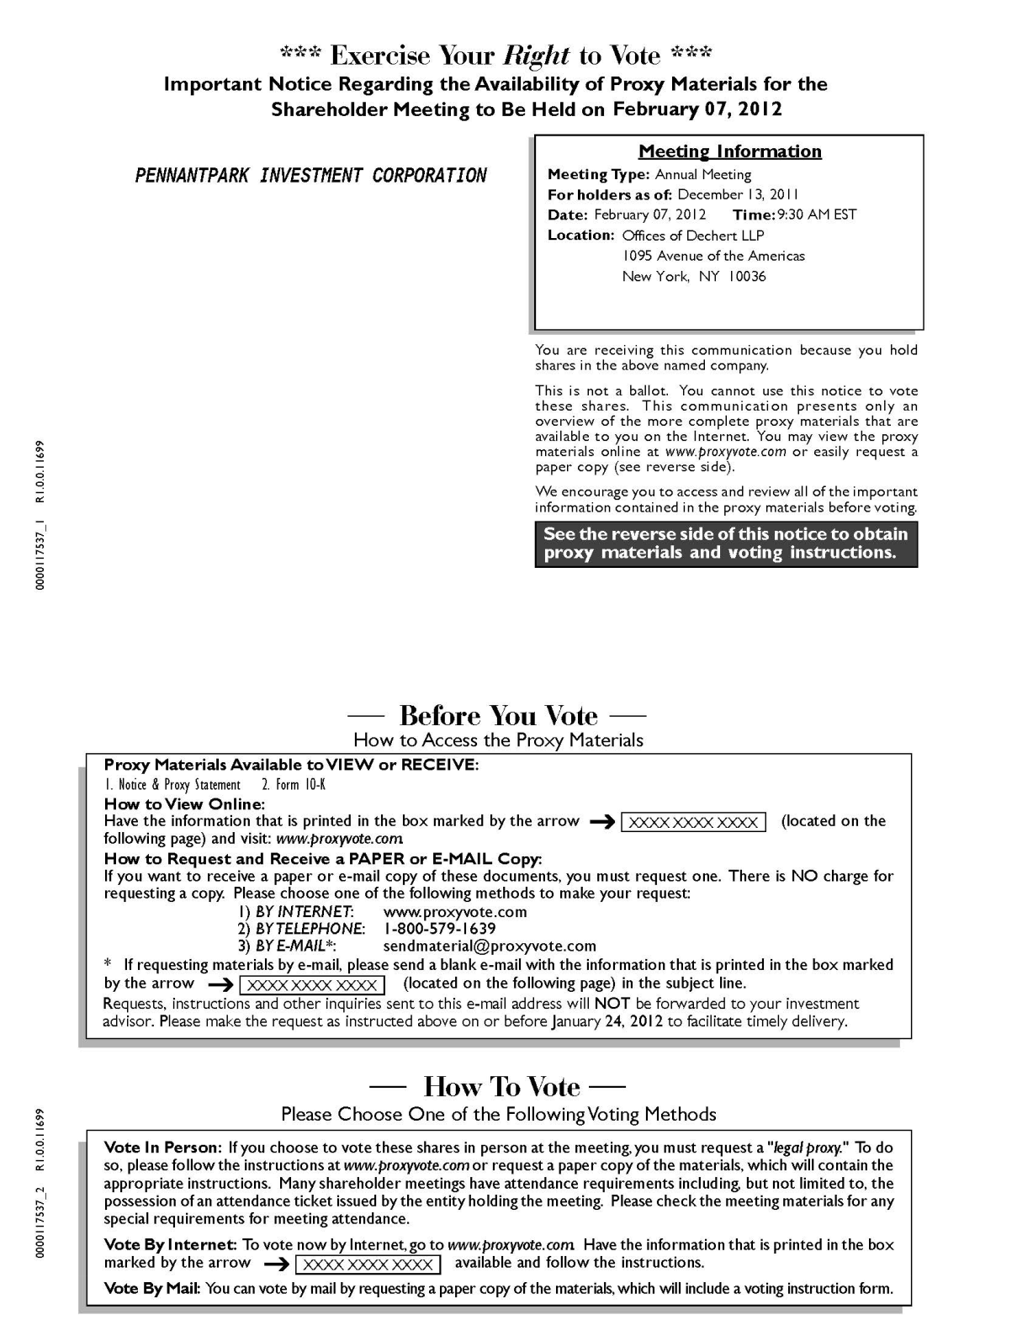

21



22

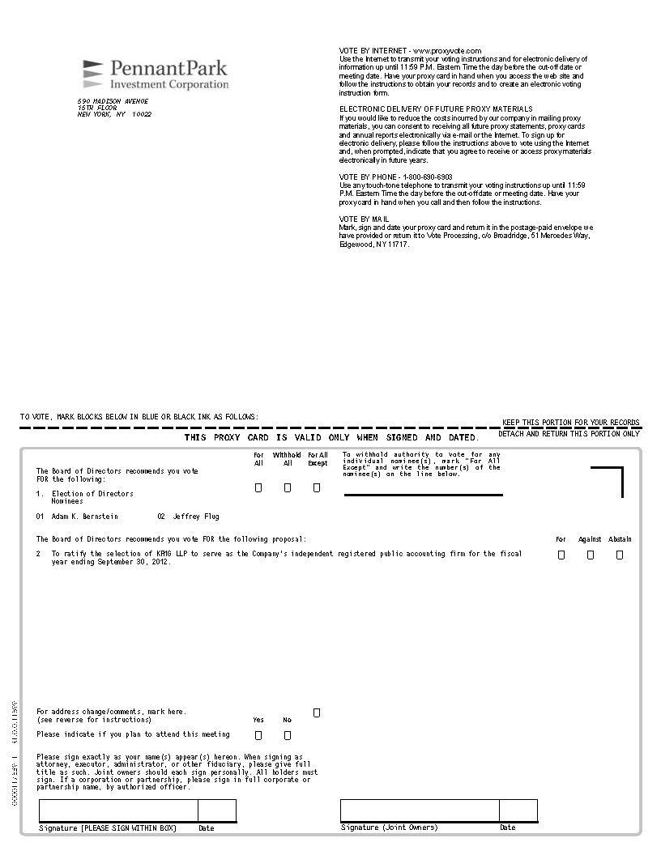

23

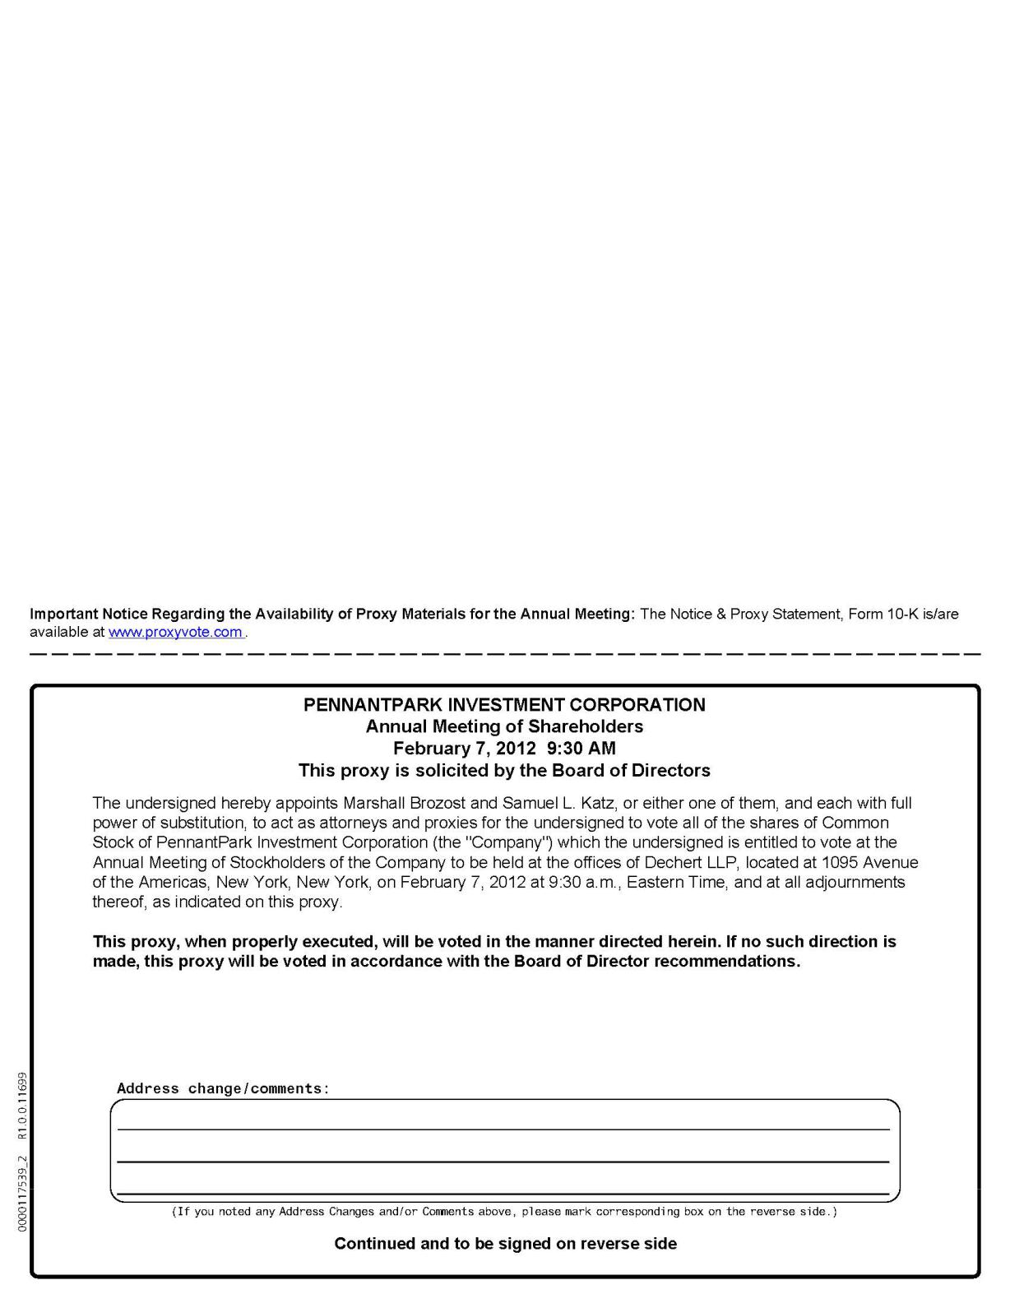

24

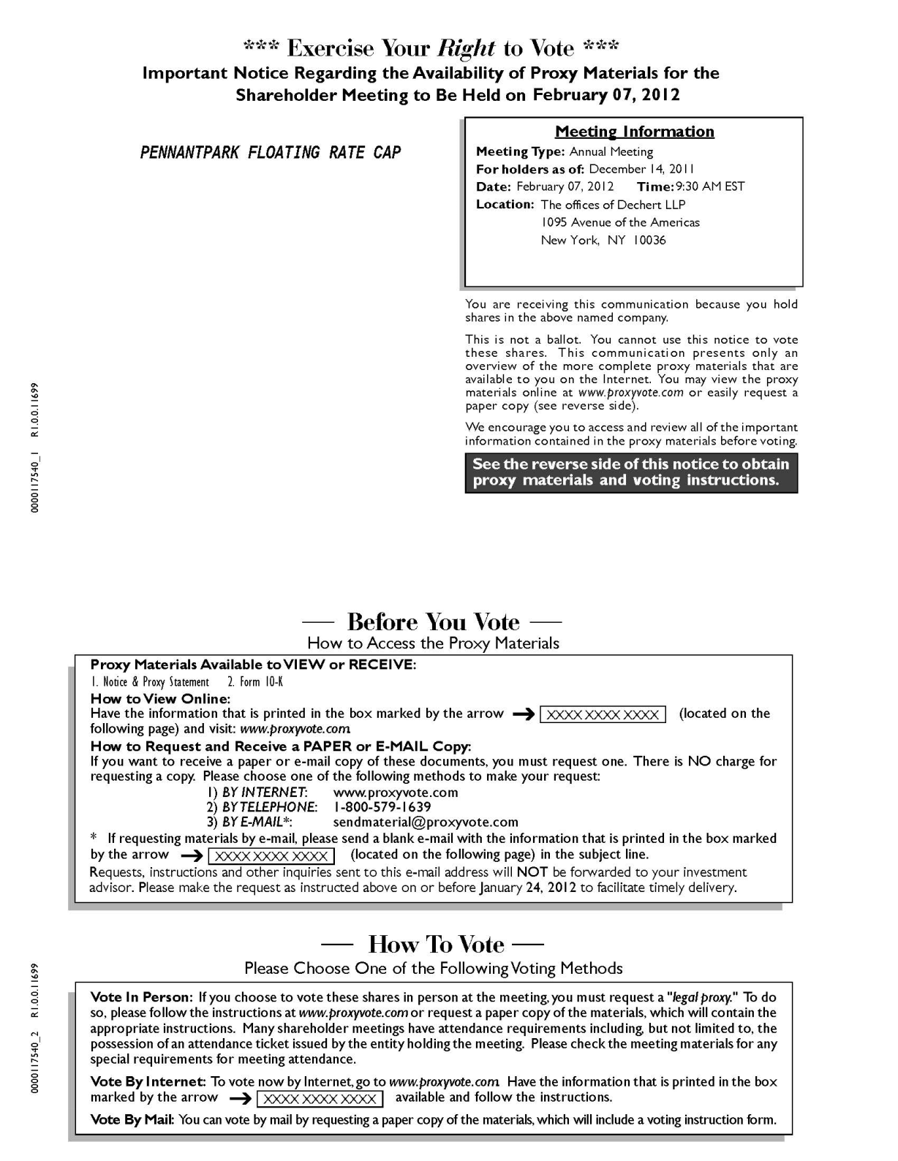

25



26

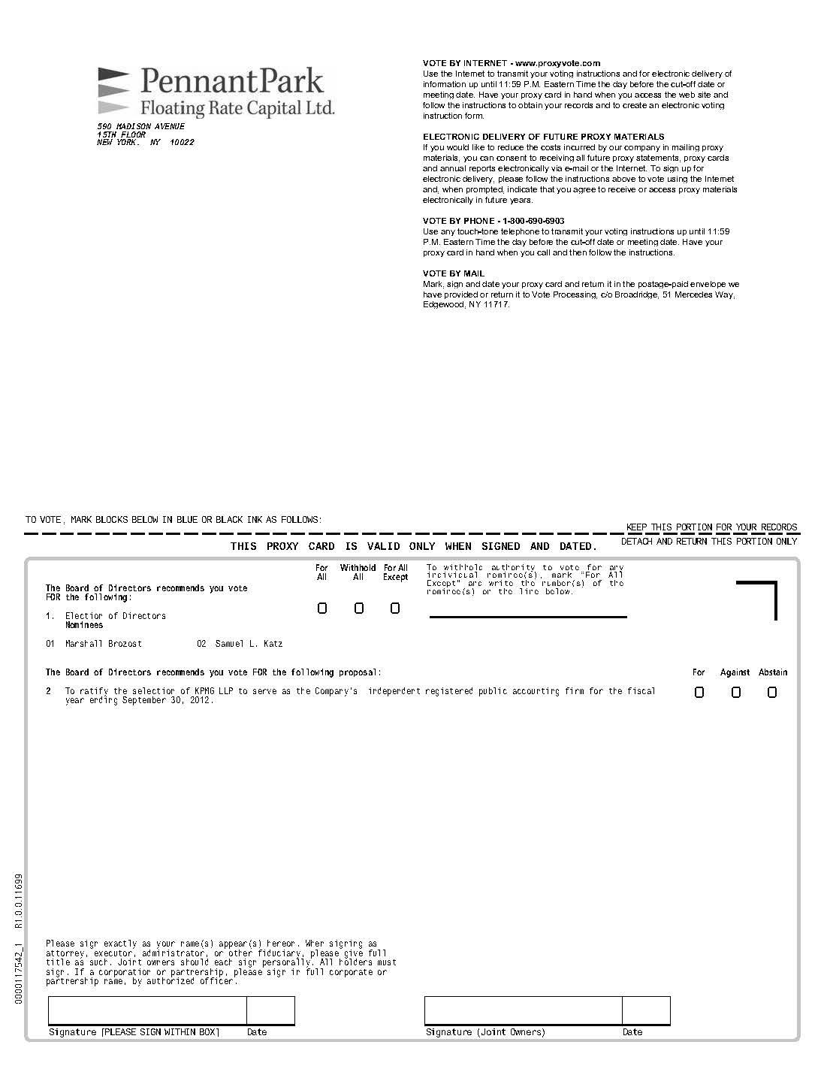

27

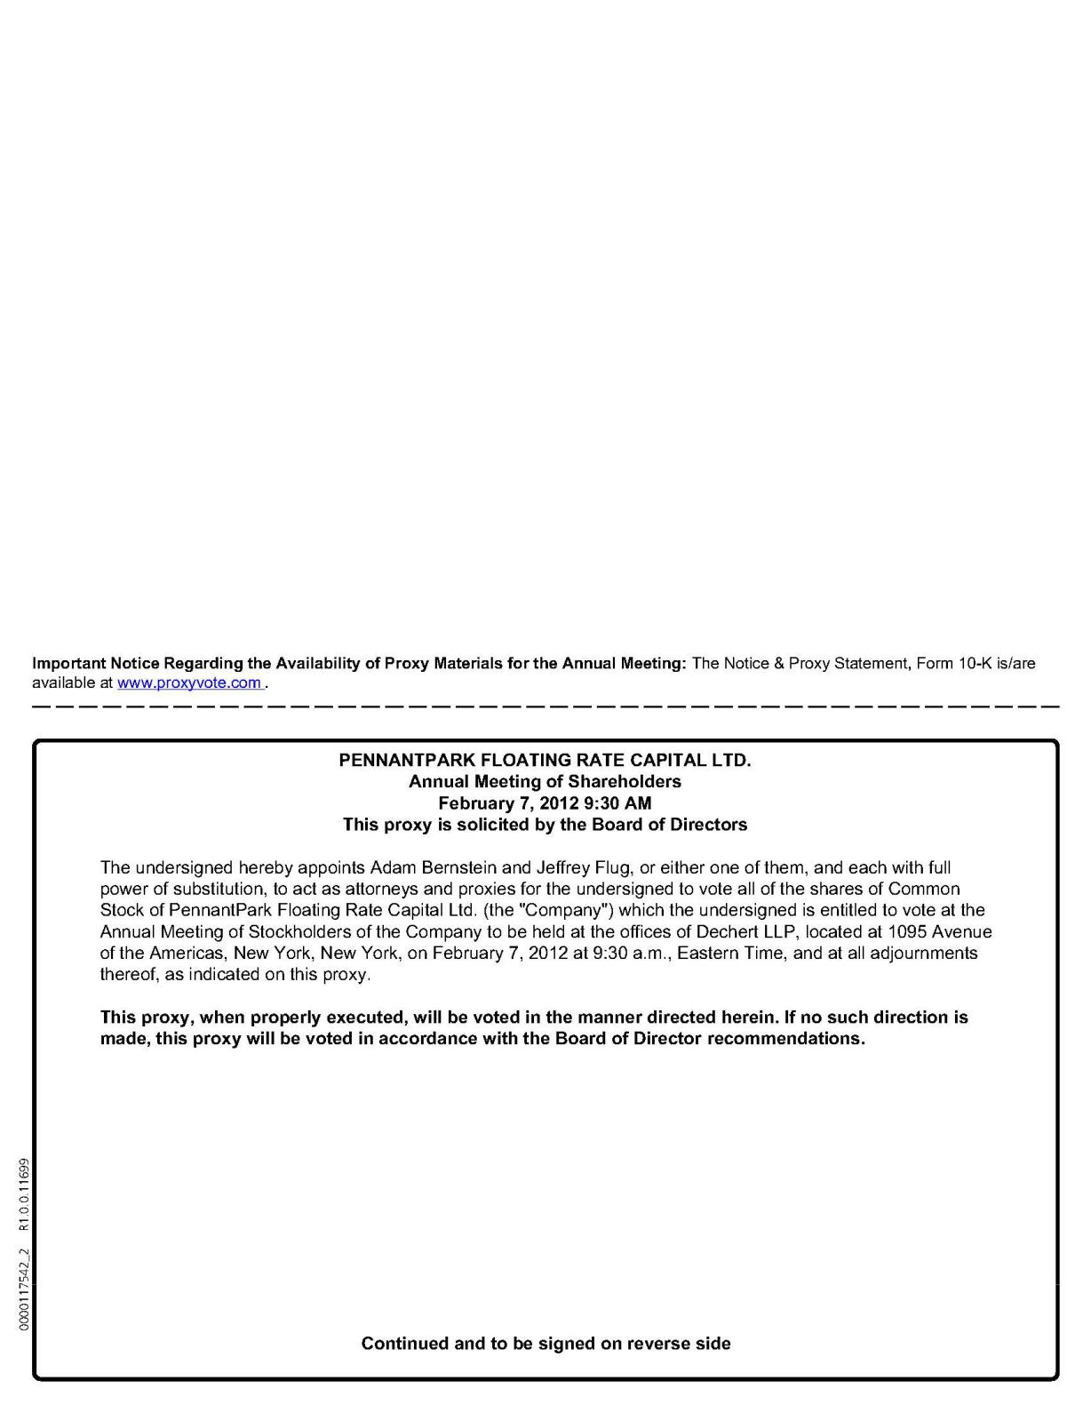

28

